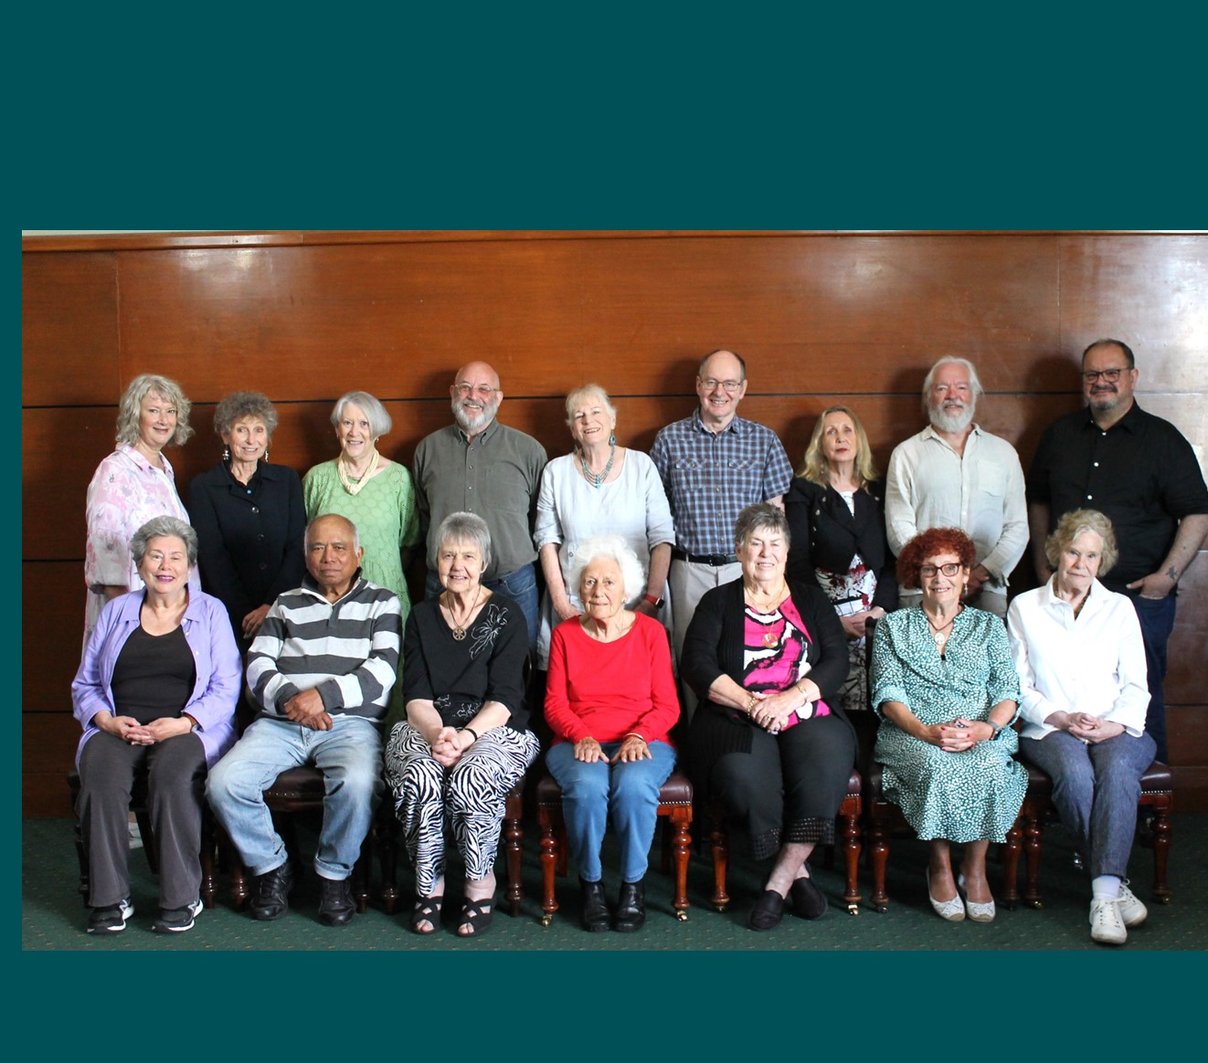


Older Persons Advisory Committee (OPAC)
Annual Report
January to December 2023



City of Port Phillip
99a Carlisle Street
St Kilda VIC 3182
Phone: ASSIST 03 9209 6777
Email: portphillip.vic.gov.au/contact-us
Website: portphillip.vic.gov.au

Divercity
Receive the latest news from your City and Council portphillip.vic.gov.au/divercity



National Relay Service
If you are deaf or have a hearing or speech impairment, you can phone us through the National Relay Service (NRS):
TTY users, dial 133677, ask for 03 9209 6777.
Voice Relay users, phone 1300 555 727,
then ask for 03 9209 6777.
relayservice.gov.au


Contents
OPAC Annual Report 2023 4
Acknowledgement of Country 4
About OPAC 4
The Stated Purpose of the OPAC: 4
Message from the 2023 Chair 5
OPAC Terms of Reference Objectives 6
OPAC Key Achievements 2023 7
Vale Sheila Quairney 9
Membership 10
Election of Office Bearers 11
Membership, Recruitment and Nominations 11
OPAC Objectives and Planning, January to December 2023 12
Meetings 13
Subcommittees and Working Groups 13
About the OPAC Governance Subcommittee 14
Membership and Representation 14
Council Advisory Committees/Networks: 14
External Community Groups/Networks: 14
Consultation 15
2023 Council Business – OPAC Consultations, Feedback and Information 15
Matters Affecting Older Residents Highlighted to Council by the OPAC Members 19
OPAC Activities and Engagement 21
OPAC Events 22
City of Port Phillip Seniors Festival 1 to 15 October 22
Acknowledgement 24
New Members Endorsed in 2023 25
Retiring Member 27

OPAC Annual Report 2023

Acknowledgement of Country
In accordance with the strategic vision advocating to the Community and the Council on behalf of older residents, including First Nations people, OPAC respectfully acknowledges the traditional owners of the land, the people of the Kulin Nations. We pay our respects to their Elders, past present and emerging and support their right to be heard and recognised.

About OPAC
The Older Persons Advisory Committee (OPAC) has been appointed by the City of Port Phillip council to be its main advisory body on all issues affecting older residents living in the City of Port Phillip. Encompassing a wide range of backgrounds and views, the OPAC is accessible and engaged.

The Stated Purpose of the OPAC:
The Older Persons Advisory Committee will provide advice to the Council and council officers about policies, plans and services affecting older people.

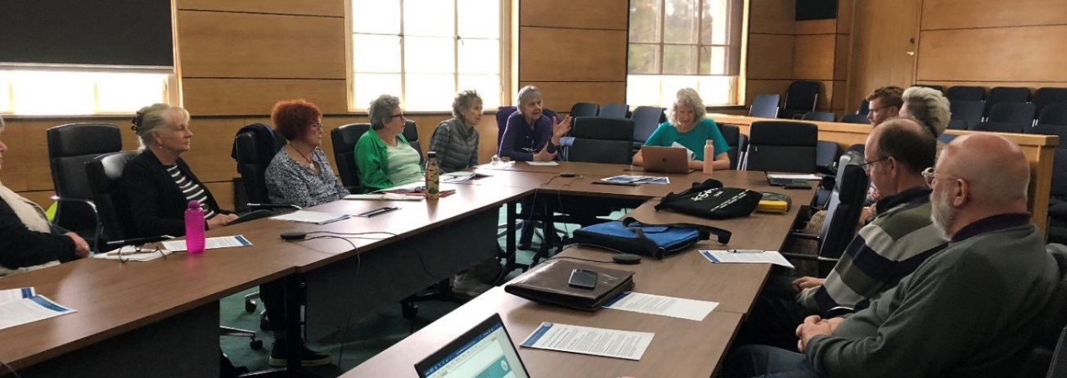
Image – OPAC Meeting November 2023.

Message from the 2023 Chair
Welcome to the 2023 OPAC Annual Report.
2023 was a busy year for OPAC as we continued to advocate to Council on behalf of Port Phillip’s older residents. Highlights include:
- The Positive Ageing Policy was endorsed by Council in May 2023. We look forward to further work in 2024 with Council on embedding actions that assist residents to age in place in their community. We will be watching to see how this overarching policy is reflected in Councillor decisions.
- We welcomed five new residents as members of OPAC, improving our reach to different parts of our community and bringing further passionate voices and skills to our Committee. This also enabled OPAC to give greater attention to our focus areas in preparation for input and advocacy to Council and beyond.
- We had success advocating to Council in the 2023 Budget including reviewing the Community Bus Service, in lowering the age limit for resident-attended community facilities, and for a hard copy of Divercity to be posted to older residents when requested. In addition we have advocated strongly for a broader Digital Literacy programme.
This year our biggest focus was the consideration of Council’s Home Services and how or if this would continue under the Federal Governments Aged Care Reforms. We have watched surrounding Councils’ decisions in this space and read media reports of outcomes that are less than ideal for those who rely on the care provided by trusted Council carers, so OPAC was grateful to be included in the consultation process.
Council’s Draft Aged Care Reform was open to community consultation until early December and will now come back to Council in February. Whilst we are disappointed that it is proposed the in-home services will no longer continue, we will be working closely with Council to ensure residents are not left without support, and that Council continues to work in this space to assist those who find navigating the Aged Care support process difficult. We also expect Council to be active in continuing to support its older residents to live well and enact its own Positive Ageing Policy.
OPAC looks forward to another year working closely with Council Officers and representing older residents of our beautiful City of Port Phillip.


Wendy Priddle
OPAC Chair

OPAC Key Focus Areas 2023
- Positive Ageing Policy Development/Implementation, Aged Care Reforms and Ageism Awareness (actively engage)
- Council Plan & Budget 2023/24 (input)
- Health & Wellbeing and Physical Environment (actively engage with Council on these issues)
- Housing (stay informed/provide advocacy support if applicable)
- Environmental Sustainability (stay informed/provide advocacy support if applicable)
- Communications (including digital literacy).

OPAC Terms of Reference Objectives
- To be the peak advisory and advocacy body on issues affecting the wellbeing of older people (55 years and over) within the Port Phillip municipality.
- To be representative and advocate on behalf of older persons from our diverse community including people with disabilities, people who identify as lesbian, gay, bisexual, transgender or intersex (LGBTI), people of Aboriginal or Torres Strait Island background, people experiencing financial disadvantage (including people who are homeless or at risk of homelessness) and our multicultural and multifaith communities.
- To provide advice to the Council and its officers on policies, plans and services that affect older people and their interests, and encourage the Council to advocate to other levels of government.
- To advocate to the Community and the Council, on behalf of older people, reflecting the United Nations Aged Friendly Cities Framework and the principles of independence, participation, care, self-fulfilment, and dignity.
- To connect with other relevant internal and external community advisory committees. To liaise with other organisations and networks that have a direct interest in older persons in the City of Port Phillip and the wider community.
- To continue to advocate for and support significant events, activities and services relating to older persons, including Port Phillip Seniors Festival, Linking Neighbours Program and Seniors Register, information forums, aged care services and the like.

OPAC Key Achievements 2023
Activity | Achievement
OPAC were key subject matter experts and stakeholders in the finalisation of the Positive Ageing Policy. | Council officers adopted OPAC advice about the design and content of the policy to make the policy more user friendly and readable including case studies.
OPAC participated in three workshops with Community Services to provide feedback about the proposed Changes to Aged Care Services in Port Phillip. | OPAC feedback incorporated in the engagement collateral.  OPAC provided a formal response to Council in December 2023.
Through its Council Plan and 2023/24 Budget Submission OPAC joined with the community to advocate for changes and improvements to a number of significant programs and services affecting older people.  The OPAC Council Plan and 2023/24 Budget submission aligned to Council’s strategic objectives and complimented the implementation of Positive Ageing Policy. | Changes implemented in 23/24:  - A print and post option for Divercity by request  - Funding and staffing to support older people to improve their digital literacy skills by delivering programs in Libraries and community centers  - Council’s Community Bus service returned to a ‘Hop On Hop Off’ service  - Community facilities fees are waived where 65% of attendees are aged over 60 years (lowered from 65 years).
OPAC instigated a Joint Special Advisory Committee Meeting. | The inaugural Joint Special Advisory Committee meeting was held on 21 March, chaired by Wendy Priddle.
The OPAC continued to raise awareness about ageism against older people and seek ways to end ageism. | The OPAC Ageism Awareness Working Group delivered Ageism Awareness Information sessions to the community and council staff, members of ELT, Mayor and Councillors and CEO.
Activity | Achievement
OPAC worked to ensure Council continues to consider the needs of older persons in relation to climate, accessibility, housing, the built environment and public spaces. | OPAC consulted with Council officers about the Positive Ageing Policy, Accessibility Action Plan, Public Toilet Plan, E-Scooter Trial, Council’s Ten-year Integrated Transport Strategy, Act and Adapt Sustainable Environment Strategy, Places to Live: Port Phillip Housing Strategy.
OPAC advocated for an increase in participation of older people in local sport, recreation and social activities. | The OPAC Sport and Recreation Working Group worked with Council’s Sport and Recreation team to design a phone survey which was delivered to ten local sporting clubs.

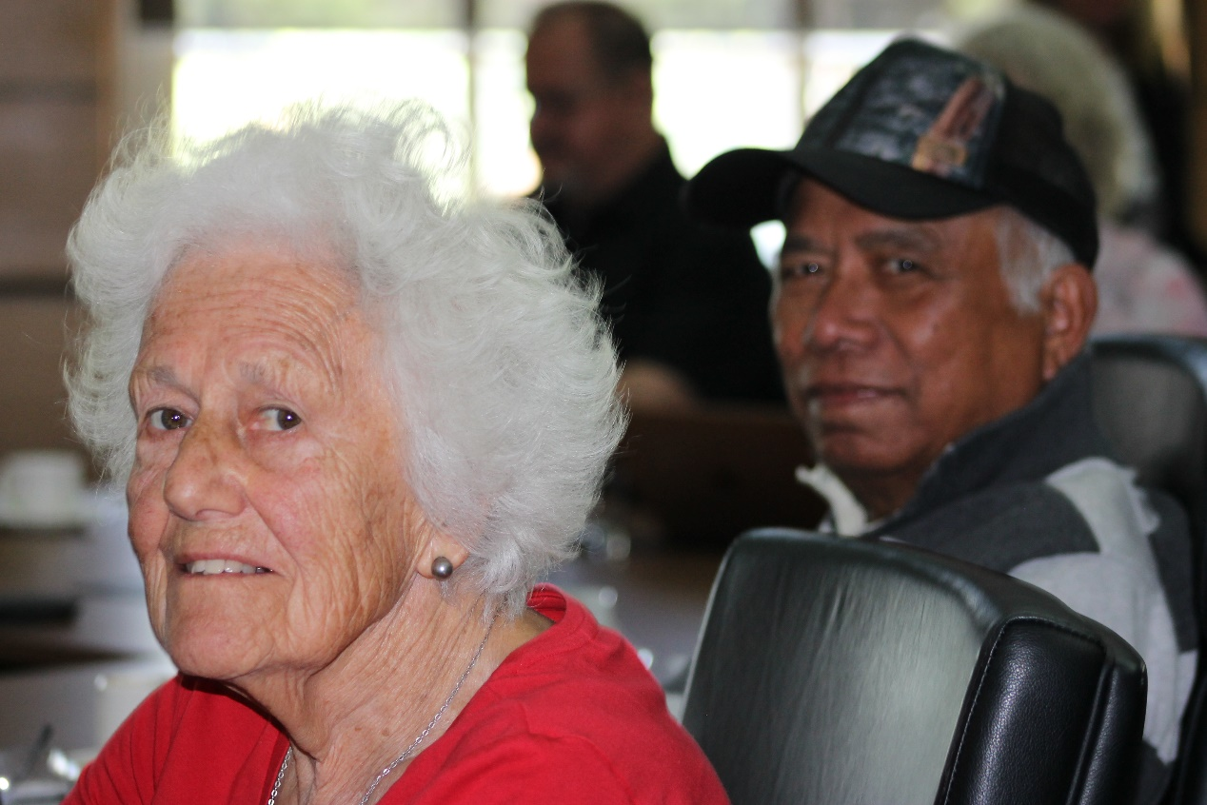
Image – Betty and Neville OPAC December Meeting.

Vale Sheila Quairney

It was with deep sadness that the community learned of the untimely and sudden death of Sheila Quairney in April 2023.
Shelia moved to Melbourne from the United Kingdom in 2019 to be with her partner and very quickly immersed herself in City of Port community life joining the University of the Third Age Port Phillip (U3APP), Port Phillip Life Activities Group and local walking and singing groups.
Sheila joined the Older Persons Advisory Committee (OPAC) in August 2020 after a competitive recruitment round. Sheila impressed the OPAC interview panel with her expertise, agility and passion to support the civic and social participation of older people in the City of Port Phillip.
During her tenure on the OPAC Sheila contributed to a number of flagship activities and programs including participating in the Objectives and Planning Working Group in 2023, the Council Plan and Budget Working Group in 2022, the South Melbourne Market Accessibility Working Group from 2020 to 2022 and the Communication Working Group in 2022 to 2023.
A published writer, Sheila joined the Seniors Festival Writing Awards judging panel in 2022 providing exceptional advice and guidance as part of that panel. Sheila was a contributor to the Seniors Festival Writing Awards in 2020 and 2021 and was awarded prizes for outstanding achievement in creative writing on both occasions.
In December 2021 Sheila was appointed President of the University of the Third Age Port Phillip and was tireless in her commitment to that role bringing a wealth of leadership, energy and expertise.

Membership
Current Members | Location
Neville Aphoy | St Kilda East
Judith Armstrong | Elwood
Kevin English | Albert Park
Freda Erlich | St Kilda
Janet Gardner | Elwood
Betty Knight | Albert Park
Coralie Ling | St Kilda
Ada Lubin | St Kilda
Jeanette Lyons- McKinnon | Port Melbourne
Ian MacDonald | St Kilda
Sue McGowan | Port Melbourne
Wendy Priddle | Elwood
Rosemary Rule | Port Melbourne
Liz Robson | Port Melbourne
Vasileios Tsialtas | St Kilda
Richard Whitfield | Port Melbourne
Office Bearers | Position
Wendy Priddle | Chairperson (appointed March 2023)
Ian MacDonald | Deputy Chairperson (appointed March 2023)
Past /Retiring Members | Location/Term
Sheila Quairney | Port Melbourne (August 2020 to April 2023)
Georgina Tsolidis | Elwood (March 2018 to April 2023)
Council Representative | Ward
Cr Peter Martin | Gateway Ward
Council Officer/s | Position
Cathy Horsley | Team Lead Community Building
Gavin Murphy | Coordinator Grants and Community Building

Election of Office Bearers
The OPAC Terms of Reference (adopted 16 June 2021) state ‘the Chair and Deputy Chair will be nominated from among the members. The Chair and Deputy Chair will serve a one-year term, with the appointment renewable for an additional consecutive term’.
At the meeting 6 February 2023 Freda Erlich and Coralie Ling resigned as Chair and Deputy Chair respectively having completed their term as outlined on the OPAC Terms of Reference.
OPAC members were invited to nominate for the vacant positions. Nominations were open from 27 February to 3 March 2023. Six members were nominated, two members accepted their nomination, one for Chair, one for Deputy Chair.
At the meeting 6 March 2023 quorum was achieved and the two nominees were unanimously endorsed by members in attendance without the need for a vote. The following members were elected at the 6 March meeting:
- Wendy Priddle - Chair
- Ian MacDonald - Deputy Chair

Membership, Recruitment and Nominations
As a result of the resignation of four members in 2022 and the untimely death of a member in 2023 the OPAC cohort was reduced to eleven members, resulting in six vacancies.
In May 2023 Council called for Expressions of Interest (EoI) from people wishing to join the OPAC. This opportunity was promoted broadly to the community via digital distribution through existing networks, e-newsletters, Council website and social media platforms. Hard copies of information were also made available at St Kilda and Port Melbourne Assists and St Kilda and Port Melbourne Libraries.
Ten EoI’s were received. After a short-listing process, nine people were interviewed by the panel. The panel comprised the Coordinator Grants and Community Building, Gavin Murphy, OPAC Councillor Representative Cr Peter Martin and OPAC Chair Wendy Priddle.
The panel were impressed by the calibre of all applications and recommended five people join the committee. The five recommendations were presented to the OPAC for endorsement at the meeting 3 July 2023 and endorsed by Council at the meeting 19 July.
Attachment 1 – New Members Endorsed and Retiring Member 2023.

OPAC Objectives and Planning, January to December 2023
The OPAC Objectives and Planning Working Group was established in 2020 to develop the OPAC objectives and action plan for each year. The Objectives and Planning meeting held on 16 January 2023 was made up of the OPAC Chair, Deputy Chair and eleven members of the OPAC who nominated to participate. Team Leader Community Building also attended/contributed to provide relevant information and administrative support.
The 2022 Objectives and Plan was developed within the context and aligned to the following documents:
- OPAC Terms of Reference
- City of Port Phillip Council Plan 2021-31
- City of Port Phillip Health and Wellbeing Implementation strategy
- OPAC 2022 Objectives and Action Plan
- World Health Organisation (WHO) Age Friendly Cities (AFC) Framework.

Seven Key Focus areas were identified and aligned to the Council Plan and AFC Framework; they were:
- Positive Ageing Policy/Aged Care Reforms (Changes to Aged Care Services)
- Council Plan & Budget 2023/24 Input
- Ageism
- Health & Wellbeing and Physical Environment
- Housing
- Environmental Sustainability
- Communication.

The draft 2023 Action Plan was endorsed by the OPAC at the 6 February meeting.

Attachment 2 - City of Port Phillip Older Persons Advisory Committee (OPAC) Action Plan January – December 2023.

Meetings
The OPAC continued to meet monthly. Meetings were held from February to December. A quorum at each meeting was upheld. A total of eleven OPAC meetings were held in 2023. In addition to monthly committee meetings OPAC worked collaboratively with the Community Services Team to provide feedback about the Council’s proposed Changes to Aged Care Services. The support this an additional four meeting/workshops were held between October and December 2023.
OPAC members continued to consult on matters relevant to older people residing in the City of Port Phillip and deliberated on specific council matters concerning older people and the broader community. Community trends relevant to council were identified through OPAC meetings where reports were provided from OPAC representatives. The OPAC continued to maintain connections with relevant associations and participate in relevant networks and forums both within and external to Council.

Subcommittees and Working Groups
The following OPAC Working Groups and Subcommittees were maintained/established to progress the actions highlighted in the 2023 Action Plan:
  - 2023 Objectives and Planning Working Group
  - Positive Ageing / Aged Care Reforms
  - Council Plan and Budget Working Group
  - Seniors Festival Subcommittee
  - Governance Subcommittee
  - South Melbourne Market Working Group
  - Ageism Awareness Working Group
  - Sport and Recreation Working Group
  - Housing and Homelessness Working Group
  - Public Space and Physical Environment Working Group
  - Communication Working Group

About the OPAC Governance Subcommittee
The OPAC Governance Subcommittee was established in 2020 to support the OPAC to develop guidelines and processes to ensure OPAC meetings are running effectively and efficiently. Where appropriate it has a role in implementing decisions taken by OPAC.
In 2023 the Governance Subcommittee utilised the following tools to assist with its stated aim of efficient and effective operations:
- OPAC Governance Sub Committee Guidelines
- Guidelines for the establishment of OPAC Working Group and Sub-Committees
- Agenda setting and meeting procedures
- Consultation guidelines for council officers
- Process for introducing New Items for action by OPAC
- Procedure for Subcommittees and Working Groups.

Membership and Representation
OPAC members represented the following associations/networks and reported relevant activities at the OPAC monthly meetings.

Council Advisory Committees/Networks:
  - Linking Neighbours Leadership Group - Neville Aphoy, Sue McGowan
  - Port Phillip Multicultural Advisory Committee - Georgina Tsolidis / Bill Tsialtas
  - Port Phillip Multifaith Network - Coralie Ling

External Community Groups/Networks:
  - Bicycle Users Group – Freda Erlich
  - Elwood Croquet Club – Judith Armstrong
  - Fishermans Bend Urban Renewal Area (FBURA) - Cr Martin
  - Port Phillip Citizens for Reconciliation – Rosemary Rule
  - University of the Third Age Port Phillip (U3APP) – Sheila Quairney/ Kevin English

Consultation
As part of the consultative role of the OPAC, council officers regularly sought advice and feedback on council activities and initiatives relating to the needs, engagement, and inclusion of older people. In turn the OPAC brought to the meetings feedback and issues on council business that were raised by the community.
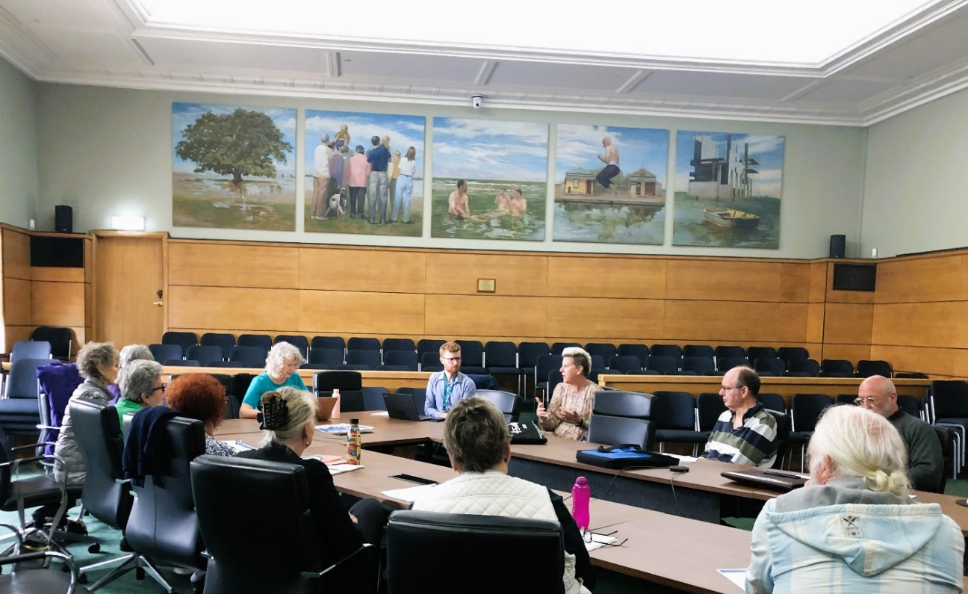
Image – OPAC Changes to Aged Care Services consultation November 2023.

2023 Council Business – OPAC Consultations, Feedback and Information
Positive Ageing Policy Finalisation and Endorsement (February to May meetings)
OPAC received regular updates from council officers regarding the Positive Ageing Policy development and endorsement. Deputy Chair Ian MacDonald, Coralie Ling and Rosemary Rule attended the Council meeting 17 May to speak in support of the endorsement of the Positive Ageing Policy and ask about implementation plans. OPAC Chair Wendy Priddle provided a written response however was unable to attend due to connectivity issues.
Positive Ageing Policy Implementation (June to September and December meeting)
OPAC received updates from officers regarding the Positive Ageing Policy (PAP) Implementation and heard that the PAP Implementation Plan will be delivered alongside other diversity focused policies and will be included in the Diversity Equity and Inclusion Framework – the PAP will sit under this Framework along with the Accessibility Action Plan, LGBTIQA+ Plan.
Changes to Age Care Services in City of Port Phillip (Feb to December meetings)
OPAC received regular updates from Council officers regarding proposed changes to Aged Care Services. OPAC were consulted as part of this process. On 20 October thirteen members participated in a workshop conducted by the Community Services team. OPAC members provided feedback about the proposed changes and contributed important feedback and suggestions about the engagement plan. OPAC initiated two additional member workshops in November 2023 to examine Councils proposed Changes to Aged Care Services providing detailed feedback (including identifying themes). OPAC participated in a workshop on 4 December where Community Services staff shared early feedback gathered from the Changes to Aged Care Services engagement. OPAC provided a response to the Council’s Proposed Changes to Aged Care Services which was submitted during the formal feedback and engagement period.
Draft Council Plan and Budget 2021 - 2031
OPAC 23/24 budget submission complimented the implementation of Positive Ageing Policy and Council’s review of delivery of Aged Care Services. The submission was further strengthened with the inclusion of resourcing indicators. The submission included the following items which were subsequently endorsed:
- Council offers a print and post option for Divercity by request
- Funding to support older people to improve their digital literacy skills with classes in the community, partnering with libraries, tech organisations and community groups
- Council’s Community Bus service return to a ‘Hop On Hop Off’ service
- Request that the age at which community facilities fees are waived where 65% of attendees are aged over 65 be lowered to 60 years in line with the Positive Ageing Policy.
Introduction to Mayor Heather Cunsolo (February Meeting)
The Chair thanked the Mayor for attending and explained the role of the OPAC (advancing the voice of older people in the Port Phillip community) and added that the committee strives to share the opinions and advocate for the rights of older people. The Chair noted that Communication is a key objective for OPAC and OPAC are keen to advocate for the needs of older people so they can access information and provide feedback to Council particularly important is digital literacy. The Chair also flagged the following OPAC priorities with Mayor Cunsolo; access to hard copies of Divercity for older residents, lowering the age for discounted community centre hire, return to the hop on hop off bus service, access to information about climate, particularly managing flooding and heat stress.
Upgrade Barkly Street Lighting (May and November meetings)
At the May meeting OPAC were advised that this project is delayed. The prices received from the energy distributors United Energy and CitiPower originally were 80% higher than anticipated. Council has now negotiated a fair and reasonable price with these utility companies and have recently signed contracts for delivery. State owned roads have not been included in Stage 1 of this project as further negotiations are in progress with the Department of Transport to fund State Roads. At the November meeting OPAC received an update from Head of Asset Management who explained that “United Energy are still working to clear their backlog of streetlighting issues. Ongoing delays, with installing streetlights, are expected to continue for the near future.”
Act and Adapt - Sustainable Environment Strategy 2018 -28 (April and July meetings)
Senior Sustainability Strategy Officer Andrew Sargeant shared a presentation which included five key components and associated activities and tasks. Andrew explained there has been significant progress in up to half of the strategy actions and many of the sub actions, there is great progress in this space. The five-year review point provides an opportunity for review and input for the next five years.
Accessibility Action Plan (AAP) Engagement 2023 - 2025 Update (May meeting)
Council’s Social Policy Advisor attended the May meeting and shared that the plan is a legislative requirement which needs to be reported against. Disability Discrimination Action Plan may be a better description as the plan is an important tool for protecting the rights of people with disability. Engagement on the Accessibility Acton Plan draft was mostly online and did also include a session with the Voices of the South Side, a representative group. The remit includes people with disability with a variety of experiences and captures the experience of Carers. The Accessibility Action Plan is an internal and externally facing document – some of the decisions will directly affect the community.
Introduction to Bridget Monro-Hobbs Manager of Community Services (June meeting)
Bridget thanked the committee for the invitation explaining that she is passionate about Aged Care and Ageism, and she has come to City of Port Phillip from Maribyrnong City Council where she managed Aged Care and Community Services.

Draft Public Toilet Plan Consultation
OPAC member Freda Erlich provided feedback on this plan noting it may not be a top priority for the OPAC however it is important to older people. The strategy will provide an opportunity to plan for more and better maintained public toilets and that this topic intersects with homelessness.
Introduction to Leo Kelly the Newly Appointed Manager of Community Building and Inclusion (August meeting)
Leo introduced himself and provided the committee with a snapshot of his work with City of Port Phillip over twenty years. Leo described his background working to support first people’s topics and housing and homelessness. Leo has a connection to Port Phillip and St Kilda though accessing the area for recreation and during the thriving 1980s band scene. Leo has experience working to support family members ageing in place and supporting their access to Aged Care Services.
Kahlia Flett - Recreation Participation and Projects Officer provided an update about creating opportunities for older people to participate (August meeting)
Kahlia explained that she has been working with the OPAC Sport and Recreation Working Group to develop opportunities for increased participation by older residents with a focus on Walking Netball. Kahlia shared that Netball Victoria has agreed to facilitate a four-week walking netball trial. Netball Vic would provide the volunteers and facilitate the trial program. There was call out for OPAC members to champion and also support the trial.
Update on Wellington Street Project and Social and Affordable Housing General - Gary Spivak Coordinator Housing, Safety and Reconciliation (September meeting)
Gary shared that in CoPP there has been an increase of funding for community housing some of this on Council land. Council has adopted the In Our Back Yard Policy to retain levels of social housing in CoPP. Council sets ambitious aspirations for levels of social and affordable housing and there is more funding that comes from State Government and Federal Government which will assist with this program of works. Part of Gary’s work is to determine the best way to attract additional funds.
Update on Move Connect Live - Karen Roache Acting Coordinator of Strategic Transport (September meeting)
Karen discussed the Council’s ten-year integrated transport strategy which looks at how we move around the city safely. Information determined from the mid-cycle review helped Council understand if Council is meeting its obligations. Karen shared that regarding protected bike lane corridors – two are delivered. Council will look at what other treatments can be used to promote sustainable transport. Karen discussed the e-scooter trial underway until 5 October. The most likely outcome of the trial is that e-scooters will be permitted to operate in City of Port Phillip.
Update and Feedback on Port Phillip Library Services – Adult Programs, Rubie Bridie Adult Programs Librarian and Kate Foster Library Projects Lead (October meeting)
Kate shared that there are four new Adult Programs Librarians and much of their work will focus on programs for older persons including digital literacy.
Rubie provided some background: the Library has received a grant with a focus on delivering digital literacy. This includes expanding the current weekly digital essentials classes at St Kilda Library to the Port Melbourne Library. The team have also introduced one on one Device Advice tech sessions at Port Melb and St Kilda Libraries. The OPAC provided feedback and provided suggestion for programming for older persons.
Councillor Visit, Deputy Mayor Cr Louise Crawford (December meeting)
Cr Crawford said OPAC has been amazing in 2023 and have stepped it up to another level in terms of letting Council know the needs of older people. Cr Crawford thanked the committee for its input into the proposed Changes to Aged Care Services and reiterated that Council is keen to continue to receive OPAC feedback regarding the proposed Changes to Aged Care Services.
Council Website Testing Research (May 2023)
Five members participated in a project which sought user feedback on the Council website to better improve the website and the content/layout. Five OPAC Members worked with TestMate agency to test the website useability and provide feedback.

Matters Affecting Older Residents Highlighted to Council by the OPAC Members
The Future of South Melbourne Market
In November the OPAC South Melbourne Market Working Group met with Sophie (Executive Director), Meagan Scott (Head of Marketing and Customer experience), Alice Coulson Engagement Advisor to discuss the refurbishment / improvement plan for South Melbourne Market. The Working Group heard that improvements are still running to a 10-year plan, but COVID impacted on this. The Working Group sought feedback from the committee to contribute to community feedback. The OPAC heard that further surveys are planned for 2024 as the refurbishment plan develops.
Community Bus - Return to Hop On Hop Off Service
Members of the OPAC Public Spaces and Physical Environment Working Group received a briefing from Rohan Bond Head of Aged Access and Inclusion in November. Rohan addressed the Working Group’s questions about how the service is funded and staffed. Rohan shared that the two community bus routes intersect at a number of stops e.g. South Melbourne Market, MSAC etc. Discussion ensued regarding the possibility of the service being extended during daylight saving in order to allow older residents to attend the special, after-hours functions being offered in the community e.g. outdoor theatre performances in the Botanical Gardens. Rohan agreed to take this request to management.
Communications – How to Contact Council
The OPAC Communication Working Group worked with the Community Building Officer and Council’s Communications team to design a flier outlining how to contact Council. The flier includes information about how to contact your Councillors, The CEO and The Mayor, How to Report an Issue and How to Request to Speak at a Council Meeting. The flier is in draft and will be finalised early 2024.
Port Phillip E-Scooter trial
Members of the OPAC Public Spaces and Physical Environment Working Group received a briefing from e-scooter providers Lime and Neuron in November. This provided an opportunity to share feedback and raise concerns shared by older residents. The Working Group focused on patronage and usage, trip mapping, problems and accidents, improper parking, failing to wear helmets. The Working Group heard that on 6 October 2023 the Victorian Government announced the extension of the trial for a further 6 months until 5 April 2024.
Acknowledgement of the Passing of Sheila Quairney (May Meeting)
At the meeting 1 May OPAC Chair Wendy Priddle acknowledged the passing of Sheila Quairney and one minute of silence was observed. Sheila joined the Older Persons Advisory Committee (OPAC) in August 2020 after a competitive recruitment round. Sheila impressed the OPAC interview panel with her expertise, agility and passion to support the civic and social participation of older people in the City of Port Phillip. Wendy noted that during her tenure on the OPAC Sheila contributed to a number of flagship activities and programs including participating in the Objectives and Planning Working Group in 2023, the Council Plan and Budget Working Group in 2022 and the South Melbourne Market Accessibility Working Group from 2020 to 2022.

OPAC Activities and Engagement
Introduction to MP Nina Taylor (Australian Labor Party, Member for Albert Park) and opportunity for questions (August and October meetings)
At the meeting 7 August OPAC shared their 2023 Action Plan objectives and asked to hear MP Taylor’s party’s thoughts on the following topics:
- What does the State Government do in relation to the development and design of Aged Care policy? (OPAC are keen to understand how three levels of government work together in this space)
- Will you/your party advocate with the Federal Government in this space?
- What are your party’s priorities and focus areas?
OPAC members had the opportunity to ask about the tenancy rates and management of social and affordable housing.
At the meeting 2 October MP Nina Taylor provided a response to questions posed by the OPAC at the August Meeting and took further questions.
Statement on the Indigenous Voice to Parliament (September meeting)
On 4 September, the OPAC Draft Statement on The Indigenous Voice to Parliament was put to the committee for endorsement:
The OPAC’s strategic vision is to advocate to the Community and the Council on behalf of older people for a world where older people are respected, healthy, and included. A world where older Indigenous Australians are included must be determined not for First Nations people, but by First Nations people. Therefore, the OPAC recommends that the City of Port Phillip Council support the indigenous Voice to Parliament being enshrined in the constitution. The OPAC supports the Voice as a mechanism for those who have historically been excluded from participation and providing a path towards rectifying the structural challenges that define the extreme but preventable inequalities that First Nations people experience.
OPAC instigated Joint Advisory Committee Meeting
The inaugural Joint Advisory Committee Meeting was held on 21 March 2023 at St Kilda Town Hall. OPAC Chair Wendy Priddle chaired the meeting. In attendance: Ian MacDonald OPAC, Georgina Tsolidis MAC, Helene Kammoun MAC, Liam McAuliffe LGBTIQA+ AC, Megs Alston FoSC, Carey Rohrlach PPMN, Abe Schwarz PPMN, Bhakta Dasa PPMN. Council staff in attendance: Allison Kenwood, General Manager Community Wellbeing and Inclusion, Katrina Terjung Manager Community Building and Inclusion, Gavin Murphy Coordinator Grants and Community Building, Cathy Horsley Team Leader Community Building, Sandra Khazam Diversity Officer, Carlene Harlock, Coordinator Friends of Suai / Covalima. At the meeting members discussed the meeting purpose and shared opportunities for alignment including a possible joint budget submission where objectives align as well as public events and website improvements.
2023 Advisory Committee End of Year Celebration
The end of year celebration for all advisory committees held on 29 November acknowledged the dedicated service of members during 2023. Ten OPAC members attended and enjoyed meeting members of Council’s other special and delegated committees.
EveryAge Counts (EAC) Campaign Leading the Way to End Ageism in Australia
An Ageism Awareness Information Session was delivered by Wendy Priddle on 15 June for World Elder Abuse Prevention Awareness Day (WEAAD) as part of Councils Community Training Calendar. There were 12 participants from local Aged Care service providers. A further six sessions were conducted for Council staff in 2023. The OPAC delivered the session to members of ELT, Mayor, seven Councillors and CEO on 26 October 2023.

OPAC Events

City of Port Phillip Seniors Festival 1 to 15 October
The annual Port Phillip Seniors Festival celebrates the lives of older people and promotes positive ageing through a range of diverse and vibrant events and activities across the city.
The 2023 Seniors Festival included 35 exciting Council and community led events and activities across the municipality with an estimated total attendance of 1,700+.
The festival launch at Middle Park Bowling Club held on Sunday 1 October attracted over 150 people who enjoyed the I Love Elvis tribute show. The event was further supported by seven council staff from the Community Wellbeing and Inclusion Division who volunteered at the event.
Programs and activities on offer in Port Phillip’s 2023 Seniors Festival included croquet, community gardening, rowing, bowling, table tennis, online chair yoga, digital storytelling and art workshops.

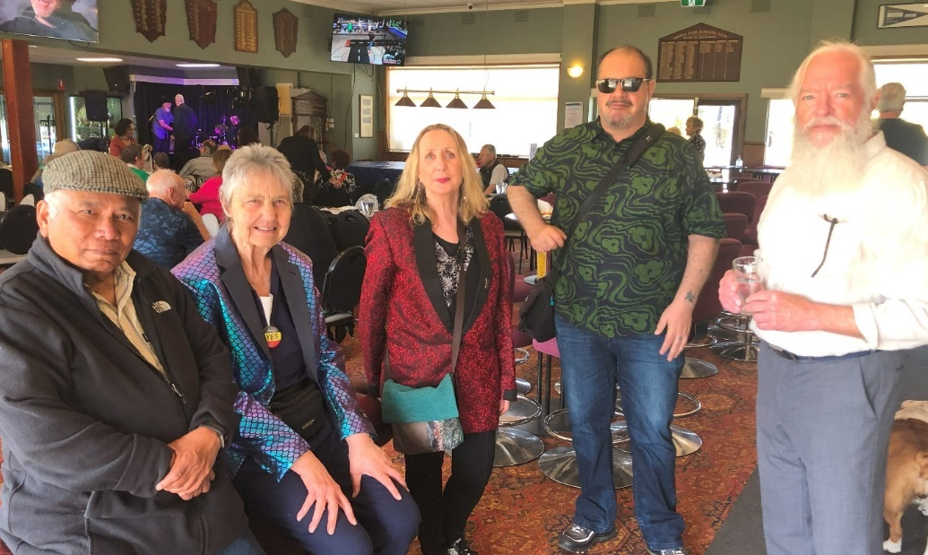
Image – OPAC members at the 2023 Seniors Festival Launch 1 October.

On 10 October, the National Ballet School students took the spotlight when they performed an excerpt of The Nutcracker in the Meet the Rising Stars of Dance and Drama show.
The festival also included a seniors safety forum, multicultural concert, healthy living seminars presented by the Alba and the Grace Retirement Community, a University of the Third Age Port Phillip arts and music showcase, Beach Boys live music tribute at Sacred Heart Homes, and a joyful celebration of Jewish culture with amazing food, music, videos, and dancing.
Writing was strongly represented with workshops on crafting everything from memoirs to newsletters and the announcement of the 19th Port Phillip Writes Seniors Festival Writing Awards.
The full program and the 2023 edition of Port Phillip Writes are available to download from the Council website.

Acknowledgement

The OPAC would like to acknowledge the support throughout the year of the Councillor nominated by the Council to support the OPAC, Cr Peter Martin.

This report was prepared by Cathy Horsley Team Leader Community Building in consultation with the 2023 OPAC Chair and Committee. It was confirmed by the OPAC Committee at the 5 February 2024.

Wendy Priddle
OPAC Chair

Attachment - 1

New Members Endorsed in 2023

Kevin English
Kevin is a retired telecommunications engineer with extensive experience in Australia and Asia. Kevin suffered a stroke thirteen years ago and as a result, is currently on an NDIS plan.
Kevin is involved in the Australian Stroke Foundation in multiple capacities including as a Strokesafe speaker and a member of their Consumer Council. Kevin was a recipient of the Australian Stroke Foundation National Volunteer of the Year Award in 2019 and is contributor to the enatHeme.org.au and irebound.enabJeme-.o,g.au websites giving information to sufferers, carers and other interested parties regarding strokes.
Kevin is a member of the Living Guidelines Steering Committee defining evidence-based treatment guidelines for stroke across Australia and New Zealand, a member of the Safecare Victoria, Cardiovascular Learning Health Network, Consumer Group and a participant in the NOVELL Redesign Project designing next generation rehabilitation facilities. Kevin is also a life member of the University of the Third Age Port Phillip.
Janet Gardner
Janet is a retired nurse who has had a life-long interest and involvement in aged care locally, regionally, and nationally. Janet has led significant aged care initiatives in Australia, including the development and implementation of the first Geriatric Assessment Team in Australia, the formation of the Continence Foundation, the first Continence Course for nurses.
Janet was Australia's first Gerontological Nurse Practitioner after completing a master’s in health care Practice at McMaster University, Ontario Canada as a Kellogg Fellow in 1982/83. Janet’s post graduate studies (including a PhD in Nursing from Monash University 2004) and clinical practice also included orthopaedics, dementia, incontinence and chronic pain. Janet identifies as disabled as a result of a workplace, spinal injury.
Janet has resided in public housing in the City of Port Phillip for the last ten years and is a resident advocate in her housing complex where the majority are elderly with complex physical and mental health issues. As a member of the Elwood Croquet Club, Janet is the editor of their quarterly newsletter, Janet is also an active member of the Dhamma Aloka Vipassana meditation community.
Ada Lubin
Ada has lived in St Kilda for sixty-seven years supporting and shopping locally and has seen the enormous changes the suburb. Ada retired in 2022, after fifty years working in a broad range of industries, in various admin roles (mostly people facing).
Both Ada’s parents were holocaust survivors, and their terrible ordeal has made Ada a compassionate, caring, inclusive, open minded and respectful, person who does not tolerate bias. Ada has done volunteer work in between jobs, including a mix of ad hoc admin duties and assisting with activities in the nursing home her mother resided in until her death.
Ada participated in Glaucoma Week in March 2011, after being diagnosed with a form of Glaucoma (successfully treated) to raise awareness about this disease, through media interviews. Ada continues to support Glaucoma Australia to this day, as well as other local charities. Ada is a member of Linking Neighbours.
Jeanette Lyons- McKinnon
Jeanette has a master’s degree in Sociology and has worked in the Public Relations field for over twenty-five years in Australia and the United Kingdom (UK). Jeanette has worked across diverse communities including LGBTQI plus and with people from Aboriginal and Torres Island communities.
In the UK Jeanette lobbied for the development of the Disability Discrimination Act (DDA). This included submissions and presentations to parliamentary committees. In Australia Jeanette has been involved in representing the interests of people with leukaemia and asthma in the media and political arena.
Jeanette has strong knowledge of the My Aged Care system including accessing City of Port Philip domestic assistance and home help services for herself and her mother. Jeanette is a member of Voices of the South Side (VOSS) program which provides employment and training opportunities for people from marginalized backgrounds.
Richard Whitfield
With a background in academia as well as business, Richard has worked with a number of charities in Macau, supporting people with disability and at-risk children and elderly.
Richard managed the Macau Quality of Life Report for several years, a major social research project investigating a wide variety of local quality of life issues.
Since moving to Port Melbourne in 2021 Richard completed the Environmental Leaders Course run by City of Port Phillip and is involved on the Pot Phillip Emergency Climate Action Network and the Beach Patrol Community groups.

Retiring Member
Georgina Tsolidis
The City of Port Phillip Council and the Port Phillip Older Persons Advisory Committee (OPAC), previously known as the Older Persons Consultative Committee (OPCC) thank Georgina for her significant contribution and commitment to delivering the OPAC objectives from 2017 to 2023 including performing the role of OPCC Chair from 2018 to 2020.
We acknowledge Georgina’s valuable contribution to the development Council’s Positive Ageing Policy as a member of the Positive Ageing Subcommittee in 2022, as well as her contribution to the delivery of OPAC forums and participation in OPAC responses to governmental reviews. We acknowledge Georgina’s contribution to the OPAC Governance Subcommittee from 2020 to 2023 and the Objectives and Planning Working group each year from 2017 to 2023. Georgina’s contribution has helped shape the Committees objectives that are still relevant today.
Through her participation on the Committee, Georgina brought a wide range of experiences and expertise in the area of consumer participation and service provision and an in depth understanding of issues impacting older people in the municipality which greatly assisted the OPAC in delivering their objectives.

