Friends of Suai
Strategic Framework 2025

In September 2020, Council reaffirmed its Friendship with Covalima district through a third ten-year Friendship Agreement for 2020-30 and endorsed the Friends of Suai 2020-25 Strategic Plan.

In December 201, Council made the decision to implement a transition plan to cease Council funding for the friendship program by 2025/26. The Friendship Agreement remains in place and Council has committed to provide in-kind support and ongoing assistance to the Friends of Suai Community Reference Committee.

In light of these significant changes to resourcing for the friendship, the 2020-25 strategic plan has been reviewed and replaced by this strategic framework. An annual desktop review of the framework will occur each year to ensure currency.

This framework outlines the goals and strategies for the friendship and will guide decision making and planning of activities for the friendship. The fundamental goal continues to be to support the CCC and strengthen programs towards sustainability. All activities will support this focus.



An enduring relationship between Port Phillip and Covalima communities based on friendship, mutual understanding, learning and respect.

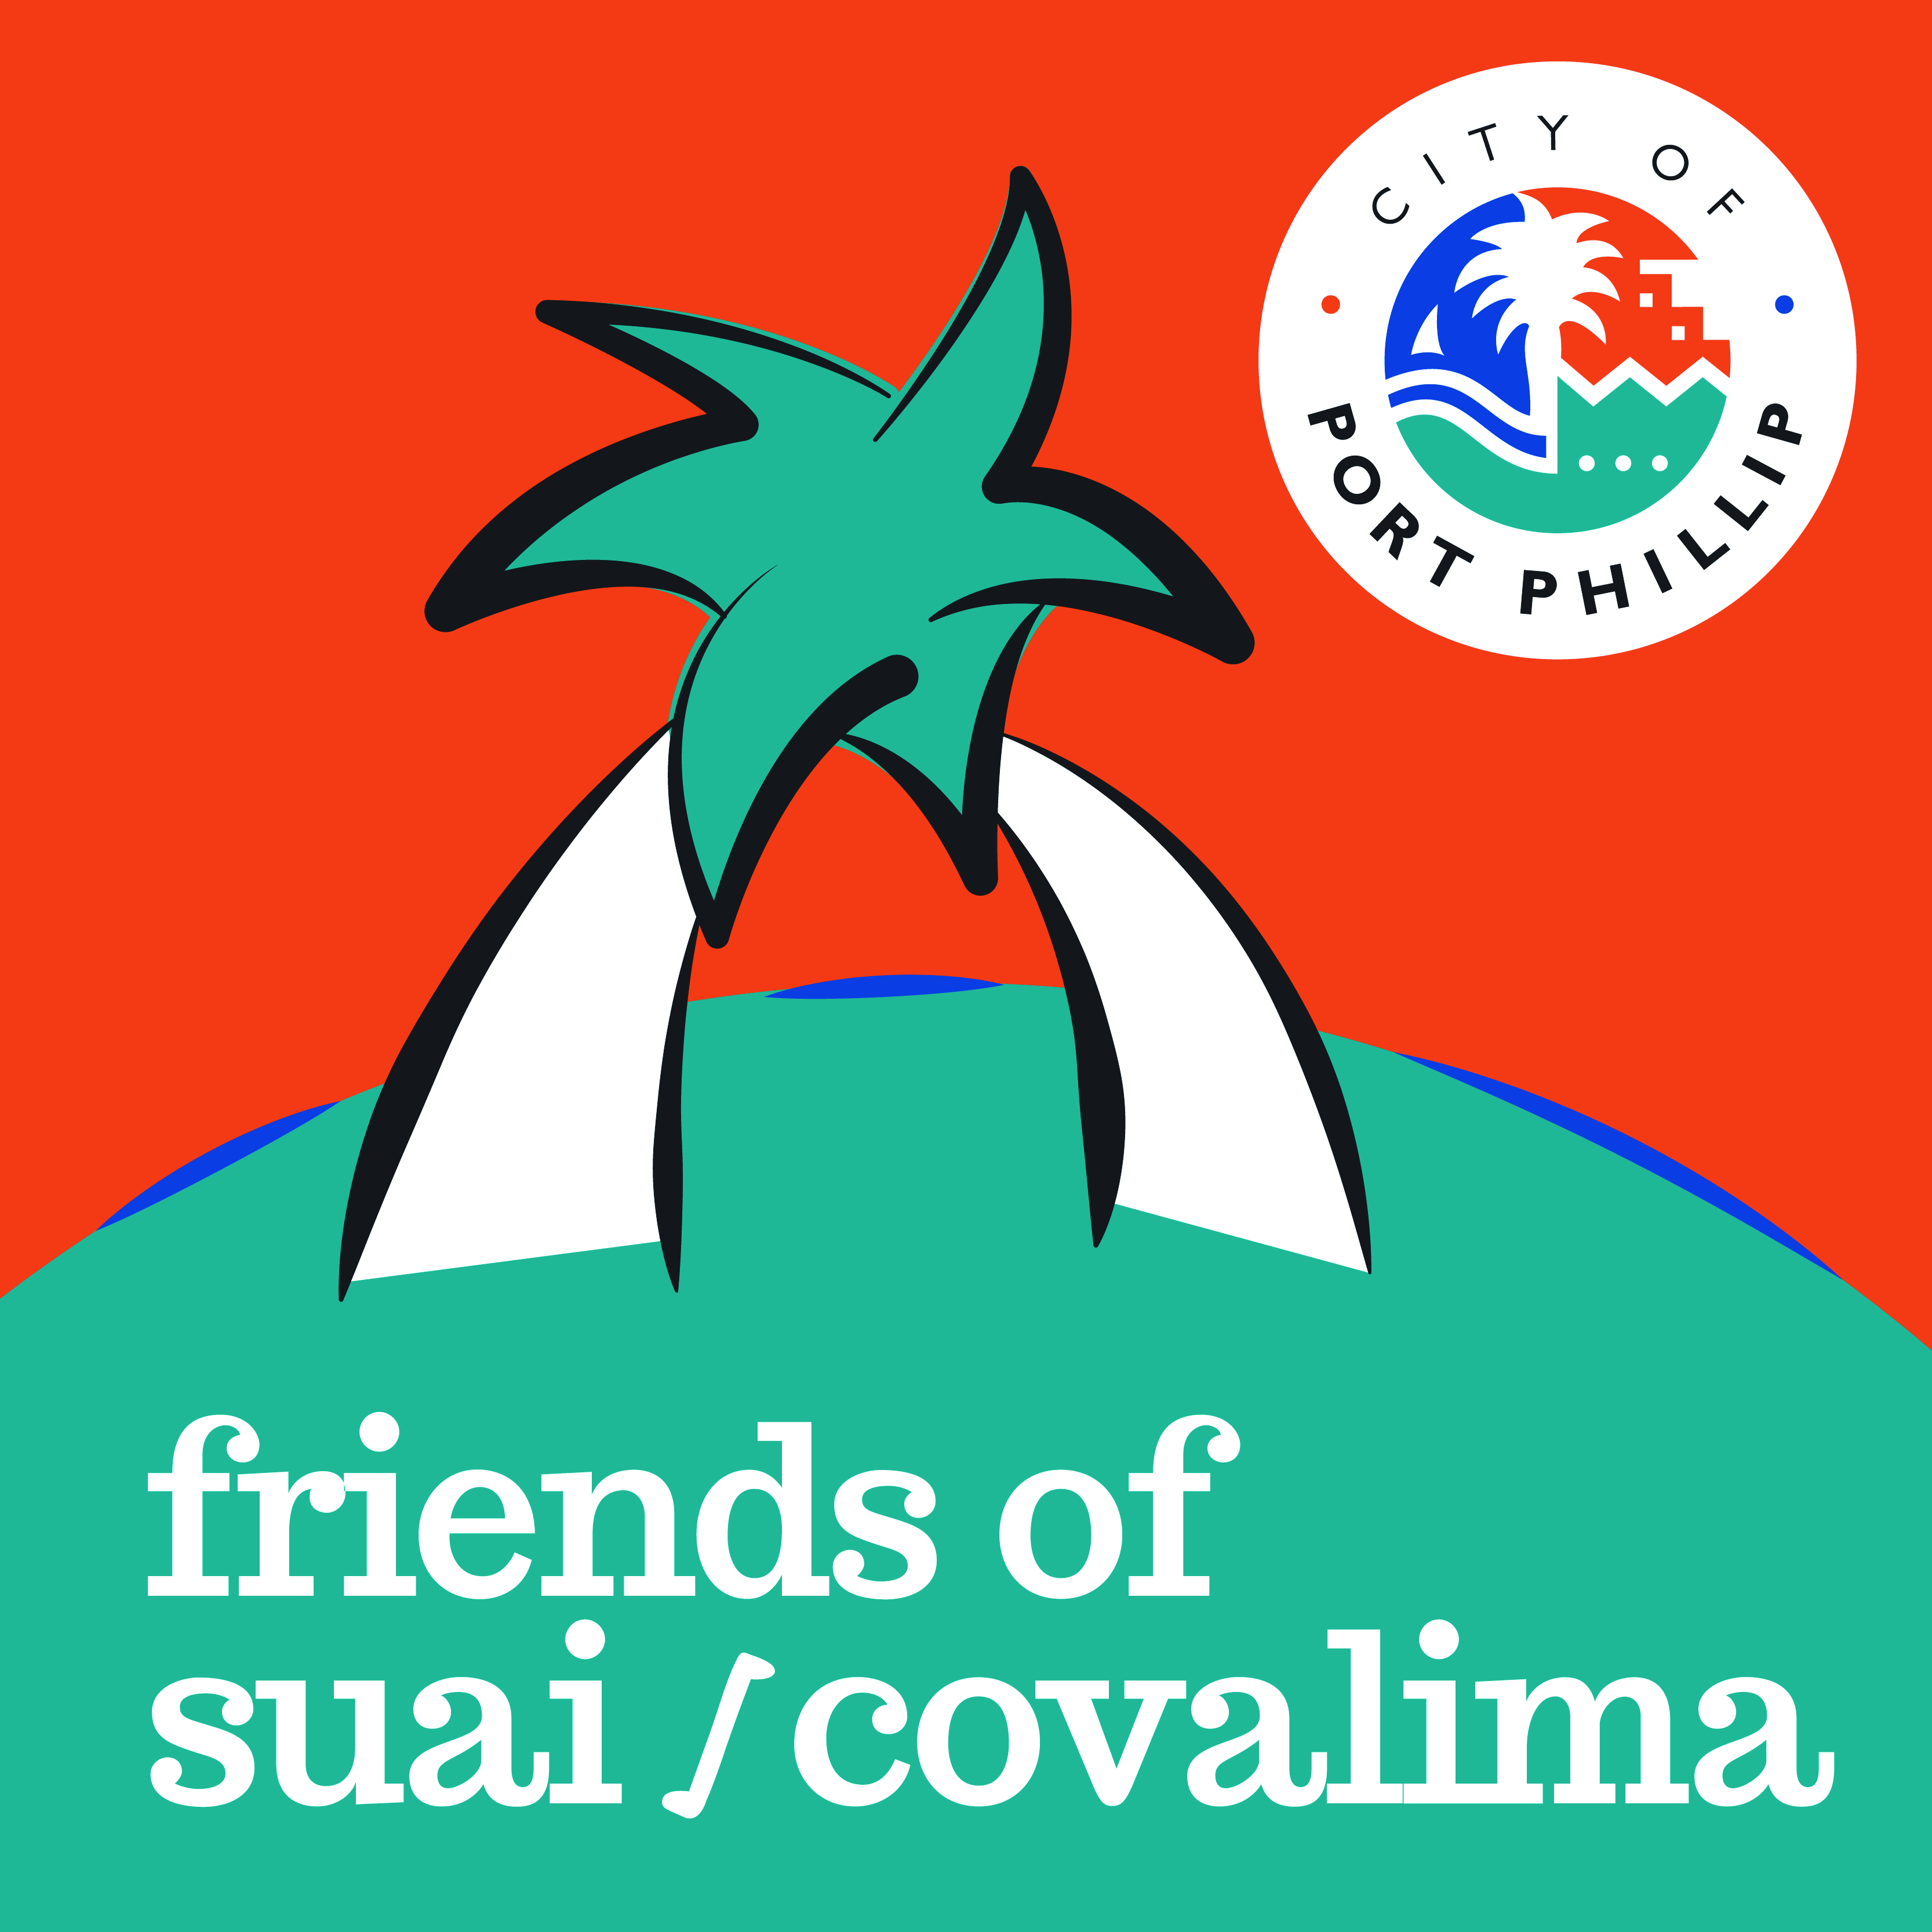


Contribute to social, economic and environmental development for the benefit of the Covalima community and build our understanding of community development and cultural diversity.



Equity - We work towards building and sustaining our relationship with Covalima municipality in a fair and impartial way, allowing give and take by both parties.

Respect - Our communication is open, honest and respectful; we will act ethically, recognising each other’s wishes, rights and beliefs.

Integrity - We work together to achieve our common goals through transparent democratic institutions and processes.

Mutual learning - We acknowledge and value the new understandings, knowledge and skills we share and gain from each other.

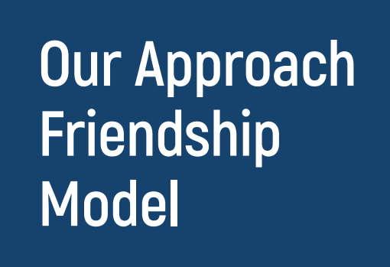
The Friendship between City of Port Phillip and Covalima is a productive relationship with dialogue, trust and strategic vision.

Friends of Suai/Covalima demonstrates a model where local government and the community can work productively together on a people-to-people and community-to-community basis to assist in building relationships with our regional neighbours in Timor-Leste. It is part of a wider friendship network and recognises the unequal development contexts of Australia and Timor-Leste.

Friendship relations and humanitarian support are especially important and more relevant than ever in 2022, given Australia’s heightened interest in its nearest neighbours, including Timor-Leste, from a climate and geo-political point of view.

The Friendship between our two community organisations has matured and deepened over twenty years with consistent support and funding from the City of Port Phillip. It embodies a community development approach which is central to the Friendship.
It has made a major contribution in strengthening the Covalima Community Centre which has developed into a dynamic hub of training, education and innovative program development, human resource development, women’s empowerment, leadership, social enterprise and building livelihoods.
For the City of Port Phillip, the Friends of Suai/Covalima program provides a platform for social connection and transformative action through which our community listens, provides support and leadership, learns about Timorese cultural heritage, builds cross-cultural understanding and enriches the lives of those who contribute.

Friends of Suai/Covalima continues to have far reaching impact that is showing itself to be sustainable and enduring whilst learning from the challenges. Our ongoing work together promotes democracy and good governance.

The Statement of Friendship sets out the understanding and intent between the citizens of Covalima and the citizens of the City of Port Phillip.

In 2016 City of Port Phillip was one of 15 local governments that signed a Municipal Agreement with Timor-Leste at a ceremony at the State Parliament to formalise cooperation to support decentralisation and the creation of municipal government in Timor-Leste.

Timor-Leste is one of the newest nations in the world and one of the poorest in South-East Asia. Friends of Suai/Covalima looks forward to continuing its friendship and support for this energetic, young country as it continues to develop its potential.

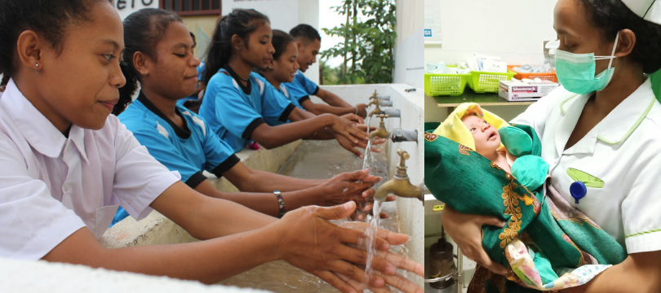

The Covalima Community Centre (CCC) and its programs are strengthened towards sustainability.

Strategies
- Support CCC priority programs in education, public health, climate adaptation, livelihoods, social enterprise and advocacy
- Assist and provide mentoring support for CCC capacity strengthening priorities in areas of human resources, management and governance
- Actively work to assist the CCC to gain funding, support and resources.


City of Port Phillip (CoPP) and Covalima municipality and their communities are actively engaged in cultural exchange, mutual learning and development activities

Strategies
- Increase engagement with community organisations, businesses and CoPP residents with the support of Councillors
- Friends of Suai/Covalima hold community events and cultural exchanges (in person or virtual) to celebrate the friendship with the Covalima municipality.


Friends of Suai/Covalima is accountable, effective and efficient

Strategies
- Facilitate communications with CoPP Council, staff, residents and key stakeholders
- Develop new donors and fundraising initiatives
- Implement the Community Reference Committee Terms of Reference

