enterprise asset management plan
2022-32

Plan Governance
Responsible Service / Department:
Property and Assets
Adoption authorised:
Council
Date of adoption:
June 2022
Date effective from:
June 2022
Content Manager folder:
[Insert Text]
Content Manager file:
[Insert Text]
Endorsed CEO or ELT member or department manager to make and approve document editorial amendments:
Manager Property and Assets
Annual desktop review date:
September
Review date:
June 2024
Completion date:
June 2026
Version number:
Version 1.
Stakeholder review and engagement:
Aligned to the Council Plan and Budget process
Relevant Legislation:
Local Government Act 2020
Associated Strategic Direction #:
Well Governed
Associated instruments:

Supersedes:

Review history:
Name | Content Manager File Reference | Date | Description of Edits
Enterprise Asset Management Plan



CONTENTS
EXECUTIVE SUMMARY 1
1 INTRODUCTION 4
2.0 ASSET MANAGEMENT FRAMEWORK 5
3.0 OUR ASSET MANAGEMENT STORY 13
4.0 FUTURE DEMAND 20
5.0 RISK MANAGEMENT PLANNING 21
6.0 ASSET MANAGEMENT MATURITY 24
7.0 LIFECYCLE MANAGEMENT PLAN 27
8.0 FINANCIAL SUMMARY 42
9.0 OUR SYSTEMS AND PROCESSES 46
10.0 CONTINUOUS IMPROVEMENT 51
11.0 MONITORING AND REVIEW PROCEDURES 56
12.0 REFERENCES 57
Annexure A Organisation Asset Management Maturity Assessment 58
Annexure B Services and their Values 83

EXECUTIVE SUMMARY

Context
We are custodians of $3.6 billion (gross value, $3.2 net value) worth of community assets. This includes land, buildings, infrastructure assets such as roads, footpaths, piers and jetties, underground drainage pipes and pits as well as soft assets such as art, library books, information technology equipment and other assets that have been acquired over many years.
A significant portion of the Council budget each year is spent on looking after, operating, improving, and growing assets. Given this, as well as being a growing City, rates capping, climate change and an urban coastal environment, Council must be great at asset management.
Our vision for asset management is that,
“As trusted stewards of Council’s assets on behalf of our community, we will ensure our assets enable the delivery of agreed services that our community values and are sustainable for current and future generations.”
Over the past five years, we have undertaken a significant program to improve Council’s asset management capability and practice. The transformation program has included the development of an updated Asset Management Policy, an Asset Management Strategy, an Operating Model review, implementation of a new integrated asset management system as part of a wider technology uplift across council, and significant uplift of the data that is relied on to forecast required expenditure on assets over time.

Purpose of the Enterprise Asset Management Plan
This Enterprise Asset Management Plan (EAMP) is a new document that responds to the Local Government Act 2020 requirement for Council to adopt an asset management plan. The EAMP describes the integrated policy, processes and tools (people, process and technology) that are being used by Council to manage and maintain operational assets at target service levels while optimising life-cycle costs and asset life. It also provides a summary overview of the state of Council’s assets and the 10-year plan for the maintenance, renewal, acquisition, expansion, upgrade, disposal and decommissioning of infrastructure assets.
Ongoing development and review of this EAMP will promote the viability and long-term use of assets in line with Council’s organisational objectives.
This EAMP also demonstrates Council’s commitment to aligning its system for managing assets to the international Standard ISO 55001: Management System - Asset Management and the National Asset Framework (NAF). Our aim is to achieve a ‘Advanced’ Maturity measured by National Asset Framework (NAF) and all requirements to meet ISO55000 for asset management activities by 2025 and continue maturity improvement where the benefits exceed the costs.

Our Long Term Challenges
The Covid-19 pandemic has changed how we live, work and move around. It has also affected the financial security of many in our community, including local businesses.
This Plan responds to our 8 long-term challenges, as well as the Covid19 Pandemic, to help achieve the Community Vision for Port Phillip- “a liveable and vibrant City that enhances the wellbeing of our community”.
Our challenges are:
A City of economic & social contrasts
- Changing customer expectations and needs
- Government, legislation and technology changes
- Climate change and the environment
- The strength and diversity of our local economy
- Getting around our dense inner City
- Future-proofing our growing City
- Waste management
We will endeavour to manage these challenges within available funding by:
- Including actions from Council Plan, Organisational Strategies and Actions into our asset management plans and modelling the costs of implementing actions by inputting various scenarios in our Strategic Asset Model (SAM) to inform the long-term financial plan
- Prioritising projects based on risk and deliverability, resourcing and reviewing project delivery through strong governance structures.

Our Achievements
Council embarked on our asset management in 2016, undertaking a compressive review of the service and aligning our policy with ISO55001 and best practice Integrated Planning and reporting framework for local government. Our asset management maturity measured using the National Assessment Framework (NAF) scores is 860/1100 on the “Advanced Scale”.
This level of maturity has provided the Council with data and systems, governance, management structures and transparency around our decision making and processes.
We are now much more agile in responding to our key challenges. Key achievements include:
- We have an integrated corporate system which is customer facing and future ready to adopt modern technologies such as artificial intelligence and IoT (Internet of Things)
- Our data accuracy is high, providing informed decision making and transparency in reporting
- We have leading technology to help us address climate change such 3D flood modelling, Asset Vulnerability Assessment Tool, Strategic Asset Management (SAM) model.
- We are delivering Council objectives such as Accessibility and Climate resilience through business-as-usual maintenance and minor capital work programs, delivering such things as:
- Accessible pram ramps across our footpath network
- Accessible BBQ and tables in our park and foreshore area
- Updating fittings in our accessible public toilets to meet current standards
- Improving paths of travel from our disability parking spaces
- Increased cleaning of our stormwater network removing waste from entering Port Phillip Bay and CCTV survey to improve service levels, reduce spot flooding and inform capital renewal and upgrade programs.
- Converting lighting in our buildings to LeD and degassing buildings when assets are due for replacement
- Installing insulation and window glazing in our buildings
- Providing air purification in our corporate and childcare buildings in response to SARS Covid 19 pandemic
- Supporting the circular waste economy with the use of recycled materials in road and footpath pavements. Upcycling of building materials and office furniture. Purchase of recycled products such as bridge material, public furniture and traffic control devices
- Installation of LoRaWan gateways for Internet of things (IoT) with sensor data monitoring asset health, utilisation, and service requirements. Converting this data to information, providing this knowledge to our community
We are in a strong position to build on these achievements and meet our asset management vision.

10 years' operating and capital forecast
The projected operational and maintenance outlay necessary to provide the services covered by this EAMP includes for existing assets over the 10-year planning period is $273M in total, or $27M on average per year.
The projected required capital outlays including renewal/replacement and upgrade of existing assets and acquisition of new assets over the 10-year planning period $416M or $41M on average per year.
Councils' depreciation calculations are on average $29.4M per annum or $294M over 10 years. This figure includes Councils soft assets such as Library books, arts and culture collection, office furniture and it also includes an estimate of 3.5% for asset growth. Whilst soft assets are included in our asset registers, asset plans and modelling have not been included for soft assets in this plan and will be included in future Portfolio Plans.
Our infrastructure assets are $18.5M per annum or $185M over 10 years with our renewal forecast over the same period being $268M and a budget forecast of $304M. This provides Councils with a renewal ratio of 114%, based on advanced asset management principals of calculating budget/demand renewal. Core asset management principals of forecasting budget/depreciation calculates the renewal ratio at 166%. This places Council in a low-risk category of not meeting renewal demands.
This projected operational and capital expenditure over the next 10 years has been developed to deliver the Council Plan. It will do this through achieving Council’s Asset Management Policy outcomes of assets that: are fit for purpose, provide community benefit, respond to environmental sustainability targets, are financially sustainable, and achieve advanced asset management practice.
Achieving financial sustainability requires balancing service levels and performance with cost and risk. It may not be possible to meet all expectations for services within current financial resources, particularly within the current context of the unprecedented pressure that the Covid19 pandemic has placed on Council’s revenue and ability to deliver capital projects. We will continue to engage with our community to ensure that highly valued services are provided at appropriate levels of service at an affordable cost while managing risks.

Confidence Levels and Next Steps
This Plan is based on Medium level of confidence information. All assets are now contained in the One Council integrated asset and financial system, which was brought online in 2020. The works management component has been configured to capture Operation, maintenance and Capital costs, which provides an integrated system where all works to assets is uploaded directly into the system, providing real time data on the state of our assets and what has been spent on maintenance, renewal and upgrades.
Continuous improvement is occurring to the One Council system to unlock its full potential by creating further efficiencies, enhanced customer experience and advanced modelling capabilities. Asset and Financial modelling that informs Council’s asset plans, will occur within the system by 2022/23 and by 2024/25 Council will have the highest level of confidence in our data, with our processes and people optimizing the full functionality of the system.
The continuous improvement actions resulting from this Plan are listed in the improvement plan in Section 8.

- INTRODUCTION
We are custodians of $3.6 billion (gross value, $3.2 net value) worth of assets that enable Council to provide the services that our community value. This includes land, 228 buildings, 294 km of roads, 473 kilometres of footpaths, 256km of underground drainage pipes, 12,551 drainage pits as well as art, library books and other assets that have been acquired over many years.
A significant portion of the Council budget each year is spent on looking after, operating, improving, and growing assets for the benefit of the community. We budget over $40 million per year for renewing, improving and growing our assets. We also budget around $27 million each year to operate and maintain assets. Combined, around 30 per cent of our total annual expenditure is asset related. Given this sizable investment, the importance of these assets to achieving community outcomes and that we are a growing City, with the Fishermans Bend urban Renewal Project being the largest urban renewal area in Australia, general population growth, rates capping, climate change and an urban coastal environment, Council must be good at asset management.
The Local Government Act 1989 was amended in 2020. The amended Act requires Council’s to develop, adopt and implement a 10-year Asset Plan each year following a council election, that contains information about maintenance, renewal, acquisition, expansion, upgrade, disposal and decommissioning in relation to each class of infrastructure assets, in accordance with its deliberative engagement practices. The first of these since the new requirement in the Act came into force, is due by 30 June 2022.
We have had 10-year asset management plans in place for each asset class for the past five years, that are annually updated to inform the development of Council’s 10-Year Financial Plan and the annual budget process. With this new requirement in the Act, we have developed an Enterprise Asset Management Plan (EAMP) that will be reviewed and adopted by Council each year after an election, to support delivery of the Council Plan.

2.0 ASSET MANAGEMENT FRAMEWORK

2.1 Asset Management System
The delivery of services to the community is guided by Council plans, strategies and policies. These also drive our approach to asset management. Asset management enables an organisation to realise value from assets in the achievement of organisational objectives, while balancing financial, environmental and social costs, risk, quality of service and performance related to assets.
An asset management system is more than ‘management information system’ software. An asset management system is a set of interrelated and interacting organisational policy, processes and tools (people, process and technology) used to manage and maintain operational assets at target service levels while optimising life-cycle costs and asset life. The asset management system provides a means for:
- coordinating contributions from and interactions between functional units within an organisation, and
- consistent application of the asset management processes to achieve uniform outcomes and objectives.
The asset management system includes the:
- Asset Management Policy
- Enterprise Asset Management Plan
- Asset management plans, that are implemented in:
  - operational planning and control
  - supporting activities
  - control activities
  - other relevant processes.
- Operational/Service Delivery Plans
- Knowledge management system
Council has a strong vision for the future of asset management which includes sustainable services delivery, community satisfaction, sustainable financial position and acceptable risk exposure.
The asset management system fits within the organisation’s strategic planning and delivery process as shown in Figure 1. Council’s Asset Management Strategy, which despite being called a strategy is an operational plan for improving asset management maturity, has now been incorporated into the EAMP.
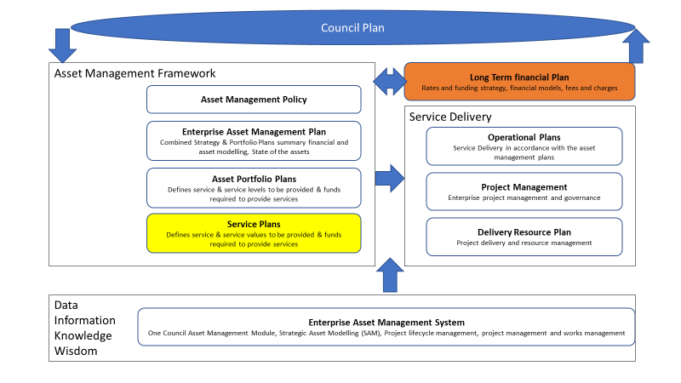

Figure 1: The Asset Management System

2.2 Council Plan Priorities 2021-31
The integrated Council Plan 2021-31 makes a commitment to outcomes and priority initiatives across five strategic directions. Effective asset management will support the Council Plan outcomes and the delivery of sustainable services.
Council has developed its Council Plan to focus its services on the communities it serves. The outcomes and priority initiatives in the Council Plan have been developed through engagement with the community and key stakeholders to achieve agreement on the scope and level of service provided over the 10-year period of the plan with a focus on the first four years.
An annual review of the 10-year plan occurs in conjunction with the development of the annual budget. Council’s rates strategy and asset management plans are updated as part of this budget development process. The Council Plan on a page (Figure 2) provides an overview of the strategic objectives for each strategic direction.

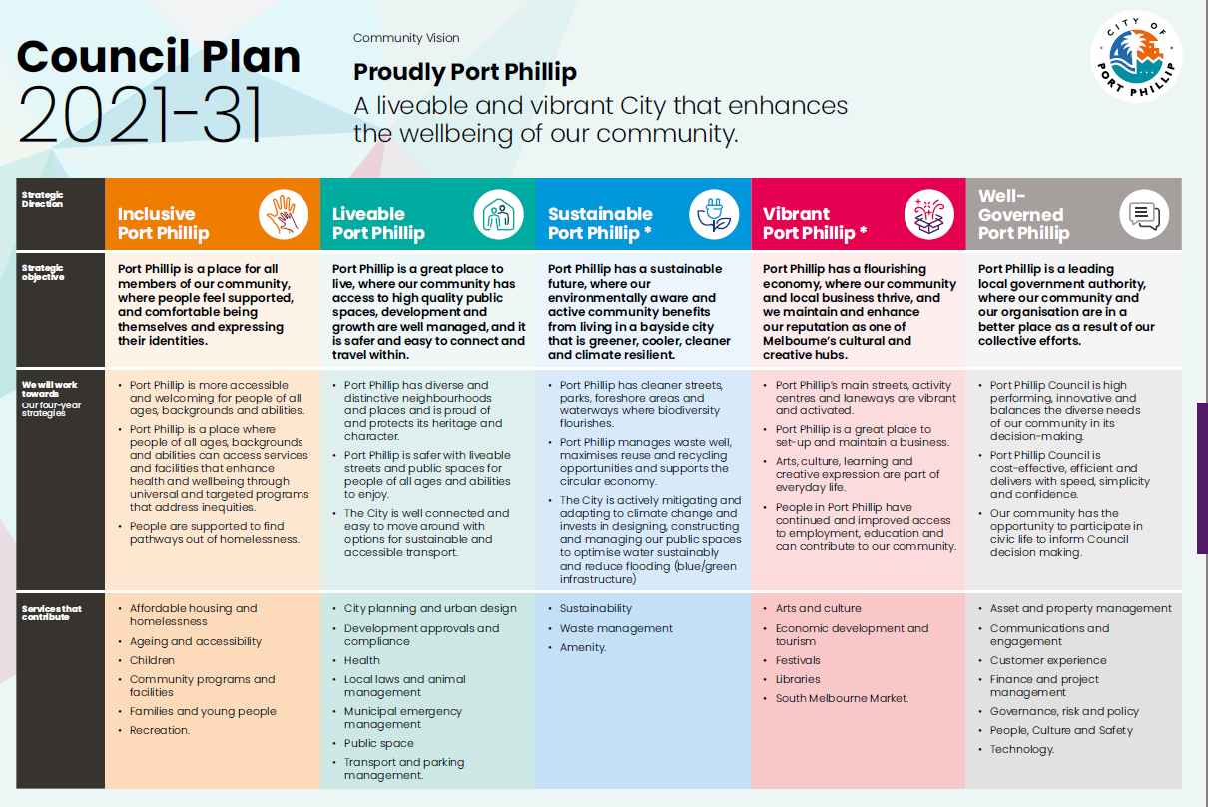Figure 2: Council Plan 2021-31 on a Page

2.3 Services and the Value We Provide
Council delivers 28 Services under the Council plan which is shown in Table 1. The value the Services provide and the link to the Council Plan Strategic Directions is provided in Annexure B.
We engage with the community through the budget building process in line with our Community Engagement Policy https://www.portphillip.vic.gov.au/media/pf3jjjdo/final_community_engagement_policy_adopted-february_2021.pdf to ensure community service levels are affordable and meet community expectations. Community engagement is necessary to ensure that informed decisions are made on future levels of service and costs and that service and risk consequences are known and accepted by stakeholders. We have identified community expectations for service levels to be generally consistent with current levels of service.

2.4 Alignment of Services and Asset Management
A requirement of Asset Management Plans is to show the how integration of Council Service Plans is achieved to deliver the Objectives of the Council Plan. The following tables show the alignment of key service plans and strategies by Asset portfolio.

Table 1 Alignment of key service plans and strategies to asset management actions
Alignment to Portfolio Asset Management Plan | Key Service Plans and Strategies
Transport Portfolio Plan | Integrated Transport Strategy, Act and Adapt Sustainable Environment Strategy 2018-28, Climate Response Plan 2019-24, Access and Inclusion Plan 2019-21
Building Portfolio Asset Management Plan | Children Services Policy, Library Action Plan, Public Toilet Plan, OHS Policy, Municipal Emergency Management Plan, Access and Inclusion Plan 2019-21, Act and Adapt Sustainable Environment Strategy 2018-28, Climate Response Plan 2019-24
Public Space Portfolio Asset Management Plan | Public Space Strategy, Greening Port Phillip Access and Inclusion Plan 2019-21, Soil Contamination Management Policy and Guidelines 2020-24, Act and Adapt Sustainable Environment Strategy 2018-28, Climate Response Plan 2019-24
Integrated Water Portfolio Asset Management Plan | Port Phillip Flood Study, Act and Adapt Sustainable Environment Strategy 2018-28, Climate Response Plan 2019-24, Greening Port Phillip-An urban forest approach, Water sensitive City Implementation Plan 2019-2024
Clever City Portfolio Asset Management Plan | Clever Port Phillip Action Plan (work in progress), Fleet Strategy, Act and Adapt Sustainable Environment Strategy 2018-2028

2.5 Asset Management Policy
The Asset Management Policy sets out the approach to asset management at the City of Port Phillip, which is informed by the International Standards Organisation ISO 55000 and National Asset Management Framework (NAMAF). It is designed to ensure sustainable management and development of Council’s infrastructure and assets to meet current and future community needs. It’s supports Council’s response to climate change. The Asset Management Policy is available on Council’s web site asset-management-policy-2021-v2-1.pdf (portphillip.vic.gov.au).
The council’s Asset Management Policy seeks to achieve the following outcomes from asset management:
Fit for Purpose: assets will deliver agreed levels of technical of service to the organisation and community in terms of function (including safety and accessibility), condition, and capacity.
Community Benefit: Council will innovatively use its asset base to support the social, cultural and economic wellbeing of the community.
Environment Sustainability: assets are planned and developed to incorporate climate resiliency and mitigate our environmental impact.
Financial Sustainability: asset management decisions and practices ensure the council has the funds to look after, improve and grow its assets for current and future generations.
Advanced Practice: Council will demonstrate advanced asset management practice including the use of smart technology to optimise decisions and performance.

2.6 Enterprise Asset Management Plan (EAMP)
The EAMP documents the relationship between the organisational objectives set out in the City of Port Phillip Council Plan 2021-2031 and the asset management (or service) objectives and defines the strategic framework required to achieve the asset management objectives.
The EAMP describes the integrated processes and tools (people, process and technology) that are being used by Council to manage and maintain operational assets at target service levels while optimising life-cycle costs and asset life. It also provides a summary overview of the state of Council’s assets and the 10-year plan for the maintenance, renewal, acquisition, expansion, upgrade, disposal and decommissioning of infrastructure assets, with the detail for each asset class contained in the individual Asset Management Plans (AMPs).
Ongoing continuous improvement and annual review of the EAMP will promote the viability and long-term use of assets in line with Council’s organisational objectives. The EAMP also demonstrates Council’s commitment to aligning its system for managing assets to the international Standard ISO 55001: Management System - Asset Management and the National Asset Framework (NAF). Our aim is to achieve ‘Advanced’ asset management maturity as measured by the National Asset Framework (NAF) and all requirements to meet ISO55000 for asset management activities by 2025, and to continue maturity improvement where the benefits exceed the costs.
The Enterprise asset management plan incorporates strategies to achieve the asset management objectives. The strategies are developed in 4 steps:
- Our Asset Management Story - What is the Value of our Assets? (Section 3.0.)
- State of our Assets - Our Assets Performance (Section3.2)
- Lifecycle Management Plan - How much does it cost to provide Services? (Sections 5)
- Continuous Improvement - Where do we want to be and how will we get there? (Section 8)
A key requirement of asset management planning is to demonstrate how integration of Council Service Plans is achieved to deliver the Objectives of the Council Plan. Throughout this Plan, specific linkages are made to the 28 services that Council provides to demonstrate how asset management planning is supporting delivery of those services. Also provided in Appendix B, is a table that provides a description of the key service strategies and plans linked to the Council Plan Objectives, with a description of how these are informing asset management planning.

2.7 Asset Management Plans
Council’s Asset Management Plans (AMPs) are a means of documenting the key elements involved in managing our extensive asset base. AMPs combines management, financial, engineering and technical practices to ensure that the levels of service required by our range of stakeholders are provided at the lowest long-term cost to the community within the limits of any fiscal constraints set by Council.
Asset management plans are a key element of Council’s strategic asset management framework. Council has adopted the Institute Public Works Engineers Association (IPWEA) National Asset Management System (NAMS) plus templates. These templates are recognized as industry best practice and meets the requirements of ISO 55001 and National Asset Framework (NAF). The specific purpose of asset management plans is to:
- Demonstrate responsible stewardship by the Council
- Define and articulate how the infrastructure is and will be managed to achieve the organisation’s objectives
- Provide a basis for customer consultation to determine the appropriate levels of service
- Manage risk of asset failure
- Achieve savings by optimising whole of life costs
- Support long term financial planning.
The outcomes of the asset management plans identify the future funding requirements to support service delivery, accounting for the following factors:
- Levels of Service
- Future demand for infrastructure and current asset performance
- Asset failure
- Risk
- Required works
- Funding constraints
- Monitoring and Improvement.
The City of Port Phillip’s assets are categorised across five separate Asset Portfolios where each Portfolio is an aggregation of asset classes that together deliver on the strategic service objectives for that particular Portfolio.
Each of the five Asset Portfolios has an individual AMP with is the amalgamation of asset class sub plans and all five of the portfolio AMPs are summarised in the EAMP. The following diagram shows are asset management plan library.
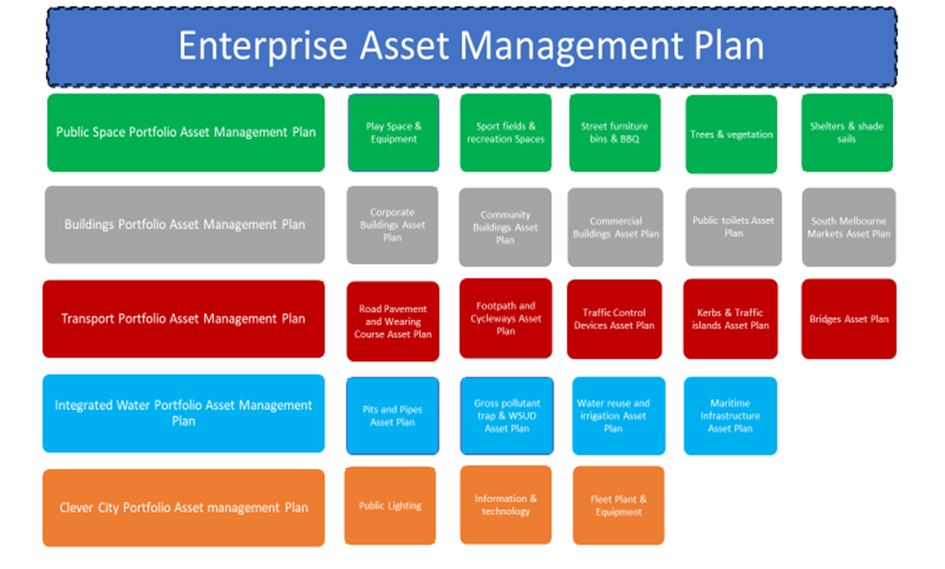

Figure 3: Asset Management Plan Structure

2.7.1 Asset Hierarchy
An asset hierarchy provides a framework for structuring data in an information system to assist in collection of data, reporting information and making decisions. The hierarchy includes the asset class and component used for asset planning and financial reporting and service level hierarchy used for service planning and delivery.
Each asset portfolio has an asset hierarchy that reflects the function of individual asset classes. The hierarchy structures groups like assets and are a useful tool to assign ownership, responsibilities, and inspection requirements, etc as per the service need.

2.7.2 Levels of Service
Service levels can be defined in two interconnected ways, customer levels of service and technical levels of service. These are supplemented by organisational measures which are the Council Plan, Community Plan, and the Long Term Financial Plan. Service performance results are reported through Council’s Annual Reports.

2.7.3 Community Levels of Service
Community Levels of Service measure how the customer receives the service and whether value to the customer is provided. Community surveys are used to determine performance and customer satisfaction.
Customer levels of service measures used across our asset management plans are:

Quality | How good is the service … what is the condition or quality of the service?
Function | Is it suitable for its intended purpose- Is it the right service?
Capacity/Use | Is the service over or under used … do we need more or less of these assets?
Sustainability | Is our service delivery balancing environmental, economic and social impact for current and future generations?

2.7.4 Technical Levels of Service
Technical Levels of Service provide a balance compared to customer perception that can be more subjective. They support the community service levels by providing operational or technical measures of performance. These technical measures relate to the allocation of resources to service activities to best achieve the desired customer outcomes and demonstrate effective performance.
Technical service measures are linked to Council’s activities and annual budgets covering:
Operations | The regular activities to provide services (e.g. opening hours, cleaning, mowing grass, inspections, etc.
Maintenance | The activities necessary to retain an asset as near as practicable to an appropriate service condition. Maintenance activities enable an asset to provide service for its planned life (e.g. road patching, footpath grinding, building and structure repairs),
Renewal | The activities that return the service capability of an asset up to that which it had originally (e.g. road resurfacing and pavement reconstruction, pipeline replacement and building component replacement),
Asset Improvement | The activities to provide a higher level of service (e.g. widening a road, sealing an unsealed road, replacing a pipeline with a larger size) or a new service that did not exist previously (e.g. a new library).

2.8 Integrated Planning and Reporting
Asset planning and the development and review of this Plan and the Portfolio Asset Plans that inform this Plan, is part of the organisation’s strategic and annual planning and reporting cycle as shown in Table 2 below. The 10 Year Portfolio Asset Plans are reviewed and updated every year at the start of the annual budget cycle to ensure that any changes in condition of an asset that may trigger works, changes in service levels, or new services that may require modification or new assets to be developed, are appropriately considered as part of the budget prioritisation process.

Table 2 Enterprise Asset Management Plan within the Planning and Reporting Cycle
 | Plan | Planning Cycle | Performance Reporting | Reporting Method
Council  Plan | 10-Year Council Plan with modelling for 4 and 10 years will extend out to 20 years in 2023/24 | 4 years with annual updates | Community Objectives Indicators | Annual Report
Strategic  Planning | 10-Year Financial Plan | 4 years with annual updates | Organisational Objectives | Annual Report  State of the Asset reports
Strategic  Planning | 10-Year Financial Plan | 4 years with annual updates | Financial Indicators | Annual Report  State of the Asset reports
Strategic  Planning | Asset Management Policy Enterprise Asset Management Plan  10 years Asset Management Plans | 4 years with annual updates | Asset Management Objectives | Annual Report  State of the Asset reports
Operational Planning | First four years of Council Plan | 4 years with yearly review | Delivery Plan tracks Delivery of the Council Plan reported into Annual Plan | Annual Report
Annual Planning  & Budget | Annual Plan &  Budget  Service Profiles | Annual | Annual Objectives  Budget Objectives | Annual Report Monthly Reports to Council/Board
Annual Planning  & Budget | Departmental/Directorate Work Plans | Annual | Work Plan Objectives | Monthly Reports to Council/Board
Annual Planning  & Budget | Individual Work Plans | Annual | Work Plan Objectives | Performance Reviews

This Plan summarises all the individual portfolio plans and provides an overview of the proposed 10-year expenditure for the maintenance, renewal, acquisition, expansion, upgrade, disposal and decommissioning of infrastructure assets. Once the budget process has been finalised, this Plan must also be updated to reflect any changes in service or project priorities that have been made by Council through engagement with the community in the annual council plan and budget process.

3.0 OUR ASSET MANAGEMENT STORY

3.1 The Value of Our Assets
We manage a wide variety and number of assets to provide services to our community. The total gross replacement value of our assets is $3.6 million. The Gross Replacement Value of our assets across the five asset portfolios is provided in Table 3. The table also includes values for annual depreciation, accumulated depreciation and the current replacement value of the assets. The further breakdown of asset values for all asset classes is provided in Annexure C.
A brief explanation of each of the different values is provided below:
- Gross Replacement Value: Total cost to substitute an entire asset with a new or equivalent asset without enhancement of capabilities.
- Annual Depreciation: Is the standard yearly rate at which depreciation is charged to a fixed asset which accounts for the reduction in the value of the asset over time.
- Accumulated Depreciation: is the cumulative depreciation of an asset up to a single point in its life.
- Current Replacement Value: Is the depreciated value (book value) of an asset using generally accepted accounting principles and reflected on the balance sheet.
Gross replacement value considers the modern equivalent engineering replacement of the asset. In other words, if Council was to replace a Fleet vehicle being a 2015 Toyota Corolla Hatch which cost $25,000 at the time of purchase and the modern-day equivalent is a Toyota Prius hybrid which retails at $35,000. The $35,000 required to purchase the Prius is accounted for in the Gross replacement value to maintain a similar service.
The Annual depreciation of our assets is an indication of the rate our investment in our infrastructure is being consumed. Councils' depreciation calculations are $18.5M per annum or $185M over 10 years with our renewal forecast over the same period being $219M. This provides Councils with a renewal ratio of $118%. This places Council in a low-risk category of not meeting renewal demands.

Table 3 The Value of the Assets
ASSET DESCRIPTION | GROSS REPLACEMENT COST ($) | ANNUAL DEPRECIATION ($) | ACCUMULATED DEPRECIATION ($) | CURRENT REPLACEMENT VALUE / WDV ($)
Total Transport | 420,487,678.36 | 5,671,195.33 | 125,318,151.86 | 295,169,526.50
Total Land & Buildings | 2,938,751,694 | 4,522,758 | 221,965,792 | 2,716,785,902
Total Integrated Water Management | 137,741,848.02 | 980,352.76 | 54,505,126.72 | 83,236,730.30
Total Open Spaces Portfolio | 94,105,260.08 | 3,022,746.70 | 34,453,231.29 | 59,652,064.79
Total Clever City Portfolio | 31,074,031.31 | 4,289,244.10 | 15,801,325.15 | 15,272,706.16
Grand Total | $ 3,622,160,512 | $ 18,486,297 | $ 452,043,627 | $ 3,170,116,930

Note* Buildings valued at cost per m2 value and plant, and equipment valued at cost, where available. The revaluation and depreciation calculations will be reviewed in 2023/24.

Note **Office furniture and fittings, library books etc. are non-infrastructure assets and are not included in these figures

3.2 State of Our Assets
The asset registers under Health and Risk have been configured with these measures and the Strategic Asset Models utilizes this data along with risk tables shown in 5.0 together with budget forecasts. Scenario modeling is used to inform the long-term financial plan. The performance of our assets is measured on agreed service levels through condition, function and capacity assessments. Our State of the Assets Report monitors the performance of the assets under four technical service indicators as shown in the table 4:

Condition, Function, Capacity and Sustainability Rating
Element |  | Condition  Consider: visual appearance, apparent maintenance issues, safety hazards, age of asset |  |  | Function  Consider: size, shape, configuration, suitability for intended purpose, and flexibility to change |  |  | Capacity / Utilisation / Sustainability  Consider: space based on service delivery requirements, capacity to accommodate current use and future demand
Rating | Potential to meet Level of Service | Condition | Wear | Maintenance Requirement | Functionality | Obsolescence (Technology) | Regulatory | Capacity | Utilisation | Sustainability
1 | Very Good | New or near new condition. Asset performing in a safe condition and as installed. | Negligible wear | Only planned maintenance required | Meets program/service delivery needs in a fully efficient and effective manner. | Up-to-date | Meets regulatory requirement | Usage corresponds well with design capacity and no operational problems experienced | Repeatedly utilised | Sustainability measurements are well within agreed parameters based on whole of life outputs.
2 | Good | Very well maintained and in a sound condition. Asset exceeds minimum performance specification standards. | All wear within design tolerance | Minor maintenance required plus planned maintenance | Meets program/service delivery needs in an acceptable manner | Acceptable | Meets regulatory requirement | Usage is within design capacity and occasional operational problems experienced | Frequently utilised | Sustainability measurements are acceptable based on whole of life outputs and asset is performing as expected
3 | Average | Requires minimal maintenance. Asset meets minimum performance specification standards. | Wear approaching allowable limits | Routine maintenance required. | Meets most program/service delivery needs and some inefficiencies and ineffectiveness present | Dated but meeting need | Minor regulatory infraction. Modification may meet short-term need | Usage is approaching design capacity and/or operational problems occur frequently | Moderate utilisation | Sustainability measures could be improved through minor interventions or improvements
4 | Fair | Asset useable but requires immediate remedial works to meet minimum performance standards. | Wear beyond allowable limits | Reactive maintenance. Renewal works planned within two years | Limited ability to meet program/service delivery needs | Out-of-date, just tolerable | Regulatory requirement necessitates planned renewal | Usage exceeds or is well below design capacity and/or significant operational problems are evident | Infrequent utilisation | The asset is performing poorly against sustainability measures and is increasing our carbon footprint
5 | Poor | Very poor condition with health or safety implications. Unsafe condition and requires immediate renewal works | Substantial deterioration | Priority renewal item for Capital Works program Failure imminent or has failed. | Is critically deficient, does not meet program/service delivery and is neither efficient nor effective | Redundant | Does not meet regulatory requirement | Exceeds design capacity or is little used and/or operational problems are serious and ongoing. | Not utilised | The asset is severely impacting on our sustainability measures and is increasing our carbon footprint

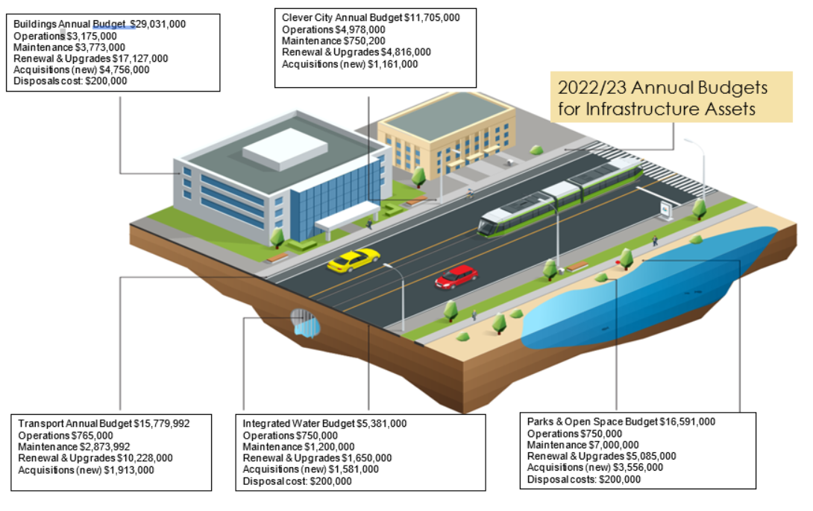

Figure 4: State of the Assets

3.2.1 Asset capacity and performance
The City of Port Phillip adopts a consistent approach to the assessment of the how our assets enable and support services. The four key performance measurement areas are:
- Condition (Quality)
- Capacity (Quantity & utilisation)
- Function (Fit for Service purpose)
- Sustainability (Economic & Environmental).
Condition, function, capacity and sustainability are all measured using a 1 – 5 grading system. A State of the Assets Report is prepared as part of Councils Annual Report.
Every asset class/category has their own deterioration curve assigned based on design, construction quality, maintenance schedules and the future ability to meet the anticipated service the asset is required to provide (technology and legislation changes are considered in this equation).

3.1.2 Transport Portfolio
The asset performance for our Transport Portfolio is rated low risk. We have high confidence in our condition data through pavement deflection testing which tests the compaction of the subsurface providing a remaining useful life calculation. Our footpath network was audited in 2022 and surface or wearing course road audits will be undertaken in 2023.
We have made improvements with our sustainability targets using recycled asphalt products such as Plastiphalt and the use of recycled glass in our concrete materials. The function of the asset to provide outcomes highlighted in Greening Port Phillip, Water Sensitive City and Integrated Transport strategies is an area of focus to improve our processes and reporting. We have made progress in this area and actions from these strategies are mapped in the Portfolio asset management plans.
We have increased focus on accessibility and safety transport assets (FUNCTION) including improvements such as through increased investment in making crossings safe for prams and improving the safety and accessibility of St Kilda Junction.

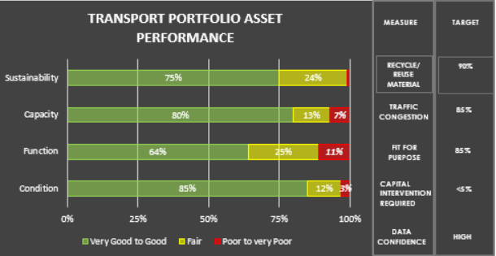
High
Medium
Medium
Data Confidence

Figure 5: Transport Portfolio Asset Performance

3.1.3 Buildings
The asset performance of our building's portfolio has improved significantly in asset condition. Buildings which are underperforming in relation to capacity, function and sustainability have been identified and are included in the Draft Property Portfolio Action Plan, an operational document which is aligned to the Building Portfolio Asset Management Plan. Service reviews are being rolled out to ascertain the future requirements to enable continued or improved service delivery.
Although we have made good progress implementing sustainability outcomes on an asset class/type level (eg mechanical HVAC) our aging building stock and heritage listed buildings are problematic when trying to achieve desired sustainability outcomes.
We are also considering the impacts of climate change in our building portfolio asset management planning. This is particularly relevant to CoPP given our coastal location and the projected impacts of sea level rise. This is being factored into redevelopment of Elwood Foreshore through relocation and refurbishment of facilities.
We are also continuing to look at improving the accessibility and safety of our buildings including such things as more disabled toilets, improved disabled access and increasing female change rooms for our sporting facilities.

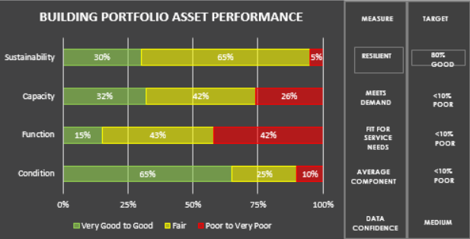
Data Confidence
High
Medium
Medium

Figure 6: Building Portfolio Asset Performance

3.1.4 Integrated Water
Function of our existing network is the key priority area for Council. Significant investment in our pipe cleaning program will continue until we can achieve 90% very good function. CCTV survey of our assets is providing valuable data to our Flood Model which will drive future delivery programs and significant work has been done over the past three years to survey, clean and repair our network.
The Portfolio asset management plan has been mapped to Council's sustainability targets, including water sensitive urban design and the increased use of recycled water. This work is has influenced and will be influenced by the Fishermans Bend Water Sensitive City Strategy.
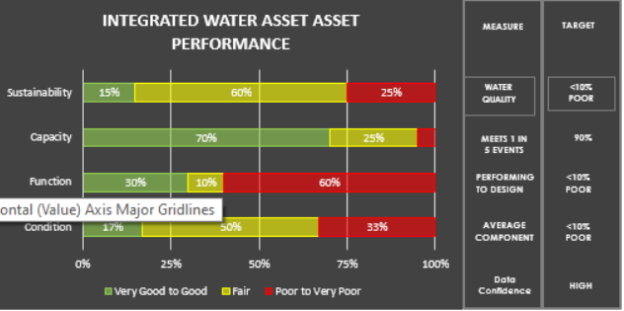
Data Confidence
Medium
High
Medium

Figure 7: Integrated Water Portfolio Asset Performance

3.1.4 Public Space
The asset management Portfolio plan has been mapped to the recently adopted Public Space Strategy. Asset and financial modelling of this Portfolio will continue to improve with the planned introduction of the Strategic Asset Model (SAM) in July 2022.
Sustainability, through increasing the use of recycled materials and improving our quality assurance systems of our maintenance delivery program to ensure our assets meet their intended useful life are a key focus area of this portfolio.
Our Public space assets are highly valued and utilized and increasing the capacity through better use of our urban environment such as reviewing the functional requirements of our road network is another key focus area.
Safety and accessibility is also a focus in this area including upgrading BBQs to enable all abilities access, accelerating implementation of playground safety audits and ensuring future public space projects factor in accessibility and crime prevention through environmental design principles.
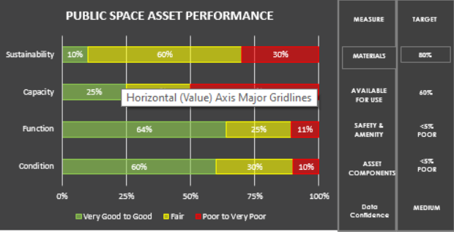
Data Confidence
Medium
Medium
Medium

Figure 8: Public Space Portfolio Asset Performance

3.1.5 Clever City
Clever City Portfolio has a variety of assets that are interrelated to future advances in technology. Public Lighting with smart sensors will form part of a meshed communication network for autonomous vehicles. Underpinning all asset types/classes in this portfolio is technology hardware and software. Council’s must have the ability to be future ready and implement technology changes in an agile and sustainable manner.

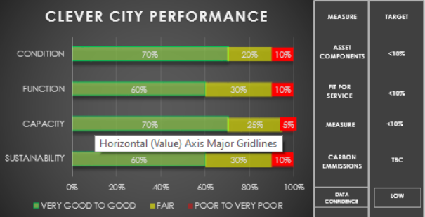
Medium
Medium
Medium
Data Confidence

Figure 9: Clever City Portfolio Asset Performance

4.0 FUTURE DEMAND

4.1 Demand Drivers
Impacts that can cause changes to the existing management environment for Council’s asset and services include:
- Urban growth and densification.
- Growth in population and demographic profiles changes.
- The need for assets to remain relevant to community needs.
- Legislative and policy influences.
- Technological advancement.
- Environmental pressures and climate change.
- Changing community expectations regarding the types and quality of services which Council provides.
Council’s goal is to provide the community with assets that are in a condition which satisfies their needs in a way that minimises risk and impact on the environment, and which demonstrates best value and financial sustainability.
Each individual portfolio asset management plan outlines the specific demand issues and management strategies relating to the class of assets which it covers.
We are working closely with the State Government and other agencies to plan for the redevelopment of the Fisherman’s Bend Urban Renewal Area which is expected to see almost a doubling of our population over the next 30 years. This is a key asset management planning and financial sustainability challenge.

4.2 Demand Management Plan
Demand for new services will be managed through a combination of managing existing assets, upgrading of existing assets, providing new assets, and other management initiatives. Demand management practices include non-asset solutions, insuring against risks and managing failures.
Non-asset solutions focus on providing the required service without the need for asset ownership and management actions including reducing demand for the service, reducing the level of service (allowing some assets to deteriorate beyond current service levels) or educating customers to accept appropriate asset failures. Examples of non-asset solutions include providing services from existing infrastructure such as libraries that may be in another community area or public toilets provided in commercial premises.
Demand management opportunities and proposals with cost and timing information are provided in each portfolio asset management plan. Management actions may include:
- Non-asset-based solutions.
- New and upgrade works.
- Asset rationalisation and/or colocation of services to multi-use facilities.

4.3 Asset Programs to meet Demand
Changes to the size and scope of Council’s asset networks is an ongoing issue that can be driven by changes in work practices, technology, and growth. Acquiring these new assets will commit us to fund ongoing operations and maintenance costs for the period that the service provided from the assets is required. Council may need to increase annual maintenance and operational budgets to ensure sufficient funds are allocated to maintain service levels over the life cycle of all newly created assets.
An example of our work in this space includes our Public Space Strategy which has informed our Public Space Portfolio Asset Management Plan and drives investment in purchase of new public spaces and expansion of existing spaces to cater for increased population growth and demand.

5.0 RISK MANAGEMENT PLANNING
The purpose of infrastructure risk management is to document the findings and recommendations resulting from the periodic identification, assessment and treatment of risks associated with providing services from infrastructure, using the fundamentals of International Standard ISO 31000:2009 Risk management – Principles and guidelines.
Risk Management is defined in ISO 31000:2009 as: ‘coordinated activities to direct and control with regard to risk’.
Council has adopted the following Risk management framework - risk-management-framework.pdf (portphillip.vic.gov.au)

The following table is configured in the asset registers under Health and Risk. The table combines with the asset health which was shown in 3.2 State of our assets. The Strategic asset management models utilises this data to determine the priority of asset renewals based on the risk profile.

Asset System Risk Matrix
Element | Risk Consequence |  | Risk Likelihood |  | Criticality
Rating | Short Description | Description | Short description | Description | Short Description | Description
1 | Insignificant | Injuries or ailments not requiring medical treatment | Rare | Rare but may occur in exceptional circumstances | Non-critical | Non-Critical little top no impact on service delivery
2 | Minor | Minor injury or first aid treatment case | Unlikely | Unlikely but could occur given right circumstances | Moderate | Moderate- may cause minor delays to service delivery
3 | Moderate | Serious injury causing hospitalisation | Possible | Might occur sometime in the future | Important | Important will cause delays and service disruptions
4 | Major | Life threatening injury | Likely | Will probably occur | Critical | Critical will cause major delays and may impact services in the future
5 | Catastrophic | Death or multiple life-threatening injuries | Almost certain | Is Expected to occur
Table 5 Asset Risk Matrix configured in Asset Registers

5.1 Critical Assets
Critical assets are defined as those which have a high consequence of failure causing significant loss or reduction of service. Similarly, critical failure modes are those which have the highest consequences.
Examples if failure mode could include:
- Physical failure, collapse
- Essential service interruption

Critical assets, failure modes, and required operations and maintenance activities are detailed in each individual portfolio asset management plan.

Table 4 Critical Assets
Critical Asset(s) | Failure Mode | Impact
Stormwater Outlets | Major Blockages | Flooding
Corporate Buildings | Major Damage | Ability to service customers
Information Technology | Virus | Ability to Service customers and loss of data

By identifying critical assets and failure modes an organization can ensure that investigative activities, condition inspection programs, maintenance and capital expenditure plans are targeted at critical assets.

5.2 Risk Assessment
The risk management process used in this project is shown in Figure 10 below. It is an analysis and problem-solving technique designed to provide a logical process for the selection of treatment plans and management actions to protect the community against unacceptable risks.
The process is based on the fundamentals of the ISO risk assessment standard ISO 31000:2009.

Figure 10 Risk Management Process – Abridged
The risk assessment process identifies credible risks, the likelihood of the risk event occurring, the consequences should the event occur, develops a risk rating, evaluates the risk and develops a risk treatment plan for non-acceptable risks.
An assessment of risks associated with service delivery from infrastructure assets has identified the critical risks that will result in significant loss, ‘financial shock’ or a reduction in service.
Critical risks are those assessed with ‘Extreme’ (requiring immediate corrective action) and ‘High’ (requiring corrective action) rating identified in the Infrastructure Risk Management Plan.
The risk assessment process compares the likelihood of a risk event occurring against the consequences of the event occurring. In the risk rating table below, a risk event with a likelihood of ‘Possible’ and a consequence of ‘Major’ has a risk rating of ‘High’ as shown in the following table.

Table 5: Risk ratings
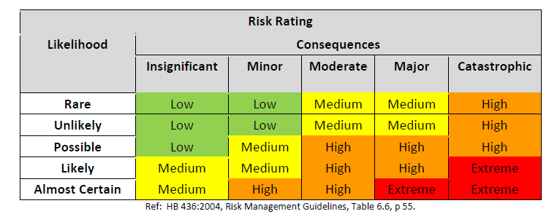
Note * The residual risk is the risk remaining after the selected risk treatment plan is implemented.

5.3 Infrastructure Resilience Approach
The resilience of our critical infrastructure is vital to the ongoing provision of services to customers. To adapt to changing conditions we need to understand our capacity to “withstand and given level of stress or demand” and to respond to possible disruptions to ensure continuity of service.
Resilience is built on aspects such as robustness, response and recover planning, financial capacity and crisis leadership.
Our current measure of resilience is shown in Table 8 which includes the types of threats and hazards, resilience and assessment and identified improvements and/or interventions.

Table 6: Current Measure of Resilience
Threat/Hazard | Resilience Actions | Improvements/Interventions
Climate Change | Outlined in Portfolio Plans | Implement Climate emergency actions
Covid-19 Pandemic | Outlined in Portfolio Plans
Rates capping | Review Services and Service levels | Strategic Asset management Modelling to inform Long Term financial Plan
Advances in Technology | Integration and agility to use proof of concept methodology prior to large investments | Clever City working group develop a action plan for implementation

6.0 ASSET MANAGEMENT MATURITY
We have taken significant steps to improve our asset and financial management performance over the past five years including assessing alignment of our asset management maturity with IS0 55001 Asset Management – Management Systems – Requirements and National Assessment frameworks (NAF).
The transformation program has included the development of an updated Asset Management Policy and an Asset Management Strategy, an Operating Model review, implementation of a new integrated asset management system as part of a wider technology uplift across council, and significant uplift of the data that is relied on to forecast required expenditure on assets over time.
This has resulted in Council achieving ‘Core Asset Management Maturity’ in 2020/21 and being well on our way to achieving ‘Advanced Asset Management Maturity’. Figure 11 shows our journey from learning to predictive asset management from 2016-2021. We are aiming to develop our systems, process and people together with the introduction of new technologies to move towards ‘Intelligence as a Service’ beyond 2022/23.
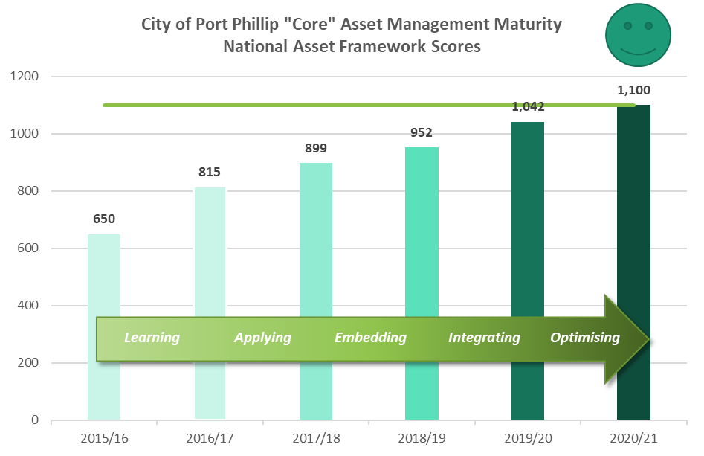
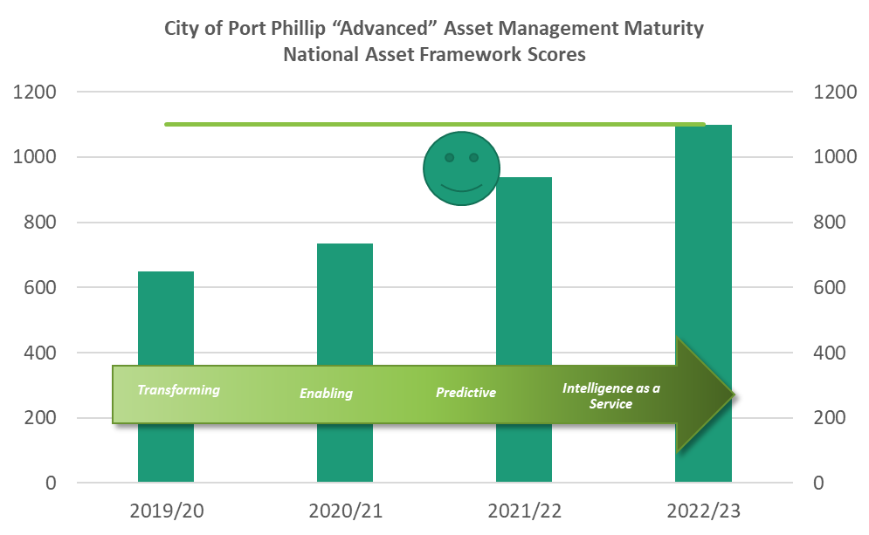

Figure 11: Our Asset Management Maturity Journey

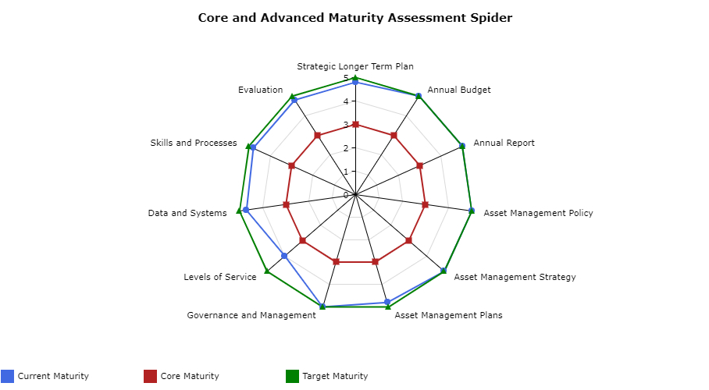

Figure 12: Current and target alignments with the eleven elements of NAF
Figure 12 shows the current and target alignments with the eleven elements of the NAF. Improvement in maturity is indicated by movement of the blue (current maturity) line to the green line (full alignment with ISO 55001 requirements). The red line indicates that we have exceeded Core maturity.
Elements to improve maturity scores are:
- Further defining Levels of Service engagement with our community as part of the annual Council Plan and budget process and for specific projects or topics of key interest or impact.
- Data and system ‘Our new One Council solution was implemented on 1st July 2020. At least 24 months (about 2 years) of system configuration improvements and data analysis will be required to achieve an elevated level of data confidence
The risk to the organisation from the current level of asset management maturity is low, as shown in Figure 6, given all that has been achieved over the past five years. The priority for NAF maturity risk reduction is indicated by the length of the blue bars. The element with highest priority for improvement is further defining levels of service with our community including community engagement and more detailed service plans.
Service levels are defined and measured usually by frequency and cost per service to deliver the desired outcomes. Customer expectations may be different to technical standards or asset optimization/performance. Effective Service Planning and community engagement will ensure Council can deliver the services our community value and are willing and able to pay for.
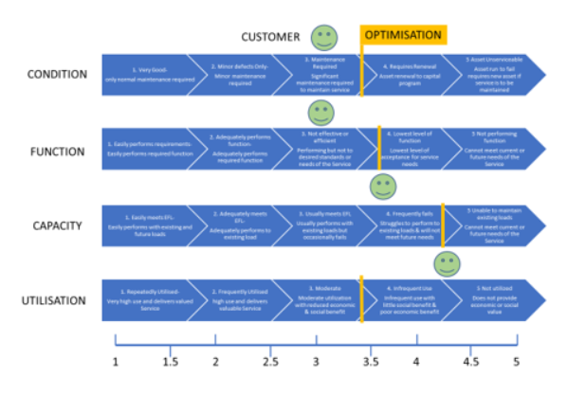

Some services are mandatory, like Essential Safety Measures (ESMs) and Fire Services checks in our buildings. Other service levels are desirable, like how often we clean our toilets, windows, floors, etc. in our buildings. Then there is discretionary expenditure like how often we paint internal walls to refresh the amenity of the buildings.

There are two levels of service which the Council consider in our asset management plans.;
Technical levels of service- include maintenance schedules to ensure asset components are operating at the intended service level- frequency of roof gutter cleans, cleaning of air filtration systems, inspections of playground equipment
Community Levels of Service-what level of service do the community expect to be delivered and what level are they prepared to pay for? The operational days and hours of our library service, The type of desirable services Council provides such as childcare, the level of funding to provide these additional services. Generally, changes to community Services and community service levels are made through community consultation
Our assets are only provided to enable Services and the utilization, community value that is derived from asset is a principal factor when determining what the levels of service should be set at. Whilst Council has made substantial progress in the “defining Service Levels” element of the NAF framework, we have several actions to complete to meet the full requirements.

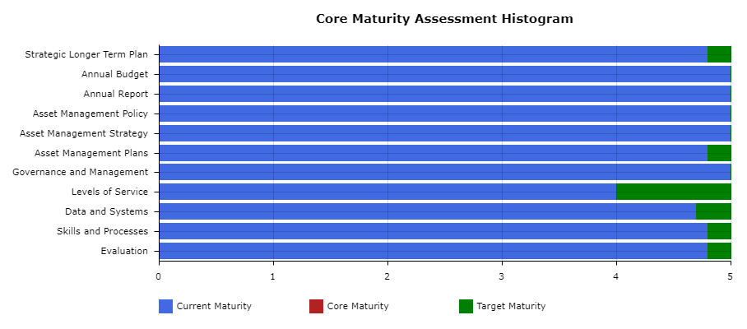

Figure 13: Maturity Risk Assessment

7.0 LIFECYCLE MANAGEMENT PLAN
The lifecycle management plan details how the organisation plans to manage and operate the assets at the agreed levels of service (while optimising life cycle costs and managing risks).
Lifecycle management focuses on management options and strategies considering all relevant economic and physical consequences as part of an asset's life cycle, from initial planning to disposal.
It is paramount that recognition of all costs associated with the operation and maintenance of an asset over its entire life is considered when determining the performance of that asset. In undertaking this assessment, it is important to also recognise that initiatives to reduce life cycle costs can be considered in five key stages as described in Figure 14.
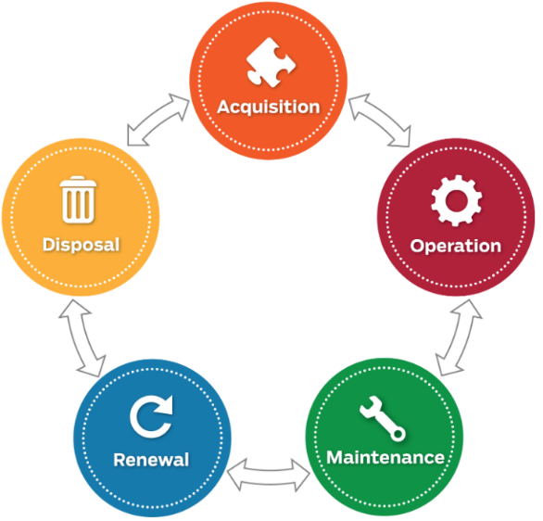

Figure 14: Lifecycle Costs of assets

7.1 Routine Operation and Maintenance Plan
Operations include regular activities to provide services such as public health, safety and amenity, e.g. cleansing, utility services, street sweeping, grass mowing and street lighting.
Routine maintenance is the regular on-going work that is necessary to keep assets operating, including instances where portions of the asset fail and need immediate repair to make the asset operational again.

7.1.1 Operation and Maintenance Plan
Operational activities affect service levels including quality and function, such as cleanliness, appearance, etc., through street sweeping and grass mowing frequency, intensity and spacing of streetlights and cleaning frequency and opening hours of building and other facilities.
Maintenance includes all actions necessary for retaining an asset as near as practicable to an appropriate service condition including regular ongoing day-to-day work necessary to keep assets operating, e.g. road patching but excluding rehabilitation or renewal.
Maintenance expenditure levels are adequate, with a substantive increase being provided in the Integrated water portfolio for increased service levels in Councils Stormwater Pipe and Pit maintenance levels. If maintenance expenditure levels decrease which would result in a lesser level of service, the service consequences and service risks will be identified, and service consequences highlighted in the respective asset management plan and service risks considered in the Infrastructure Risk Management Plan.

7.1.2 Operation and Maintenance Strategies
We will operate and maintain assets to provide the defined level of service to approved budgets in the most cost-efficient manner. The operation and maintenance activities include:
- Scheduling operations activities to deliver the defined level of service in the most efficient manner.
- Undertaking maintenance activities through a planned maintenance system to reduce maintenance costs and improve maintenance outcomes. Undertake cost-benefit analysis to determine the most cost-effective split between planned and unplanned maintenance activities (50 – 70% planned desirable as measured by cost).
- Maintain a current infrastructure risk register for assets and present service risks associated with providing services from infrastructure assets and reporting Very High and High risks and residual risks after treatment to management and Council/Board.
- Review current and required skills base and implement workforce training and development to meet required operation and maintenance needs.
- Review asset utilisation to identify underutilised assets and appropriate remedies, and over utilised assets and customer demand management options.
- Maintain a current hierarchy of critical assets and required operation and maintenance activities
- Develop and regularly review appropriate emergency response capability.
- Review management of operation and maintenance activities to ensure we are obtaining best value for resources used.

7.1.3 Summary of future operation and maintenance expenditures
Future operation and maintenance expenditure is forecast to trend in line with the value of the asset stock as shown in Figure 15. The forecast expenditures have been accommodated in the organisation’s long-term financial plan. Our operation and maintenance costs are stabilized with future savings through efficiency offsetting CPI (Consumer Price Index) and asset acquisitions. Note that all costs are shown in current dollar values (i.e., real values).
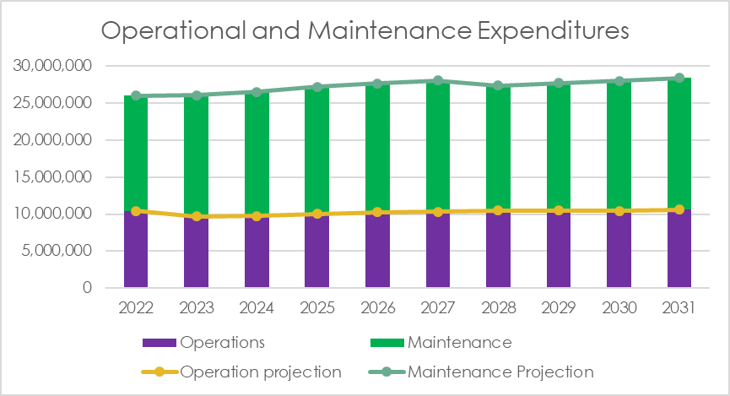

Figure 15: Projected Operation and Maintenance Expenditure and LTFP (Long Term Financial Plan) Outlays

7.2 Renewal/Replacement Plan
Renewal and replacement expenditure is major work which does not increase the asset’s design capacity but restores, rehabilitates, replaces, or renews an existing asset to its original or lesser required service potential. Work over and above restoring an asset to original service potential is upgrade/expansion or new works expenditure.

7.2.1 Renewal and Replacement Strategies
We will plan capital renewal and replacement projects to meet level of service objectives and minimise infrastructure service risks by:
- Planning and scheduling renewal projects to deliver the defined level of service in the most efficient manner
- Undertaking project scoping for all capital renewal and replacement projects to identify:
  - The service delivery ‘deficiency,’ present risk and optimum time for renewal/replacement.
  - The project objectives to rectify the deficiency.
  - The range of options estimated capital and life cycle costs for each option that could address the service deficiency.
  - evaluate the options against evaluation criteria adopted by Council
  - Select the best option to be included in capital renewal programs.
- Using optimal renewal methods (cost of renewal is less than replacement) wherever possible.
- Maintain a current infrastructure risk register for assets and service risks associated with providing services from infrastructure assets and report Very High and High risks and Residual risks after treatment to management, Audit Committee and Council.
- Review current and required skills base and implement workforce training and development to meet required construction and renewal needs.
- Maintain a current hierarchy of critical assets and capital renewal treatments and timings required.
- Review management of capital renewal and replacement activities to ensure we are obtaining best value for resources used.

7.2.2 Renewal ranking criteria
Asset renewal and replacement is typically undertaken to either:
- Ensure the reliability of the existing infrastructure to deliver the service it was constructed to facilitate (e.g., replace a bridge that has a 5-t load limit), or
- To ensure the infrastructure is of sufficient quality to meet the service requirements (e.g., roughness of a road).
Capital renewal and replacement priorities are indicated by identifying assets or asset groups that:
- Have a high consequence of failure
- Have a high utilisation and loss of service would have a significant impact on users
- Have the highest average age relative to their expected lives
- Are identified in the AM Plan as key cost factors
- Have high operational or maintenance costs, and
- Where replacement with modern equivalent assets would yield material savings.
The ranking criteria used to determine priority of identified renewal and replacement proposals is detailed in the respective asset management plans.

7.2.3 Summary of future renewal and replacement expenditure
Figure 16 below provides an overview at ‘total asset’ level for predicated renewal demand and projected renewal expenditure over the next ten (10) years The forecast expenditures have been accommodated in the organisation’s long-term financial plan. Note that all amounts are shown in real values.
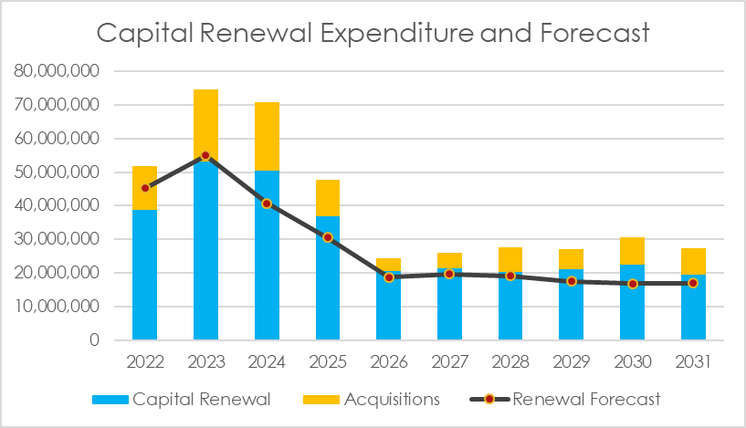

Figure 16: Projected Capital and Replacement Expenditure

7.2.4 Summary of Asset renewal ratios
Council has moved to funding renewal forecasts. Each asset portfolio renewal requirements are modelled on future use and existing condition-based requirements. This enables Council to prioritise expenditure where it is required and when it is required. Traditional flat line depreciation methods were used to calculate renewal ratios prior to 2018. Ratios and KPI were based on funding 100% of the annual depreciation cost. The following tables are an example of the difference between traditional flat line depreciation renewal ratio and condition-based renewal ratios.
Example: Council purchases 20 BBQ at total cost $200,000 each BBQ expected to last 10 years
Flat Line depreciation funding
Annual Depreciation | Funded depreciation per year | Capital Funding Required year 1-9 | Annual Renewal ratio year 1-9 | Year 10 funding req. | Year 10 Renewal ratio
$20,000 | $20,000 | $0 | 100% | $200,000 | 10%
Overfunding assets in year 1-9 is widespread practice for Councils using this method. Often the budget is spent in other areas

Condition Based Renewal ratios
Annual Depreciation | Funded depreciation year 1-9 | Capital Funding Required year 1-9 | Annual Renewal ration 1-9 | Year 10 funding required and budgeted | Condition based Funding in year 10
$20,000 | 0 | 0 | 0% | $200,000 | 100%
Budgets are built based on condition and immediate requirements. The renewal ratio per asset class and Portfolio will fluctuate over time if reported against depreciation. Reporting against asset drivers (condition, function, capacity, sustainability) and the optimum renewal period ensures the Council is replenishing its assets at the appropriate time and meeting community demands.
Our asset maturity level has increased to a level, with increased confidence in our data, process and systems has allowed us to successfully transition to condition-based asset depreciation forecasting.

7.3 Creation/Acquisition/Upgrade Plan
New works are those works that create a new asset that did not previously exist or works which upgrade or improve an existing asset beyond its existing capacity. They may result from growth, social or environmental needs. Assets may also be acquired at no cost to the organisation from land development.
Prior to the acquisition of any asset, a thorough examination of that asset and of any alternatives needs to be undertaken. This examination should include the preparation of a service delivery strategy, which must include a thorough assessment of the full life cycle costs of acquiring, operation, maintaining and disposing of that asset. The key cost components to the life cycle of an asset are:
- Investigation/feasibility,
- Design and construction/acquisition,
- Operations and maintenance,
- Rehabilitation and renewal,
- Ultimate replacement or rationalisation,
- Depreciation, and
- Disposal.
Issues that also need to be considered include:
- Is there a need? (Need analysis)
- Have all life cycle costs been assessed? (owning & operating)
- What level of service is required from the asset to meet community needs and expectations?
- How long is the asset required?
- Have alternatives for the provision of the service been reviewed?
- Can the existing assets to be augmented or altered to provide service?
- Are the costs for new services or service levels justified?
- Has a risk analysis been undertaken (probability and consequences of failure able to be predicted)?
- Can the performance of the asset be predicted (Aggregated total asset base & individual assets and components)?

7.3.1 Selection criteria
New assets and upgrade/expansion of existing assets are identified from various sources such as community requests, proposals identified by strategic plans or partnerships with other organisations. Candidate proposals are inspected to verify need and to develop a preliminary renewal estimate. Verified proposals are ranked by priority and available funds and scheduled in future works programmes. The priority ranking criteria is detailed in the respective asset management plans.

7.3.2 Capital Investment Strategies
We will plan capital upgrade and new projects to meet level of service objectives by:
- Planning and scheduling capital upgrade and new projects to deliver the defined level of service in the most efficient manner.
- Undertake project scoping for all Renewal projects to identify:
  - The service delivery ‘deficiency’, present risk and required timeline for delivery of the upgrade/new asset.
  - The project objectives to rectify the deficiency including value management for major projects.
  - The range of options estimated capital and life cycle costs for each option that could address the service deficiency.
  - Management of risks associated with alternative options.
  - Evaluate the options against evaluation criteria adopted by Council.
  - Select the best option to be included in renewal programs.
- Review current and required skills base and implement training and development to meet required construction and project management needs.
- Review management of capital project management activities to ensure we are obtaining best value for resources used.
Standards and specifications for maintenance of existing assets and construction of new assets and upgrade/expansion of existing assets are detailed in relevant asset management plans.

7.3.3 Summary of future upgrade/new assets expenditure
Projected upgrade/new asset expenditures and estimated long-term financial plan outlays are summarised in Figure 17. The forecast expenditures have been accommodated in the organisation’s long-term financial plan. The projected upgrade/new capital works program for each Portfolio is shown in the Portfolio Asset Plans
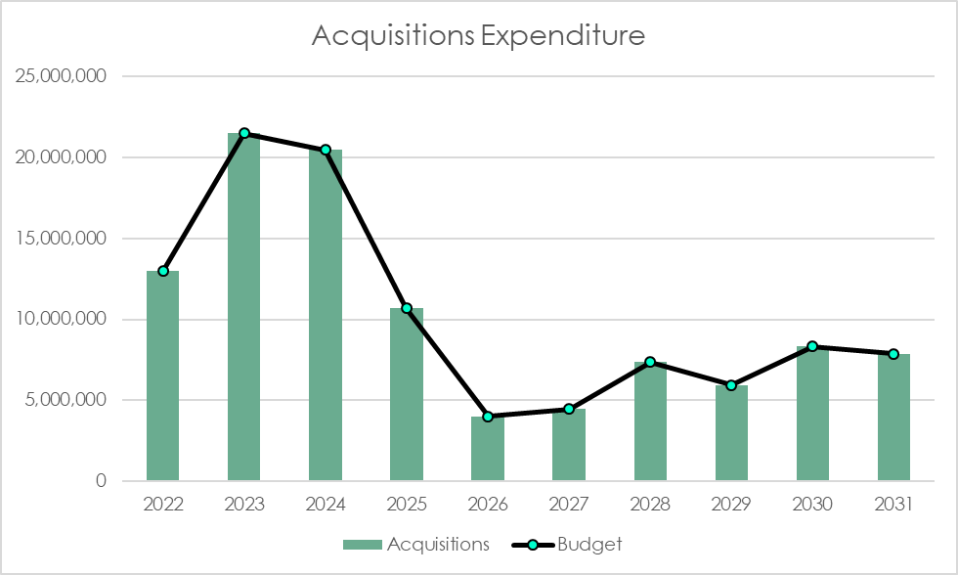

Figure 17: Renewal Asset Expenditure and Budget

7.4 Disposal Plan
Disposal includes any activity associated with disposal of a decommissioned asset including sale, demolition, or relocation. Routine disposals of end-of-life assets such as park benches, BBQs, lighting etc, are identified in each of the portfolio asset management plans. Disposal of land or buildings, given the value of the assets, are only included in the asset management plans once there has been a council resolution to dispose of the land/building.
Disposal works involve a logical examination of the asset to be able to answer several questions, including:
- Is the asset still required by the community?
- Can the need be satisfied by a less expensive or alternative asset?
- Is it the role of Council to provide a particular service delivered by the asset?
Assets may become surplus to requirements for any of the following reasons:
- Underutilisation
- Obsolescence
- Provision exceeds required level of service
- Uneconomic to upgrade or operate
- Policy change
- Service provided by other means, or
- Potential risk of continued ownership or management
The prime component in planning for asset disposal is having the required information to be able to make an informed decision on any disposal. Understanding the current condition and ramifications of failure are critical.
Disposal and rationalisation policies need to be determined so that the most cost-effective options are considered. These options include:
- Sale
- Donation
- Exchange
- Disposal.
Cash flow projections from asset disposals are not presently available and these will be developed in future revisions of Council’s portfolio asset management plans.

7.4.1 Service Consequences and Risks
The organisation has prioritised decisions made in adopting the asset management plans summarised in this strategic asset management plan to obtain the optimum benefits from its available resources.
The asset management plans are based on balancing service performance, cost, and risk to provide an agreed level of service from available resources in our long-term financial plan.

7.4.2 Deferred initiatives and projects
Every Council would like to do more for their community. In reality, we have a finite number of resources. Our annual budget is planned and built from the bottom-up approach. Mandatory Services that we must provide to meet Regulatory and Legislative requirements are prioritized over Preferred Services which are the additional Services valued by our community. Discretionary spending, “would like to do” investment in new Services or Infrastructure has limited opportunities in a balanced budget approach as shown in Figure 18 below.
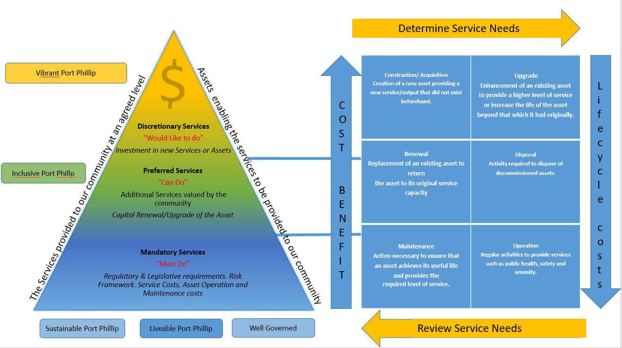

Figure 18: Budget Build Prioritisation

Note that Council has no deferred initiatives or project for the delivery of Mandatory or Preferred Services.

7.4.3 Service consequences
Discretionary Service projects which are not selected in the budget build will form part of the deliberative consultation with our community to ensure that the priority of selected projects are the projects or Service expectations which the community value and are prepared to fund.

7.5 Lifecycle Costs
Lifecycle costs (or whole of life costs) are the average annual costs that are required to sustain the service levels over the longest asset life. Lifecycle costs include operation and maintenance expenditures plus asset consumption (depreciation). This measure is more relevant when Councils are using “Core” asset management principals to forecast future costs.
Life cycle costs can be compared to lifecycle expenditure to give a comparison of current expenditures to lifecycle costs of services. Lifecycle expenditure measurements is most appropriate for Councils using “Advanced” asset management practices as strategic decisions on asset acquisitions, renewals and disposals are included model.
Lifecycle expenditures include operation and maintenance expenditures (excluding depreciation) plus capital renewal expenditure. The capital renewal component of lifecycle expenditure can vary depending on the timing of asset renewals.
Council is in a good position to deliver on our commitments in the Council Plan. Our Capital renewal program is fully funded, and a program deliverability assessment has also been completed to prioritise the portfolio delivery over the next 4 years. The lifecycle cost forecast puts Council at low risk of not meeting the adopted asset risk profile and delivery service demands.
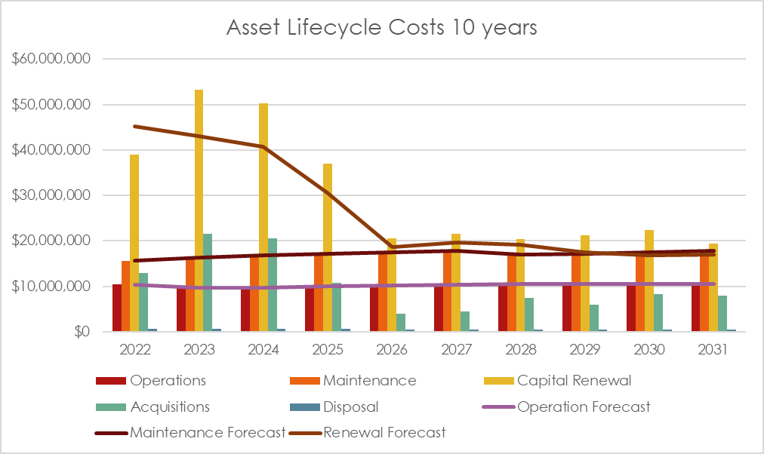
Figure 19: Renewal Asset Expenditure and Budget

The lifecycle costs and expenditures averaged over the 10-year planning period are shown in Table 7.
Asset Portfolio | Lifecycle Cost ($M/yr) | Lifecycle Expenditure ($M/yr) | Lifecycle Expenditure Indicator
Transport | 9,547,406 | 12,061,411 | 126%
Buildings | 12,214,960 | 19,769,402 | 162%
Public Space | 11,267,863 | 13,763,117 | 122%
Integrated Water | 2,748,063 | 3,405,411 | 124%
Clever City | 10,019,984 | 8,792,440 | 88%
TOTAL | 45,798,277 | 59,547,682 | 124%

Table 7: Asset Lifecycle Costs

Total lifecycle expenditure may reasonably be higher/lower than lifecycle costs in periods of above/below average asset renewal/replacement activity. The lifecycle indicator is a measure of estimated need over the long-term. It is dependent on the age profile of the assets, with older assets expected to have a higher LC indicator and newer assets a lower LC indicator.

7.5.1 Transport Portfolio Lifecycle Expenditure
The lifecycle expenditure forecast for the Transport Portfolio is shown in Figure 20. The peak in 2023 and 2024 is a result of Broadway Street Bridge over Elwood canal being transferred to Council ownership from the State Government in 2021/22. The bridge is in poor condition and requires immediate replacements. Council is seeking funding contributions from the State through grants processes. Whist the lifecycle indicator is 126% the overall consumption of the asset is at 30% which is reflective of the very strong investment in the portfolio over many years.
Acquisitions are forecast through developer contributions in the Fishermans Bend Urban Renewal Area (FBURA).

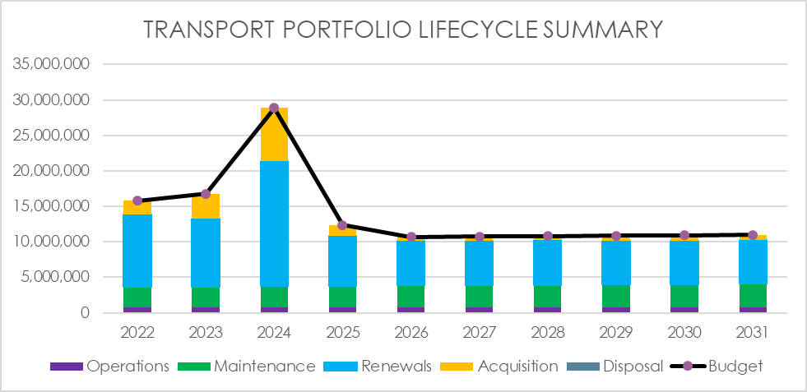

Figure 20: Projected 10 years Lifecycle Expenditure Transport Portfolio

7.5.2 Transport Portfolio opportunities or risks
- De-pavement opportunities by reviewing the function of the road reserve to meet future community requirements, providing cooler green spaces.
- Flood mitigation by adjusting the longitudinal and horizontal cross falls of our roads to improve hydraulic flows of our stormwater network and reduce impacts of flooding on our community.
- Continue use of recycled asphalt on our road resurfacing program and investigate use of pavement cooling treatments.

7.5.3 Buildings Portfolio Lifecycle Expenditure
The lifecycle expenditure forecast for the Buildings Portfolio is shown in Figure 21. Whist the lifecycle indicator is 162% the overall consumption of the asset is at 49% which is reflective of the the type and age of buildings in this portfolio. The Buildings Portfolio is undergoing significant investment over the 10-year period. Major works being South Melbourne Town Hall, South Melbourne Markets, Elwood foreshore and other buildings identified in the Property Portfolio Strategy for investment and divestment.

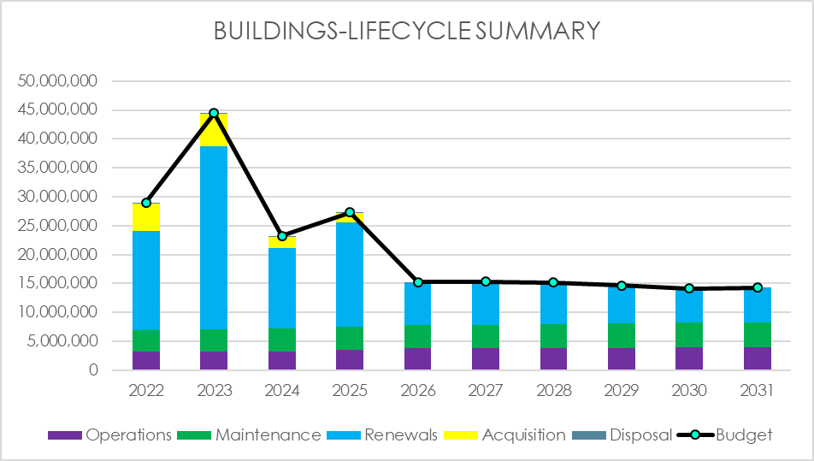

Figure 21: Projected 10 years Lifecycle Expenditure Buildings Portfolio

7.5.4 Buildings Portfolio opportunities or risk
- Continue to implement Property strategy to invest in assets which meet the key performance criteria and divest assets which cannot meet the current or future needs of the Services which they enable. This includes assessment of the provision of Disability Access and gender equality across the portfolio
- Improve our selection of materials to ensure building materials are environmentally sustainable and financially sustainable throughout their useful life. Where possible upcycle and recycle of materials at disposal.
- Use of Smart technology to improve building efficiency, safety, and compliance.

7.5.5 Integrated Water Portfolio Lifecycle Expenditure
The lifecycle expenditure forecast for the Buildings Portfolio is shown in Figure 22. The lifecycle indicator at 124% is in a solid position. A significant increase in maintenance service levels over the past three years will continue over the next 5 years to have our system functioning at a minimum 90% capacity. CCTV continues to find additional assets which are inputted directly in Councils new 3D flood model. The model will drive our investments into major upgrades from 2025 onwards.
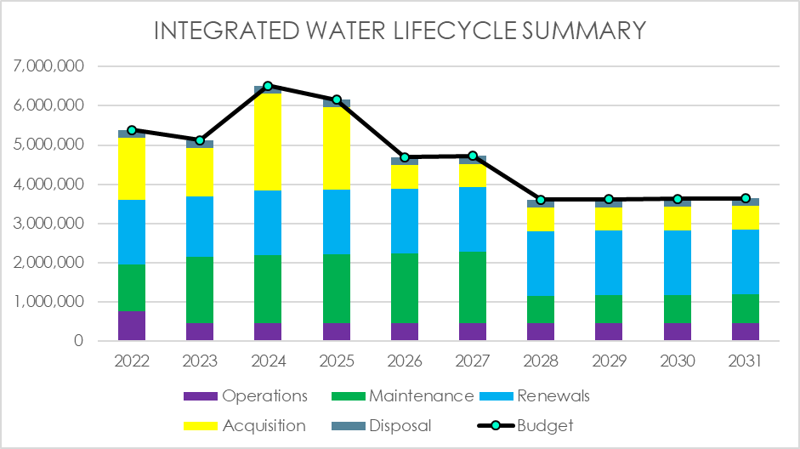

Figure 22: Projected 10 years Lifecycle Expenditure Integrated Water Portfolio

7.5.6 Integrated Water Portfolio opportunities or risk
- Implement TUFLOW 3D stormwater model with DRAINS hydraulic model to ensure the cost benefits are known for each project put forward.
- Continue to identify opportunities to ensure the existing infrastructure is functioning and the intended design capacity is utilized to its full potential
- Provide data and analysis of hydraulic flows and impacts to flood levels for road.

7.5.7 Public Space Portfolio Lifecycle Expenditure
The lifecycle expenditure forecast for the Buildings Portfolio is shown in Figure 23. The lifecycle indicator at 122% is meeting existing service requirements whilst the asset consumption is at an acceptable 37%. Major projects like Luna Park and Palais Theatre forecourts redevelopments and upgrades to our recreation facilities at Murphy reserve, Lagoon Reserve and Elwood Foreshore development in 2027 have a significant impact on the acquisition costs. Maintenance budgets are sufficient moving forward, however our existing service levels need to be monitored closely to ensure quality assurance.
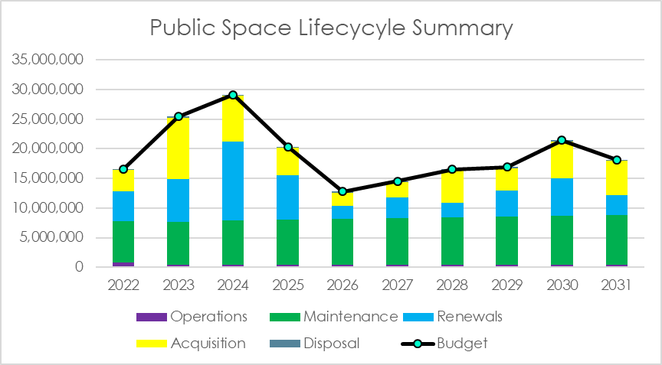

Figure 23: Projected 10 years Lifecycle Expenditure Public Space Portfolio

7.5.8 Public Space Portfolio opportunities or risk
- Review existing maintenance service levels and quality assurance systems to ensure The Council receives value for money and assets are maintained to optimize asset lifecycle costs
- In conjunction with the Transport portfolio review the function of our existing transport network to improve the livability of our city through the creation of improved public spaces
- Improve our selection of materials to ensure materials are environmentally sustainable and financially sustainable throughout their useful life. Where possible upcycle and recycle of materials at disposal.

7.5.9 Clever City Portfolio Lifecycle Expenditure
Our Clever City Portfolio is made up of three major asset classes
- Fleet and Plant
- Public Lighting
- Digital Technology Services
The lifecycle expenditure forecast is shown in Figure 24. Major projects to reduce Council's carbon footprint and obtain Council's sustainability targets have a significant impact over the next 10 years. Heavy plant converting over from fossil fuels to Electric or hydrogen vehicles has increased our renewal estimates by 60%.
Public lighting forecasts have also increased with changes to the Standard Load Table from the energy supplier. Mercury Vapor and High-Pressure Sodium lights will need to be changed over to LED during this planning period.
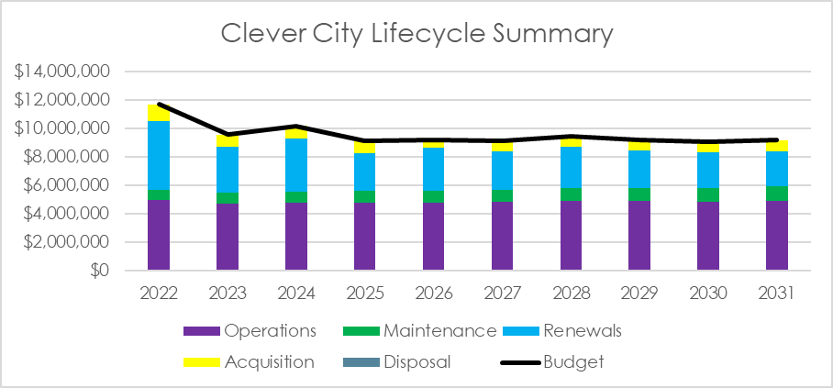

Figure 24: Projected 10 year Lifecycle Expenditure Clever City Portfolio

7.5.10 Clever City Portfolio opportunities or risk
- Planning for the conversion of our Street lighting to smart LED lighting reducing our energy and emissions
- Conversion our fleet vehicles over to electric and hydrogen vehicles
- Implementing actions from the Clever City “proof of concept” action plan.

8.0 FINANCIAL SUMMARY
This section contains the financial requirements resulting from all the information presented in the previous sections of this Plan. The financial projections will be improved as further information becomes available on desired levels of service and current and projected future asset performance.

8.1 Financial Indicators and Projections

8.1.1 Asset Renewal Funding Ratio
The Asset Renewal Funding Ratio, shown in Figure 25, indicates whether projected capital renewal and replacement expenditure can be financed in the long-term financial plan. It is calculated by dividing the projected capital renewal expenditure shown in the AMPs by the estimated capital renewal budget provided in the long-term financial plan. Over the next 10 years, we are forecasting that we will have 114% of the funds required for the optimal renewal and replacement of our infrastructure assets. Council previous % targets based on core asset principal of budget/depreciation sits at for asset renewal and upgrades 166%, with higher asset maturity and confidence in our data 114% places Council at Low risk of not being able to fund asset renewals over this period.
The Long-term financial plan allows for a 3.5% annual increase in asset valuation for CPI and therefore a similar increase in depreciation costs. The asset modelling does not include such increases as historically the replacement of assets is not like for like and providing the modern-day equivalent asset does not correlate to the same cost increases. The key assumptions made after implementation of the Strategic asset management modelling will provide an accurate analysis these differences.
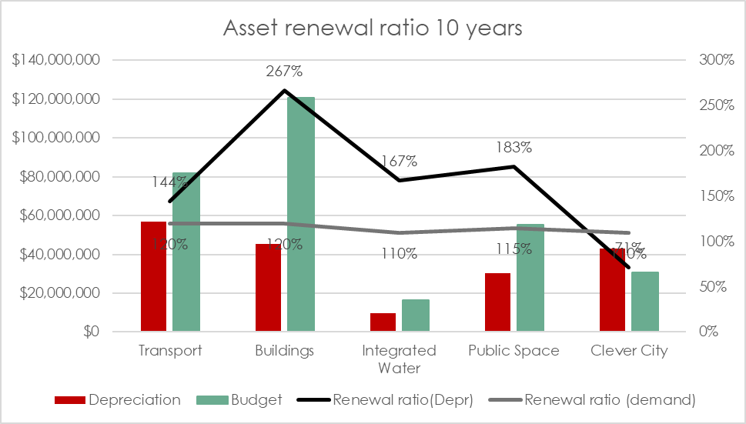

Figure 25: 10-year Asset Renewal Funding Ratio
The development of Council’s asset management plans has provided an opportunity to review the long-term forecasts of renewal expenditure for Council’s infrastructure assets. Calculating forward renewal projections provides an opportunity to optimise Council’s renewal expenditure across all of Council’s assets.
Prior to 2017, Council has used annual depreciation as a measure for future renewal expenditure. While depreciation is a good rule of thumb, a more sophisticated approach is to assess future renewal needs based on analysis using asset condition reflecting actual asset consumption. With the introduction of our Strategic asset management (SAM) model in 2022 Council will also be able to include modern day equivalent replacement costs and various funding scenarios in our consumption forecasts including divesting assets. The LGPRF and VAGO use depreciation as a proxy for determining long term renewal needs for infrastructure assets. We are presently operating under the low-risk rating for VAGO for the next 10 years
The Buildings Portfolio is funded at 267%, this is due to our ageing building stock and the need to divest stock and reinvest to ensure the assets can continue to meet the Service requirements.

Figure 26: Asset Consumption
Council’s portfolio asset management plans from 2017 onwards have been developed by calculating future renewal demand rather than using the measure of depreciation that is based on past consumption of the asset. Prior 2017 renewal programs were developed based on funding the actual annual depreciation expense. Our Service levels, funding requirements, asset consumption and knowledge of the assets in their lifecycle has continued to improve with the increase in our asset maturity. This has enabled the Council to stabilize our budget expenditure and move towards consumption/condition- based renewal programs.
Consumption of the asset will vary over the forecast period depending on the rates of addition of new assets, disposal of old assets and consumption and renewal of existing assets
Where renewal projections are based on estimates of asset useful lives, the useful lives are documented in the relevant asset management plan(s).

8.2 Funding Strategy
The funding strategy to provide the services covered by this Plan and supporting AMPs is contained within the organisation’s 10-year Long Term Financial Plan.
Council Plan 2021-31 - Volume 2 (portphillip.vic.gov.au)

8.3 Valuation Forecasts
Asset values are forecast to increase as additional assets are added to the asset stock from construction and acquisition by the organisation and from assets constructed by land developers and others and donated to the organisation. Figure 27 shows the projected capital expenditure over the planning period in real values.

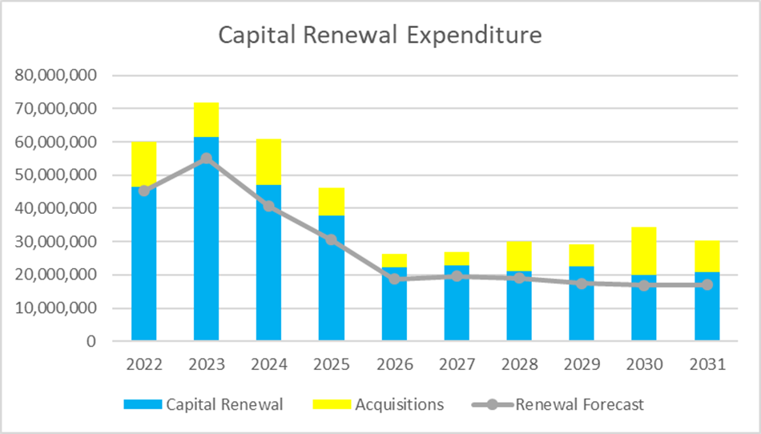

Figure 27: Capital Expenditure 10 years

8.4 Key Assumptions made in Financial Forecasts
This section details the key assumptions made in presenting the information contained in this Plan and in preparing forecasts of required operating and capital expenditure and asset values, depreciation expense and carrying amount estimates. It is presented to enable readers to gain an understanding of the levels of confidence in the data behind the financial forecasts.
Key assumptions made in this Plan and risks that these may change are shown in Table 8.

Table 8: Key Assumptions made in Strategic Asset Management Plan and associated Risks
Key Assumptions | Risk
Rates Strategy remains the same with annual rates cap in place | Annual Rates cap increases will not eventuate, and Services or service levels will need to be adjusted
New asset modelling capabilities through Strategic Asset Management (SAM) will inform long term financial Plan | Improved Asset modelling which will be implemented in 2022/23 may impact the current assumptions in the LTFP
FBURA funding GAP | Funding gap of Fishermans Bend Infrastructure does not meet by State and Council will be required to meet the funding shortfall from the DCP

8.4.1 Forecast Reliability and Confidence
The expenditure and valuations projections in this Plan are based on best available data. Currency and accuracy of data is critical to implement effective asset and fiscal management.
The estimated confidence level for and reliability of data used in this Plan is shown in Table 9.

Table 9: Data Confidence Assessment
AM Plan | Confidence Assessment | Comment
Transport Portfolio | Medium/High | Footpath condition Audit in carried out in March 2022
Buildings Portfolio | Medium | Component audit required and review of depreciation by component
Integrated Water Portfolio | Medium | CCTV Program building confidence and 30% has been surveyed. Additional assets are still being located
Public Space Portfolio | Medium | Data cleanse in 2018-2020. Quality assurance improvements required to ensure assets are fit for purpose and meet expected useful lives
Clever City Portfolio | Medium | Annual stocktakes need to be performed.

9.0 OUR SYSTEMS AND PROCESSES

9.1 System Process
Underpinning these strategic documents are numerous processes, methodologies and practices which are undertaken within the day-to-day activities of the City’s administration and management duties. The Asset Management Plan details those activities that relate to managing the network of assets within an asset group.

9.2 Asset Lifecycle Management System (ALM)
The capability for ALM is delivered via the asset and work management functional groups. The structured Asset framework of the One Council solution provides for operations, maintenance, acquisitions, disposal, renewals, strategic and financial process management of assets though out their lifecycle.
“Asset and work management” functional group is made up of four (4) key foundation components at the highest level that supports and aligns the core ALM pillar, framework and supporting processes:
- Asset Management.
- Work Management.
- Project Management
- Strategic Asset Management.
The following diagram provides Council’s integrated approach to asset and services planning.
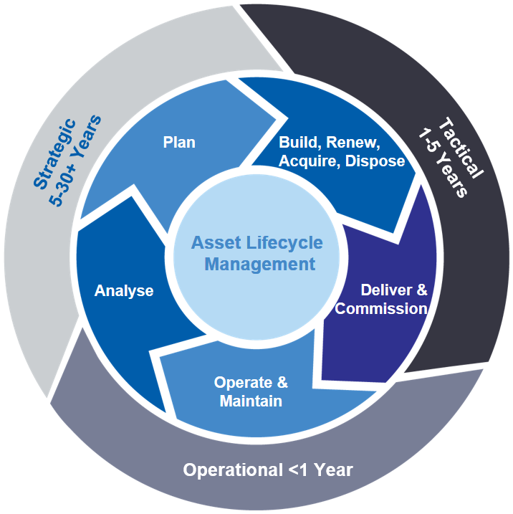

Figure 28: Integrated Approach to Asset and Service Planning

9.3 Asset and Service Planning Delivery Model
The following diagram shows Council integrated approach to delivering the actions of the Council Plan
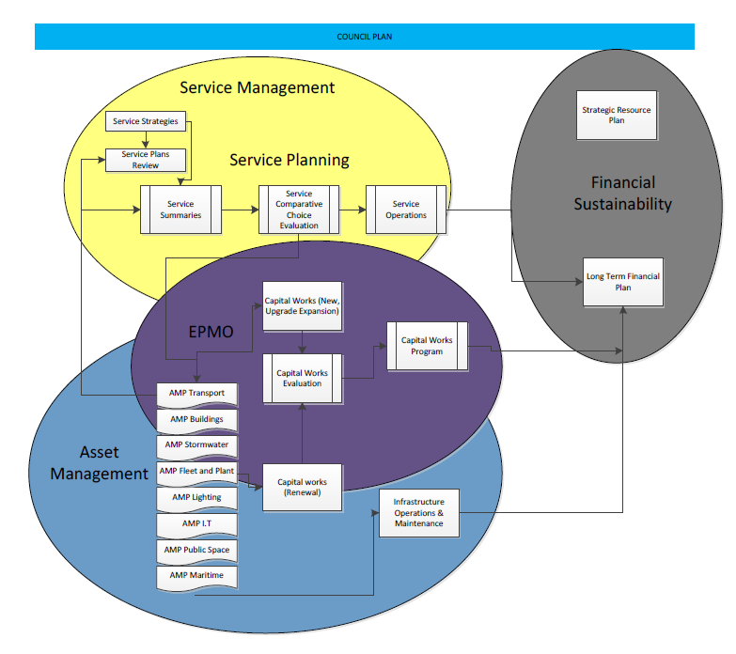

Figure 29: Asset and Service Planning Delivery Model

9.4 Asset Data Management and Information Systems
All assets are held in Technology 1- One Council system. The asset system has full integration with the finance, contracts, customer request, works management and projects modules. The council will implement the Strategic Asset Model (SAM) with the release of 2021B software upgrade. A works application called the “Field” App will be implemented in March 2022 which will provide outdoor staff and contractors greater mobility and agility in the field.

9.5 Operational Integration
The following diagram shows how Councils Operation systems integrate from initiation to delivery.

OPERATIONAL INTERGRATION

Figure 30: Operational Integration Diagram

9.6 Customer focused system configuration
The Asset management module and works management modules have been configured to provide improved customer focus Process improvement is derived from the concept of Lean Six Sigma to provide efficient and effective community services. The framework focuses on two pillars
- Customer focused operating system to streamline services
- Asset investment planning to achieve sustainability and Council Plan actions.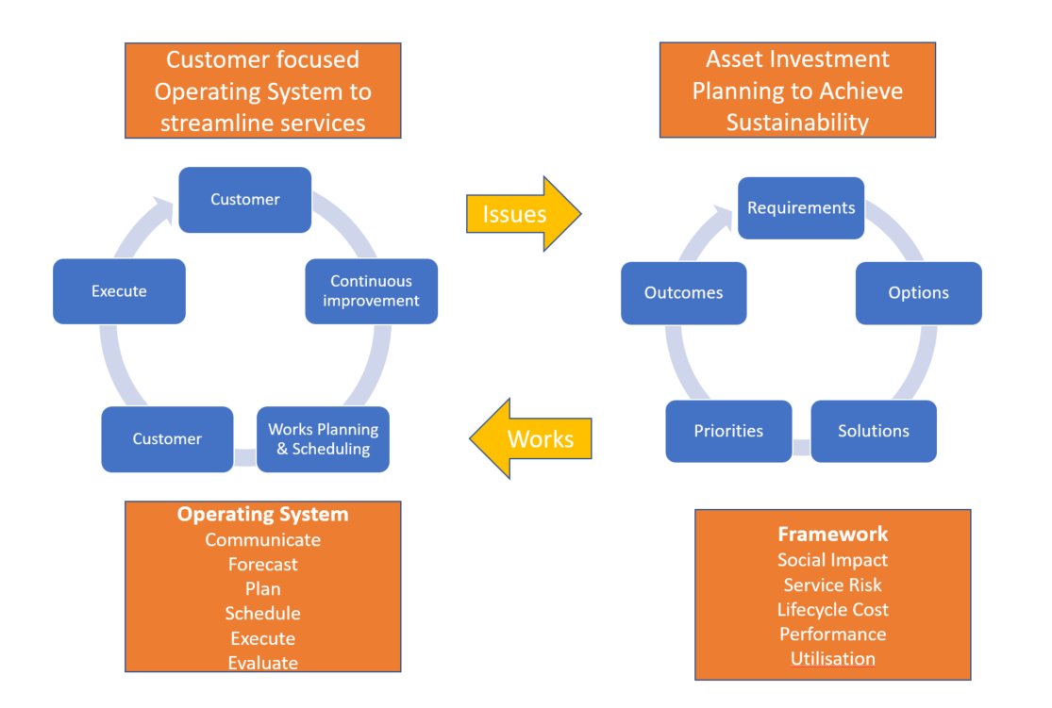

Figure 31: System Configuration

10.0 CONTINUOUS IMPROVEMENT

10.1 Status of Asset Management Practices
Council is in a strong position to meet the requirements of Section 92 of the Local Government Act 2020. The essence or the fabric of asset management is one of continuous improvement. It is essential that we continue to invest in system, process, and people improvements to provide transparency on Services we deliver, the cost of providing these services and what community value is provided.
Our service plans are integrated to Asset Management Plans, are modelled on community and technical service level data to provide cost scenario and options for consideration of Council Delivery Plans. The selection of Portfolio works for Operational; Maintenance, Renewal and Acquisitions inform the Long-Term Financial Plans.

10.1.1 How will we get there?
The actions required to continue improving our asset management maturity against ISO5501 and the NAF are shown in Table 10. These actions in Asset terms are our Strategy for achieving our asset management goals listed in the City of Port Phillips Asset Management Policy 2021

Table 10: Actions To Improve Asset Management Maturity
 | Initiative | Responsibility | Total indicative cost | 2022/23 | 2023/24 | 2024/25 | 2025/26 | Target completion | Notes
Fit-for-purpose | Undertake Service reviews and ascertain the future functional and capacity requirements of our buildings to meet service needs | Head of Asset Management | $150,000 |  | 75,000 | $75,000 |  | May 2025
Fit-for-purpose | Undertake a risk assessment for all assets, identify critical assets and develop an appropriate plan to mitigate risks | Head of Asset Management | Existing resources | annual | annual | annual | annual | Ongoing | Annual Review
Fit-for-purpose | Complete a detailed survey and modelling of the stormwater network to understand its capacity and performance. Upgrade existing camera to scanner to complete surveys | Head of Asset Management | $150,000 |  |  | 150,000 |  | June 2025 | On Track CCTV survey 40% survey of network & 3D flood model in operation
Fit-for-purpose | Develop Flood Model to show impacts of urban streetscape design and water sensitive city actions with climate change impacts | Asset Portfolio Planner-Integrated Water | Existing resources | BAU | BAU | BAU | BAU | Ongoing | Tuflow 3D model has been completed and rain on grid forecasts currently being configured
Community benefit | Develop an annual State of Our Assets report | Head of Asset Management | Existing resources | BAU | BAU | BAU | BAU | August (annual) | State of Our Assets Report included in Council’s annual report
Community benefit | Improve compliance with service levels by implementing precinct-based asset inspections using internal officers | Manager Assets & Property | Existing resources |  |  |  |  | June 2023
Community benefit | Document service plans for all services involving community discussion and engagement | GM Governance and Organisational Capability | $100,000* |  | $50,000* | $50,000* |  | June 2024 | Commenced in October 2018 as BAU and 80% completed
Community benefit | Develop and review key policies to support business practices, for example leasing and licensing, acquisition and disposal | Manager Assets & Property | Existing resources | BAU | BAU | BAU | BAU | Ongoing | Supporting Policies listed in Portfolio Plans
Environmental sustainability | Develop and implement a framework to increase Council asset resilience to the impacts of climate change. | Executive Manager Assets & Property | Existing resources |  | BAU | BAU | BAU | June 2025 | Commenced as BAU  Climate change asset resilience model
Environmental sustainability | Consider ‘green’ over ‘grey’ infrastructure where appropriate, cost effective and deliver the same level of service. | Head of Asset Management | Existing resources |  |  |  |  | Ongoing | BAU improvements ongoing
Financial sustainability | Undertake optimised scenario modelling to identify impacts of funding and/or service levels, risk profiles and investment strategies on our assets over the long term. Then model that prioritised expenditure across all of our asset portfolio and Capital Works Program. | Head of Asset Management | Existing resources |  |  |  |  | Ongoing | Strategic Asset System for Asset & financial modelling
Financial sustainability | Services and Assets Steering Committee meetings held quarterly | Executive Manager Assets & Property/ Manager Organisational Performance | Existing resources |  |  |  |  | Ongoing | Quarterly meetings July, Sept, Dec, March,
Financial sustainability | Continue to refine the process for linking asset management plans and service plans to the long-term financial plan | Executive Manager Assets & Property/ CFO | Existing resources |  |  |  |  | June 2025
Financial sustainability | Refine the capital evaluation framework to consider whole-of-life costs, consequences of not proceeding and service criticality and impacts | Executive Manager Enterprise Portfolio Management Office | Existing resources |  |  |  |  | June 2023 | Strategic Asset Management (SAM) to be implemented and integrated with PLM
Advanced practice | Work with industry to leverage opportunities for innovative techniques with cost saving opportunities | Executive Manager Assets & Property | Existing resources |  |  |  |  | Ongoing
Advanced practice | Implement AI for data collection to improve knowledge and inform decisions | Chief Innovation and Information Officer | Existing resources |  |  |  |  | Ongoing | Clever City Strategy Implementation
Advanced practice | Develop a data improvement strategy to ensure decisions are driven by quality information | Asset Management Coordinator | Existing resources |  |  |  |  | July 2023
Advanced practice | Collect and analyse asset performance data (condition, function, capacity, compliance) to improve decisions | Asset Management Coordinator | $200,000 | 50,000 | 50,000 | 50,000 | 50,000 | Ongoing
Advanced practice | Systems- Continue to Configure T1 asset systems and implement the Strategic Asset Management Module (SAM) Technology 1 solution. | Head of Asset Management | Existing resources |  |  |  |  | Ongoing
Advanced practice | Complete a skills gap analysis and implement a development program to build asset management capability | Head of Asset Management | Existing resources |  |  |  |  | Ongoing
Advanced practice | Document and formalise the asset handover process in T1 | Head of Asset management | Existing resources |  |  |  |  | June 2023
Advanced practice | Process - Develop reporting capability using dashboards to determine whole of lifecycle benefits and costings to enable better decision making. | Chief Innovation and Information Officer/ Head of Asset Management | Existing resources |  |  |  |  | Ongoing
Advanced practice | Continue to implement upgrades to core corporate systems relating to asset and fiscal management to meet enterprise needs. Includes integration/interface with key supporting systems and a review and alignment of existing business processes | GM Customer, Operations and Infrastructure | Existing resources |  |  |  |  | ongoing | Budget beyond existing budgets subject to business case

11.0 MONITORING AND REVIEW PROCEDURES
The Enterprise asset management plan has a life of 4 years (Council election cycle) and is due for complete revision and updating within 2023/24 of each Council election.

11.1 Performance Measures
The effectiveness of the Enterprise asset management plan can be measured in the following ways:
- The degree to which the required projected expenditures identified in this strategic asset management plan are incorporated into the organisation’s long term financial plan
- The degree to which 1–5-year detailed works programs, budgets, business plans and organisational structures consider the ‘global’ works program trends provided by the summarised asset management plans
- The degree to which the existing and projected service levels and service consequences (what we cannot do), risks and residual risks are incorporated into the organisation’s Strategic Plan and associated plans
- The Asset Renewal Funding Ratio achieving the target of – 100-150%.

11.2 Outlook
We can maintain existing levels of service for the next ten years based on current knowledge and projections in AM Plans and Long-Term Financial Plan.
Funding of current infrastructure lifecycle costs is considered adequate for the next 10 years. Review of services, service levels and costs will need to be carried out over the next 2 years to identify and monitor changes in demand for services and affordability over the longer-term.
Our current asset and fiscal management maturity is at ‘Advanced’ level and investment in continuous improvement is required to ensure information management, lifecycle management, service management and accountability and strategic direction meets customer expectations.

12.0 REFERENCES

ISO, 2014, ISO 55000, Asset management – Overview, principles and terminology, International Organization for Standardization, Geneva.
ISO, 2014, ISO 55001, Asset management – Management systems - Requirements, International Organization for Standardization, Geneva.
ISO, 2014, ISO 55002, Asset management – Management systems – Guidelines for the application of ISO 55001, International Organization for Standardization, Geneva.
IPWEA, 2014, ‘NAMS.PLUS3 Asset Management’, Institute of Public Works Engineering Australia, Sydney, www.ipwea.org/namsplus.
IPWEA, 2015, ‘Australian Infrastructure Financial Management Manual, Institute of Public Works Engineering Australasia, Sydney, www.ipwea.org/AIFMM.
IPWEA, 2011, 2015, ‘International Infrastructure Management Manual’, Institute of Public Works Engineering Australasia, Sydney, www.ipwea.org/IIMM
Organisation, ‘Strategic Plan 20XX – 20XX’,
Organisation, ‘Annual Plan and Budget’,
Organisation, ‘Asset Management Plans,

Annexure A: Organisation Asset Management Maturity Assessment



MATURITY ASSESSMENT PLAN
City of Port Phillip
NAF Assessment February 2022

Document Control |  | Maturity Assessment Plan
Document ID :
Rev No | Date | Revision Details | Author | Reviewer | Approver

The entity can choose either template to write/update their plan regardless of their level of asset management maturity and in some cases may even choose to use only the Executive Summary.
The illustrated content is suggested only and users should feel free to omit content as preferred (e.g. where info not currently available).
DISCLAIMER: The data and conclusions have not been reviewed for accuracy nor endorsed or adopted by the organization. DELETE if not Applicable
© Copyright 2019 – All rights reserved
The Institute of Public Works Engineering Australasia

Contents
1.0 EXECUTIVE SUMMARY 62
2.0 MATURITY ASSESSMENT 62
3.0 GRAPHS 79

EXECUTIVE SUMMARY
Enter details on Maturity Assessment.

MATURITY ASSESSMENT

 | Framework |  | Financial Planning & Reporting
 | Element |  | Strategic Longer Term Plan
 | Current Score |  | 4.8 | Core Maturity | Meets Requirements
 | Core Target |  | 3 | Risk of Current Maturity | Low
 | Advanced Target |  | 5 | Risk of Target Maturity | Low
Observations |  |  | Council uses a fully integrated system One Council which has been configured to meet Council objectives and reporting requirements. The system and data will continue to improve over time and subsequent modelling will become more sophisticated.
Implications |  |  | Council Strategic Asset Management (SAM) will be implemented in April, 2022.
Recommendations |  |  | Implement the Strategic asset management Model as planned
Maturity Score |  | Characteristic |  |  |  | Result
1 |  | Plan covers 1 year period |  |  |  | Complete
2 |  | Plan details what the asset custodian intends to do in period of plan |  |  |  | Complete
2 |  | Plan includes vision and strategic objectives |  |  |  | Complete
2 |  | Plan reflects needs of community for foreseeable period |  |  |  | Complete
2 |  | Draft Strategic Plan is advertised for public comment |  |  |  | Complete
2 |  | Plan covers 4 year term of the asset custodian's forward work program. |  |  |  | Complete
3 |  | The Long Term Financial Plan has been prepared based on the resource requirements and strategic objectives detailed in The asset custodian’s Long Term Plan and Asset Management Plans. |  |  |  | Complete
3 |  | The asset custodian has a sustainable Long Term Financial Plan covering the period of the Strategic Longer Term Plan (at least 5 year) supporting the implementation of its Longer Term Plan. |  |  |  | Complete
3 |  | The Strategic Longer Term Plan incorporates priorities and performance measures and indicates how they will be monitored and measured. |  |  |  | Complete
3 |  | The development of the Strategic Longer Term Plan included community consultation and reflects community needs. |  |  |  | Complete
3 |  | The asset custodian has a Strategic Longer Term Plan (planning horizon of at least 5 years) that incorporates a vision, strategic outcomes, mission, values and service outcomes that The asset custodian wants to achieve. |  |  |  | Complete
4 |  | The Strategic Longer Term Plan includes strategies for achieving objectives |  |  |  | Complete
4 |  | The Strategic Longer Term Plan includes a current position statement and discussion |  |  |  | Complete
4 |  | The Long Term Financial Plan clearly identifies the ongoing maintenance, operational and renewal impacts arising from capital works and contributed assets. |  |  |  | Complete
4 |  | The Long Term Financial Plan clearly separates ‘recurrent expenditure’ under the categories of operations and maintenance and clearly separates ‘capital works expenditure’ under the categories of renewal, upgrade and new. |  |  |  | Complete
4 |  | The asset custodian's Long Term Financial Plan is directly aligned with its Service Plans. |  |  |  | Well Progressed
4 |  | The asset custodian has a sustainable Long Term Financial Plan (ideally 20 years - at least 10years) which establishes its prudential limits on debt, revenue raising, reserve funding, asset management funding and capital works to support its Long Term Plan. |  |  |  | Complete
4 |  | The development of the Strategic Longer Term Plan included community engagement and reflects community/customer needs. |  |  |  | Complete
4 |  | The asset custodian has a Strategic Longer Term Plan (ideally 20 years - at least 10 years) that incorporates a vision, mission, values and long term service outcomes that reflects how the asset custodian plans to provide for community needs. |  |  |  | Complete
5 |  | Optimum life cycle costs are known and supported by high levels of data, information and knowledge in all key areas. Political decisions are informed by multiple service level / cost / funding model data, information and knowledge on tradeoffs for economic, social, cultural and environmental consequences. |  |  |  | Well Progressed

Characteristic | Result
Does your organisation have an adopted strategic longer term plan? | Meets requirements

 | Framework |  | Financial Planning & Reporting
 | Element |  | Annual Budget
 | Current Score |  | 5.0 | Core Maturity | Meets Requirements
 | Core Target |  | 3 | Risk of Current Maturity | Low
 | Advanced Target |  | 5 | Risk of Target Maturity | Low
Observations |  |  | Annual budget is integrated within the One Council System
Implications
Recommendations |  |  | Continual improvement with configuration and reporting
Maturity Score |  | Characteristic |  |  |  | Result
1 |  | Annual budget is available to those who ask |  |  |  | Complete
2 |  | Budget is adopted after public advertising and consideration of comments received |  |  |  | Complete
2 |  | Budget includes an explanation of the asset custodian's financial position and performance |  |  |  | Complete
2 |  | Budget contains estimates of revenue and expenditure for year |  |  |  | Complete
2 |  | Budget is publically available and readily accessible to all interested readers |  |  |  | Complete
3 |  | The asset custodian’s Annual Budget includes resources to implement Strategic Longer Term Plan strategies. |  |  |  | Complete
3 |  | The Annual Budget aligns with Year 1 of the Long Term Financial Plan, and was adopted following community consultation. |  |  |  | Complete
3 |  | The Annual Budget reflects the asset custodian's strategic objectives and contains a statement of how the asset custodian will meet the goals and objectives of its Strategic Longer Term Plan. |  |  |  | Complete
3 |  | The Annual Budget contains estimates of revenue and expenditure with an explanation of the assumptions and methodologies underpinning the estimates, an explanation of the financial performance and position of the asset custodian and has been prepared based on the resource requirements and strategic objectives detailed in the asset custodian’s Strategic Longer Term Plan, Asset Management Plans and Long Term Financial Plan. |  |  |  | Complete
4 |  | The Annual Budget clearly indicates the ongoing maintenance, operational and renewal impacts arising from capital works and contributed assets. |  |  |  | Complete
4 |  | The Annual Budget clearly separates ‘recurrent expenditure’ under the categories of operations and maintenance and clearly separates ‘capital works expenditure’ under the categories of renewal, upgrade and new. |  |  |  | Complete
4 |  | The Annual Budget is prepared based on ‘service levels’ as reflected in the Strategic Longer Term Plan and contains indicators and measures to assess performance against achieving the asset custodian 's strategic objectives. |  |  |  | Complete
4 |  | The Annual Budget financial ratios (liquidity, debt, underlying operating position) align with the asset custodian’s Long Term Financial Plan. |  |  |  | Complete
5 |  | Budget contains indicators of achieving the asset custodian's strategic objectives |  |  |  | Complete

Characteristic |  |  |  |  |  | Result
Does your organisation prepare an annual budget? |  |  |  |  |  | Meets requirements
 | Framework |  | Financial Planning & Reporting
 | Element |  | Annual Report
 | Current Score |  | 5.0 | Core Maturity | Meets Requirements
 | Core Target |  | 3 | Risk of Current Maturity | Low
 | Advanced Target |  | 5 | Risk of Target Maturity | Low
Observations |  |  | Annual report meets all the requirement of this element
Implications |  |  | nil
Recommendations |  |  | Continue to refine annual report
Maturity Score |  | Characteristic |  |  |  |  | Result
1 |  | Annual report is published each year |  |  |  |  | Complete
2 |  | Annual report contains explanation on variations between budget and actual results |  |  |  |  | Complete
2 |  | Annual report reports on the asset custodian's operations for the year in terms of goals and objectives for preceding year |  |  |  |  | Complete
2 |  | Annual report is widely available to the general public |  |  |  |  | Complete
2 |  | Annual report contains audited financial statements |  |  |  |  | Complete
3 |  | "In relation to the financial reporting framework in the Annual Report, the Annual Report addresses the following issues in accordance with relevant statutory policies, Accounting Standards and other best practice guidelines: |  |  |  |  | Complete
3 |  | The Annual Report includes details of any major changes in functions of the asset custodian, organisation structure and/or policy initiatives and how these changes might impact on The asset custodian’s Strategic Longer Term Plan. |  |  |  |  | Complete
3 |  | The Annual Report reviews the performance of the asset custodian against its strategic objectives and explains variations between the budget and actual results and how these variations impact on the Strategic Longer Term Plan. |  |  |  |  | Complete
3 |  | The Annual Report includes independently audited financial statements that are prepared on an accrual basis in accordance with applicable statutory financial reporting requirements. |  |  |  |  | Complete
3 |  | The Annual Report complies with all statutory requirements including publication by the due date and is made widely available to the public. |  |  |  |  | Complete
4 |  | "The asset financial reporting within the Annual Report, is such based on the following: |  |  |  |  | Complete
4 |  | The Annual Report includes a statement on “State of the Assets” and the financial sustainability of services provided by its infrastructure assets including any proposed adjustment to services/assets to address issues as they arise. |  |  |  |  | Complete
4 |  | The Annual Report distinguishes between ‘recurrent expenditure’ under the categories of operations and maintenance and ‘capital works expenditure’ under the categories of renewal, upgrade and new. |  |  |  |  | Complete
4 |  | The Annual Report includes a statement of actual performance for the year as measured against the Long Term Financial Plan, including reporting on measures of actual financial performance against short and long term financial sustainability indicators. |  |  |  |  | Complete
4 |  | The Annual Report includes a performance assessment of progress towards achieving the goals and strategic objectives of the Strategic Longer Term Plan. |  |  |  |  | Complete
5 |  | Annual report includes results of Value for Money audit |  |  |  |  | Complete

Characteristic | Result
Does your organisation publish an annual report? | Meets requirements

 | Framework |  | Asset Management & Planning
 | Element |  | Asset Management Policy
 | Current Score |  | 5.0 | Core Maturity | Meets Requirements
 | Core Target |  | 3 | Risk of Current Maturity | Low
 | Advanced Target |  | 5 | Risk of Target Maturity | Low
Observations |  |  | Asset management Policy created in 2017 and full review completed in 2021 which was adopted by Council and is displayed on Councils website.
Implications |  |  | nil
Recommendations |  |  | Complete review in 2025
Maturity Score |  | Characteristic |  |  |  | Result
1 |  | AM Policy in place but not adopted by the asset custodian OR some awareness by the asset custodian of asset management policy elements and asset management principles. |  |  |  | Complete
2 |  | AM Policy adopted by the asset custodian's executive. |  |  |  | Complete
3 |  | AM Policy identifies a process for meeting training needs in financial and asset management practices for the asset custodian's executive and operational staff. |  |  |  | Complete
3 |  | AM Policy defines asset management roles, responsibilities and reporting framework. |  |  |  | Complete
3 |  | AM Policy requires the adoption of Asset Management Plans informed by community consultation and applicable financial reporting frameworks. |  |  |  | Complete
3 |  | AM Policy has a direct linkage with the asset custodian’s Strategic Longer Term Plan and Long Term Financial Plan. |  |  |  | Complete
3 |  | The asset custodian has an adopted Asset Management Policy which defines the asset custodian’s vision and service delivery objectives for asset management. |  |  |  | Complete
4 |  | AM Policy includes audit and review procedures, specifies review dates and has a sunset clause. |  |  |  | Complete
4 |  | AM Policy identifies the need for the asset custodian reporting to be in terms of operational, maintenance, renewal, upgrade and new expenditure classifications. |  |  |  | Complete
4 |  | AM Policy has appropriate context and acknowledges the importance of asset management in supporting services provided by the asset custodian . |  |  |  | Complete
4 |  | "AM Policy clearly articulates the principles and financial implications upon which decisions relating to assets and their performance will be based. |  |  |  | Complete
4 |  | AM Policy provides a reasonable basis for long-term integrated decision making by the asset custodian and for participative decision making by the community and subsequent accountability to the community about the activities of the asset custodian |  |  |  | Complete
5 |  | Policy guides informed political decisions informed by data, information and knowledge on tradeoffs for economic, social, cultural and environmental consequences |  |  |  | Complete

Characteristic | Result
Does your organisation have an adopted asset management policy? | Meets requirements

 | Framework |  | Asset Management & Planning
 | Element |  | Asset Management Strategy
 | Current Score |  | 5.0 | Core Maturity | Meets Requirements
 | Core Target |  | 3 | Risk of Current Maturity | Low
 | Advanced Target |  | 5 | Risk of Target Maturity | Low
Observations |  |  | Strategy first developed in 2018. New Enterprise Asset Management Plan has a combined Strategy
Implications |  |  | nil
Recommendations |  |  | Annual report on Strategy and Improvement plan continues to be part of the State of the Assets annual report
Maturity Score |  | Characteristic |  |  |  | Result
1 |  | Draft AM Strategy Prepared but not adopted. |  |  |  | Complete
2 |  | Strategy implements the service level and risk goals set out the asset custodian's strategic plans aligned with ISO 55000. |  |  |  | Complete
2 |  | Strategy shows what assets the asset custodian has under its control. |  |  |  | Complete
3 |  | The asset custodian's Asset Management Strategy documents the current status of asset management practices (processes, asset data and information systems) and what actions must be taken to implement the Asset Management Policy, including resource requirements, timeframes and accountabilities. |  |  |  | Complete
3 |  | The asset custodian’s Asset Management Strategy is linked to the Asset Management Policy and integrated into the Strategic Longer Term planning and annual budgeting processes. |  |  |  | Complete
3 |  | The asset custodian has an Asset Management Strategy which shows how the asset portfolio can meet the service delivery needs of customers and defines the future vision of asset management practices. |  |  |  | Complete
4 |  | Strategy details service level and risk management goals. |  |  |  | Complete
4 |  | Strategy details how the asset custodian gets to where it wants to be including comparison with current situation and proposed future scenarios to highlight where strategies will need to be developed to cater for any changes. |  |  |  | Complete
4 |  | Planning for new assets and the upgrade of assets is driven by the asset custodian's Strategic Longer Term Plan, Service Plans and Asset Management Plans. |  |  |  | Complete
5 |  | Strategy drives asset management planning and service delivery aligned with ISO 55000 |  |  |  | Complete
5 |  | Strategy includes analysis of cost/benefit options for service delivery |  |  |  | Complete

Characteristic | Result
Does your organisation have an adopted asset management strategy? | Meets requirements

 | Framework |  | Asset Management & Planning
 | Element |  | Asset Management Plans
 | Current Score |  | 4.8 | Core Maturity | Meets Requirements
 | Core Target |  | 3 | Risk of Current Maturity | Low
 | Advanced Target |  | 5 | Risk of Target Maturity | Low
Observations |  |  | Modelling for Asset management Plans completed in NAMS plus in 2018-2021.
Implications |  |  | NAMS does not provide for scenario modelling
Recommendations |  |  | Implementation of the Strategic Asset management in April 2022 as planned
Maturity Score |  | Characteristic |  |  |  | Result
1 |  | Stated intention to develop AM Plan(s) |  |  |  | Complete
2 |  | AMPs Include an improvement plan |  |  |  | Complete
2 |  | AMPs include all assets on asset register |  |  |  | Complete
2 |  | AMP's in place but not regularly reviewed or adopted |  |  |  | Complete
2 |  | Separate AMP's for each asset group - high level overall framework but not consistent |  |  |  | Complete
3 |  | AMPs have all been prepared in association with customer/community consultation. |  |  |  | Complete
3 |  | AMPs link to the asset custodian’s AM Policy, AM Strategy, Strategic Longer Term Plan, Long Term Financial Plan and other relevant policy objectives. |  |  |  | Complete
3 |  | o. Identify changes in service potential of assets through projections of asset replacement costs, depreciated replacement cost and depreciation expense. |  |  |  | Complete
3 |  | n. Include consideration of non-asset service delivery solutions (leasing private/public partnerships) |  |  |  | Complete
3 |  | m. Include an asset management improvement plan. |  |  |  | Complete
3 |  | l. Include an asset consolidation and disposal program; and |  |  |  | Complete
3 |  | k. Address asset performance and use measures and associated targets as linked to levels of service; |  |  |  | Complete
3 |  | iv. Operational expenditure (including depreciation expense); |  |  |  | Complete
3 |  | iii. Maintenance expenditure; |  |  |  | Complete
3 |  | ii. New Assets and Upgrades of existing assets; |  |  |  | Complete
3 |  | i. Asset Renewals; |  |  |  | Complete
3 |  | j. Include forward programs identifying cash flow forecasts projected for: |  |  |  | Complete
3 |  | i. Address life cycle costs of assets; |  |  |  | Complete
3 |  | h. Include demand management forecasts; |  |  |  | Complete
3 |  | g. Provide information about assets, including particular actions and costs to provide a defined (current and/or target) level of service in the most cost effective manner |  |  |  | Complete
3 |  | f. Include risk assessment and criticality profiles; |  |  |  | Complete
3 |  | e. Document the adopted useful lives of assets; |  |  |  | Complete
3 |  | d. Document the current condition function capacity and use of assets; |  |  |  | Complete
3 |  | c. Document the asset hierarchy within each asset group; |  |  |  | Complete
3 |  | b. Include all assets and document asset inventory information for the asset group/category as recorded in the asset register; |  |  |  | Complete
3 |  | a. Refer to the asset custodian's Asset Management Policy and Asset Management Strategy; |  |  |  | Complete
3 |  | AMPS cover at least 10 years and |  |  |  | Complete
3 |  | AMPs define which asset groups are covered by each Plan in accordance with a clearly documented Infrastructure asset hierarchy. |  |  |  | Complete
3 |  | AMPS adopted by the asset custodian for all significant asset groups in a consistent format in accordance with industry best practice (E.g. International Infrastructure Management Manual (IIMM)) and are available to all relevant staff across the organisation. |  |  |  | Complete
4 |  | AMPs include Infrastructure Risk Management Plan |  |  |  | Complete
4 |  | Asset Management Plans include a process for ensuring decisions to obtain the best value outcome for defined levels of service and risk by use of scenario modelling and tradeoffs. |  |  |  | Complete
4 |  | Asset Management Plans include the financial requirements to meet target levels of service levels for at least the next 10 years for each asset class and are correlated with the data in the Long Term Financial Plan. |  |  |  | Complete
4 |  | Asset Management Plans are influenced by the level of community enquiry – feedback on customer levels of service. |  |  |  | Complete
4 |  | Asset Management Plans include future demand projections and forecasts based on population and demographic projections. |  |  |  | Complete
4 |  | Planning for new and upgraded assets driven by Asset Management Strategy and AMP. Highly responsive to policy direction with scenarios showing cumulative consequences of decision scenarios. |  |  |  | Complete
5 |  | AM Strategy & AMP provide optimum value for defined service using scenarios to inform service performance. Multiple scenarios to show best value options. |  |  |  | Well Progressed
3 |  | Include consideration of possible effects of climate change on asset useful lives and maintenance costs |  |  |  | Complete

Characteristic | Result
Does your organisation have adopted asset management plans? | Meets requirements

 | Framework |  | Asset Management & Planning
 | Element |  | Governance and Management
 | Current Score |  | 5.0 | Core Maturity | Meets Requirements
 | Core Target |  | 3 | Risk of Current Maturity | Low
 | Advanced Target |  | 5 | Risk of Target Maturity | Low
Observations |  |  | Council has good governance structures and process in place.
Implications
Recommendations |  |  | Continue to develop One Council system to assist with governance reporting
Maturity Score |  | Characteristic |  |  |  | Result
1 |  | Informal AM Steering activities |  |  |  | Complete
2 |  | AM improvement plan in operation |  |  |  | Complete
2 |  | Multi-disciplinary AM Steering Committee in operation with regular meetings |  |  |  | Complete
3 |  | There are internal processes to promote Asset Management across the asset custodian |  |  |  | Complete
3 |  | The asset custodian has an Asset Management Steering Committee, with cross functional representation and clearly defined and documented terms of reference, focussed on coordinating the linkages between service delivery and asset management implementation. |  |  |  | Complete
3 |  | The asset custodian involves all its departments in Asset Management. |  |  |  | Complete
3 |  | The asset custodian has a documented process for making capital investment decisions, which is driven by the Strategic Longer Term Plan, Long Term Financial Plan and the Service Plan and explicitly details the impacts on the future operations and maintenance budgets, “Whole of Life” costs and risk management assessments. |  |  |  | Complete
3 |  | The staff structure and position descriptions clearly define asset management functions, responsibilities and skill requirements for managing all asset classes. |  |  |  | Complete
3 |  | Roles and responsibilities are clearly defined in a matrix or policy, identifying positions responsible for determining levels of service and positions responsible for managing the assets to meet service delivery needs. |  |  |  | Complete
3 |  | The asset custodian has mechanisms in place to provide high level oversight by the CEO/GM and Executive Management Team, for development and implementation of the Asset Management Strategy and Asset Management Plans. |  |  |  | Complete
4 |  | The asset custodian has an Internal Audit Committee or equivalent with competency to understand the risk aspects of advanced asset management and the Internal Audit Committee provides an independent review and annual report on asset risk management performance. |  |  |  | Complete
4 |  | Key decision makers are provided with an annual ‘State of the Assets’ report covering asset condition, risk, performance, intervention levels, level of service monitoring and future financial sustainability options and consequences. |  |  |  | Complete
4 |  | When considering the annual Capital Works Program, project priority is based on cost/benefit assessments (including risk) with resource implications reflected into the Long Term Financial Plan. |  |  |  | Complete
4 |  | Strategic levels of service and technical levels of service are monitored are reported to the Executive Management Team and key stakeholders . |  |  |  | Complete
4 |  | The asset custodian uses their Infrastructure Asset Hierarchy as a basis for consistent reporting. |  |  |  | Complete
4 |  | Accountability mechanisms are maintained to ensure that the asset custodian's resources are used optimally to implement strategic asset management objectives, as detailed in the Asset Management Strategy and Asset Management Plans aligned with ISO 55000 |  |  |  | Complete
5 |  | Bottom up and top down feedback on performance with defined measures for service delivery and governance aligned with ISO 55000/01. |  |  |  | Complete
5 |  | Common purpose and focus on service delivery with agreed nexus between funding and service level and risk outcomes. |  |  |  | Complete

Characteristic | Result
Does your organisation have good management practices linking AM to service delivery? | Meets requirements

 | Framework |  | Asset Management & Planning
 | Element |  | Levels of Service
 | Current Score |  | 4.0 | Core Maturity | Meets Requirements
 | Core Target |  | 3 | Risk of Current Maturity | Low
 | Advanced Target |  | 5 | Risk of Target Maturity | Low
Observations |  |  | Strategic Asset Management Model with provide Council with the ability to scenario model impacts and costs of increasing or decreasing services
Implications
Recommendations |  |  | Implement SAM as planned
Maturity Score |  | Characteristic |  |  |  | Result
1 |  | Service levels are consequences of annual budget allocaton and not defined. |  |  |  | Complete
2 |  | Service levels in some areas - fragmented |  |  |  | Well Progressed
3 |  | Technical levels of service are incorporated into service agreements and/or maintenance, operational and capital renewal procedures. |  |  |  | Complete
3 |  | Current and target levels of service (for both community levels of service and associated technical levels of service) are clearly defined in each Asset Management Plan. |  |  |  | Complete
3 |  | The asset custodian has undertaken the process of defining, quantifying and documenting current community levels of service and technical levels of service, and costs of providing the current levels of service. |  |  |  | Complete
3 |  | The asset custodian has Service Objectives for each of its services which have been developed in consultation with the community. |  |  |  | Complete
4 |  | The asset custodian , in conjunction with the community, regularly reviews its community levels of service and technical levels of service, to determine the financial impact of a change in service levels. If a change occurs this is then reflected into the Asset Management Plan and Long Term Financial Plan. |  |  |  | Well Progressed
4 |  | The cost of maintenance and operational activities are reported against adopted levels of service. |  |  |  | Well Progressed
4 |  | The asset custodian has a communication plan to communicate information on infrastructure service levels and the management of service levels against set targets to internal and external stakeholders. |  |  |  | Complete
4 |  | Target community levels of service are defined through community consultation, considering population and demographic change projections, trend analysis and customer feedback and requests. |  |  |  | Well Progressed
4 |  | The asset custodian has undertaken the process of identifying the costs associated with each level of service, including the increased cost or decreased cost associated with increasing or decreasing each level of service respectively to assist in scenario modelling. |  |  |  | Well Progressed
5 |  | Documented feedback on long term cumulative impacts of decisions on service levels. |  |  |  | Partially Complete
5 |  | Optimum life cycle costs known and supported by high levels of data, information and knowledge in all key areas. Political decisions informed by data, information and knowledge on tradeoffs for economic, social, cultural and environmental consequences. |  |  |  | Well Progressed

Characteristic | Result
Does your organisation have a defined process for determining current and target levels of service and costs? | Meets requirements

 | Framework |  | Asset Management & Planning
 | Element |  | Data and Systems
 | Current Score |  | 4.7 | Core Maturity | Meets Requirements
 | Core Target |  | 3 | Risk of Current Maturity | Low
 | Advanced Target |  | 5 | Risk of Target Maturity | Low
Observations
Implications
Recommendations
Maturity Score |  | Characteristic |  |  |  | Result
1 |  | Intention to develop an Asset Register |  |  |  | Complete
2 |  | Data needs are documented for the Asset Management Information System |  |  |  | Complete
2 |  | Asset Management Information System needs are prioritised |  |  |  | Complete
3 |  | The asset custodian has a defined process for operations, maintenance, renewal and acquisition (upgrade, new and expansion) planning for its existing assets. |  |  |  | Complete
3 |  | The asset custodian has defined and documented procedures for determining asset replacement costs and a table of unit rates, which are stored in the Asset Management Information System. |  |  |  | Complete
3 |  | The Asset Management Information System has the ability to generate maintenance and renewal expenditure forecasts. |  |  |  | Complete
3 |  | The asset custodian's systems, procedures and processes allow it to benchmark its asset management performance against similar organizations over time. |  |  |  | Complete
3 |  | The asset custodian's asset financial reporting functionality is comprehensive and includes audit trails, depreciation calculations, reporting thresholds and records of acquisition and disposal of assets |  |  |  | Complete
3 |  | The asset custodian has documented repeatable methodologies to carry out consistent asset condition surveys and defect identification assessments, as documented in a Condition Rating Assessment Manual for applicable asset classes. |  |  |  | Complete
3 |  | There is a common corporate data framework used across all asset groups, which is defined by the asset custodian’s Infrastructure Asset Hierarchy. |  |  |  | Complete
3 |  | The asset custodian has a consolidated, integrated, accurate, up to date asset register with appropriate components and the required functionality to ensure security and data integrity, which includes all information about each asset sorted by asset group. |  |  |  | Complete
4 |  | Data and systems allow projections which inform a range of service provision scenarios and costs. Adopted scenarios are incorporated into Asset Management Plans and the Long Term Financial Plan with an annual review in line with applicable statutory requirements. |  |  |  | Well Progressed
4 |  | Data is available and accessible to enable performance measurement and reporting against Key Performance Indicators used to measure levels of service. Processes and information are driven by an asset knowledge management strategy linked to the Asset Management Plans and the Long Term Financial Plan. |  |  |  | Complete
4 |  | The asset custodian’s Asset Management System used to manage operations and maintenance functionality is driven by an asset knowledge management strategy, with specific functionality for each service area to monitor operations and maintenance costs and trends. |  |  |  | Complete
4 |  | The asset custodian benchmarks its infrastructure funding gap against relevant industry indicators. |  |  |  | Complete
4 |  | The asset custodian has a documented data standards for inclusion in Asset Management systems upon the commissioning of new (and/or modified) assets. |  |  |  | Well Progressed
4 |  | The asset custodian's Asset Management Systems is used to monitor asset performance over time. |  |  |  | Complete
4 |  | Functionality of the asset custodian's Asset Management systems includes the ability to generate maintenance and renewal programs based on available budget and future condition profiles, to generate scenario specific cash flow forecasts and to generate optimized programs. |  |  |  | Complete
4 |  | The asset custodian's Asset Management system is integrated with other corporate knowledge systems such as the finance, GIS and property information systems. |  |  |  | Complete
4 |  | The asset custodian's Asset Management System can generate works orders based on intervention levels and customer requests which are also linked to the asset register. It has the capacity to monitor completion targets and perform facilities management functions. |  |  |  | Complete
4 |  | Asset Management systems are able to predict asset life based on various assessment factors and compare actual against predicted deterioration behaviour. |  |  |  | Well Progressed
4 |  | The asset custodian records the results of asset condition surveys and defect assessments against individual assets, linked to the component inventory in the asset register. Time series condition data is maintained to allow monitoring of asset performance. |  |  |  | Complete
4 |  | Asset Management systems have risk management functionality available to predict criticality of assets, record risk assessments, risk treatment, treatment costs and residual risk. |  |  |  | Complete
4 |  | Asset renewal funding requirements and funding gaps are determined to achieve the lowest life cycle costs with consideration of the service level and risk tradeoffs. |  |  |  | Complete
4 |  | Asset data is available to operations, design and planning staff across services areas when planning and undertaking works. |  |  |  | Complete
5 |  | Asset data is integrated and responds to required decision support information needed for optimum service delivery |  |  |  | Complete
5 |  | Annual skills and knowledge audit on capacity and capacity needed to deliver corporate plan with linked service provision plan. |  |  |  | Well Progressed

Characteristic | Result
Does your organisation have the skills & knowledge to perform the asset management activities? | Meets requirements

 | Framework |  | Asset Management & Planning
 | Element |  | Skills and Processes
 | Current Score |  | 4.8 | Core Maturity | Meets Requirements
 | Core Target |  | 3 | Risk of Current Maturity | Low
 | Advanced Target |  | 5 | Risk of Target Maturity | Low
Observations
Implications
Recommendations
Maturity Score |  | Characteristic |  |  |  | Result
1 |  | Leadership is supportive of delivering the essential asset management activities |  |  |  | Complete
2 |  | Skills & knowledge requirements determined |  |  |  | Complete
2 |  | Audit completed to determine current skill & knowledge levels |  |  |  | Complete
2 |  | Position descriptions incorporate an asset management knowledge requirement |  |  |  | Complete
3 |  | The asset custodian provides ongoing training programs for executive leaders and elected members on key asset management topics. |  |  |  | Complete
3 |  | The asset custodian has a process to communicate the financial implications of the Asset Management Plans to internal and external stakeholders. |  |  |  | Complete
3 |  | The asset custodian has formal processes for the handover of assets to asset custodians/owners. |  |  |  | Complete
3 |  | The asset custodian has a process to collect and record asset data into an Asset Management system upon the commissioning of new (and/or modified) assets, including built and contributed assets. |  |  |  | Complete
3 |  | The asset custodian has a defined methodology for assessing the Remaining and Useful Life, Residual Value and Depreciation Method of assets. |  |  |  | Complete
3 |  | The asset custodian has assessed the skills and knowledge required to perform asset data management activities, conduct financial reporting valuations and develop Asset Management Plans. The asset custodian has a current asset management skills matrix. Staff training needs have been identified and training scheduled. |  |  |  | Complete
3 |  | The asset custodian has a process to annually review and update the financial forecasts for all asset classes and update the Long Term Financial Plan. |  |  |  | Complete
3 |  | The asset custodian has a process to identify operational risks, assign responsibilities and monitor risk treatment actions all recorded within a risk register. |  |  |  | Complete
3 |  | The asset custodian has a process to review and update Asset Management Plans for all asset groups on a maximum of a 3 to 4 year cycle consistent with the asset custodian election cycle. Asset Management Plans are formally adopted by The asset custodian . |  |  |  | Complete
3 |  | The asset custodian has a process to review and update the Asset Management Strategy on a maximum of a 5 year cycle. The Asset Management Strategy is to be formally adopted by the executive. |  |  |  | Complete
4 |  | Asset Knowledge Management Strategy identifies data framework requirements |  |  |  | Complete
4 |  | Contingency plans in place to ensure continuity of activities when staff turnover occurs |  |  |  | Complete
4 |  | Staff are trained in best practice operating and maintenance procedures and activities. |  |  |  | Complete
4 |  | Capital Works priority is based on the application of business cases incorporating whole of life costing, risk and benefit quantification and all data used in decision making is documented and recorded. |  |  |  | Complete
4 |  | The asset custodian has an Optimum Decision Making framework to ensure consistent decision making. The Optimum Decision Making framework considers multivariable criteria linked to service and performance standards. There is a shift in emphasis from asset condition to service performance and value. |  |  |  | Complete
4 |  | The asset custodian has a process whereby community enquiry and operational response issues are linked to individual assets. |  |  |  | Complete
4 |  | Asset failures and causes of failures are recorded and analysed to identify failure trends and asset group rectification strategies. |  |  |  | Complete
4 |  | There is a process to analyse risks and incorporate risk mitigation strategies into contingency plans within the planning cycle. |  |  |  | Complete
4 |  | When undertaking operations and maintenance activities there is a process to allow staff to communicate asset related issues to other service areas. |  |  |  | Complete
4 |  | The asset custodian has a documented process that identifies the outcomes of service delivery reviews for input into Asset Management Plans and the Long Term Financial Plan. |  |  |  | Complete
4 |  | The asset custodian has a process linked to a Disposal Policy that identifies any services (and associated assets) that are surplus to future service level needs. |  |  |  | Well Progressed
4 |  | The asset custodian has a process which incorporates research into the determination of asset lives based on condition and consumption rates. |  |  |  | Complete
4 |  | Following each Annual Budget cycle, Asset Management Plans and the Long Term Financial Plan are updated to reflect the current financial position and to maintain alignment between all documents. |  |  |  | Complete
5 |  | Annual skills and knowledge audit on capacity and capacity needed to deliver corporate plan with linked service provision plan. |  |  |  | Well Progressed

Characteristic | Result
Does your organisation have a process to evaluate progress and use of resources on implementation of the Frameworks? | Meets requirements

 | Framework |  | Asset Management & Planning
 | Element |  | Evaluation
 | Current Score |  | 4.8 | Core Maturity | Meets Requirements
 | Core Target |  | 3 | Risk of Current Maturity | Low
 | Advanced Target |  | 5 | Risk of Target Maturity | Low
Observations
Implications
Recommendations
Maturity Score |  | Characteristic |  |  |  | Result
1 |  | No formal evaluation process |  |  |  | Complete
2 |  | Improvement tasks are included in staff performance plans and reviews |  |  |  | Complete
3 |  | Community levels of service are monitored and performance reported. |  |  |  | Complete
3 |  | Technical levels of service are monitored and performance reported. |  |  |  | Complete
3 |  | The asset custodian has a documented evaluation process by which asset management improvements are identified, timeframes established, resources allocated, actioned, monitored and reported to the Executive Management Team and/or CEO/GM. |  |  |  | Complete
4 |  | The asset custodian benchmarks its asset management performance improvement against relevant industry indicators and reports annually on its asset management improvement performance against set targets. |  |  |  | Complete
4 |  | Quantitative Key Performance Indicators (KPI’s) are set for technical levels of service. KPI’s are monitored, measured and reported to The asset custodian against time based ‘targets’. |  |  |  | Complete
4 |  | The asset custodian has a documented evaluation process by which asset management improvements are identified, timeframes established, resources allocated, actioned, monitored and reported to the Internal Audit Committee (or equivalent) and the executive. |  |  |  | Complete
5 |  | Qualitative Key Result Areas (KRA’s) are set for Community levels of service. KRA’s are monitored, measured and reported to The asset custodian , against time based ‘targets’. |  |  |  | Well Progressed
5 |  | The asset custodian undertakes an annual audit within the entity to report on trends on ISO 55000 / Triple Bottom Line / Quadruple Bottom Line service delivery and accompanying financial sustainability compared to the Strategic Longer Term Plan. |  |  |  | Complete

GRAPHS

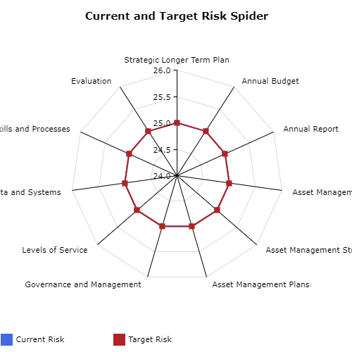

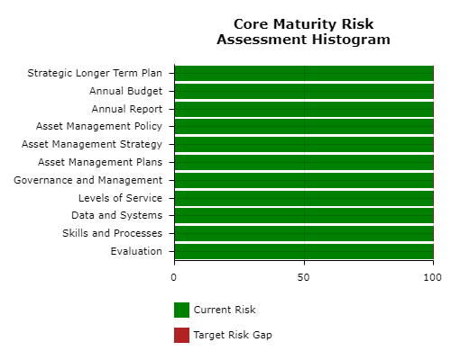

Annexure B: Services and their Values
Service | Strategic Direction |  | Value we Provide
Affordable housing and homelessness | 1 | Inclusive | 1. Increased affordable housing for very low, low and moderate-income households in housing stress, including supported housing for persons who are experiencing homelessness and sleeping rough. 2. Prevention of homelessness or reduced time spent without a secure home, for older Port Phillip residents facing housing stress or loss. 3. Creation of partnerships that work collectively to increase affordably housing and reduce homelessness
Ageing and accessibility | 1 |  | Facilitate independence and promote social connectedness for older people and those with a disability, through the provision of high- quality support services and community building initiatives.
Children | 1 |  | 1. Create healthy starts to life for children born and living in the city. 2. Support parents and children to be healthy and connected 3. Offer programs to promote optimal development for children
Community programs and facilities | 1 |  | 1. Create opportunities that build social connections, values diversity and address health and wellbeing inequities in our communities. 2. Build the capacity of the local community sector to support vulnerable and disadvantaged community members. 3. Commitment to reconciliation and support for the Aboriginal and Torres Strait Islander community
Families and young people | 1 |  | Opportunities for all children, young people and families to be healthy and connected to reach their full potential.
Recreation | 1 |  | Plan, deliver and activate sport, recreation and open space facilities and services to create community health and wellbeing.
Transport and parking management | 2 | Liveable | 1.Support a reliable, safe and well-connected transport system 2. Enable people to more easily move around, connect and get to places as the city grows.
City planning and urban design | 2 |  | Strategic planning, controls and urban design outcomes to enhance Port Phillip’s character and create a liveable, attractive and sustainable city.
Development approvals and compliance | 2 |  | 1. Support well designed, sustainable and safe development that protects heritage and neighbourhood character, maximises community benefit. 2. Support outdoor dining to enhance our city liveability and vibrancy
Health | 2 |  | Maintain, improve and protect public health in the community, through education and inspection services.
Local laws and animal management | 2 |  | 1. Protect Council assets, the environment and the health and safety of the community. 2.Ensure responsible pet ownership
Municipal emergency management | 2 |  | Operational and strategic emergency management services across preparedness, response and recovery.
Public space | 2 |  | High quality and unique parks, open spaces and foreshore for the enjoyment of our community and visitors.
Sustainability | 3 | Sustainable | Improve the sustainability of our city and respond to the Climate Emergency by reducing carbon emissions, water use and waste generation, increasing trees, vegetation and biodiversity, improving water quality and ensuring we are adapting and resilient to the impacts of climate change, including flooding and heat.
Waste Management | 3 |  | A clean and safe city by keeping our streets, parks and foreshores clean and protecting the environment.
Amenity | 3 |  | A clean, safe and enjoyable environment which improves the ways our community and visitors experience the city.
Arts culture and heritage | 4 | Vibrant | Foster creative, diverse and inclusive participation to our arts and culture sectors while supporting the heritage and unique identity of Port Phillip.
Economic development and tourism | 4 |  | Local, domestic and international promotion to support residents, visitors and industry achieve stronger economic outcomes.
Festivals | 4 |  | Bring a wealth of benefits to a community including health and wellbeing of residents through to economic development for local businesses, cultural vibrancy and social engagement.
Libraries | 4 |  | Support learning, social engagement and community connectedness.
South Melbourne Market | 4 |  | Operate an engaging and entertaining market environment where our community and visitors spend time shopping, dining and supporting local business.
Asset and property management | 5 | Well Governed | Ensure Council has the right assets at the right time for the right cost to support service delivery now and in the future.
Communications and engagement | 5 |  | Inform the community about Council and facilitate opportunities for the community to inform Council projects, initiatives, policies and strategies.
Customer experience | 5 |  | Customers receive services that meet their needs and expectations, and they achieve their goals with greater ease and satisfaction.
Finance and project management | 5 |  | Ensure the financial sustainability and transparency of Council and that investments in projects deliver value for ratepayers.
Governance, risk and policy | 5 |  | 1. Support sound decision-making through transparency, accountability, community participation, risk management and compliance. 2. Advocate through partnerships with stakeholders to deliver on community priorities, co-create solutions to community challenges and contribute to shared visions for the city.
People culture and capacity | 5 |  | Enable a safe workplace and a high performing workforce.
Technology | 5 |  | Support Council operations including efficient and effective service delivery through information, communication and technology services.

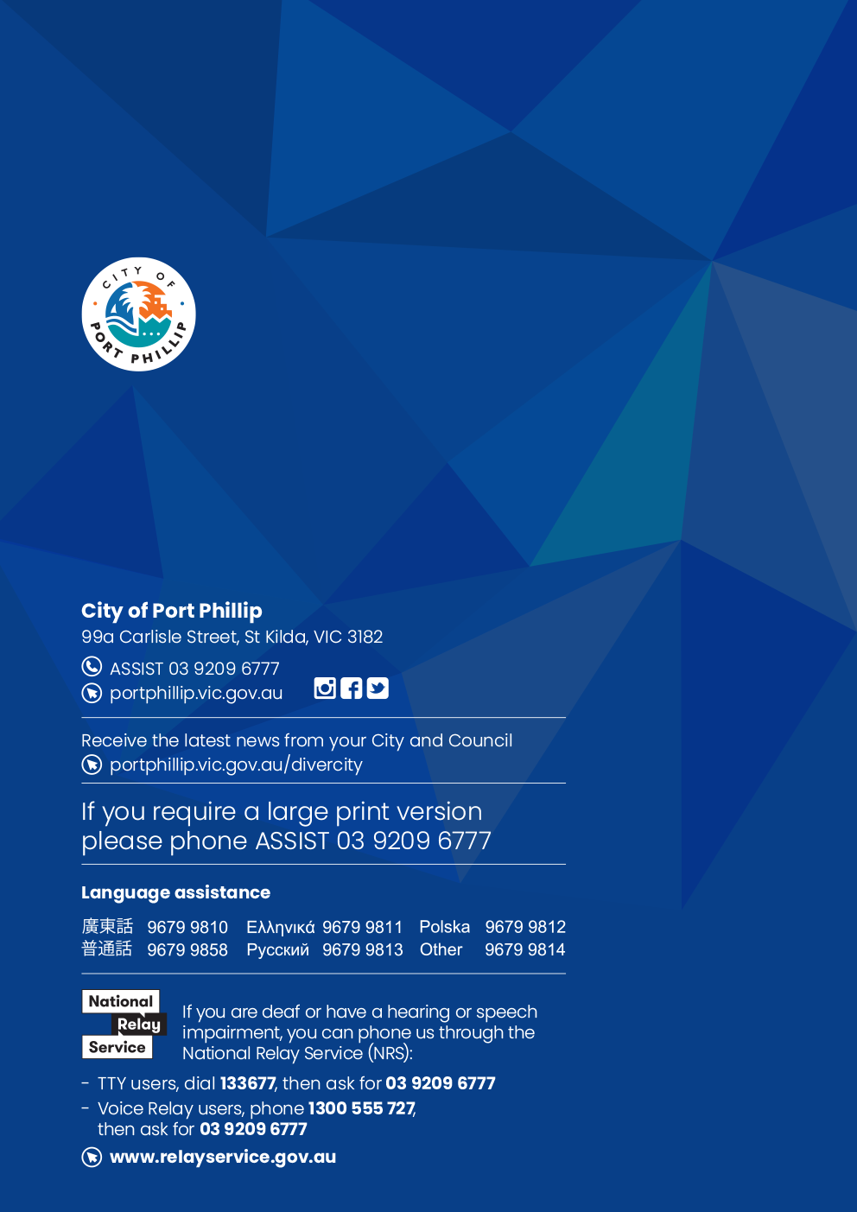

ISO, 2014, ISO 55000, Sec 2.2, p 2
ISO, 2014, ISO 55000, Sec 2.5.1, p 5
ISO, 2014, ISO 55002, Sec 4.1.1, p 2.
ISO, 2014, ISO 55002, Sec 5.2, p 7.
ISO, 2014, ISO 55002, Sec 4.1.1, p 2.
LGPMC, 2009, Framework 2, Sec 4.2, p 4.

