
St Kilda Strategic Plan
Volume 2 – Background report
December 2021

Table of Contents
Table of Contents 2
Introduction 9
St Kilda & the St Kilda study area 9
Purpose of this report 11
Limitations 11
Demographics 13
Population 13
Strategic planning policy context 16
State and regional 16
Local 17
Community engagement – what we heard from stakeholders 21
Engagement approach 21
Engagement findings 21
Land use 23
Context 23
Challenges 24
Opportunities 26
Economy & Tourism 28
Economic and employment 28
Context 28
Challenges 28
Opportunities 30
Tourism 32
Context 32
Challenges 33
Opportunities 33
Built environment 34
Built form 34
Context 34
Challenges 37
Opportunities 37
Heritage and character 38
Context 38
Challenges 41
Opportunities 41
Development 43
Context 43
Challenges 48
Opportunities 49
Housing 50
Context 50
Challenges 51
Opportunities 52
Public space & amenity 55
Context 55
Challenges 56
Opportunities 57
Climate change & sustainability 58
Context 58
Challenges 58
Opportunities 61
Transport & parking 64
Transport network and infrastructure 64
Context 64
Challenges 66
Opportunities 67
Parking 68
Context 68
Challenges 68
Opportunities 69
Community infrastructure 70
Context 70
Challenges 71
Opportunities 71
Social issues 72
Context 72
Challenges 72
Opportunities 75
Recommendations 76
Primary Recommendations 76
Secondary Recommendations 78
Appendix 1 – Project sequencing 80
Appendix 2 - Community facilities in the study area 81
Appendix 3 – Potential actions for removing barriers to businesses 85


Executive summary
Purpose
This report will identify and define current trends, challenges and opportunities in the St Kilda study area, to establish the justification for future strategic planning work. It has been informed by research and targeted stakeholder engagement.
This report (Volume 2 – Background) should be read in conjunction with Volume 1 which provides the road map for future strategic planning work, and supporting technical reports referred to in Volume 1.
Key findings
Land use - There are a number of different land uses spread across the study area, including land zoned Commercial 1, General Residential, Neighbourhood Residential, Mixed-Use zone and Industrial 3 Zone. Some key challenges and opportunities in terms of land use include:
Challenges | Opportunities
Outdated Activity Centre Strategy. | Review the need for an updated Activity Centre Strategy that includes a retail supply and demand assessment.
Lack of overarching vision and direction in relation to future growth, land uses and built form in the St Kilda MAC sub-precinct. | Prepare a Structure Plan for the St Kilda MAC sub-precinct.

Economy & tourism - The study area accommodates 12 per cent of the total employment in the municipality. Accommodation & Food Services and Professional, Scientific & Technical Services are the top two employment industries within the study area. In 2019, St Kilda attracted 2 million visitors. Some key challenges and opportunities include:
Challenges | Opportunities
Heavily reliant on regional, interstate and international visitors. | Build on the existing diversity of retail and businesses to support the ongoing vibrancy of centre by encouraging uses that service the local residential population.
Barriers to short-term tenancies / businesses. | Remove barriers to new and temporary businesses opening, and existing business expanding.

Built environment – The study area has a diverse built form character that is generally low to mid-rise, with built form typologies that include contemporary mixed-use apartment buildings as well as residential pockets. The height and character of each sub-precinct is guided by the relevant Design and Development Overlays (DDOs) and Heritage Overlays (HOs), which sets out among other things, mandatory height and sightline controls. Some key challenges and opportunities include:
Challenges | Opportunities
Some existing built form controls that contain mandatory requirements are perceived as being prohibitive and restricting development and have not been reviewed for a number of years. | Prepare an Urban Design Framework (UDF) as part of a Structure Plan for St Kilda MAC to address the dual problems of both absence of built form direction and out-of-date built form controls.
Lack of built form direction related to the William Street precinct. | Complete the outstanding key Balaclava Walk Master Plan projects.

Development - Over the past few years, the study area has seen a number of key medium to large scale developments occurring in or at close proximity to the MACs. Additionally, there are currently several key transformational projects happening within the St Kilda foreshore. Some key challenges and opportunities include:
Challenges | Opportunities
Recent site-specific amendments suggests the existing built form controls within the study area are out of date and have not been reviewed for a number of years. | Review and update the built form controls to ensure that the controls are achieving the intended outcomes.
Lack of a centralised strategic vision for the transformational projects occurring within the St Kilda foreshore. | Facilitate delivery of catalyst sites that have an economic and social benefit.

Housing - St Kilda and Balaclava/St Kilda East have a large amount of lone person households. The predominant dwelling structure in each the study area is flats or apartments. Some key challenges and opportunities include:
Challenges | Opportunities
The City of Port Phillip Housing Strategy 2007-2017 is out of date. | Prepare a new municipal-wide Housing Strategy to detail area based planning and activity-centre planning.
Lack of diversity, accessibility and adaptability in the housing stock. | Identify strategic sites and facilitate the delivery of affordable housing in locations that have access to community services.

Public space & amenity - The study area includes a number of public spaces as well as the key retail streetscapes of Fitzroy, Acland, Carlisle and Chapel streets. Some key challenges and opportunities include:
Challenges | Opportunities
Community’s sense of safety, both actual and perceived, in public spaces. | Investigate opportunities to ensure appropriate levels of sunlight in parks across the municipality through relevant planning mechanisms.
Balaclava/St Kilda East neighbourhood has the lowest amount of open space of all Port Philip’s neighbourhoods. | Once adopted, implement the relevant priority actions from the Places for People Public Space Strategy.

Climate change & sustainability – At the study area level, sea level rise, flooding due to storm surges and rising temperatures are some of the key challenges that will impact residents and visitors. Some key challenges and opportunities include:
Challenges | Opportunities
Several areas are identified as having high vulnerability to heat. | Once completed, review and implement the findings to protect and increase vegetation on private property through relevant mechanisms.
Rising sea levels pose a significant challenge due to low-lying landscape and proximity to the foreshore. | Update flood modelling to inform public realm and planning requirements.

Transport & parking – The study area has good access to public transport and transport infrastructure includes a network of marked on-road bike lanes, shared micro-mobility and network of car share vehicles. Some key challenges and opportunities include:
Challenges | Opportunities
Poor pedestrian safety, amenity and accessibility in certain parts of the study area. | Upgrades to the bicycle riding network and traffic signals to optimise pedestrian and bike ride experience and safety.
Increase in the use of private vehicles and decrease in public transport usage as a result of the Covid-19 pandemic. | Implement the relevant key strategic transport projects identified in Move, Connect, Live: Integrated Transport Strategy 2018-28.

Community infrastructure – St Kilda has long been a hub of community infrastructure that support the health and wellbeing of the community, including marginalised and vulnerable groups. Some key challenges and opportunities include:
Challenges | Opportunities
Lack of community facilities that are co-located. | Undertake a Community Infrastructure Needs Assessment to determine the community facilities and services required in each centre.
Number of Council-owned facilities are not fit-for-purpose. | Continue to invest in and renew Council owned and managed facilities, and opportunities for co-location when properties are available for lease.

Social issues – St Kilda has a complex social identity, made up of a diverse and evolving community of people drawn there to live, work, be entertained and access services. As a result of this, social challenges in the study area are complex and evolving. Some key challenges and opportunities include:
Challenges | Opportunities
Some of the short term and crisis accommodation options have closed and/or been redeveloped. | Continue to lead partnered response to reduce incidents of rough sleeping through Port Phillip Zero initiative.
The social and cultural benefits of tourist and entertainment uses in the study area needs to be balanced with the alcohol related harm and amenity impacts. | A Licenced Premises Policy to guide the appropriate location and design of licensed premises to ensure they make a positive contribution commensurate to the role of each activity centre and to effectively manage amenity impacts.

Recommendations
In response to the challenges and opportunities identified, this report makes 12 primary and secondary recommendations that will guide the future strategic planning work in the study area. The primary recommendations are the key priority actions recommended for Council. These are:

0 – 5 years

  - Undertake initial feasibility investigation of selected catalyst sites within the St Kilda MAC.
  - Work with proponents to facilitate development of catalyst sites that have an economic or social benefit through site specific planning scheme amendments (if required) or planning permit applications0F.
- Remove barriers to new and temporary businesses opening, and existing business expanding, in existing activity centres through an advocacy strategy and business improvement initiatives within the organisation.

5 – 10 years
- Prepare a structure plan for the St Kilda MAC sub-precinct.

Introduction

St Kilda & the St Kilda study area
St Kilda is an iconic place, with its unique mix of bohemian and inclusive culture, seaside amenities, entertainment offerings and diverse heritage. In 2019, it attracted 2 million1F visitors to its world-class attractions and events.
The St Kilda study area (the study area) contains two designated Major Activity Centres (MACs)2F: the St Kilda MAC and the Carlisle Street MAC (see Figure 1). The study area was chosen to encapsulate key areas of change such as the MACs and the immediate residential areas. St Kilda Road South precinct was omitted from the study area due to the existing 2015 Urban Design and Land Use Framework that applies to the precinct3F. Some themes consider the wider area, where relevant.
Each MAC provides a suburban focal point for services, employment, housing, public transport and social interaction. For the purposes of this report, the two MACs will be referred to as ‘sub-precincts’ and include the following areas:
- St Kilda MAC sub-precinct: includes Fitzroy Street, Acland Street, the St Kilda foreshore and surrounding residential areas. (See Figure 2)
- Carlisle Street MAC sub-precinct: includes surrounding residential areas. (See Figure 3)
These two sub-precincts have their own unique attributes. Carlisle Street MAC sub-precinct has a strong local flavour with goods and service offerings for the local community, and associations with its Eastern European and Jewish heritage. By contrast, the St Kilda MAC sub-precinct, has multiple focus points and, Fitzroy Street in particular, draws visitors from around the world with its iconic foreshore and entertainment offerings. However, within the St Kilda MAC sub-precinct, Acland Street with its two supermarkets and some local retailors has a much greater focus on serving local residents.
Historically these two sub-precincts have been planned for separately. The St Kilda MAC sub-precinct is the only MAC in the municipality with no comprehensive framework of land use and built form controls (such as a structure plan).4F A 2006 built form review formed the basis of the existing Design and Development Overlay – Schedule 6 (DDO6) (see Figure 6) which applies to some of the sub-precinct and provides guidance on built form outcomes under the planning scheme.
Meanwhile the Carlisle Street MAC sub-precinct was the subject of a 2009 structure plan and urban design framework. This informed the Design and Development Overlay – Schedule 21 (DDO21)(see Figure 8) and a local policy which provides guidance on built form and land use outcomes under the planning scheme.
Figure 1 Map of St Kilda study area
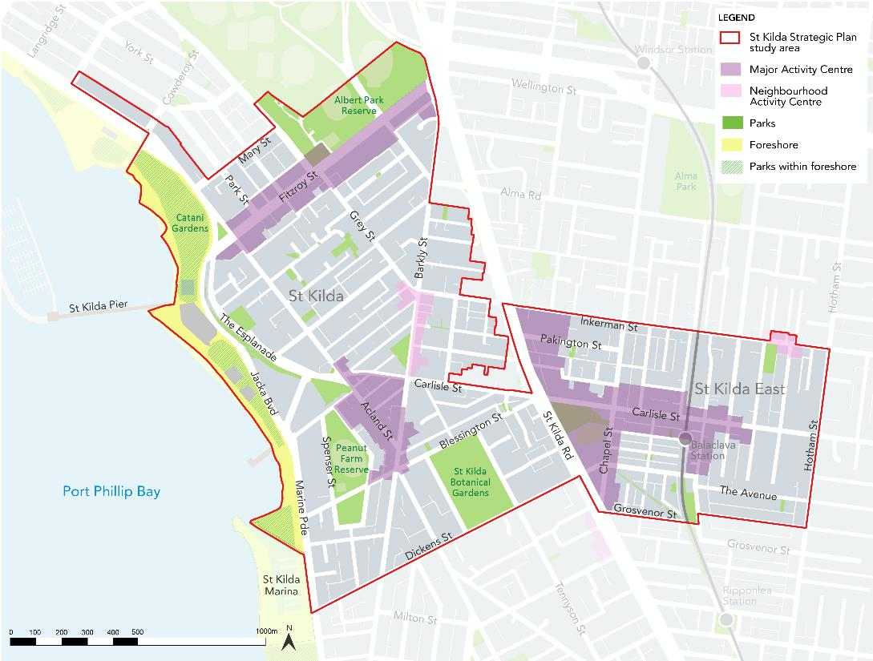

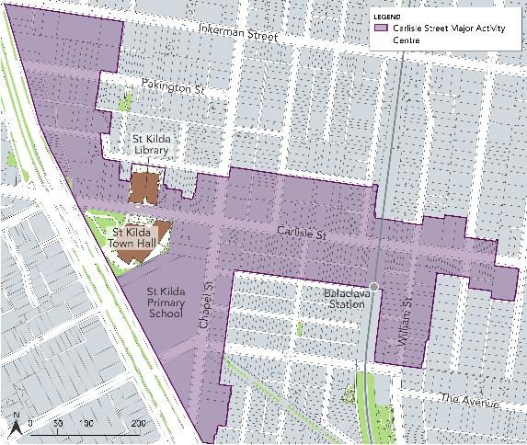
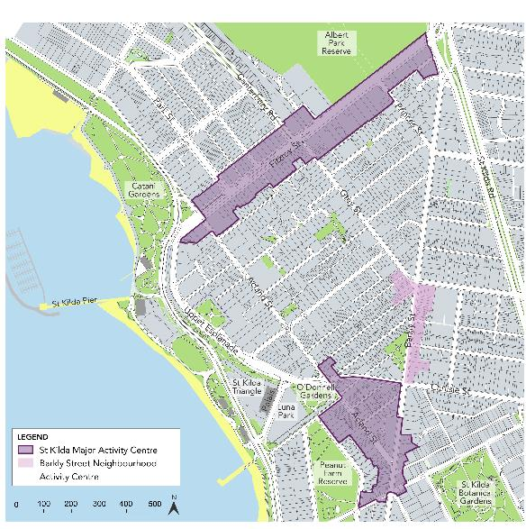
Figure 3 Map of Carlisle Street MAC sub-precinct

Figure 2 Map St Kilda MAC sub-precinct

Purpose of this report

This report will identify and define current trends, challenges and opportunities in the St Kilda study area, to establish the justification for future strategic planning work. It has been informed by research and targeted5F stakeholder engagement.
The report will highlight key short-term activities for Council as well as providing the road maps for future strategic planning work. The report will guide and recommend the timing, priority and sequencing of future strategic planning work required to respond to the challenges and opportunities identified.
This report (Volume 2 – Background) should be read in conjunction with Volume 1 which provides the road map for future strategic planning work, and supporting technical reports referred to in Volume 1.

Limitations
It should be noted that several sections of the report have been informed by 2016 ABS Census data, as it was the most current dataset that was available at the time of writing. The next Census occurs in August 2021, with results expected to be available in 2022. It is acknowledged that this data does not take into consideration the significant impact of the Covid-19 pandemic, and therefore may not capture the current state and recent trends of the study area. Since the start of the pandemic there has been significant changes, particularly in terms of population demographics and numbers, economy, employment and tourism.
Demographics

Population
For the purpose of this chapter, the naming conventions for the two sub-precincts have been aligned with naming conventions used by the Australian Bureau of Statistics (ABS). St Kilda refers to the area generally encapsulated by St Kilda MAC sub-precinct and Balaclava/St Kilda East refers to the area generally captured by the Carlisle Street MAC sub-precinct.

Existing and forecast
Table 1 Population in St Kilda & Balaclava/St Kilda East
 | Current population (2021) | Population 2041 (forecast) | Growth %
St Kilda | 25,887 | 29,930 | 15.6
Balaclava/St Kilda East | 18,209 | 19,841 | 8.9
Source: City of Port Phillip Population Forecast, forecast.id, accessed 05 July 2021
As shown in Table 1 above, with a combined projected growth of 24.5 per cent or 5,676 people by 20416F, this study area is experiencing a sizeable amount of population growth.
However, it is acknowledged that this expected population growth and or the growth rate may change as a result of the Covid-19 pandemic. Since the start of the pandemic there has been significant changes in the population demographics, including people leaving the municipality, lack of immigration, international students and tourism.

Age
The median age in St Kilda is 34 and 33 in Balaclava/St Kilda East7F. Table 2 below shows the age groups within the two sub-precincts. In comparison to the Port Phillip age demographics, St Kilda and Balaclava/St Kilda East population includes a greater portion of younger age groups.
Table 2 Age Groups in St Kilda & Balaclava/St Kilda East
Age groups | % of population (St Kilda) | % of population (Balaclava/St Kilda East) | % of population (Port Phillip comparison)
0-4 | 3.2 | 5.5 | 4.9
5-9 | 2.4 | 4.3 | 3.8
10-14 | 1.7 | 3.0 | 3.0
15-19 | 2.3 | 3.0 | 2.9
20-24 | 8.3 | 7.8 | 6.5
25-29 | 16.7 | 16.2 | 12.6
30-34 | 16.2 | 14.5 | 13.4
35-39 | 10.2 | 10.3 | 9.9
40-44 | 7.4 | 7.9 | 8.1
45-49 | 6.5 | 6.4 | 7.3
50-54 | 6.1 | 5.0 | 6.1
55-59 | 5.3 | 4.2 | 5.6
60-64 | 4.1 | 3.5 | 4.5
65-69 | 3.4 | 2.9 | 4.1
70-74 | 2.2 | 1.9 | 2.8
75-79 | 1.4 | 1.3 | 1.9
80-84 | 1.0 | 1.1 | 1.3
85+ | 1.6 | 1.1 | 1.4
Source: ABS Census 2016

Diversity
The residents of St Kilda and Balaclava/St Kilda East are predominantly of English and Australian ancestry with majority identifying as speaking ‘English only’8F. Analysis of the country of birth in St Kilda population indicated 33.8 per cent of people born overseas, which is similar to the Greater Melbourne proportions (33.8 per cent)9F. In Balaclava/St Kilda East the proportion of people born overseas was 33 per cent and 31.9 percent respectively, which is lower than Greater Melbourne’s10F. Between 2011 and 2016, the number of people born overseas increased by 17.4 per cent in St Kilda, whilst in Balaclava/St Kilda East the number decreased by 6.0 percent and 1.6 per cent respectively11F. In both St Kilda and Balaclava/East St Kilda the largest non-English speaking country of birth was India.
In Balaclava/St Kilda East, Russian (2.1 per cent)12F and Hebrew (1.4 per cent)13F are amongst the top 3 languages (other than English) spoken at home, which is likely reflective of the significant Jewish population living in the area. 11.4 per cent of population in Balaclava/St Kilda East identified Judaism as the affiliated religion which is significantly higher than the State (0.7) proportions14F.

Strategic planning policy context

State and regional

Plan Melbourne 2017-2050
Plan Melbourne sets the context for the next 30 years of growth and land management in Melbourne. It integrates long-term land use, infrastructure and transport planning to meet the City’s future environmental, population, housing and employment needs15F.
Melbourne 9 (M9)
M9 is a new collaborative partnership, working under a memorandum of understanding, of the original Inner Melbourne Action Plan (IMAP) member Councils (Port Phillip, Yarra, Stonnington, Maribyrnong, Melbourne), as well as Hobsons Bay, Moonee Valley, Moreland, and Darebin Councils. It was formed following a review of IMAP in 2020.
The primary focus of the M9 will be advocacy on key strategic challenges, including waste and circular economy, affordable and social housing, climate change and renewable energy, economic recovery, active transport and community resilience.
Inner Metropolitan Partnership
The Inner Metropolitan Partnership is an advisory group established by the Victorian Government. The Partnership is a way for local communities to engage directly with state and local governments and advise the Victorian Government of the top priorities across the region.
The Inner Metropolitan Partnership’s vision for the region is to harness the opportunities growth provides in a way that supports a strong economy, a sustainable future and greater social inclusion. The partnership includes local government areas of Melbourne, Yarra and Port Phillip.

Activity Centre Pilot Program
The Activity Centre Pilot Program was established by the State government to identify how planning controls could be used to provide greater clarity and certainty about development outcomes in activity centres.

Planning Practice Note (PPN) 58: Structure Planning for Activity Centres
PPN 58 provides State government guidance on the activity centre structure planning process. This includes the work that is required to inform structure planning.

Local

The Council Plan 2021-31
Port Phillip Council Plan 2021-31 sets out the long-term vision for the City of Port Phillip over the next 10 years. Initiatives outlined in the Plan include providing an updated Port Phillip Planning Scheme, including precinct-based Structure Plans, that provides a framework of local policies and controls to effectively manage growth, land use change and support community sustainability, health and wellbeing16F.

Key policies and strategies
Table 3 lists Council policies and strategies that are relevant to the future development of St Kilda.
Table 3 Key Council policies
Document | Description
Port Phillip Planning Scheme | Sets out the objectives, policies and provisions all use and development activity within the municipality. The following clauses are most relevant to the study area:17F  - 21.01 Vision and Approach  - 21.02 Municipal Context and Profile  - 21.03 Ecologically Sustainable Development  - 21.04 Land Use  - 21.05 Built Form  - 21.06 Neighbourhoods  - 21.07 Incorporated documents  - 22.11 Carlisle Street Major activity centre policy  The following overlays also apply within the study area:  - 43.01 Heritage Overlay  - 43.02 Design and Development Overlay (schedules 6 and 21)  - 43.04 Development Plan Overlay (schedule 1)  - 44.05 Schedule 1 to Special Building Overlay (schedules and & 2)
Land Use
City of Port Phillip Activity Centre Strategy 2006 | Provides a holistic understanding of the role and function of activity centres in Port Phillip including the contribution that they make to the local community. It provides ‘key strategic directions’ that should be considered as input to any detailed structure planning for a Major Activity Centre. This document is out of date and requires review.18F
Carlisle Street Activity Centre Structure Plan 2009 | Outlines the extent and type of change in the Carlisle Street Major Activity Centre to set the vision for the future of the study area
Economy
Art and Soul Creative and Prosperous City Strategy 2018-28 | Describes the actions Council will take to deliver a creative and prosperous future for our community, ensuring our public places are dynamic and distinctive, activated through art and cultural events
Built environment
Carlisle Street Urban Design Framework 2009 | Builds upon the strategic direction of the Carlisle Street Activity Centre Structure Plan and sets out an urban design framework which comprises urban design principles, objectives and guidelines
Port Phillip Heritage Review | Incorporated document to the Port Phillip Planning Scheme that comprises a thematic environmental history of Port Phillip and heritage place and precinct citations that provide the basis for heritage controls in the study area.
Housing
City of Port Phillip Housing Strategy 2007-2017 | Sets out a broad vision and makes recommendations for housing and residential development in Port Phillip
In our Backyard – Growing Affordable Housing in Port Phillip, 2015-2025 | Council’s plan to address housing affordability and reflects Council’s commitment to maintaining a diverse, inclusive and equitable City. It identifies the actions Council will take to grow the supply and diversity of affordable housing to address priority local housing needs
Public space
Draft Places for People Public Space Strategy 2021-31 | Informs Council’s ongoing planning and investment in public spaces and will transform our existing spaces through an integrated action plan for each of our neighbourhoods
Sustainability
Act and Adapt Sustainable Environment Strategy 2018-28 | Establishes Council’s commitment to environmental sustainability for the organisation and the wider community ensuring we are continuing to increase greening, biodiversity and using water efficiently in our public spaces
Don’t Waste It! Waste Management Strategy 2018-28 | Provides the blueprint for how Council and the community will work together to create a more sustainable future for our City
Foreshore Management Plan 2012 | Establishes the long-term strategic vision and direction for the Port Phillip foreshore, providing a framework for future use of the foreshore considering the range and complexity of coastal challenges
Greening Port Phillip, an Urban Forest Approach 2010 | Provides the strategic framework and policy context for the management of trees in Port Phillip, ensuring that greening in our public spaces enhances the amenity, liveability, character, sustainability and biodiversity of our City.
Street Tree Planting Program 2017-22 | Response to one of the directions set out in Greening Port Phillip, an Urban Forest Approach 2010 that aims to prioritise street tree and park tree planting through-out the City.
Transport & parking
Move, Connect, Live Integrated Transport Strategy 2018-28 | Sets the key priorities to ensure a well-connected transportation future for our City.
Parking Management Policy | The Policy provides a framework for the ongoing management of Port Phillip’s existing 53,000 on-street and 4,000 Council-managed off-street spaces used for parking and storage of motor vehicles.  The overarching objectives of the Policy are to:  - Address the City’s existing and future growth and transport challenges.  - Provide fairer and more reliable access to parking in all locations and at all times.
Social issues
Think and Act: Homelessness Action Strategy 2015-2020 | Seeks to reduce the risks associated with homelessness through the development of agreed actions, continuing council’s roles as a leader, advocate, planner, facilitator and service provider.
Community Safety Plan: Building a Safe Community Together 2019 – 2023 | Commits to building a community where both residents and visitors feel safe to live, work and play.

Community engagement – what we heard from stakeholders

Engagement approach
A targeted engagement approach was undertaken to understand the concerns and aspirations of a limited number of key stakeholders: property and business owners, traders, community groups and resident associations. The consultation was not promoted to the wider community as broader community engagement would be undertaken as part of any future strategic planning work.
The consultation was promoted specifically from 8 March to Sunday 29 March 2021 to existing St Kilda stakeholders known to Council, who were invited to complete an online survey and express interest in attending a focus group session.
Outputs were gathered from two online focus group sessions attended by 15 people in total and a survey which had 20 respondents.
Limitations
Limitations to community engagement include:
- Contributions to this engagement program do not constitute a representative snapshot of our broader community, people have self-selected to participate.
- Due to the limited numbers and the consultative method, this engagement provides only a high-level snapshot of community sentiment and does not reflect deeper engagement on this topic.
- Diversity of the respondents and participants was somewhat limited, noting that marginalised individuals were not included at this time.

Engagement findings
Survey respondents and focus group participants were questioned on key drivers for change under the themes of: housing, development, economy, built environment (including built form, public space, heritage and character), land use, amenity, transport (including transport network and infrastructure, and parking), community infrastructure, social challenges and sustainability. The majority of responses focused on the St Kilda MAC sub-precinct, with limited feedback provided specific to the Carlisle Street MAC sub-precinct. The key findings are discussed as follows.
Improving the economy and amenity were identified as having the greatest opportunities to renew the study area. We heard that elements that make up the unique character of St Kilda including the live music scene and the mix of commercial and cultural activity is highly valued. However, there has been a decline in the Acland Street and Fitzroy Street Activity Centres over the past 10 years, which was perceived to relate to amenity and safety challenges. The perceived key social challenges in St Kilda were identified as homelessness, drug and alcohol use, and community safety by survey respondents and focus group participants
We heard that Council needs to encourage development that features mostly mid-rise buildings, up to five stories or to the height of the Pride Centre, retains heritage buildings/facades, includes affordable residential and commercial spaces to support a supermarket and shops for locals, such as delis and butchers and other diverse retail. Participants told us that the study area needs to increase and maintain green spaces, public art spaces, community gardens and improve walkable connections from the foreshore to the St Kilda MAC sub-precinct. We heard that development as described above and improvements to amenity, built form and public spaces and free parking will encourage more people and tourists to come into the area, resulting in improved safety and a more vibrant precinct. It should be acknowledged that it is unlikely that the precinct will be able to rely heavily on international tourism for some time due to travel restrictions associated with the Covid-19 pandemic.

Land use

Context

St Kilda MAC sub-precinct
The land use mix along Fitzroy Street is predominantly characterised by retail, hospitality, late night entertainment, accommodation and residential uses, with one small-medium sized supermarket. The foreshore, area between Jacka Boulevard and the beach, includes a number of well-known restaurants and bars including the Stokehouse and Donovans. While the Esplanade includes predominantly mid to high rise residential and the well-known Esplanade Hotel. Acland Street comprises street-based retail and hospitality venues with some office uses. Two shopping centres, both centred around supermarkets, are located in arcades.
There are a high proportion of places to ‘see’ creative work within the sub-precinct, including theatres, galleries and music venues. Almost 70 per cent19F of identified music venues in Port Phillip are located in St Kilda, which reinforces its important role as an entertainment precinct within the municipality. The majority of creative businesses in the sub-precinct are clustered in the Commercial 1 Zone and the Mixed-Use Zone.
Zoning is shown in Figure 4. Fitzroy, Acland and Barkly streets and their immediate surrounds are zoned Commercial 1. A pocket of former industrial area bounded by St Kilda Road, Carlisle and Barkly streets is zoned Mixed Use. There are substantial areas zoned Public Park and Recreation, including the foreshore and key public spaces. Other areas are zoned General Residential, with small pockets of Neighbourhood Residential Zone to the north of the Acland Street commercial zone, around the St Kilda Botanical Gardens, and north of Fitzroy Street.

Carlisle Street MAC sub-precinct
Carlisle Street comprises of street-based retail with community and administrative uses clustered around the Town Hall and Primary School. Chapel Street is characterised by multi-unit developments and older factory buildings. Along St Kilda Road/ Nepean Highway is a mix of newer commercial and residential with office uses and some showrooms and large format retail uses. The north section of William Street contains small scale industrial and commercial buildings.
Carlisle Street is zoned Commercial 1, with the area to the south/west zoned Public Use and the north end of William Street zoned Industrial 3. The south part of Chapel Street is zoned Mixed Use and St Kilda Road is zoned Commercial 1. Behind the Commercial 1 Zone, on Inkerman, Pakington and Martin Streets, is a Mixed-Use Zone dominated by commercial/residential developments such as Aldi.
The remainder of the sub-precinct is largely zoned General Residential with pockets of Neighbourhood Residential and a small area of Residential Growth Zone to the north of Carlisle Street around Nelson Street. There is also a small area of Commercial 1 Zone on Inkerman Street accommodating a neighbourhood centre.

Figure 4 Map showing land uses within the study area
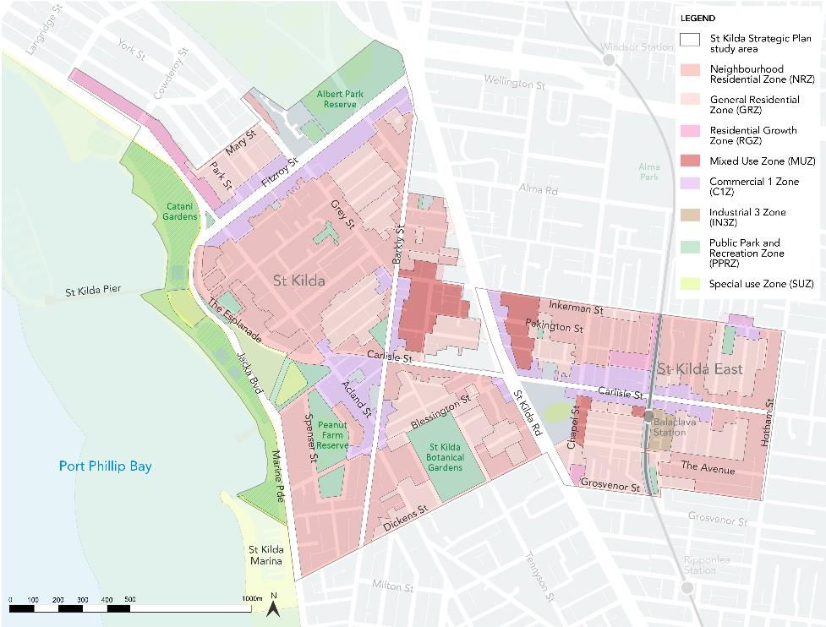

Challenges
The 2013 commercial zones reform resulted in several business zones defaulting to Commercial 1 Zone, which allows a broad range of as-of-right and permit required uses, including residential uses. The high market value of housing is seeing a market preference for residential use and a decline in office uses in commercial zones and non-residential uses in the Mixed Use Zone.20F Some projects that seek to respond to this issue are:
- Stonnington’s Activity Centre Zone for Chapel Street which features vertical zoning requirements.
- Urban Manufacturing IMAP project researching urban manufacturing and policy options to retain creative industries in the inner-city.
- City of Melbourne’s West Melbourne Structure Plan, Amendment C309melb, which proposes a customised schedule to the Special Use zone to create a mixed use precinct facilitating a variety of employment uses, while allowing some residential uses.21F

The City of Port Phillip Activity Centre Strategy 2006 is over 11 years old and is outdated22F. The land use policies that outlined in the Strategy is need of an update, particularly in identifying the current strengths and weaknesses of activity centres and guiding permit discretion on land use mix.

St Kilda MAC sub-precinct
Fitzroy Street is Port Phillip’s primary night-time precinct, with the majority of businesses operating over the night and approximately 60 per cent of floorspace comprising food catering and non-retail entertainment uses23F. This results in a lack of daytime retailers and a high commercial vacancy rate (15.5 per cent compared to average strip vacancy rates of between 3-7 percent).24F
Acland Street has an identified shortfall in supermarket floorspace to serve expected populations growth.25F
Lack of overarching vision and direction in relation to future growth, land uses and built form.

Carlisle Street MAC sub-precinct
The William Street Industrial Zone (see Figure 5) requires further strategic planning work to review the zoning and built form controls26F which has not occurred. It is strategically placed to both support and benefit from high public transport accessibility, and the growth and vitality of the activity centre. Several properties sold in the last 5 years have been subject of planning permit applications or preapplication enquiries.27F Capitalising on these locational attributes are primary considerations in determining future directions for this precinct.
Two respondents to the engagement survey supported redeveloping the Coles and Woolworths and the adjacent carparks, stating that the supermarkets are currently inadequate to service the community. This is also identified as an issue in the Carlisle Street Activity Centre Structure Plan 2009.
Figure 5 Industrial zoned William Street
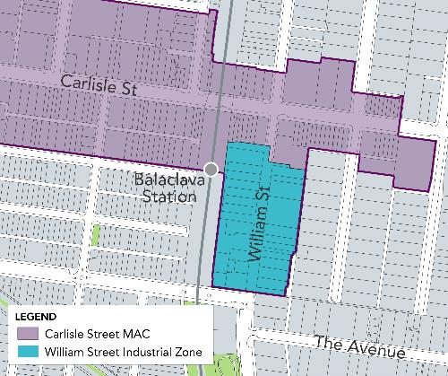

Opportunities
Further strategic work is required to understand the contribution of employment land within the Port Phillip to the wider economy, and how to balance the City’s role as an employment destination with its need to cater for housing growth. Any future rezoning decisions should be based on a wider study of employment land supply/demand and not be made in isolation.
The study area
As part of the Spatial Economic and Employment Framework, there is an opportunity to better define the boundaries, roles and difference between the sub-precincts within the study area.
A new Activity Centres Strategy would provide Council with an understanding of the projected growth in demand for retail floorspace and the capacity of the activity centres and mixed-use areas to accommodate this growth. It will also provide insight into the role and function of each Neighbourhood Activity Centre (NAC) and their ability to fulfil their role in accommodating the local living needs of surrounding population28F.
As part of the structure planning process for the study area, undertake a comprehensive needs analysis for the current and future land uses in the study area, with the underlying strategic basis provided by new housing strategy, economic analysis and employment trend analysis.
St Kilda MAC sub-precinct
Creating and curating St Kilda as an arts precinct by capitalising on the existing high concentration of creative businesses and organisations.
Prepare a structure plan to guide future growth and land use.
Carlisle Street MAC sub-precinct
Investigate whether there is a need to review the zoning and built form controls for the William Street precinct in accordance with the recommendations of the Carlisle Street Activity Centre Structure Plan and Urban Design Framework.29F
Facilitate catalyst projects that have an economic and social benefit through the development of the two supermarket sites.

Economy & Tourism
Urban Enterprise consultants were engaged by Council to prepare a current state analysis of the St Kilda study area, focussing on economic and land use challenges. The content in this section has been taken directly from St Kilda Current State Analysis Report (Urban Enterprise, 2021) unless otherwise specified.

Economic and employment

Context
The area is defined by three distinctive local activity areas which differ in terms of their role and economy: Fitzroy Street, Acland Street and Carlisle Street.
There were almost 9,200 jobs in the statistical study area in 2016, an increase of 1,511 jobs between 2011 and 201630F. The statistical study area accommodates 12 per cent of the total employment in the municipality31F. The most significant employing industry in 2016 was Accommodation and Food Services (20 per cent), while there was also a significant proportion in Professional, Scientific and Technical Services (14 per cent), Retail Trade (12 per cent), Health Care and Social Assistance (11 per cent), and Public Administration and Safety (9 per cent)32F.
Strong employment in both the Accommodation and Food Services and Retail Trade reflect the role of St Kilda as a tourism, visitor, hospitality and entertainment precinct. However substantial employment in professional services, health and education are also evident, suggesting the precinct also supports a diverse base of knowledge-based services.
St Kilda is a historic creative cluster that continues to support a thriving creative community. It benefits from its high proportion of iconic venues, access to public transport, its proximity to the foreshore as well as its well-loved entertainment precincts.33F

Challenges
In November 2020, the Covid-19 Financial Impact Index provided analysis of the impact of Covid-19 per postcode area. St Kilda and St Kilda East have experienced a severe impact and are included in list of top 10 hardest hit suburbs in Victoria34F.
St Kilda is heavily reliant on regional, interstate and international visitors. Due to travel restrictions posed by the Covid-19 pandemic, the visitation numbers are severely impacted.35F

St Kilda’s hospitality role is weighted towards night-time venues with many parts of the study area exposed to broader restaurant industry challenges and risks.
Presence of ‘traditional’ retailers that are exposed to broader retail sector challenges such as the growth in digital and online shopping.
There is a need to better define the boundaries, role and difference between sub-precincts within the study area.
The changing demographic profile of the study area’s residential communities, including having regard to the type of residential development occurring nearby.
Currently, there is a lack of understanding about the profile of the local resident workforce and the implications of a higher proportion of the professional workers working from home and/or seeking local office space in the future.
Most strategies, plans and policies are based on studies are now more than 10 years old. Economic and property market conditions have changed considerably over this period and many parts of the study area are particularly exposed to recent economic trends.
Barriers to short-term tenancies / businesses include clarity and difficulty around getting permits for outdoor trading, liquor licensing, health and building permits, as well as a lack of fit-for-purpose spaces available and vacant spaces not being advertised for lease.36F

St Kilda MAC sub-precinct
The St Kilda MAC sub-precinct lacks a recent economic assessment and policy direction that responds to recent economic changes and challenges, and which clearly differentiates between the separate roles and functions of Acland Street and Fitzroy Street.
Fitzroy Street
The vacancy rate on Fitzroy Street is currently 12 per cent37F due to poor economic performance over a long period and the high level of exposure to challenges in the restaurant, hospitality and nightlife sectors. This should have regard to changes in consumer preferences and competition from other precincts and entertainment types.
The night-time economy focus results in a low level of diversity, utilisation and footfall on business days, limiting the attractiveness to retailers relying on this type of visitation to the area.
The apparent misalignment between the retail roles and catchment of Fitzroy Street and the needs of its immediate residential catchment, including having regard to the income and profile of local residents.
Real or perceived high commercial rents in the study area and the underlying causes.
Acland Street
The vacancy rate on Acland Street is 11 per cent38F.
The extent to which the hospitality role of the centre is exposed to competition from other centres, and how any changes to the role of Fitzroy Street might impact the centre.

Carlisle Street MAC sub-precinct
Given the increasing employment in the area, changing demographics of the broader catchment, ongoing presence of a diverse local community and physical barriers to movement across the Nepean Highway, there needs to be an analysis of the catchment for retail and hospitality uses in the sub-precinct.
The need to facilitate an improved public realm to support and catalyse pedestrian amenity, investment and land use transition.
The potential challenges presented by the smaller landholdings and ownership within the sub-precinct, in terms of the extent to which property redevelopment is possible in order to support reinvestment and land use change.

Opportunities
A high proportion (31 per cent) of the local workforce live in the Port Phillip municipality39F. 26 per cent of the workforce live in neighbouring municipalities so a combined 57 per cent of workers in St Kilda live within relatively close proximity to the area40F. This indicates that proximity to local employment opportunities is likely to be an attractive proposition to existing and future residents of the study area.
Trends toward decentralised office work is increasing demand for office space in city fringe locations and St Kilda could benefit from both attracting a greater share of local retail demand from resident professionals and accommodating smaller businesses seeking office and collaboration space in the study area. Additionally, there is an opportunity to investigate the nature and scale of demand for office floorspace in each part of the study area given regional employment and floorspace demand projections.
There is an opportunity to provide diverse and affordable work and enterprise spaces to support the growing creative industries within the study area41F.
Full retail demand and competition analysis to understand the scale and type of demand for retail goods and services of St Kilda residents, and the extent to which this demand is met outside of the local area.
Building on the connections between St Kilda’s open space assets to encourage a healthy living place brand by utilising the emerging demand for health, lifestyle, personal services, fresh food and other local land uses and opportunities.
Support the short term economic recovery in the study area by continuing to:
- Respond to the increase in local day-time population by ensuring all activity centres have temporary or permanent street furniture, greenery and places to sit and meet.
- Provide ongoing support to traders to facilitate increased capacity of venues during restrictions. i.e. through the parklets program, footpath trading etc.
- Attract new and temporary businesses and events to attract and serve the local community, particularly in Fitzroy Street.
- Investigate the inclusion of St Kilda as a live music precinct in the Port Phillip Planning Scheme.
- Continue to capitalise on government investment in the Victorian Pride Centre by, for example, utilising the spaces for a variety of professional uses and not for profits.
- Continuing the Live, Love, Local initiative into the future42F.
Investigate the following short term economic recovery activities:
- Establishing a business data base that facilitates regular contact, communication and feedback between Council and businesses.
- Developing a monitoring program for local centres (similar to City of Yarra’s Precinct Pulse Program) to track activity centre land use mix, vacancies and trends to enable timely information and ability for Council to respond.
- Establishing a ‘buy local’ campaigns for each Activity Centre in the study area.
- Investigating local demand / interest in a co-working facility.
- Responding to the substantial increase in local day-time population by ensuring all activity centres have temporary of permanent street furniture, greenery and places to sit and meet and increasing visitation, expenditure and dwell time.
- Remove barriers to new and temporary businesses opening, and existing business expanding, in existing the St Kilda and Carlisle Street MAC sub-precincts through an advocacy strategy and business improvement initiatives within the organisation. (See Appendix 3)

St Kilda MAC sub-precinct
Undertake a full retail demand and competition analysis and investigate the nature and demand for office floorspace in each part of the study area, as part of the structure planning process for St Kilda MAC sub-precinct.
Fitzroy Street
Capitalise on government investment in the Victorian Pride Centre by, for example, utilising the spaces for a variety of professional uses and not-for-profits.
Acland Street
Build on the existing diversity of retail and businesses to support the ongoing vibrancy of centre by encouraging uses that service the local residential population.
Carlisle Street MAC sub-precinct
Existing policy seeks to protect the ‘primary role’ of retail in the centre. Retail land uses are still the primary use in the centre and central to the economic role of the Activity Centre, however planning policy should consider the changes to the types of retail that are being provided in the centre (focus on fresh food in particular, as distinct from other goods retailing), as well as the emergence of a greater hospitality role.

Tourism

Context
St Kilda was 7th on a list of Melbourne’s Top Attractions in 2019, attracting 2 million visitors (an increase of 12%) including 1.1 million domestic overnight visitors (up 23%) and 884,400 international overnight visitors (up 1%)43F. Of the top 10 attractions, St Kilda had the largest increase in both overall and domestic overnight visitation and was one of only two locations to have an increase in international overnight visitors44F. As a top attraction, St Kilda is acknowledged for its tourism and events role, hosting local and international events.45F Some of these events gain global media coverage making an impression of St Kilda on people across the globe.

Challenges
The impacts of the Covid-19 pandemic on all forms of visitation, particularly international, have been significant. Tourist numbers have dropped by 78 per cent from 2019 to 2020, with NVS Data showing that 1.06 million visited in 2019, compared to 229,000 in 202046F.
It remains unclear how long international borders will remain closed bringing uncertainty to tourism reliant businesses. While local events continue and interstate travel may augment this, a gap will remain until international visitation returns to full capacity.

Opportunities
Reconsider the optimal mix of land uses, particularly around Fitzroy Street, to ensure that the local economy and industry is sustainable.
Support the short term economic recovery in the study area by:
- Identifying and facilitating day-time events, initiatives and temporary businesses within activity centres to drive footfall in Fitzroy Street, especially from local residents.
- Working with local live music businesses to identify the most relevant form of Council support given the ongoing capacity restrictions that apply to indoor venues.

St Kilda MAC sub-precinct
Fitzroy Street
Capitalise on the proximity of major tourism assts and recent hotel and higher quality apartment developments.

Built environment

Built form

Context

St Kilda MAC sub-precinct
Fitzroy Street
Fitzroy Street is a well-established mixed residential, retail and commercial centre. The built form character is fine grain and generally low to mid-rise with a defined street wall, and comprises a mix of 19th and 20th century buildings and contemporary mixed-use apartment buildings with commercial or retail space at ground floor.
Landmark heritage places include the Ritz Mansions, former Wesleyan Church, George Hotel, Seaview Ballroom, Prince of Wales Hotel and numerous other buildings of individual or contributory heritage significance along Fitzroy Street. These buildings are complemented by the mature street trees and ornamental tramway poles, which impart a boulevard character.
New development is guided by Design and Development Overlay - Schedule 6 (DDO6) (see Figure 6) which includes sub-precincts that specify the preferred character and design objectives for each area and amongst other things include mandatory height requirements that aim to maintain the low to mid-rise scale along Fitzroy Street. Site specific amendments supported by Council and/ or VCAT or in some cases decided by the Minister for Planning have allowed for built form outcomes that depart from the controls specified in the DDO (e.g. the Victorian Pride Centre and the QT Hotel).
Built form is also guided by a Heritage Overlay (through HO5 St Kilda Hill precinct) and HO444 (Middle Park and St Kilda West Precinct) (see Figure 8).
The heritage architecture, the iconic buildings and large buildings with active frontages in Fitzroy Street were identified by participants during targeted engagement as elements they liked about the study area’s built form.
Acland Street
Characterised by its village atmosphere and pedestrianised streetscape, Acland Street has a predominantly low rise, fine grain built form of up to two storeys at the street edge with a mix of mainly 20th century buildings and contemporary shopfronts with upper level residential commercial uses.
Key landmarks within Acland Street include the St Kilda RSL and the O’Donnell Gardens with the historic Vineyard Restaurant and mature palm trees. Acland Street also has views to key buildings and locations within the study area, including the Palais Theatre, Luna Park, the foreshore and Upper Esplanade.
DDO6 Schedule 8 applies to Acland Street and parts are also included within either HO5 (St Kilda Hill) or HO7 (St Kilda, Elwood, Balaclava, Ripponlea). Similar to Fitzroy Street, these controls encourage the form, scale and siting of new built form to be respectful of the valued heritage character.
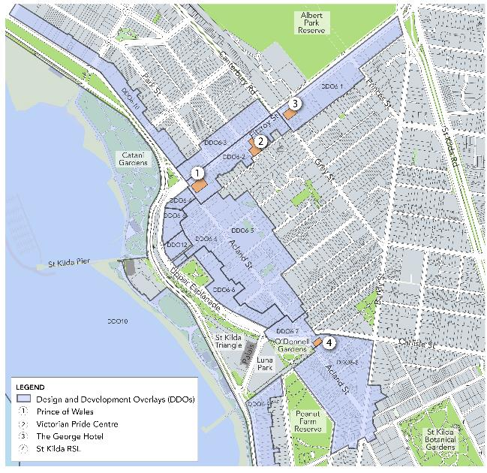
Other built form typologies in the St Kilda MAC sub-precinct include residential areas that range from Victorian era mansions and terrace houses to Edwardian and interwar detached houses and apartments to post-war and modern infill development. Built form in the residential area generally consists of one to two storey detached houses or townhouses, or low-rise apartment buildings. The exception is The Esplanade, which includes several mid to high rise apartment buildings.
Figure 6 St Kilda MAC sub-precinct, Design and Development Overlay 6 (DDO6)

Carlisle Street MAC sub-precinct
This sub-precinct is characterised by its distinctive heritage and character, fine grain built form and commercial one to two storey shop-front buildings with hard-edged alignment to the street.
New development in this area are guided by Design and Development Overlay – Schedule 21 (DDO21) (see Figure 7) which sets a mix of mandatory and discretionary height and setback controls. DDO21 includes additional sub-precinct areas that specify the preferred character and design objectives for each area.
The sub-precinct has some larger scale building footprints.
Surrounding are well-established residential areas which reflect different waves of development including Victorian and Edwardian cottages, interwar and post-war walk-up flats and recent contemporary buildings.
St Kilda Town Hall at the corner of Brighton Road and Carlisle Street is a key landmark. New development close to the St Kilda Town Hall (area between Brighton Road and Chapel Street) is guided by the DDO21 objective to ensure that the visual prominence of the key landmark is maintained.
This sub-precinct falls within Heritage Overlay – Schedule 7 (HO7 St Kilda, Elwood, Balaclava, Ripponlea) (see Figure 8). As such, there is a significant emphasis on built form outcomes retaining and responding the existing heritage. Additionally, a key objective of DDO21 is to ensure that new development is of a scale and form which respects any adjoining or nearby heritage place. It also encourages the adaptive reuse of buildings which contribute to the heritage or built form character of a precinct.
Similarly, to Fitzroy Street, majority of respondents to the engagement survey stated that they liked the old shops as they are indicative of the prosperity and diversity of St Kilda’s past.

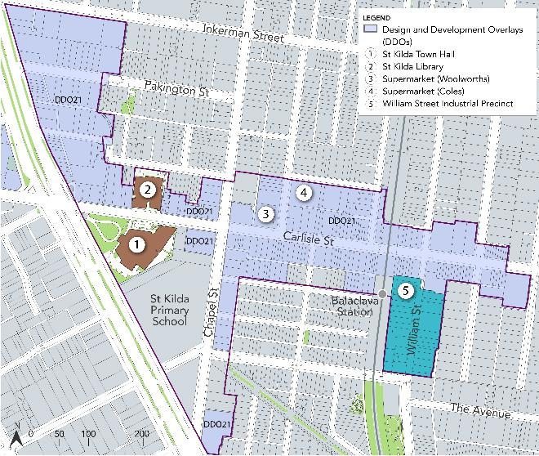
Figure 7 Carlisle Street MAC sub-precinct, Design and Development Overlay 21 (DDO21)

Challenges
Lack of built form direction outside of the DDO and heritage areas. This includes areas experiencing development pressure including the William Street industrial precinct and Inkerman Street between Barkly Street/St Kilda Road and sections of Barkly Street north and south of Inkerman Street.
Some existing built form controls that contain mandatory requirements are perceived as being prohibitive and restricting development and have not been reviewed for a number of years. The number of recent site-specific amendments around the St Kilda MAC sub-precinct is suggestive of this.
Mandatory controls within the MACs require review and must be strategically justified having regard to the Activity Centre Pilot Program and Planning Practice Notes 59 and 6047F. For example, internal review of the recent development proposals has found that the mandatory heritage sightline control on Carlisle Street under DDO21 has limited development, compromising opportunities for high quality, sustainable outcomes. Furthermore, full concealment of new development within MACs with heritage controls does not reflect current practice in activity centres.48F
Maintaining active frontages is becoming more difficult as retail vacancies continue to rise. This impacts pedestrian amenity, safety and comfort along the key shopping strips.

St Kilda MAC sub-precinct
DDO6 requires a review ‘to ensure the built form requirements are achieving intended outcomes’.49F
The documents that informed much of the review of DDO6, St Kilda Foreshore Urban Design Framework (2002) and the Issues in the control of built form, Background paper to DDO6 Review (2004), are dated.

Opportunities
Study area
Undertake a built form review for Inkerman Street between Barkly Street and St Kilda Road, to inform planning controls, such as a DDO.

St Kilda MAC sub-precinct
Prepare an Urban Design Framework (UDF) as part of a Structure Plan to address the dual problems of both absence of built form direction and out-of-date built form controls, by:
- Establishing a built form vision for each individual activity centre (Fitzroy Street and Acland Street) that supports 20-minute neighbourhoods and employment areas that are adapting and resilient to climate change
- Establishing a strategic basis for introducing or updating design and development controls into the planning scheme to replace the existing DDO6.
- Identify opportunities for public realm linkages and improvements that will enhance connectivity, liveability, identity, legibility, pedestrian amenity and function of the place.
- Facilitate high quality built form and public realm outcomes.

Carlisle Street MAC sub-precinct
Undertake a built form review for the Carlisle Street MAC sub-precinct to review the existing built form controls and identify those that are outdated. This would inform the amendment of the existing DDO21.
As part of the William Street precinct review, investigate the need for a built form review to inform planning controls, such as a DDO.
Review and investigate the feasibility of completing the outstanding key Balaclava Walk Master Plan projects, noting that the Master Plan has been largely completed50F.

Heritage and character

Context
The area now known as St Kilda has long been a traditional gathering place for Indigenous people. Albert Park Reserve was once a rich willam or camp for the Yalukut Weelam, with miams (huts) built alongside today’s Albert Park Lake. The Ngargee (Corroboree) Tree located in the south-east corner of Albert Park is one of the oldest living things in Melbourne, and also the site of the ceremonial dance circle and Ngargee grasslands that are a current day focus for cultural and reconciliation activities.
The study area includes St Kilda Hill, which is one of the earliest post-contact settlement sites in Melbourne. Consequently, the study area has a rich array of heritage places dating from the 1840s to the late twentieth century meaning that a large part of the study area is included within heritage overlays51F and comprises a number of heritage precincts (see Figure 8):
European settlement and development was encouraged by the opening of the railway line in 1854 and St Kilda became a seaside resort as well as a desirable residential area favoured by Melbourne’s elite. In the early twentieth century the character of the area began to change as St Kilda became a popular location for flats and this spurred significant development during the interwar period, and again during the 1950s and 1960s,when some of the first high rise flats in Melbourne were constructed.
St Kilda MAC sub-precinct
- Heritage Overlay 5 (HO5) St Kilda Hill precinct
- Heritage Overlay 444 (HO444) Middle Park and St Kilda West precinct
- Heritage Overlay 446 (HO446) Albert Park precinct

Carlisle Street MAC sub-precinct
- Heritage Overlay 6 (HO6) St Kilda East precinct
- Heritage Overlay 7 (HO7) Elwood St Kilda Balaclava Ripponlea precinct
- Heritage Overlay 439 (HO439) Nightingale precinct.

Figure 8 Map of existing Heritage Overlays in the study area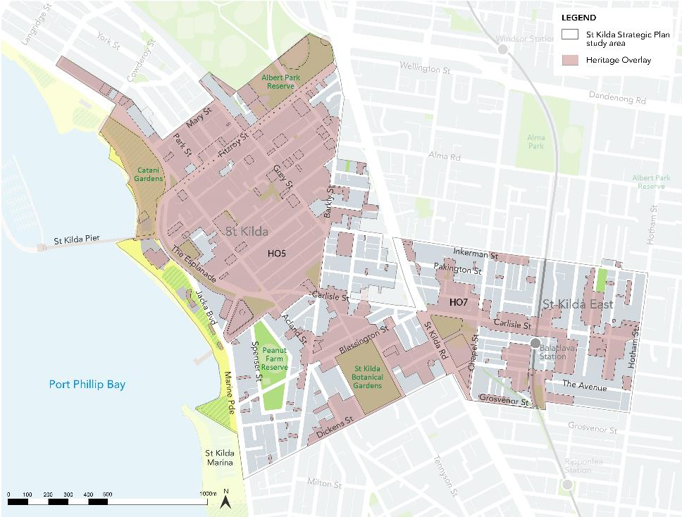

There are also numerous places of individual heritage significance including several on the Victorian Heritage Register (VHR). Most of these are contained within the broader precinct areas listed above. These include the cluster of VHR places along the foreshore area with icons such as Luna Park, the Palais Theatre and Catani Gardens. Other notable individual heritage places include the historic group of civic and community buildings comprising the St Kilda Town Hall and Library, Wesleyan Church complex, St Kilda Primary School and the Holy Trinity Anglican Church complex.
Through the engagement, heritage buildings and architecture were identified by the survey respondents as one of the key elements they liked in both St Kilda MAC and Carlisle Street MAC sub-precincts.
In 2018 Council established a Heritage Program to deliver various heritage projects including a systematic review of out-of-date heritage precincts. The HO6 heritage precinct was reviewed in 2018 and subsequently implemented into the planning scheme by Amendment C142 (gazetted in 2020). A review of the HO7 heritage precinct is currently underway and will be finalised later in the year and subsequently implemented into the planning scheme through an amendment. It includes the review and updating of existing PPHR citations for individual places and new heritage citations for the Acland Street (Village Belle) commercial centre, and the Carlisle Street commercial centre.52F

Challenges
The heritage place and precinct citations prepared by the 1998 PPHR are now more than 20 years old (some that were transferred from previous heritage studies are older still, dating from as early as 1982). More recently, State government requirements for heritage documents and provisions in the planning scheme have changed, including when Planning Practice Note 1: Applying the Heritage Overlay53F was updated in 2018. This means that Council will have to systematically review all citations (and potentially other associated heritage documents), potentially as shortened ‘fix-up’ amendments.54F
The present HO444 and HO446 precincts were created following the 2008 review of the former HO3 heritage precinct. A new precinct citation was created for HO444, but the places with individual PPHR citations within it were not reviewed.
The HO5 St Kilda Hill precinct requires review to ensure heritage controls are robust and up-to-date.55F A preliminary review by Council’s heritage advisor identified some key challenges including:
- Incomplete or out of date information (including very brief or inadequate statements of significance) in both the HO5 precinct and individual place citations.
- the HO5 precinct boundaries require review, including some small extensions at the edges, and two potential sub-precincts (or separate precincts), one applying to the Fitzroy Street mixed use/commercial strip, and other to the foreshore area extending from Catani to O’Donnell Gardens including the Esplanade Slopes.

Opportunities
The implementation of the HO7 heritage review into the planning scheme will ensure that there is up to date information about heritage precincts and places within these areas.
Undertake the HO5 precinct and surrounds review, preferably prior to or in conjunction with any nearby built form reviews.
Funding from the Victorian Government to undertake gathering place research which will centre on St Kilda, the traditional gathering place for Indigenous people in Port Phillip. Through this process, a greater understanding of traditional gathering places in St Kilda will be gained, and therefore appropriate actions taken to preserve and protect these places. This also presents the opportunity to involve the traditional owners in the design and management of public spaces more generally.
Activate the sports pavilion within the Peanut Farm Reserve, used to host barbeques for the indigenous community, as a shared space for Indigenous people when not being used after hours by sporting clubs.
Protect the Cork Oak trees that are located at the St Kilda Railway Station, which are of local significance, by preparing a statement of significance.

Development

Context
As the resident and worker population of this precinct continues to grow and change, so too does the type and location of developments the area. Over the past few years, the study area has seen a number of key developments constructed, approved, or discussed with officers through a pre-application process (see Figure 9) . A snapshot of the recent key development sites is included below in Table 4 and Table 5.
Subdivision data shows medium to large scale developments mostly occurring in or at close proximity to the sub-precincts, with some of the more larger scale developments occurring in the St Kilda MAC sub-precinct (see Figure 10) .Within the residential areas, the development occurring are largely of a smaller scale (2-20 lots). Over the past decade, the largest amount of subdivision applications was received by Council in 2014 (30 applications) and 2015 (44 applications). In the years since, the number of applications received has decreased but has remained generally consistent. Council’s subdivision data shows that the Covid-19 pandemic in 2020 did not impact the number of applications received within the study area (21 applications compared to 11 in 2019), however, as of 28 June 2021 Council has only received one application for the year 2021 (see Figure 11).
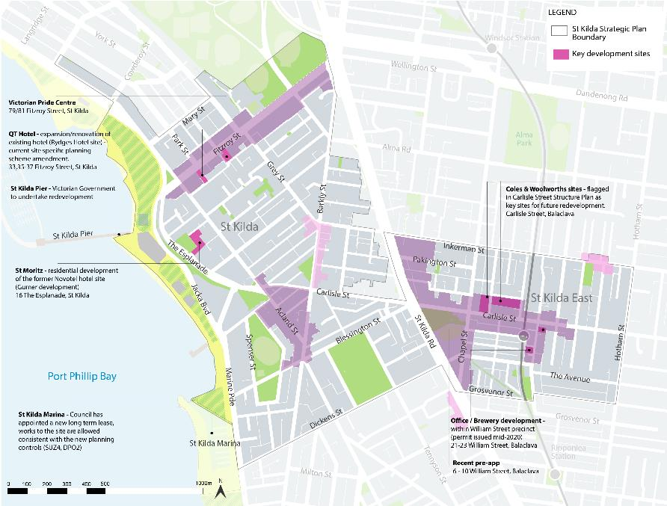
Figure 9 St Kilda study area – Key development sites

Figure 10 Heatmap showing development patterns in the study area
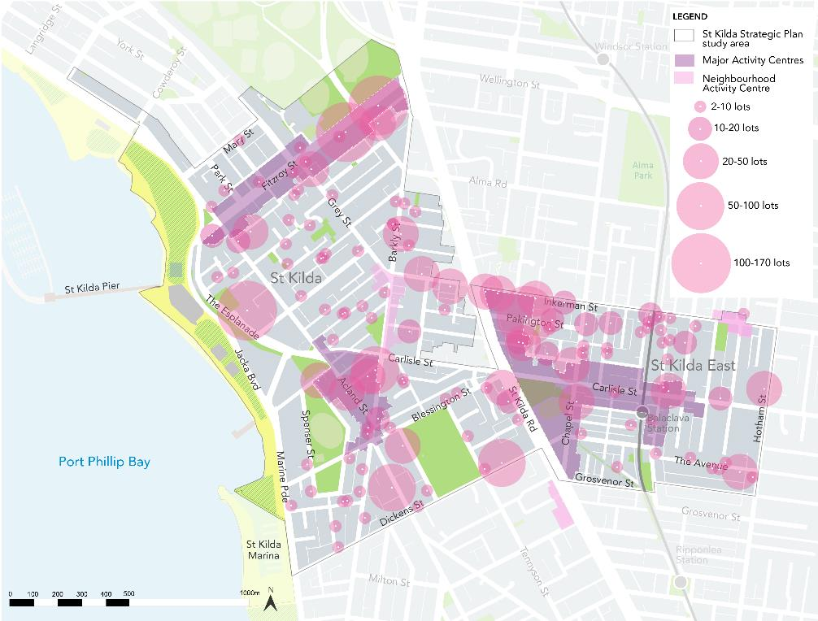

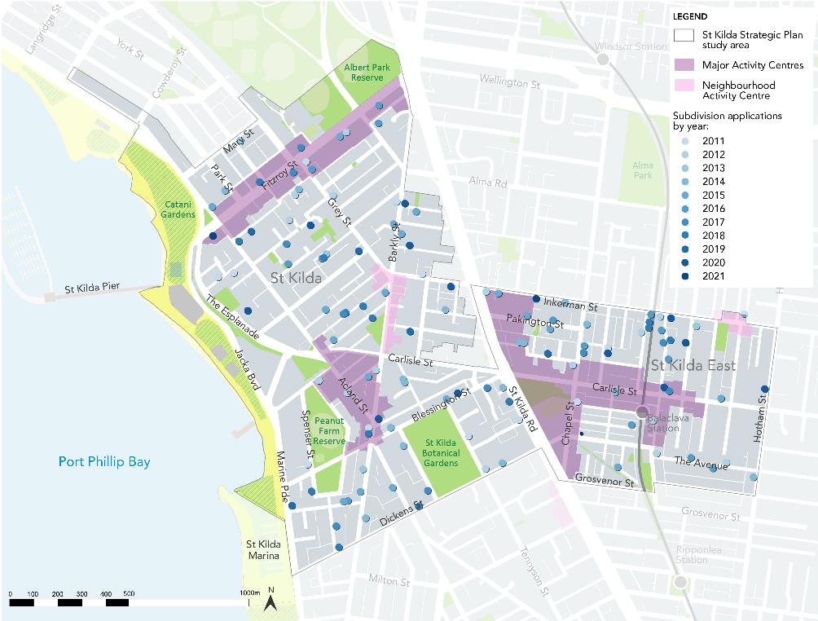
Figure 11 map showing subdivision applications by year
On 18 August 2021 Council passed a motion to progress the 2016 St Kilda Triangle Masterplan, resolving to:
- Undertake work on the costs, high level approach, staging and broad timeframes required to undertake planning and initial market sounding for the key commercial elements of the St Kilda Triangle site as described in the 2016 St Kilda Triangle Masterplan.
- Begin discussions with State Government about support to deliver the St Kilda Triangle Masterplan, including the development of a business case for investment in the St Kilda Triangle.

St Kilda MAC sub-precinct
Table 4 below summarises key recent developments.
Table 4 Recent key developments in St Kilda MAC sub-precinct

Place name | Address | Description | Status
Saint Hotel | 54 Fitzroy Street, St Kilda | Redevelopment and refurbishment of existing hotel | Completed
Village Belle Hotel | 202 Barkly Street, St Kilda | Redevelopment and refurbishment of existing hotel | Completed
The Esplanade Hotel | 11 The Esplanade, St Kilda | Redevelopment and refurbishment of historic hotel and live music venue | Completed
Victorian Pride Centre | 79-81 Fitzroy Street, St Kilda | Demolition of existing buildings, construction of multi-storey community building | Site-specific amendment process undertaken. Under construction – completion expected late-2021
St Moritz | 161 The Esplanade, St Kilda | High end residential development of 133 apartments on the former Novotel site (Gurner development) | Under construction
St Kilda Marina | Marina Reserve, 29P Marine Parade St Kilda | Council has appointed a new long-term lease, works to the site are allowed consistent with the new planning controls (SUZ4, DPO2). | Site-specific amendment process undertaken. Construction yet to commence
QT Rydges Hotel | 33, 35-37 Fitzroy Street, St Kilda | Expansion and renovation of existing hotel | Site-specific planning scheme amendment in process
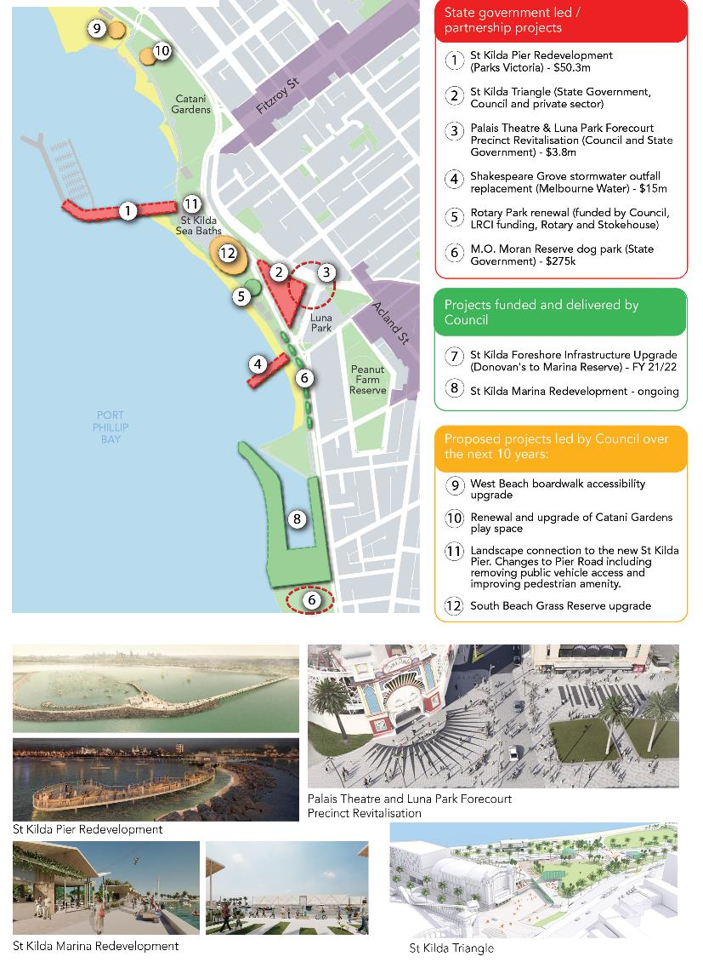
There are currently several key transformational projects happening within the St Kilda foreshore which would improve access and user experience on the foreshore. Figure 12 below maps these projects and identifies funding and leading agency for each.
Figure 12 map showing key projects within the St Kilda foreshore

Carlisle Street MAC sub-precinct
Table 5 below summarises key recent developments.
Table 5 Recent key developments in the Carlisle Street MAC sub-precinct
Place name | Address | Description | Status
Office/brewery development | 21-23 William Street, Balaclava | Six storey mixed use development. | Planning permit issued mid-2020
 | 14 Nelson St, Balaclava | 4 storey development comprising 6 townhouses | Approved
 | 191-193 Carlisle St, Balaclava | 5 storey mixed use development, tallest building on Carlisle Streets | Application lodged
Carlisle Street supermarkets site | Carlisle Street Balaclava | Redevelopment of Coles and Woolworths sites flagged in Carlisle Street Structure Plan. Council has commenced the formal process of selling the car parks. | N/A

The existing Carlisle Street Activity Centre Structure Plan identifies some key development sites, or areas for change, including the Coles and Woolworths supermarket sites on Carlisle Street, Balaclava, and the William Street Industrial precinct. In addition to these key sites, public realm projects have taken place to improve the study area, such as the Balaclava Walk which links and improves pedestrian connectivity from the Balaclava and Ripponlea train stations.

Challenges
As previously discussed, the number of recent site-specific amendments reflects that the existing built form controls within the study area are perceived as being prohibitive and not achieving desired outcomes, and have not been reviewed for a number of years. There are also extensive areas that lack any built form direction. This is potentially resulting in a lack of, or underdevelopment of, some key sites in the study area.
St Kilda MAC sub-precinct
As shown in Figure 12, St Kilda foreshore has several transformational projects that are currently being undertaken without a centralised strategic vision.

Opportunities
Refer to land use and built form opportunities.
Review and update the built form controls to ensure that the controls are achieving the intended outcomes.
Ensure catalyst developments benefits the community (e.g. increasing public space provision, improving public realm, delivers affordable housing)
St Kilda MAC sub-precinct
Develop a holistic plan to guide the development of the St Kilda foreshore (or incorporate into a structure plan for the sub-precinct). Due to the number of stakeholders and unique challenges relevant to the foreshore, it may be better to deal with as separate to a wider structure plan.
Identify catalyst sites within the sub-precinct that have potential to be key development sites or areas for change.

Housing

Context

Household makeup
St Kilda and Balaclava/St Kilda East have an average number of people per household of 1.8 and 2 people respectively 56F.
Nearly half of residents in St Kilda (46.7 per cent) live in lone person households57F. In Balaclava/St Kilda East that amount is 39.2 per cent of people. 42.2 per cent of households in St Kilda are families, with that increasing to 47.7 per cent of households in Balaclava/St Kilda East58F. Group households account for 11.1 per cent of households in St Kilda and 13.1 per cent in Balaclava/St Kilda East.59F
Balaclava/St Kilda East has a larger portion of household composition that is made up of family households. In comparison to other suburbs within the municipality, St Kilda and Balaclava/ St Kilda East has a higher portion of single person households, with St Kilda West being the only other suburb that recorded a higher per centage (43.4 per cent).60F Additionally, both suburbs have the highest portion of group households within the municipality.

Dwelling types
The predominant dwelling structure in each the study area is flats or apartments. These account for 78.7 per cent of dwellings in St Kilda and 70.7 per cent in Balaclava/St Kilda East61F. Separate houses account for just 5.8 per cent in St Kilda and 14.5 per cent in Balaclava/St Kilda East, semi-detached houses 11.2 per cent and 13.4 per cent in St Kilda and Balaclava /St Kilda East respectively. 62F
In comparison to the dwelling structure of other suburbs within the municipality, St Kilda has the highest portion of flats or apartments that make up the occupied private dwellings, while Balaclava/St Kilda East has the fourth highest portion, preceded by Elwood (71.9 per cent) and St Kilda West (71.7 per cent)63F. Balaclava/St Kilda East, preceded by Middle Park and Albert Park, has one of the highest portion of separate houses within the municipality (14.5 per cent), conversely St Kilda has one of the lowest (5.8 per cent) 64F. Both suburbs have the lowest portions of semi-detached houses within the municipality.

Challenges
Housing growth presents both challenges and opportunities to:
- Manage the highly valued character and heritage of established residential areas
- Provide for diversity, adaptability and universal accessibility in housing, to support an increasingly diverse and ageing community
- Increase the supply of affordable and social housing to address declining affordability.
To accommodate growth and meet demand, the study area will likely need to accommodate a mix of medium to high density residential development. Additionally, there is expected to be continued pressure to convert commercial areas to residential use.
The City of Port Phillip Housing Strategy 2007-2017 is out of date65F and needs to be revised in light of greater anticipated growth and significant changes to state policy66F.
Housing affordability and diversity in the study area continues to be a concern as most low and moderate income households find buying a home and private rental increasingly unaffordable67F.
Table 6 below summarises the weekly median rent and mortgage payments as well as affordability statistics in St Kilda and Balaclava/St Kilda East in comparison to the state and national medians. It is evident that the median rent and mortgage payments in the two suburbs are higher than the State and national medians. Similarly, there are a higher percentage of households that are paying more than or equal 30 per cent of the household income on rent compared to state and national medians. However, according to the ABS data, the percentage of households that are paying more than or equal to 30 percent of the household income on mortgage repayments appears to be lower. It should be noted that these percentage may be overstated due to the income imputation68F.

Table 6 Median rent & mortgage repayments Source: ABS Census 2016
 | St Kilda | Balaclava/St Kilda East | Victoria | Australia
Median rent (weekly) | $371 | $360 | $325 | $335
Households where rent payments are more than or equal to 30 per cent of household income69F | 22. 4 % | 17.8% | 10.4% | 11.5%
Median mortgage (weekly) | $2,000 | $2,000 | $1,728 | $1,755
Households where mortgage payments are more than or equal to 30 per cent of household income70F | 4.6% | 5.2 % | 7.5% | 7.2%

There is also a lack of diversity, accessibility and adaptability in the housing stock. If no new social housing units are delivered in the City over the next decade, this crucial component of affordable housing as a proportion of the City’s total housing stock will reduce from 7.2 per cent in 2015 to a forecast 5.9 per cent in 202571F. This decline will detract from the study area’s reputation as diverse, inclusive and equitable.
The need for new development to include affordable residential components came through in the engagement.

Opportunities
Housing Strategy (due to commence in 2022)
A municipal-wide Housing Strategy will:
- Form the basis for, and is a pre-requisite to, undertaking more detailed area-based planning, and, activity-centre planning. For instance, for structure plans, it will provide:
  - direction on the amount of housing growth to be accommodated in each centre; and
  - strategic justification.
  - Likeliness of Council achieving preferred built form controls in activity centres and established housing areas if Council has done the foundational work (a Housing Strategy) that demonstrates that there is ample capacity to accommodate projected housing growth elsewhere in the City.
It will also provide Council the opportunity to ensure:
- Projected housing growth for the next 15-20 years is appropriately planned for within the City and is directed to appropriate locations. This will help to protect the character and heritage of established neighbourhoods while also assisting in delivering the 10-minute neighbourhoods envisaged in the Council Plan.
- Use of the new residential zones more effectively directs housing growth in preferred locations and achieves desired neighbourhood character outcomes.
- There is a policy framework to support:
  - An increase in affordable and social housing.
  - Delivery of housing diversity, adaptability, visitability and universal accessibility by the market to support the needs of an increasingly diverse and ageing community as well as changes in household and lifecycle needs.
- New residential development is high quality and sustainable.
- Meaningful engagement with the community around planning for, and managing, future housing growth.
- Council is best positioned to respond to the longer-term implications of Covid-19 pandemic in terms of populations growth, migration and the way people live, work and move and housing growth and trends in the City.

The Council Plan 2021-31 aims to facilitate and advocate for the Victorian Government, community housing organisations, and the philanthropic and private development sectors to facilitate new affordable and social housing within the municipality, including the renewal of existing social housing sites to achieve the outcomes identified in the In Our Backyard Strategy72F.
Council can identify strategic sites and facilitate the delivery of affordable housing in locations that have access to community services. Figure 13 below identifies potential opportunity sites for affordable housing within and adjacent to the study area.

Figure 13 Map showing strategic sites for the delivery of affordable housing
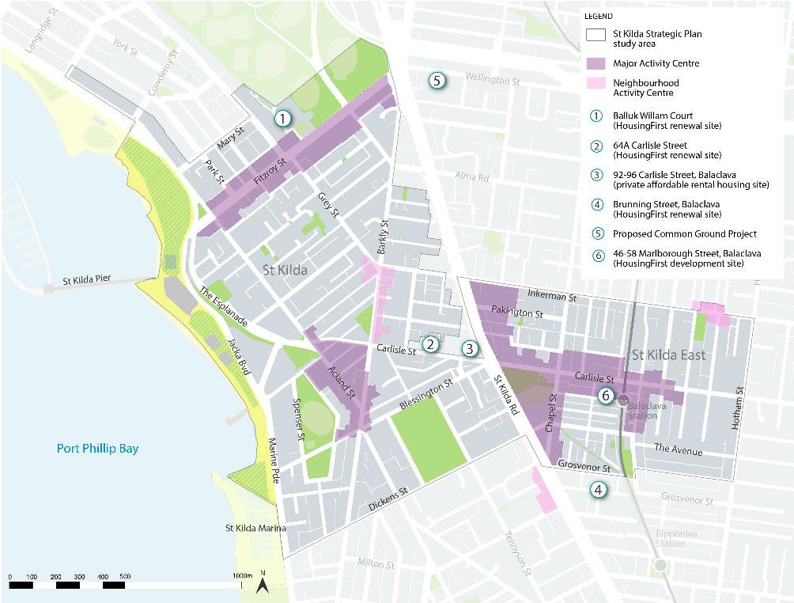

Additionally, Council can also:
- Influence housing provision following significant reform of state planning policy and residential zones in recent years. This includes the potential to capitalise on stronger state policy on affordable housing and to reflect Council’s affordable housing strategy.
- Advocate for State government funding for the delivery of the proposed Common Ground Project at 28 Wellington Street, St Kilda.
- Advocate for State Government funding for the delivery of supported social housing, such as the Common Ground model, to house persons who were homeless and sleeping rough
- Strengthen existing planning controls, advocate for additional (mandatory) planning mechanisms and identify new delivery models for applying planning mechanisms.
- Investigate value capture opportunities and negotiate voluntary contributions in proposed developments.
- Review planning controls to identify locations suitable for discretionary height bonuses that include social and affordable housing.

Public space & amenity

Context
The public realm includes public spaces, streets, parks and paths. The study area includes a number of public spaces (approximately 20 in St Kilda and 5 in St Kilda East), as well as the key retail streetscapes of Fitzroy and Acland Streets in St Kilda, and Carlisle Street and Chapel Street in Balaclava. Figure 14 shows open spaces across the study area.
Figure 14 Map showing open spaces across the study area
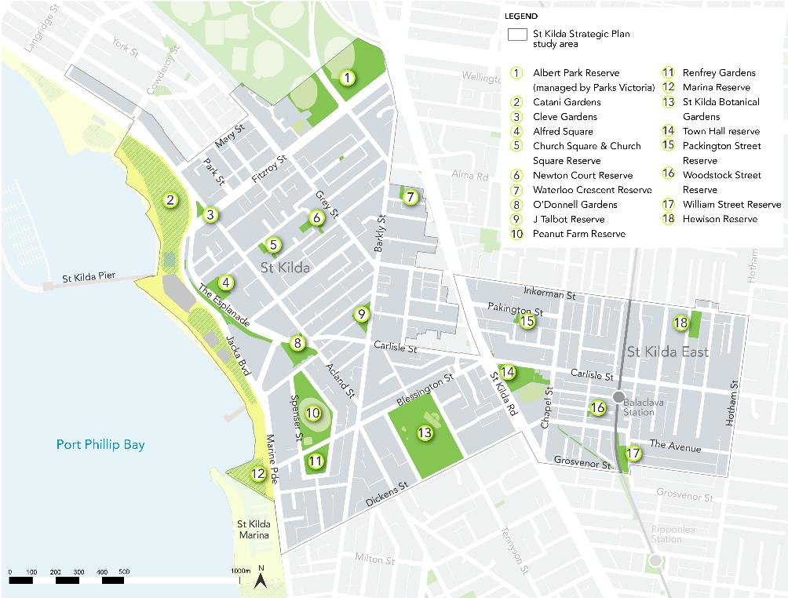
The St Kilda MAC sub-precinct has a good walking network, with wide road reserves with large broad-spreading canopy trees. This sub-precinct is known for its iconic foreshore and St Kilda Botanical Gardens and has approximately 20 public spaces distributed throughout, making up 17 per cent of the land area73F. This means public spaces are generally within a short walking distance of all residents. Public spaces in this sub-precinct are complemented by a range of commercial uses, including St Kilda Sea Baths and the St Kilda Marina.

Challenges
As the portion of people living in high density housing increases, fewer people have access to private open spaces (i.e. backyards) and are more reliant on public space for access to nature, recreation and socialising.
Public spaces in the study area need to be able to provide for a higher level of use, for a range of uses including active, informal and passive recreation events. This also means that the cost of maintenance will increase.
The community’s sense of safety, both actual and perceived, is a key issue relating to public spaces within the study area. During targeted engagement, respondents to the engagement survey stated that they felt unsafe in public spaces in Fitzroy Street and Carlisle Street MAC, citing criminal and anti-social behaviour as the key reason. Public spaces in the study area must be designed to ensure people feel safer, including those who are vulnerable.
The use of public spaces for commercial activities (such as personal training, events and outdoor dining) will also need to be considered as a way to stimulate economic recovery in the study area both as a result of historical decline, and the Covid-19 pandemic.
Lack of existing planning controls that all protect public spaces from overshadowing74F.

St Kilda MAC sub-precinct
The challenges of climate change, including more frequent and extreme weather events, are making the foreshore more vulnerable. Given the proximity to the foreshore, public spaces in this sub-precinct will need to be designed to cope with these challenges, including projected sea level rise, rising temperatures and heat-related health stress.

Carlisle Street MAC sub-precinct
This sub-precinct is situated within Balaclava/St Kilda East, which has the lowest amount of open space of all our neighbourhoods, significantly lower than the Port Phillip average of 17 per cent. The neighbourhood has a lack of tree canopy cover and poor walking permeability in the street network, which does little to offset the lack of public space.
The Balaclava/St Kilda East neighbourhood will be a focus area for the provision of new public space.75F

Opportunities
The movement and place approach outlined in Council’s Move, Connect, Live Integrated Transport Strategy 2018-28 takes the approach that each street functions as either a part of the transport network (movement) or as part of the neighbourhood for social, goods or services exchange (place). Rolling out the actions therein would result in better pedestrian facilities.
Provision of more public open space will be important for exercise and mitigating urban heat island effect in the medium to high density neighbourhoods.
Providing access to parks and urban spaces as a place to be outdoors, social interactions and have access to winter sunlight and nature, for those with limited access to private open spaces.
Ensuring public opens spaces are adaptable and appeal to the wide range of users that live and visit the study area.
St Kilda MAC sub-precinct
Once adopted, implement the relevant actions from the Places for People Public Space Strategy.
There is an opportunity for Council to transform the landside interface with the pier and reimagine Pier Road and the area surrounding the St Kilda Sea Baths, the Yacht Squadron, and even the connection between the foreshore, Fitzroy Street and the Esplanade Hotel. These connections and upgrades are essential for public access and DDA compliance.
Carlisle Street MAC sub-precinct
Once adopted, implement the relevant actions from the Places for People Public Space Strategy. As the principal movement spine and retail heart of the activity centre, there is an opportunity to establish Carlisle Street as one of the most important aspects of the public realm.
The Carlisle Street Activity Centre Structure Plan 2009 identifies the following public space opportunities:
- The inclusion of a public space in the future redevelopment of the car park adjacent to Coles.
- Implementing the ‘Balaclava Walk’ (Station) Project.
Consider the permanent closure of Dickens Street between Chapel Street and Brighton Road (adjacent to St Kilda primary school).76F

Climate change & sustainability

Context
Climate change poses a global challenge. At the study area level, sea level rise, flooding due to storm surges and rising temperatures are some of the key challenges that will impact residents and visitors. Maintaining and enhancing the environmental sustainability of the study area will require appropriate identification of the challenges and opportunities.

Challenges

Heat impacts
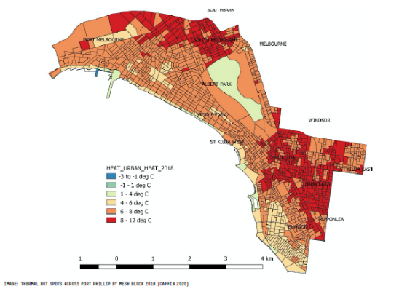
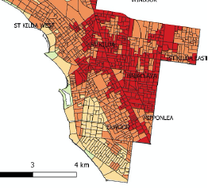
Much like other parts of the City, the study area is experiencing the impacts of urban heat island effect due to increased densification, more concrete, less permeable surfaces and average temperatures increasing year on year. Figure 15 below shows thermal hotspots across the municipality77F. It identifies significant portions of St Kilda and St Kilda East / Balaclava as areas where the urban heat is extreme, between 8 -12 degrees (Celsius). Some respondents to the engagement survey stated that there is a heat island effect in St Kilda, and identified the lack of permeability and vegetation cover surrounding recent development.
Figure 15 Map showing thermal hot spots across Port Phillip. Source: Caffin 2020

Figure 16 below identifies and indexes areas within the study area that are vulnerable to heat with 0 being least vulnerable and 5 being most vulnerable. Several areas within the study area are categorised as Heat Vulnerability 3 or 4.
Figure 16 Map showing heat vulnerability index 2018
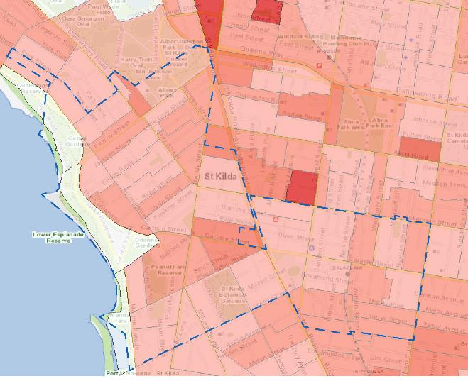

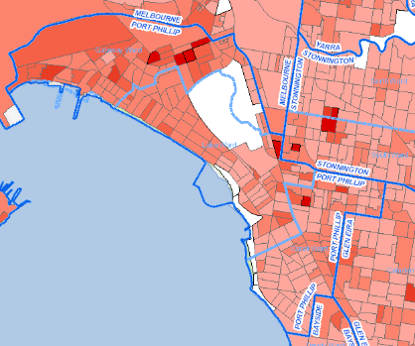

Source: Cooling and Greening Map (https://mapshare.vic.gov.au/coolinggreening/), accessed 4 April 2021.

Rising sea levels and flooding
Rising sea levels pose a significant challenge to the study area due to its low-lying landscape and proximity to the foreshore. The foreshore is experiencing increased beach erosion due to a greater number and intensity of storm surges. Rising sea levels was also identified as a key issue during targeted stakeholder engagement.
Figure 17 below shows that in the event where the sea level has risen to 82cm with a storm surge event, some areas within the study area, such as the foreshore, Catani Gardens and residential areas around and including Peanut Farm Reserve, will be inundated. Flooding due to sea level rise and storm surges present a great risk to the study area and its community.

Figure 17 Map showing 2100 sea-level rise with storm-surge.
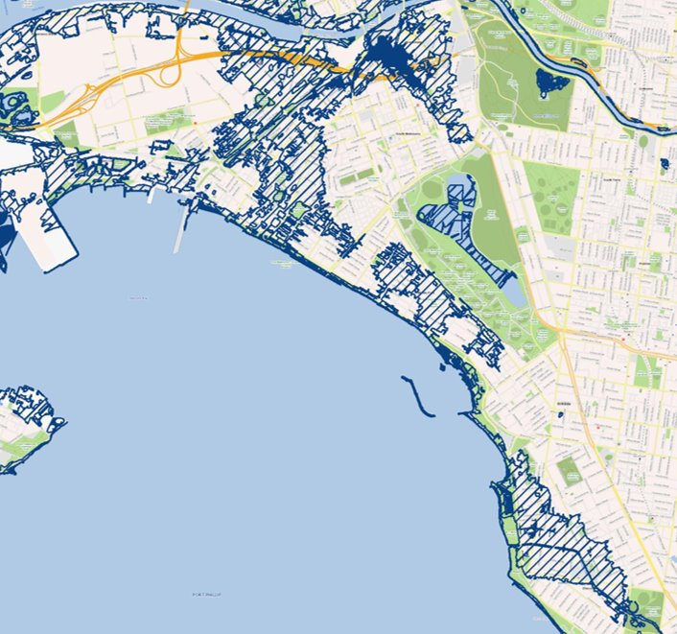
Source: Hydra (Hydra (maps.vic.gov.au)) , accessed 4 April 2021.

Greening, biodiversity and vegetation cover
With much of the land in study area being privately owned, a key challenge in terms of greening is increasing overall vegetation and canopy cover in the private realm.
Figure 18 below shows the percentages of vegetation cover within the study area. The 2018 data identifies several areas within the study area, notably around Acland Street area and Carlisle Street MAC sub-precinct, that has less than 10 per cent or no vegetation. It is important to note that the Carlisle Street MAC sub-precinct has the lowest amount of open space in all our neighbourhoods, which likely contributes to the lack of vegetation cover.
Lack of vegetation / canopy cover will contribute to the urban heat island effect within the study area and impact community amenity and wellbeing.

Figure 18 Map showing vegetation cover (2018)
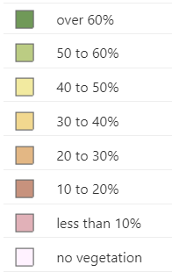
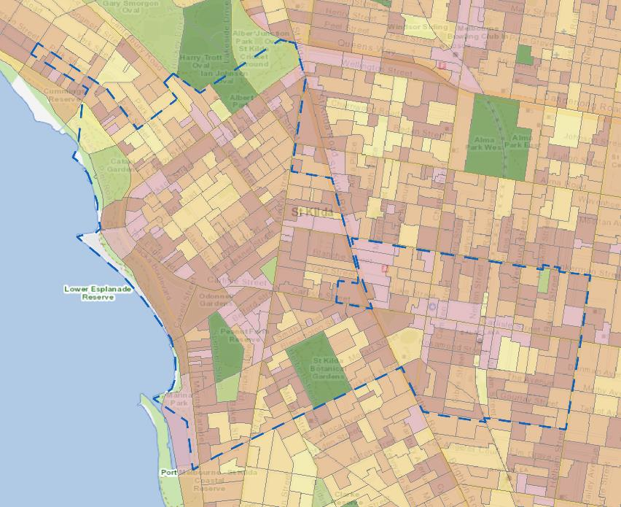
Source: Cooling and Greening Map ( https://mapshare.vic.gov.au/coolinggreening/), accessed 4 April 2021.

Waste & recycling
Many respondents to the engagement survey (9 out of 17) stated that waste and recycling is the biggest barrier to St Kilda being more sustainable. Respondents stated that better rubbish facilities and more recycling education is needed.

Opportunities
City of Port Phillip’s Act and Adapt: Sustainable Environment Policy 2018-28 outlines 47 priority actions to transition the City to a greener, cooler more liveable City, reducing our impact on the environment and being more resilient to the impacts of climate change. One of the priority actions that is currently underway is investigating mechanisms to enhance vegetation on private land.
The Places for People Public Space Strategy 2021-31 recommends updating Greening Port Philip in the short term to include the key streets and locations identified for priority greening through the Places for People Public Space Strategy 2021-31.
Council is investigating ways to protect and increase vegetation on private property.
Improving water quality through Water Sensitive Urban Design (WSUD) initiatives in the public and private realm is beneficial.
Capturing and utilising stormwater for passive irrigation will support healthier trees and increased tree canopy cover.
The stormwater management program and updated flood modelling will inform public and private realm planning requirements including Special Building Overlay (SBO) extents.
There is an opportunity to create new vegetation linkages between the key open space assets within the sub-precinct including the foreshore, Albert Park, Peanut Farm Reserve and the St Kilda Botanic Gardens. Figure 19 below also identifies possible biodiversity corridors along the foreshore, Nepean Hwy /Brighton Road and the railway corridor.

Figure 19 Map showing biodiversity opportunities within the municipality
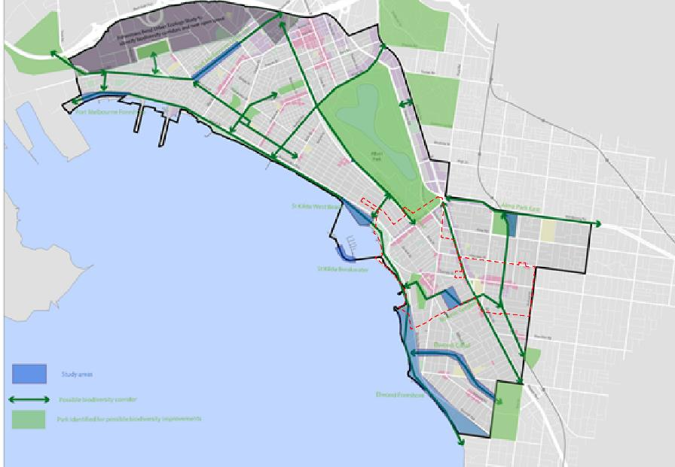
Source: City of Port Phillip

St Kilda MAC sub-precinct
Foreshore Management Plan
The current Foreshore Management Plan includes the following St Kilda foreshore specific actions:
- Implement flagship sustainability projects within the foreshore to demonstrate renewable energy and water saving technologies.
- Continue to implement the management plan to preserve the Canary Island Palm Trees and control Fusarium wilt
- Develop and implement a Vegetation Management Plan to protect and enhance vegetation along the foreshore including dune areas.
- Implement strategies that achieve high quality ecological values, shade and use of drought tolerant species including relevant actions within the:
  - Park Tree Planting Program
  - Greening Port Phillip Street Tree Strategy
  - Catani Gardens and Southern Foreshore Management Plan
Maximising stormwater harvesting in this sub-precinct due to the location of specific drains.

Transport & parking

Transport network and infrastructure

Context
The study area is connected to the CBD and other regions by a well-established transport network of roads, public transport and bike and walking infrastructure. There is good access to public transport and transport infrastructure includes a network of marked on-road bike lanes, shared micro-mobility and network of car share vehicles. Figure 20 shows the transport network within the study area.
Travel to work data indicates that within St Kilda, 34.1 per cent of people travelled to work by public transport while 40.2 per cent travelled by car.78F For those who travelled by public transport, tram was the most popular mode of choice79F.
Most respondents (9 out of 18) to the March 2021 engagement survey stated that their primary mode of transport in the study area was walking, with 5 respondents stating that they used a private car, 2 respondents used the tram and 2 respondents rode their bike.
Within the St Kilda MAC sub-precinct, Fitzroy Street, Canterbury Road and St Kilda Esplanade have dedicated tram lanes. There are designated State Strategic Cycling Corridors (SCCs) along Fitzroy Street and Beaconsfield Parade, as well as existing painted bicycle lanes on Canterbury Road (see Figure 21). Fitzroy Street is the key walking and bike riding route, connecting this area to the foreshore.
Within the Carlisle Street MAC sub-precinct, the Balaclava railway station located along Carlisle Street links this sub-precinct to other areas. Within this sub-precinct, the SCC exists along St Kilda Road, Chapel Street and Inkerman Street. Dickens Street - Westbury Street and William Street are part of a proposed Council bike corridor.

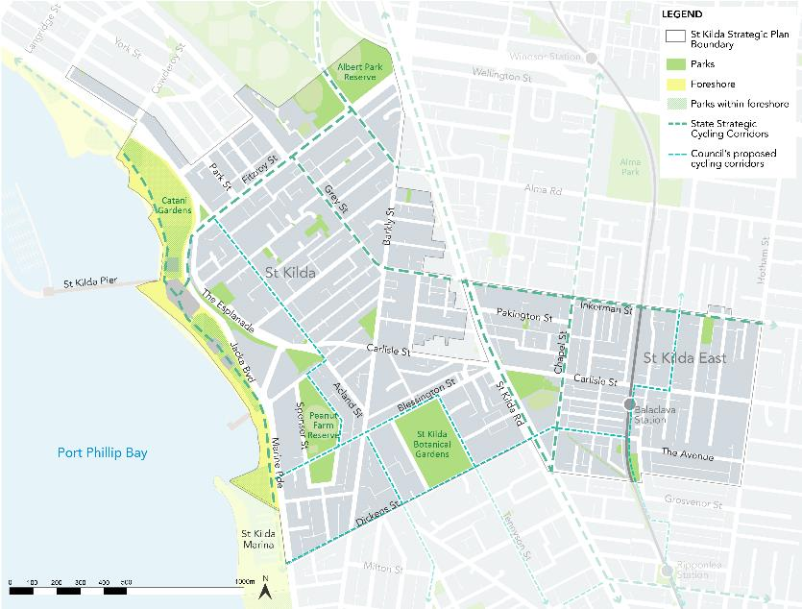
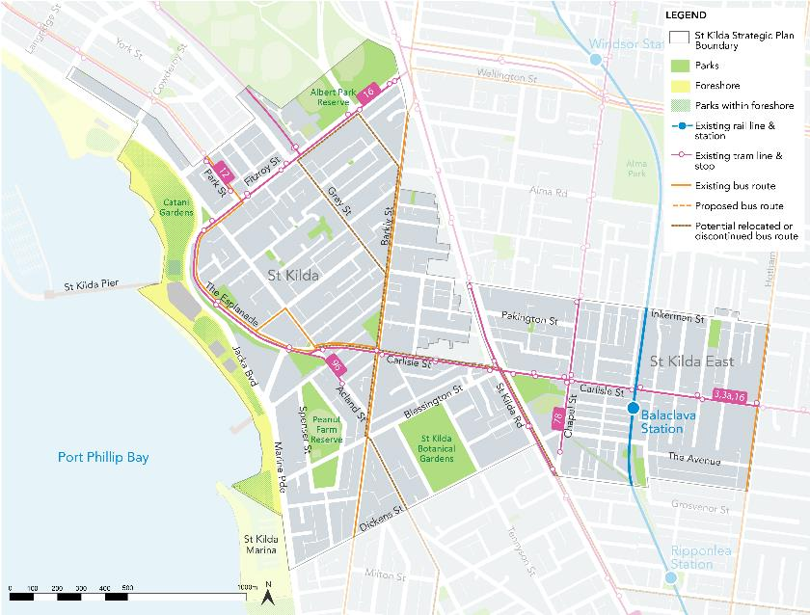
Figure 20 Map showing transport network (existing and proposed) in the study area

Figure 21 Map showing bicycle network

Challenges
The area is dissected by wide, busy roads that are difficult for pedestrians to cross including signalised intersections which often do not allow pedestrians to cross in one signal phase.
Anecdotally, the Covid-19 pandemic has resulted in an increase in the use of private vehicles and decrease in public transport usage. Depending on the length of this trend, it may present challenges in promoting the use of sustainable modes of transport and managing vehicle congesting and parking demand.
As the demand and uptake of alternative transport modes such as bicycle riding, E-scooters, micro-mobility and car share vehicles increase, more facilities and infrastructure are required both within private developments and on public land. These alternative modes of transport will create a competing demand for road space.
There is an opportunity to improve pedestrian amenity in the study area by creating wider footpaths through kerb extensions or the repurposing of on-street car-parking and providing seating and shade along key walking routes. Also, potentially future-proofing to allow creation of pick up and drop off zones for ride sharing.
Surveys completed in 2018 by the City of Melbourne (CoM) found that 83 per cent of respondents living in Melbourne and adjacent municipalities (including the City of Port Phillip) would choose to bike ride over other methods of transport if a protected bike lane was provided and 46 per cent of would aim to ride if double buffered bike lanes were provided80F. This is compared to 22 per cent who say they would be confident to ride on conventional painted bike lanes.81F
During targeted engagement, survey respondents raised concerns regarding the volume of cars in the study area, identifying this as resulting in traffic congestion along the key movement routes and a less safe environment.
Several parts of the infrastructure require upgrades, including the bridge linking the upper and lower Esplanade, which is not DDA compliant and not a preferred connection.

St Kilda MAC sub-precinct
- Poor connectivity within the sub-precinct between Fitzroy Street and Acland Street and both of these streets to the foreshore.
- Raised tram track on Fitzroy Street creates poor connectivity and makes crossing Fitzroy Street difficult.
- Car drivers do not expect to see bike riders on the Fitzroy Street bidirectional bike path coming from the direction opposite traffic flow, and this results in crashes and injuries to bike riders.
- Signalising Park Street/Fitzroy Street intersection would result in a loss of parking spaces on Fitzroy Street.
- There is poor pedestrian safety, amenity and accessibility at the St Kilda Junction, which forms a key connection point from Fitzroy Street through to East St Kilda.
- The bicycle lanes from Albert Park to Fitzroy Street are in poor condition.
- Lack of pedestrian crossing points across Jacka Boulevard.
- The incomplete bicycle network in St Kilda and St Kilda East.
- The Fitzroy Street tram stop opposite St Kilda Park Primary School needs to be upgraded to provide accessibility.

Carlisle Street MAC sub-precinct
- There is poor pedestrian amenity through parts of this precinct, including lack of ‘pause points’, inaccessible streets and lack of shade.
- There is a lack of bike riding connections both north-south and east-west across St Kilda Road at Dickens Street and William Street and Westbury Street across Carlisle Street.
- Tram stops along Carlisle needs to reviewed and upgraded.
- Tram 79 terminus on Chapel Street needs to be upgraded.

Opportunities
Implement the following key strategic transport projects, identified in Move, Connect, Live: Integrated Transport Strategy 2018-28.

Study area
- Bicycle riding network improvements on:
  - Inkerman Street
  - Grey or Alma/Princes Street connecting to Fitzroy Street
  - Acland Street (9A), Park Street (12A), Blessington Street (10A), Westbury - Dickens Street (7A) bike routes: interim shimmy treatments, long-term safety and traffic reduction treatments.
- Advocate for increased frequency of route 606 bus to connect Elwood to Fishermans Bend.
- Construction of accessible tram stops and bus priority projects on St Kilda Road, Carlisle Street, Chapel Street, Fitzroy Street and Park Street.
- Review of traffic signals to optimise pedestrian and bike rider crossing.
- Increase provision of protected bicycle lanes and bike riding improvements.

St Kilda MAC sub-precinct
- Signalisation of Park Street/Fitzroy Street intersection.
- Changing the signal sequence at the Fitzroy Street/Grey Street/Canterbury Road intersection.
- Installation of pedestrian operated signals on Marine Parade at Blessington Street and provision of pram ramps and bike lanterns.
- Provision of a scramble intersection at Marine Parade and Cavell Street.
- Accessibility upgrades for St Kilda Road Junction.
- Speed limit reduction and improvements at intersection at Grey Street and Barkley Street to promote walking and bike-riding.
- Improve connections between Fitzroy Street and foreshore, including:
- Fitzroy Street pedestrian crossing of Jacka Boulevard, which has no safe and equitable DDA compliant access to foreshore through Catani Gardens
- Fitzroy Street separated bike lane to foreshore Bay Trail and shared promenade, which currently has very poor connection.

Carlisle Street MAC sub-precinct
- Advocate for relocation of the pedestrian signals outside St Kilda Primary school to Nepean Highway/Dickens Street location, should tram stops be rationalised
- Prioritise pedestrian movement as part of any redevelopment of the Coles / car park site
- Investigate transport priorities including signalising the three bus routes82F.
- As part of the St Kilda Road Safety Improvement Project, Council is jointly advocating with CoM to the Department of Transport and Major Road Projects Victoria (MRPV) for the delivery of temporary protected bike lanes along St Kilda Road to connect to cycling corridors such as Inkerman Street.
Implement the relevant actions of the Places for People Public Space Strategy (once adopted), the improve pedestrian amenity.

Parking

Context
Parking is a limited and shared resource, with 20 per cent of Port Phillip’s road space being used for car parking83F. IN 2018 there were 53,000 on-street car parks in Port Phillip, and 4,000 Council-managed off-street car parking spaces84F.

Challenges
St Kilda is a destination frequented by visitors from outside our City. While local residents are often able to access events and services within the study area without using a car, however, many visitors would prefer to access the area by car.
There are competing demands for the use of road space and car parking spaces. For example, Council may choose to repurpose on-street car parking space for improvements to the public space, tram stops and bicycle riding network.
In 2018 car ownership trends predicted a 24 per cent85F increase in the number of cars owned in Port Phillip by 2028. There may be a pause in population growth, however there appears to be increased car use, which will put significant pressure on car parking.

Opportunities
As the demand for the provision of on-street parking continues to increase, encourage and facilitate the delivery of publicly accessible parking spaces within new developments.
As well as needing space to park and store an increasing number of vehicles, creating and maintaining a high level of liveability, mitigating the impacts of climate change and supporting greater transport choices should form part of any parking consideration.
St Kilda MAC sub-precinct
Review car parking demand and issues and the need for any car parking controls as part of the structure planning process for this sub-precinct.
Carlisle Street MAC sub-precinct
Investigate the need for any car parking controls within the sub-precinct as part of the review of Carlisle Street Structure Plan and Implementation Plan.

Community infrastructure

Context
St Kilda has long been a hub of community infrastructure that support the health and wellbeing of the community, including marginalised and vulnerable groups. Some facilities are owned and operated by Council, others are owned by Council and leased to other organisations to operate from and some are owned and operated by non-government organisations.
The St Kilda Town Hall is one of Council’s three designated ‘civic hubs’, and includes the library, Bubup Nairm Family and Children’s Centre and St Kilda Police Station.
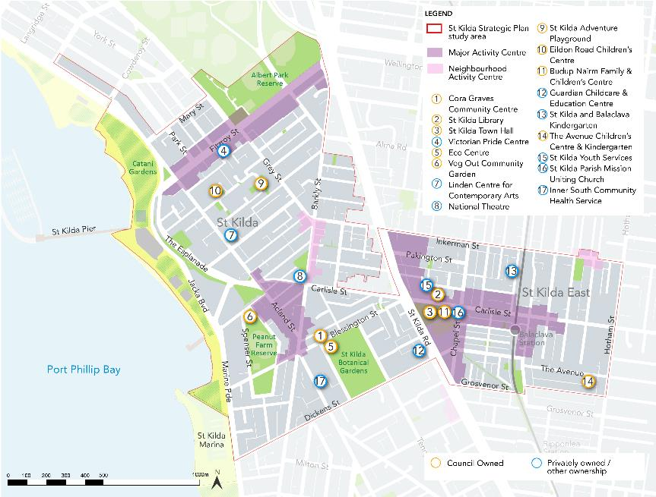
A number of services and facilities for people who are marginalised or disadvantaged are located throughout the St Kilda study area and include crisis centres, community health and drug and alcohol support and support for sex workers. Figure 22 identifies some of the key facilities within the study area. The area is also home to a range of art and cultural facilities and family support services. A more comprehensive list of current facilities available in the study area can be found at Appendix 2.86F
Figure 22 Map showing key community facilities & infrastructure

Challenges
There is a growing demand for community facilities that are co-located, currently there is a lack of such facilities.
There are a number of Council-owned facilities are not fit-for-purpose due to their age and state of disrepair, including the Cora Graves Community Centre, the Avenue Childcare and Eildon Road Childcare.
Most of the respondents (14 out of 17) to the engagement survey believed that the study area has an appropriate amount of community infrastructure, with majority (10 out of 13) of respondents stating that the current community infrastructure is diverse enough to cater for the needs of the whole community. Some respondents stated that Council needs to maintain the spaces with the Civic Precinct particularly identified as being grotty, uninviting and unsafe for kids and families to congregate.

Opportunities
As part of any future structure planning work, undertake a Community Infrastructure Needs Assessment to determine the community facilities and services required in each centre.
Continue clustering and co-locating community services and infrastructure.
Continue to invest in and renew Council owned and managed facilities (where appropriate), and opportunities for co-location when properties are available for lease.
As part of place-based strategic planning work, plan for the co-location of community facilities in accessible locations.

Social issues

Context
St Kilda has a complex social identity, made up of a diverse and evolving community of people drawn there to live, work, be entertained and access services. As a result of this, social challenges in the study area are complex and evolving. The three main social challenges that emerged in the preparation of this report are perceptions on people experiencing homelessness, illicit drug and alcohol use including violent and antisocial behaviour, and the perception of community safety.
Due to the nature of this report, a number of social initiatives being undertaken by Council (for example, equity, diversity and inclusion) are not discussed here. However, they may be relevant to future strategic planning work for the study area.

Challenges

Homelessness
Council’s statistics indicate that approximately 32 people actively sleeping ‘rough’ on the streets in the municipality each night as of May 202187F. Anecdotally, this includes an overrepresentation of people who identify as Aboriginal and Torres Strait Islander, particularly around Fitzroy Street and Acland Street.88F Over the last ten years, some of the short term and crisis accommodation options, such as the Gatwick Hotel, Oasis and the Beach House, have closed and been redeveloped.
Survey respondents stated that one of the key social challenges in St Kilda was homelessness. In the engagement there was a perceived view expressed that the Covid-19 pandemic has seen a rise in the number of homeless people, however this does not appear to be reflected in the above statistics.

Alcohol and drug related harm
In the year from 2019-2020, there was a total 1,09489F drug offenses in the City. Among the neighbourhoods, St Kilda (508) had the highest number of drug offences90F.
Survey respondents stated that key social challenges in St Kilda are drug and alcohol use in public spaces.
Port Phillip experiences higher levels of alcohol-related harm compared to other metropolitan Melbourne areas91F. As of September 2020, there were 803 liquor licenses within Port Phillip, with the majority of liquor consumed in the City occurring in restaurants, cafes, bars and nightclubs. While Port Phillip has recorded 347 public drunkenness offences in December 202092F, anecdotally more of these offences are caused by visitors. In reviewing the 58 infringement notices issued over the trial period of the public drinking laws, Port Phillip residents accounted for 22 per cent (13) of people issued fines for public drinking, while 88 per cent (45) infringements were issued to people who do not reside within the municipality93F. The social and cultural benefits of tourist and entertainment uses in the study area needs to be balanced with the alcohol related harm and amenity impacts to ensure the study area remains a desirable and safe place to visit and live.94F
Port Phillip has a greater number of residents identified as being at risk of short-term harm from alcohol, with the number of people identified as being at very high risk of short-term harm is 20.6 per cent compared to the State average of 9.2 per cent95F .
Council’s discretion in considering the health and social impacts of licensed premises is limited under Clause 52.27 (licensed premises) of the Port Phillip Planning Scheme to considering appropriate locations and amenity impacts, rather than more broadly considering alcohol-related harm in the wider community96F.

Community safety
In the year from 2019-2020, the overall criminal offences in St Kilda / St Kilda West rose from 4,545 to 4,638 which is an increase of 2.05 per cent97F (see Figure 23). However, it should be noted that within a five-year period (2016-2020) the overall criminal offences in this area has decreased from 5,160 to 4,638 (-10.6 per cent)98F.
The Fitzroy and Little Grey Street CCTV Final Evaluation Report indicated that criminal activity had reduced by 58 per cent in Fitzroy Street and the surrounding neighbourhood since the introduction of the CCTV system in 201699F .

Figure 23
Source: Crime Statistics Agency Victoria, https://www.crimestatistics.vic.gov.au/ accessed 1 June 2021

In the same year in Balaclava / St Kilda East, the overall criminal offences decreased from 1,106 to 1,086 which is a decrease of 1.03 per cent100F (see Figure 24). Similarly to St Kilda / St Kilda West, within a five-year period (2016-2020) the overall criminal offences in this area has decreased by 8.9 per cent (from 1188 to 1086)101F.
Figure 24
Source: Crime Statistics Agency Victoria, https://www.crimestatistics.vic.gov.au/ accessed 1 June 2021

In theory, the installation of CCTV cameras can improve people’s perceptions of safety, which contributes to a greater number of people accessing the public places and thereby, increasing the level of natural surveillance. In summary, if an area is being monitored by CCTV, the fear of crime is reduced, and the area is perceived to be safer. For example, as part of the Fitzroy and Little Grey Street CCTV Final Evaluation Report, key stakeholder interviews completed assessing perceptions of safety. It was found there was a strong agreement that the installation of the CCTV system had improved safety perception in the study area102F.

Opportunities
Include public safety such as Crime Prevention Through Environmental Design (CPTED) principles into strategic planning from the beginning of a project.
Ensure all public spaces feel safe and inclusive to those who are vulnerable.
Continue to support and facilitate affordable and social housing developments.
Continue to lead partnered response to reduce incidents of rough sleeping through Port Phillip Zero initiative.
Develop a licenced premises policy to guide the appropriate location and design of licensed premises to ensure they make a positive contribution commensurate to the role of each activity centre and to effectively manage amenity impacts.103F

Recommendations

Primary Recommendations
Recommendation | Indicative cost104F | Responsibilities | Committed/  Underway
0 – 5 years
- Undertake initial feasibility investigation of selected catalyst sites within the St Kilda MAC, including:  - context analysis  - constraints and opportunities analysis  - extent to which each site can achieve an economic or social benefit  - Work with proponents to facilitate development of catalyst sites that have an economic or social benefit through site specific planning scheme amendments (if required) or planning permit applications105F. | - $80k – 100k for initial feasibility assessment of selected sites within St Kilda MAC.  - Assume $70k per site specific planning scheme amendment (potential for possible developer-led funding). Depending on number of site specific amendments and/or major permit applications, it may be necessary to employ additional strategic and/ or statutory planner/s at cost of up to $140k per year | Council (lead: City Strategy & Policy) at request of and in partnership with external proponents | - No (initial feasibility assessment)  - Yes (working with proponents when approached)
- Remove barriers to new and temporary businesses opening, and existing business expanding, in existing activity centres through an advocacy strategy and business improvement initiatives within the organisation. (See Appendix 3) | BAU & additional costs (refer Appendix 3) | Council (lead: various) | Some aspects
5 - 10 years
- Prepare a Structure Plan for St Kilda MAC sub-precinct which includes:  - Review of the activity centre boundary, including of sub-precincts (such as the inclusion of Inkerman Street between Barkly Street/St Kilda Road and sections of Barkly Street north and south of Inkerman Street)  - An Urban Design Framework, which includes a built form review to inform planning controls, such as DDOs  - A plan to guide the development of the St Kilda foreshore  - A full retail demand and competition analysis  - Review of land uses  - Alignment with any foreshore management plan  - Review car parking demand and issues and the need for any car parking controls  - Consideration of public safety and CPTED principals  - Co-location and clustering of community facilities in accessible locations  - Considers the future Vision for precincts, including Fitzroy Street  - Has a focus on resilient centres. | $400k for preparation  $150k for car parking review  $120k for planning scheme amendment implementation | Council (lead: City Strategy & Policy) | No

Secondary Recommendations
Recommendation | Indicative cost106F | Responsibilities | Committed/  Underway
0 – 5 years
- Create and curate St Kilda Arts precinct (e.g. brand development, wayfaring, street signs, promotions, etc), to capitalise on existing arts organisations | Requires scoping to determine Council contribution; potential for venue contribution | Council (lead: City Growth and Culture)  Partnership with Arts organisations | No
- Complete and implement the HO7 precinct review (2021-2022) and the HO5 precinct review (2023-2024). | HO7: budget provided in 2021/22  HO5: $120k for completion in 23/24; $70k for planning scheme amendment implementation in 23/24 | Council (lead: City Strategy & Policy) | Yes – HO7 review  No HO5 review
- Further investigate the need for a review of the land use and built form controls of the William Street precinct. | $80k for preparation  $70k for planning scheme amendment implementation | Council (lead: City Strategy & Policy) | No
- Review and investigate the feasibility of completing the following key Balaclava Walk masterplan projects  - Balaclava Walk West  - Nightingale Street works. | $20k for feasibility assessment (includes calculation of budget required to undertake works)  Unknown cost for undertaking works. | Council (lead: City Design) | No
Council-wide initiatives
- Following completion of the Spatial Economic and Employment Framework and the Housing Strategy, further investigate the need for a new Activity Centres Strategy. | BAU for the initial investigation | Council (lead: City Strategy & Policy) | No
- Develop a Licenced Premises Policy to guide the appropriate location and design of licensed premises to ensure they make a positive contribution commensurate to the role of each activity centre and to effectively manage amenity impacts. | $40k for preparation (assumes no engagement) and $70k for planning scheme amendment implementation | Council (lead: City Strategy & Policy) | No
- Undertake a Community Infrastructure Needs Assessment to determine the community facilities and services required in each centre. To be completed before Structure Plan.. | $40-60k for preparation | Council (lead: City Strategy & Policy in partnership with Community Building and Inclusion) | No
5 - 10 years
- Undertake a built form review for Carlisle Street MAC (this may take the form of a review the existing 2009 Urban Design Framework) which includes, but is not limited to:  - Review of heritage sightline requirements  - Review ongoing relevance of mandatory and discretionary requirements of DDO21 | $150k for preparation  $70k for planning scheme amendment implementation | Council (lead: City Strategy & Policy) | No
10 – 20 years
- Prepare a revised Carlisle Street Structure Plan, with implementation plan, which includes:  - Review of car parking and the need for any car parking controls within the Carlisle Street MAC  This assumes there is no requirement for a UDF (as completed above). | $250k (assuming no UDF component)  $150k for car parking review  $120k planning scheme amendment implementation | Council (lead: City Strategy & Policy) | No

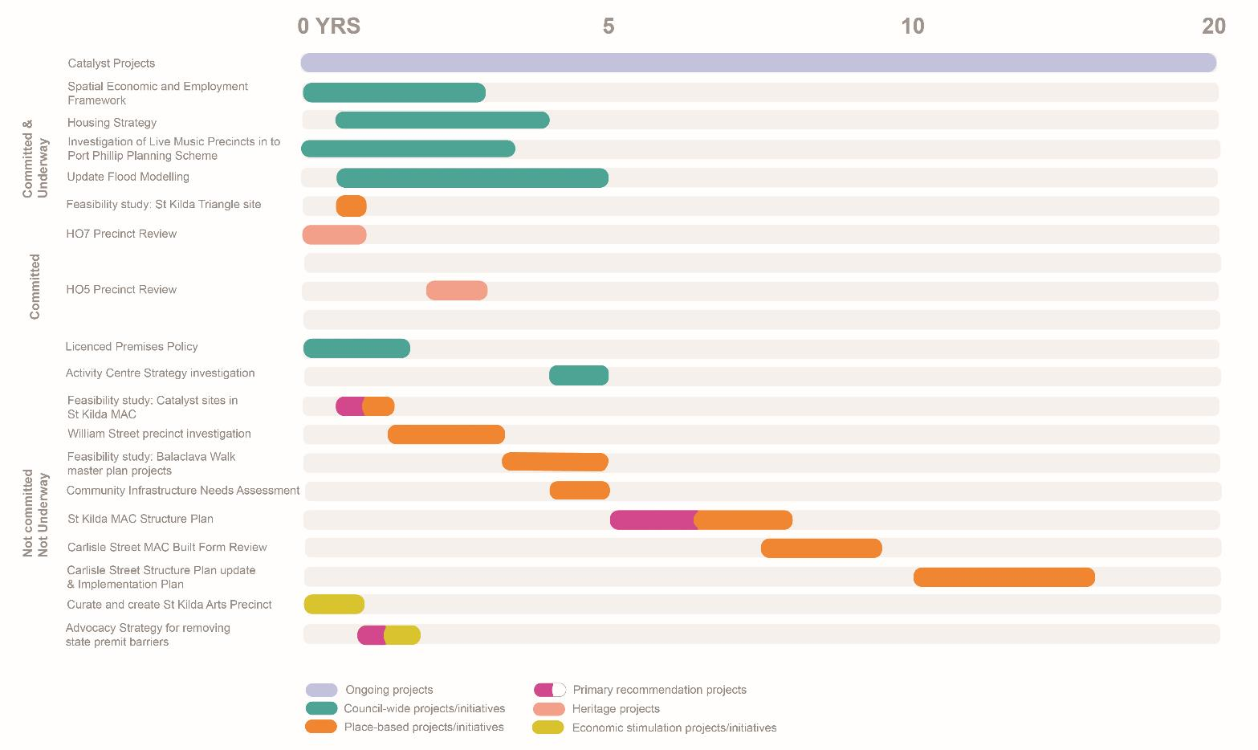
Appendix 1 – Project sequencing

Appendix 2 - Community facilities in the study area
List of current facilities available in the study area
The following details current community infrastructure under the category of services the facility primarily supports:
- Families and children
- Middle years and young people
- Older people
- Vulnerable groups
- Sport and recreation
- Arts, culture and organisation
- Sustainability groups
- Civic infrastructure
Many facilities support the delivery of more than one service. These facilities have been group by the most prominent service. For example, community rooms that can be booked by different organisations.
Families and children
Facility | Ownership | Operator | Services | Precinct
Bubup Naim Family and Childrens Centre | Council | Council | Maternal Child Health, Playgroup, Early Education and Care, Family Support | Carlisle Street MAC sub-precinct
Eildon Road Child Care Centre | Council | Community | Early Education and Care | Near St Kilda MAC sub-precinct
Guardian Childcare & Education – St Kilda South | Private | Private | Early Education and Care | Adjacent to Carlisle Street MAC sub-precinct
The Avenue Childcare | Council | Community | Early Education and Care | Near Carlisle Street MAC sub-precinct
St Kilda Balaclava Kindergarten | St Kilda Balaclava Kindergarten | Community | Early Education and Care | Adjacent to Carlisle Street MAC sub-precinct
Kimmba Biligual | Private | Private | Early Education and Care | Adjacent to Carlisle Street MAC sub-precinct
Jewish early learning centres | Private | Private | Early Education and Care | Adjacent to Carlisle Street MAC sub-precinct

Middle years and young people
Facility | Ownership | Management | Services | Precinct
St Kilda Adventure Playground | Council | Council | Supervised play for middle years children | Near St Kilda MAC sub-precinct
Melbourne City Mission | Unknown | Melbourne City Mission | Youth services | Near Carlisle Street MAC sub-precinct
PCYC | Unknown | PCYC | Youth Services | Near Carlisle Street MAC sub-precinct
Alylia Youth Services | Unknown | Unknown | Youth services | Near Carlisle Street MAC sub-precinct
St Kilda Park Primary School | Dept of Education | St Kilda Park Primary School | Primary school | Near Carlisle Street MAC sub-precinct
St Kilda Primary School | Dept of Education | St Kilda Primary School | Primary school | Near St Kilda MAC sub-precinct

Older people
Facility | Ownership | Management | Services | Precinct
Cora Graves Community Centre | Council | Council | Social inclusion services | Near St Kilda MAC sub-precinct
Acland Grange | Private | Private | Residential aged care and supported accommodation for people with disabilities | Near St Kilda MAC sub-precinct
Avonsleigh Terrace Community Hostel | Private | Private | Residential aged care and supported accommodation for people with disabilities | St Kilda MAC sub-precinct

Vulnerable populations:
Facility | Ownership | Management | Services | Precinct
St Kilda Gatehouse | Unknown | St Kilda Gatehouse | Space and support for women involved in street sex work or subject to sexual exploitation | Adjacent to St Kilda MAC sub-precinct and Carlisle Street MAC sub-precinct
Sacred Heart Mission | Sacred Heart | Sacred Heart | Sacred Heart | St Kilda MAC sub-precinct
Christ Church Community Centre | Christ Church Mission | Christ Church Mission | Socially inclusive activities, meals and emergency support | St Kilda MAC sub-precinct
St Kilda Parish Mission | St Kilda Parish Mission | St Kilda Parish Mission | St Kilda Legal Service, Port Phillip Community Group and St Kilda Drop In | Carlisle Street MAC sub-precinct
StarHealth – Fitzroy Street | Unknown | Starhealth | AOD services, antenatal social work, parenting support | St Kilda MAC sub-precinct
Salvation Army St Kilda Crisis Centre | Unknown | Unknown |  | St Kilda MAC sub-precinct
First Step Recovery Centre | Private | Unknown |  | Carlisle Street MAC sub-precinct

Infrastructure supporting sustainability outcomes
Facility | Ownership | Management | Services | Precinct
VegOut Community Garden | Council | VegOut | Community garden | St Kilda MAC sub-precinct
EcoCentre | Council | EcoCentre | Sustainability and community engagement programs | St Kilda MAC sub-precinct

Civic infrastructure
Facility | Ownership | Management | Services | Precinct
St Kilda Police Station | State | Victoria Police |  | Carlisle Street MAC sub-precinct
St Kilda Town Hall | Council | Council | Civic centre, art gallery, bookable spaces | Carlisle Street MAC sub-precinct

Appendix 3 – Potential actions for removing barriers to businesses
Action | Council lead
Committed/ underway
- Undertake a pilot program of a commercial/retail mix mapping project to develop a spatial understanding of the current mix in centres and identify clear clusters, gaps in the supply and current anchor tenants and compare them to global best practice retail mix benchmarks and strategies, includes consultation and collaboration with real estate agents (pilot program currently being developed for Acland Street) | City Growth and Culture
- Continue to progress proposed local VicSmart application types through Planning Scheme Review Planning Scheme Amendment C203 - particularly relevant to minor buildings and works, signage and liquor licenses (all within limited parameters) Amendment C203 is due to commence exhibition shortly | City Policy
Future
- Convene internal working group to triage new business enquiries and applications (ideally led by the ASSIST business concierge), attended by representatives from City Permits, Health, Building and Planning services, City Design, Economic development team etc | Various, led by Business Concierge within ASSIST
- Investigate whether rates rebates/ concessions would be an effective incentive for premises within commercial/ MUZ/ industrial zoned areas are leased at lower/ temporary rates to new and/ or targeted businesses and/ or to part of the premises (noting many vacant premises may be too big to attract desired businesses) | Rates
- Once the SEEF is completed – review the need for a gaps analysis of each activity centre and use as a basis to prepare list of ‘desired’ businesses for each activity centre (i.e. to plug missing services/ goods), and then incentivise these businesses through concierge service/ rates rebates etc | City Growth and Culture
- Investigate a fast track process for any local laws and health permits required for new and temporary businesses and/ or ‘deemed to comply’ standards to avoid permits | City Permits
- Consider appointing a commercial priority planner & adopt commercial priority process (based on the Moreland model) for new & expanding businesses | City Development
- Prepare and adopt advocacy strategy that advocates State government for the following:  - For temporary businesses & businesses wishing to trial expansion (in both cases for up to 6 months) within Commercial/ MUZ/ industrial zoned areas:  - Waive building regulations requirements (not fire, but include DDA, toilet requirements)  - Waive planning requirements for use (within certain parameters such as typical business hours), car parking, internal B&W  - Introduce State-wide VicSmart provisions for buildings and works, liquor and signage matters  - For new non-temporary businesses within commercial/ MUZ/ industrial zoned areas  - Small v Big businesses: confirm parameters to define each (eg <500 sqm floor area, certain customer or staff numbers, etc)  - Small businesses  - Waive planning requirement for car parking, internal B&W  - Introduce VicSmart provisions for buildings and works, use (within certain parameters such as typical business hours), liquor and signage matters | Advocacy strategy preparation: Partnerships and Transport, with input from various
- Set up a Planning services procurement panel, in order to enable agile use of contract staff to support statutory, compliance and strategic planning services in light of recruitment issues, particularly short-term vacancies | City Development, City Strategy & Policy & Planning Compliance, with support from procurement
- Investigate advisory/ mentoring program for new businesses - businesses can get advice on what to consider when starting up and info on regulatory requirements | City Growth and Culture
- Once a business has opened and the regulatory aspects have been finalised, handover business information on to Economic Growth. Economic Growth team can:  - introduce these businesses to support opportunities & resources through Council.  - ensure the businesses receive dedicated Port Phillip business updates by including them in the Economic Growth mailing list | Various
- Tailored Fact Sheets/checklist to assist & guide new businesses. E.g. Setting/taking over a hospitality business | Various
- Increase officer attendance at Business Association meetings. Topics and variety of presence | Various
- Resource and prioritise review of Footpath Trading Guidelines adopted by Council in 2010, (amended in 2017) | City Permits

This will follow and adhere to the statutory requirements of the Planning and Environment Act 1987.
St Kilda Current State Analysis Report, Urban Enterprise (2021)
Defined in Plan Melbourne 2017-2050
Implemented to the planning scheme via Planning Scheme Amendment C122 in 2018
Port Phillip Planning Scheme Review Audit Report (23 May 2018), p 67.
Targeted community engagement with a small sample group was undertaken to help inform this document, in part as Council has considerable feedback from a range of previous engagements in the study area and secondly as far more detailed engagement will be undertaken through a formal structure plan process at some point in the future.
City of Port Phillip Population Forecast, forecast.id, accessed 05 July 2021
ABS Census 2016
ABS Census 2016
.id
.id
.id
ABS Census 2016
ABS Census 2016
ABS Census 2016
It contains numerous policies relevant to economic development, including increasing Melbourne’s competitiveness, improving access to local jobs, the creation of jobs in urban renewal areas and a city of 20-minute neighbourhoods. Council is required to plan for the provision of adequate commercial land to support a competitive City and improve access to local jobs (Policy 1.1.7).
Port Phillip Council Plan 2021-31,Volume 1 pg 51
The Port Phillip Planning Scheme is currently undergoing review (Amendment C203port) which will result in local provisions being relocated within the scheme.
Recommendation 4 of the Port Phillip Planning Scheme Review Audit Report (23 May 2018)
Draft City of Port Phillip Business and Creative Sector Retention and Attraction Action Plan 2021-2024
This issue affects all of Melbourne as acknowledged in the 2016 Managing Residential Development Advisory Committee Report. It is also identified and discussed in the Port Phillip Planning Scheme Review Audit Report (23 May 2018).
Adoption is currently under consideration by Council
Port Phillip Planning Scheme Review Audit Report (23 May 2018), pg 66
Port Phillip Planning Scheme Review Audit Report (23 May 2018), pg 67
Port Phillip Planning Scheme Review Audit Report (23 May 2018) , pg 67
Port Phillip Planning Scheme Review Audit Report (23 May 2018), pg 68
Carlisle Street Activity Centre Structure Plan 2009
For instance, a six storey mixed use development comprising brewery at ground and office above was approved in 2020 directly adjacent to the station.
Port Phillip Planning Scheme Review Audit Report (23 May 2018), pg 67
These identify three options: continued service industrial activities, diverse business cluster with continued industrial activity with new opportunities for business services and knowledge based ‘creative’ industries, and mixed residential an business activities.
ABS Census 2016
ABS Census 2016
ABS Census 2016
Draft City of Port Phillip Business and Creative Sector Retention and Attraction Action Plan 2021-2024
Covid-19 Financial Impact Index https://taylorfry.com.au/articles/covid-19-financial-impact-index/ , accessed 05 July 2021
Opportunity identified by officers.
Feedback received through the Renew Fitzroy Street Program and the Fitzroy Street Traders Association.
Draft City of Port Phillip Business and Creative Sector Retention and Attraction Action Plan 2021-2024
Draft City of Port Phillip Business and Creative Sector Retention and Attraction Action Plan 2021-2024
ABS Census 2016
ABS Census 2016
Opportunity identified by officers as a response to the CONFIDENTIAL Draft Business Retention & Attraction Strategy, City of Port Phillip (5 May 2021). Not identified in the St Kilda Current State Analysis Report (Urban Enterprise, 2021)
Opportunity identified by officers. Not identified in the St Kilda Current State Analysis Report (Urban Enterprise, 2021)
Business Victoria
Business Victoria
These include St Kilda Film Festival, performances at the Palais Theatre, St Kilda Foreshore festivals and gigs including Listen Out, Oktoberfest and April Sun and the Australian Formula 1 Grand Prix held annually at Albert Park but supported by St Kilda.
Draft City of Port Phillip Business and Creative Sector Retention and Attraction Action Plan 2021-2024
PPN59 sets out criteria that can be used to decide whether mandatory provisions may be appropriate in planning schemes. PPN60 provides guidance on the preferred approach to the application of height and setback controls for activity centres.
For instance, the City of Yarra for the Swan Street MAC which is subject to heritage controls, introduced the concept of a ‘street wall behind the street wall’ based on consistent setbacks behind the heritage street wall rather than this being determined by a sightline.
Recommendation 79 of Port Phillip Planning Scheme Review Audit Report (23 May 2018), p180.
The Balaclava Walk (Station) project was identified as a key strategic opportunity in the Carlisle Street Activity Centre Structure Plan (2009), which has only partly been delivered.
Most of the current heritage overlays were first introduced in 2000 following the completion of the Port Phillip Heritage Review (PPHR) in 1998. The exception is the HO439 Nightingale Precinct, which was applied in 2008.
Part of the review involves breaking up this large precinct into smaller, more cohesive and thematically concise precincts, which will include: a ‘Commercial and civic’ precinct applying to Carlisle Street east of Brighton Road including the historic commercial core, and the civic sub-precinct surrounding the Town Hall; a separate residential precinct applying to the residential areas to the north and south of the Carlisle Street activity centre incorporating parts of HO7 and the whole of the HO439 precinct; a ‘Village Belle’ precinct applying to the retail centre in Acland (south of Carlisle St) and Barkly streets; a residential precinct to the south of Carlisle Street surrounding the St Kilda Botanic Gardens.
DELWP, August 2018.
Under s 20(4) of the Planning and Environment Act 1987, amendments of a minor or administrative nature can be processed quickly without exhibition. Amendments to update the form and structure of existing citations without introducing significant new content should be able to be processed in this way.
Recommendation 15 of the Port Phillip Planning Scheme Review Audit Report (23 May 2018) identifies this is required, along with HO6, HO5, HO7, HO8 and Montague precinct reviews.
ABS Census 2016
ABS Census 2016
ABS Census 2016
ABS Census 2016
ABS Census 2016
ABS Census 2016
ABS Census 2016
ABS Census 2016
ABS Census 2016
Refer recommendation 48 of the Port Phillip Planning Scheme Review Audit Report (23 May 2018).
Changes include: rezoning of Fishermans Bend in 2012; Plan Melbourne 2017-50; introduction of the new residential zones in 2013; and, subsequent changes to the residential zones including mandatory heights and garden area requirements.
The current accepted benchmark for affordability is 30 per cent or less of household income spent on accommodation costs, for households in the lowest 40 per cent of the income range. The specification of very low & low income ranges (annual) for affordable housing as of 30 June 2020 are as follows: Single adult: $26,090 - $41,750; Couple, no dependent: $39,130 - $62,620; family and dependent children: $54,780 - $87,670.
Imputation refers to when corporate tax entities distribute, to their members, profits on which income tax has already been paid, they have the option of passing on, or ‘imputing’, credits for the tax. Although the recipients are taxed on the full amount of the profit represented by distribution and the attached franking credits, they are allowed a credit for the tax already paid by the corporate tax entity. The prevents double taxation. Source: https://www.ato.gov.au/Business/Imputation/ accessed 12 July 2021.
The number of households where rent payments were 30% or more of an imputed income measure are expressed in this table as a proportion of the total number of households in an area (including those households which were not renting, and excluding the small proportion of visitor-only and other non-classifiable households). The nature of the income imputation means that the reported proportion may significantly overstate the true proportion.
The number of households where rent payments were 30% or more of an imputed income measure are expressed in this table as a proportion of the total number of households in an area (including those households which were not renting, and excluding the small proportion of visitor-only and other non-classifiable households). The nature of the income imputation means that the reported proportion may significantly overstate the true proportion.
In Our Backyard – Growing Affordable Housing in Port Phillip 2015-25, City of Port Phillip
Port Phillip Council Plan 2021-31, Volume 1 pg46
Draft Places for People Public Space Strategy, City of Port Phillip (2021)
Recently, the City of Melbourne introduced a new DDO and amended the Sunlight to Public Spaces Policy through Amendment C278melb to ensure appropriate levels of sunlight access in all parks across the municipality.
Draft Places for People Public Space Strategy, City of Port Phillip (2021)
This was temporarily closed as part of council’s Play Streets program.
The urban heat data value is based on the average difference in Land Surface Temperature (LST) in Melbourne’s metropolitan areas to a non-urban baseline LST. As noted by Caffin (2020) areas in South Melbourne, Fishermans Bend, St Kilda, St Kilda East and Balaclava all record areas of extreme heat.
2016 Census QuickStats: St Kilda (Vic.)
2016 Census QuickStats: St Kilda (Vic.)
Transport Strategy 2030, City of Melbourne https://participate.melbourne.vic.gov.au/transportstrategy/cycling, accessed 15 April 2021
Transport Strategy 2030, City of Melbourne https://participate.melbourne.vic.gov.au/transportstrategy/cycling, accessed 15 April 2021
Proposed Public transport network 2028 map in Move, Connect, Live: an Integrated Transport Strategy 2018-28
Move, Connect, Live – Integrated Transport Strategy 2018-28, City of Port Phillip
Move, Connect, Live – Integrated Transport Strategy 2018-28, City of Port Phillip
Move, Connect, Live – Integrated Transport Strategy 2018-28, City of Port Phillip
Many facilities within the study area support the delivery of more than one service. These facilities have been group by the most prominent service. For example, many facilities have community rooms that can be booked by different organisations.
Port Phillip Zero By Name List
Discussions with Council’s Indigenous policy officer.
Crime Statistics Agency Victoria, https://www.crimestatistics.vic.gov.au/ accessed 1 June 2021
Crime Statistics Agency Victoria, https://www.crimestatistics.vic.gov.au/ accessed 1 June 2021
Port Phillip Health and Wellbeing Implementation Strategy 2017-21
Department of Health and Human Services
City of Port Phillip Ordinary meeting of Council 2 October 2019 https://www.portphillip.vic.gov.au/media/yn3h3uoc/report-9-1-drinking-laws.pdf accessed 1 June 2021
Port Phillip Planning Scheme Review Audit Report (23 May 2018) , pg 109
Port Phillip Health and Wellbeing Implementation Strategy 2017-21
Port Phillip Planning Scheme Review Audit Report (23 May 2018), pg 109
Crime Statistics Agency Victoria, https://www.crimestatistics.vic.gov.au/ accessed 1 June 2021 Note: Covid-19 offences (i.e. not wearing masks, etc) have been taken out of the data to make it comparable.
Crime Statistics Agency Victoria, https://www.crimestatistics.vic.gov.au/ accessed 1 June 2021
Crime Statistics Agency, Victoria, April 2019
Crime Statistics Agency Victoria, https://www.crimestatistics.vic.gov.au/ accessed 1 June 2021 Note: Covid-19 offences (i.e. not wearing masks, etc) have been taken out of the data to make it comparable.
Crime Statistics Agency Victoria, https://www.crimestatistics.vic.gov.au/ accessed 1 June 2021
Fitzroy Street and surrounding areas CCTV system – Final Evaluation Report, City of Port Phillip 2018
Recommendation 30 of the Port Phillip Planning Scheme Review Audit Report ((23 May 2018).
These indicative costings may change as further work/business cases are prepared for each future project.
This will follow and adhere to the statutory requirements of the Planning and Environment Act 1987 which includes public exhibition and the opportunity for submissions to be lodged and considered.
These indicative costings may change as further work/business cases are prepared for each future project.

