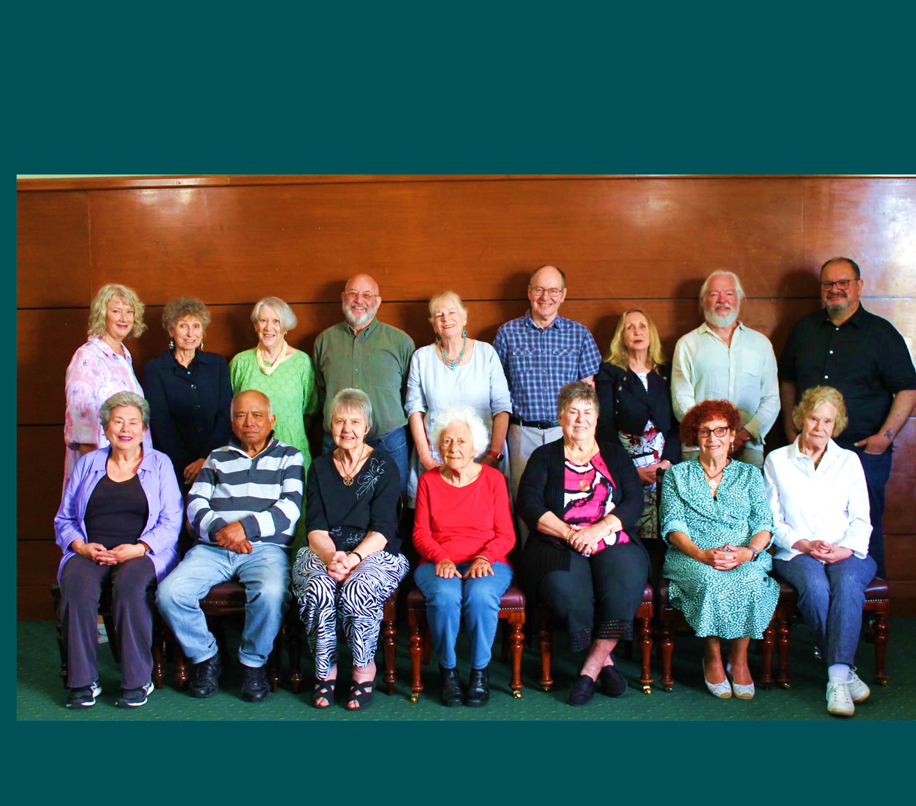


Older Persons Advisory Committee (OPAC)
Annual Report
January to December 2024



City of Port Phillip
99a Carlisle Street
St Kilda VIC 3182
Phone: ASSIST 03 9209 6777
Email: portphillip.vic.gov.au/contact-us
Website: portphillip.vic.gov.au

Divercity
Receive the latest news from your City and Council portphillip.vic.gov.au/divercity



National Relay Service
If you are deaf or have a hearing or speech impairment, you can phone us through the National Relay Service (NRS):
TTY users, dial 133677, ask for 03 9209 6777.
Voice Relay users, phone 1300 555 727,
then ask for 03 9209 6777.
relayservice.gov.au


Contents
OPAC Annual Report 2024 4
Acknowledgement of Country 4
About OPAC 4
The Stated Purpose of the OPAC: 4
Message from the 2024 Chair 5
OPAC Terms of Reference Objectives 6
OPAC Key Achievements 2024 7
Membership 8
Election of Office Bearers 9
Membership, Recruitment and Nominations 10
OPAC Plan - January to December 2024 10
Meetings 10
Subcommittees and Working Groups 11
About the OPAC Governance Subcommittee 11
Membership and Representation 12
Council Advisory Committees/Networks: 12
External Community Groups/Networks: 12
Consultation 12
2024 Council Business – OPAC Consultations, Feedback and Information 13
Matters Affecting Older Residents Highlighted to Council by the OPAC Members 16
OPAC Activities and Engagement 17
OPAC Events 17
Opening a St Kilda Film Festival free event for Port Phillip at the Alex Theatre (June 2024) 18
OPAC Chair Wendy Priddle MC’ed and facilitated the St Kilda Film Festival ‘Ageing 18
City of Port Phillip Seniors Festival 1 to 14 October 2024 18
Acknowledgement 20

OPAC Annual Report 2024

Acknowledgement of Country
In accordance with the strategic vision advocating to the Community and Council on behalf of older residents, including First Nations people, OPAC respectfully acknowledges the traditional owners of the land, the people of the Kulin Nations. We pay our respects to their Elders, past present and emerging and support their right to be heard and recognised.

About OPAC
The Older Persons Advisory Committee (OPAC) has been appointed by the City of Port Phillip Council to be its main advisory body on all issues affecting older residents living in the City of Port Phillip. Encompassing a wide range of backgrounds and views, the OPAC is accessible and engaged.

The Stated Purpose of the OPAC:
The Older Persons Advisory Committee will provide advice to Council and council officers about policies, plans and services affecting older people.
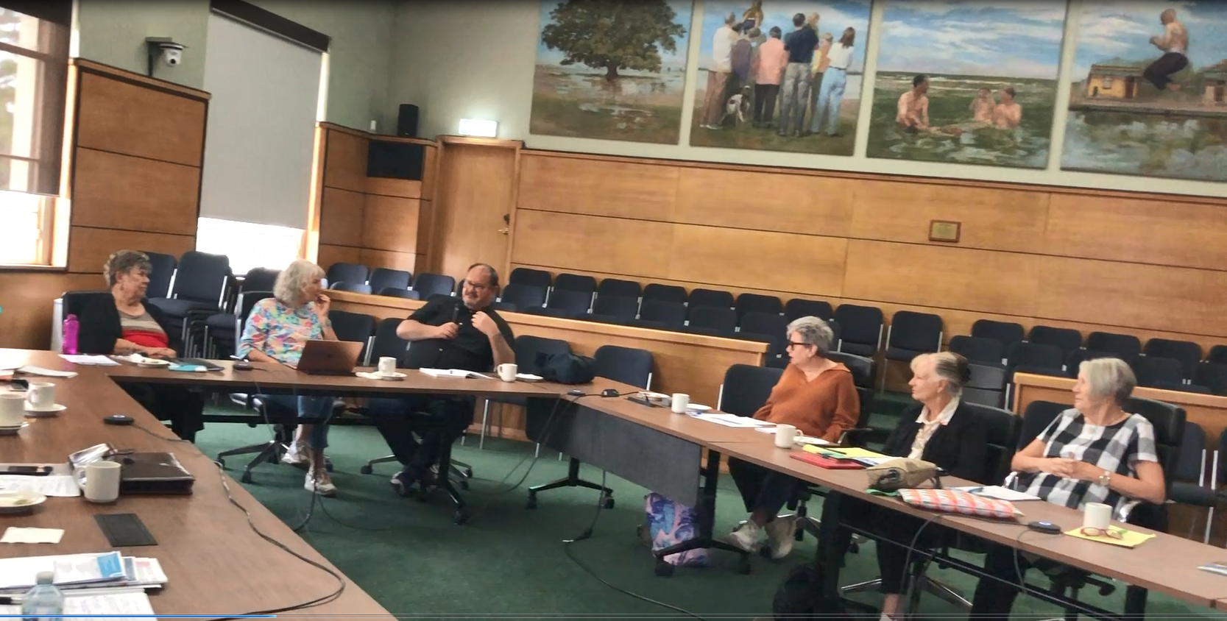
Image – OPAC Meeting February 2024.

Message from the 2024 Chair
Welcome to the 2024 OPAC Annual Report.
2024 was a truncated year for OPAC - Council elections in October 2024 meant that we did not meet during the four-week caretaker period from mid-September through to the end of the year when the new Council endorsed the continuation of the Committee and appointed a Councillor representative.
OPAC nominated its focus areas at our January 2024 Planning Day and expanded our working groups to improve our focus in a shorter year.
We worked closely with Council on the new approach to care service to the elderly in their homes and monitored the transition to new providers with monthly reports from Council Officers, providing valuable feedback to Council from clients.
A 2024 highlight was the reintroduction of the OPAC Forum, paused due to 2020 Covid restrictions. Given the changes to aged care services, we offered an information session on the different types of care available in Port Phillip, including in-home and residential services.
At the 21 August Council meeting, Cr Peter Martin proposed a Notice of Motion that the three Advisory Committees’ terms be extended to Jun 2025. It had been intended for OPAC (as well as the LGBTIQA+ and Multi-Cultural Committees) to finish up at the end of the Council term. It would take some time, potentially months, for new Committees to be up-and-running, and representation of older, multi-cultural and LGBTIQA+ residents would be limited to personal submissions to the new Council Plan and Budget for 2025-2026.
This Notice of Motion was passed, and OPAC will continue through to June 2025.
OPAC tries very hard to represent the diverse voices of Port Phillip’s older residents. We welcome questions and feedback via My Port Phillip and look forward to applications for new members later in the year should Council decide to continue with the Older Persons Advisory Committee.

Wendy Priddle
OPAC Chair

OPAC Key Focus Areas 2024
- Positive Ageing Policy Implementation, Aged Care Reforms and Ageism Awareness (actively engage)
- Council Plan & Budget 2024/25 (input)
- Health & Wellbeing (actively engage with Council on these issues)
- Public Spaces and Physical Environment (actively engage with Council on these issues)
- Housing and Homelessness (stay informed/provide advocacy support if applicable)
- Transport (actively engage with Council on these issues)
- Communications (input).

OPAC Terms of Reference Objectives
- To be the peak advisory and advocacy body on issues affecting the wellbeing of older people (55 years and over) within the Port Phillip municipality.
- To be representative and advocate on behalf of older persons from our diverse community including people with disabilities, people who identify as lesbian, gay, bisexual, transgender or intersex (LGBTI), people of Aboriginal or Torres Strait Island background, people experiencing financial disadvantage (including people who are homeless or at risk of homelessness) and our multicultural and multifaith communities.
- To provide advice to Council and its officers on policies, plans and services that affect older people and their interests, and encourage the Council to advocate to other levels of government.
- To advocate to the Community and Council, on behalf of older people, reflecting the United Nations Aged Friendly Cities Framework and the principles of independence, participation, care, self-fulfilment, and dignity.
- To connect with other relevant internal and external community advisory committees. To liaise with other organisations and networks that have a direct interest in older persons in the City of Port Phillip and the wider community.
- To continue to advocate for and support significant events, activities and services relating to older persons, including Port Phillip Seniors Festival, Linking Neighbours Program and Seniors Register, information forums, aged care services and the like.

OPAC Key Achievements 2024
It is to be noted that the key achievements for 2024 were limited due to reduced time sitting in compliance with Council’s election policy. Throughout 2024, OPAC increased advocacy in focus areas that were identified at the beginning of the year at its’ planning day. There is an ongoing commitment by all members to voice the perspective of the older person on matters that are being addressed by Council.
Activity | Achievement
OPAC worked to ensure Council continues to consider the needs of older persons in relation to health and wellbeing, transport, housing, accessibility the built environment and public spaces. | OPAC consulted with Council Officers about the Positive Ageing Policy Implementation Plan, Council Caretaker and Election Period, South Melbourne Structure Plan and the Housing Strategy Phase 3.  On various occasion throughout 2024, OPAC members presented on matters of priority to older persons at Council meetings.
Through its Council Plan and 2024/25 Budget Submission, OPAC joined with the community to advocate for changes and improvements to a number of significant programs and services affecting older people.  The OPAC Council Plan and 2024/25 Budget submission aligned to Council’s strategic objectives and complimented the implementation of Positive Ageing Policy. | Changes implemented in 24/25:  - Council advised that the 2024/25 budget for community programs, including digital literacy programs, has been enhanced. Libraries have also purchased 20 iPads that are available for public loan. There are programs and workshops to support library users, and library staff are also  available to provide one-to-one device advice each week across all library branches. This service can be increased based on demand.
The OPAC raised awareness with Council’s Live Music Lead the lack of live music options of older people of Port Phillip. Many events are held in the evenings and on weekends making it difficult or less safe for older residents to participate. | As a result of direct advocacy work through the Communications working group of OPAC there were additional live performances that were offered to older residents during the day. One such example is Little Pine Trees production of the Dame Vera Lynn Tribute Show at the St Kilda RSL venue where approximately 80 people attended.
OPAC held a positive ageing forum called ‘Ageing Gracefully in Port Phillip’ in June. | The forum was a positive ageing initiative created by OPAC with the aim to provide information and facilitate a conversation between older CoPP residents and their adult children about how they hope to live their best lives going forward whether that be ageing in place at home, with support where needed or by going into some form of residential care.
Advocated for the 6 month extension of Advisory Committees to input into the new Council Plan and support the transition for new Councillors. | At the August 21 Council meeting, a notice of motion was passed stating that Council extends terms of the Older Persons Advisory Committee, Multicultural Advisory Committee, and LGBTIQA+ Committee, to June 2025, allowing them to hold annual planning days and participate in the Integrated Council Plan and Budget process.

Membership
Current Members | Location
Neville Aphoy | St Kilda East
Judith Armstrong | Elwood
Kevin English | Albert Park
Freda Erlich | St Kilda
Janet Gardner | Elwood
Betty Knight | Albert Park
Coralie Ling | St Kilda
Ada Lubin | St Kilda
Jeanette Lyons- McKinnon | Port Melbourne
Ian MacDonald | St Kilda
Sue McGowan | Port Melbourne
Wendy Priddle | Elwood
Rosemary Rule | Port Melbourne
Liz Robson | Port Melbourne
Vasileios Tsialtas | St Kilda
Richard Whitfield | Port Melbourne
Office Bearers | Position
Wendy Priddle | Chairperson (appointed March 2023)
Ian MacDonald | Deputy Chairperson (appointed March 2023)
Council Representative | Ward
Cr Peter Martin (until 17 September 2024) | Gateway Ward
Council Officer/s | Position
Cathy Horsley | Team Lead Community Building
Simone Jamieson | Acting Team Leader Community Building
Gavin Murphy | Coordinator Grants and Community Building

Election of Office Bearers
The OPAC Terms of Reference (adopted 16 June 2021) state ‘the Chair and Deputy Chair will be nominated from among the members. The Chair and Deputy Chair will serve a one-year term, with the appointment renewable for an additional consecutive term’.
At the meeting 5 February 2024 Wendy Priddle and Ian McDonald resigned as Chair and Deputy Chair respectively having completed their term as outlined on the OPAC Terms of Reference.
OPAC members were invited to nominate for the vacant positions. Nominations were open from 31 January to 19 February 2024. Five members were nominated, two members accepted their nomination, one for Chair, one for Deputy Chair.
At the meeting 4 March 2024 quorum was achieved and the two nominees were unanimously endorsed by members in attendance without the need for a vote. The following members were re-elected at the 4 March meeting:
- Wendy Priddle - Chair
- Ian MacDonald - Deputy Chair

Membership, Recruitment and Nominations
Throughout the calendar year 2024, the OPAC membership remained unchanged. There were consistently 16 members for the entirety of 2024 therefore no new members were recruited during this period.

OPAC Plan - January to December 2024
The OPAC create an action plan for each year and the planning meeting was held on Wednesday 17 January 2024 and was made up of the OPAC Chair, Deputy Chair and twelve members of the OPAC who nominated to participate. Team Leader Community Building also attended/contributed to provide relevant information and administrative support.
The 2024 Objectives and Plan was developed within the context and aligned to the following documents:
- OPAC Terms of Reference
- City of Port Phillip Council Plan 2021-31
- City of Port Phillip Health and Wellbeing Implementation strategy
- World Health Organisation (WHO) Age Friendly Cities (AFC) Framework.

Seven Key Focus areas were identified and aligned to the Council Plan and AFC Framework; they were:
- Positive Ageing Policy/Aged Care Reforms (Changes to Aged Care Services)
- Council Plan & Budget 2024/25 Input
- Health & Wellbeing
- Public Spaces and Physical Environment
- Housing and Homelessness
- Communication.
- Transport
The draft 2024 Action Plan was endorsed by the OPAC via email after the 3 March 2024 meeting.

Meetings
The OPAC continued to meet monthly. Meetings were held from February to September (stepping down on the 17 September until 26 October due to the election period). A quorum at each meeting was upheld. A total of eight OPAC meetings were held in 2024. In addition to monthly committee meetings OPAC worked collaboratively with the Community Services Team to provide feedback about the Council’s changes to Aged Care Services.
OPAC members continued to consult on matters relevant to older people residing in the City of Port Phillip and deliberated on specific council matters concerning older people and the broader community. Community trends relevant to council were identified through OPAC meetings where reports were provided from OPAC representatives. The OPAC continued to maintain connections with relevant associations and participate in relevant networks and forums both within and external to Council.

Subcommittees and Working Groups
The following OPAC Working Groups and Subcommittees were maintained/established to progress the actions highlighted in the 2024 Action Plan:
  - Seniors Festival Subcommittee
  - Governance Subcommittee
  - Public Space and Physical Environment Working Group
  - South Melbourne Market Working Group (subgroup of the PS &PE)
  - Communication Working Group
  - Housing and Homelessness Working Group
  - Council Plan Working Group (ceased after budget submission in March)
  - Positive Ageing Working Group
  - Transport Working Group
  - Health and Wellbeing Working Group
  - Sport and Recreation Working Group (subgroup of Health & Wellbeing Working Group)

About the OPAC Governance Subcommittee
The OPAC Governance Subcommittee was established in 2020 to support the OPAC to develop guidelines and processes to ensure OPAC meetings run effectively and efficiently. Where appropriate it has a role in implementing decisions taken by OPAC.
In 2024 the Governance Subcommittee utilised the following tools to assist with its stated aim of efficient and effective operations:
- OPAC Governance Sub Committee Guidelines
- Guidelines for the establishment of OPAC Working Group and Sub-Committees
- Agenda setting and meeting procedures
- Consultation guidelines for council officers
- Process for introducing New Items for action by OPAC
- Procedure for Subcommittees and Working Groups.

Membership and Representation
OPAC members represented the following associations/networks and reported relevant activities at the OPAC monthly meetings.

Council Advisory Committees/Networks:
  - Linking Neighbours Leadership Group - Neville Aphoy, Sue McGowan
  - Port Phillip Multicultural Advisory Committee - Bill Tsialtas
  - Port Phillip Multifaith Network - Coralie Ling.

External Community Groups/Networks:
  - Bicycle Users Group – Freda Erlich
  - Elwood Croquet Club – Judith Armstrong
  - Fishermans Bend Urban Renewal Area (FBURA) – Cr Martin
  - Port Phillip Citizens for Reconciliation – Rosemary Rule
  - University of the Third Age Port Phillip (U3APP) – Kevin English.

Consultation
As part of the consultative role of the OPAC, council officers regularly sought advice and feedback on council activities and initiatives relating to the needs, engagement, and inclusion of older people. In turn the OPAC brought to the meetings feedback and issues on council business that were raised by the community.
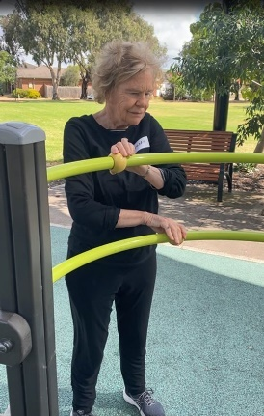
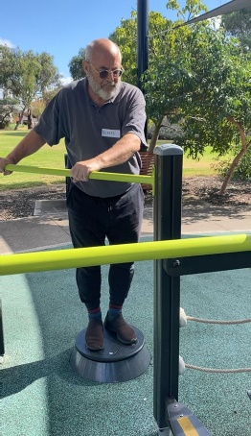
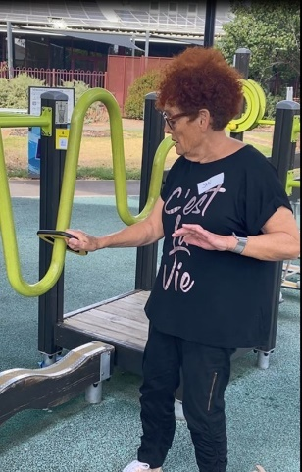

Image – OPAC members exploring a senior’ exercise park in Hoppers Crossing

2024 Council Business – OPAC Consultations, Feedback and Information
Draft Council Plan and Budget (Year 4)
OPAC, though robust discussion and the prioritising of issues affecting older people in Port Phillip put forward the following 24/25 budget submission request:
- Council to have a dedicated Positive Ageing Team
- The Community bus to include more hospitals and broader promotion of South Port Day Links
- Additional digital literacy education via the Port Phillip Library Service
- Well designed seating in public places
- Items requiring additional funding request:
  - Seniors exercise park equipment
  - Disability Advisory Committee

Consider future needs:
- Funding reserves for social housing beyond the 24/25 budget.
Advisory Committee Term Extension (February meeting with Governance)
OPAC advocated to extend the terms of the Older Persons Advisory Committee, Multicultural Advisory Committee, and LGBTIQA+ Committee, to June 2025, allowing them to hold annual planning days and participate in the Integrated Council Plan and Budget process. A notice of motion was moved at the 21 August 2024 Council meeting. It was accepted that OPAC would cease meeting activity from the beginning of the election period on September 19 and resume activities once Councillors were elected in late November 2024. OPAC did not have any ordinary meetings after September for the remainder of 2024 as a Councillor representative was appointed in mid-December 2024. Part of the extension will include the development of a standardised terms of reference to be adopted by each advisory committee.
Roll out of Village Model in Aged Care Services in Port Phillip (February to September)
OPAC was updated and consulted on the changes to Age Care Services throughout 2023 and remained a significant sounding board during 2024 for the Community Services team.
Once the changes to Aged Care Services delivered by Council were pass in February 2024, OPAC received monthly updates on changes to aged care services and provided feedback and comment on the transition process from Council providing in home care to the Village Model. The transition period was from February 2024 to September 2024. The contribution from OPAC members on this change was critical for Council officers to ensure a smoother transition. OPAC members raised the questions and concerns voiced from older residents in their networks such as sporting clubs, social clubs and neighbours. At the August meeting, OPAC met the first appointed Community Connector and were able to offer support for the role and insights from the older resident community throughout the process thus far.
Positive Ageing Policy Implementation (February, April and August)
OPAC received regular updates from council officers regarding the implementation plan of the Positive Ageing Policy and it’s established six goals. As reporting for the Positive Ageing Policy is quarterly the updates from the Senior Divercity Officer will align with reporting. This level of updating supports OPAC members with alignment in their advisory and advocacy work.
Engagement - Draft South Melbourne Structure Plan (March)
OPAC were presented with the Draft South Melbourne Structure Plan that they had previously had input into during Phase 2. The plan is about improving South Melbourne’s capacity to work with increased population. Engagement was to be completed prior to the Caretaker period in September 2024. Initial input from OPAC was to focus on shade/cool spaces, seating, footpaths and toilets.

Housing Strategy Phase 3 Engagement (March and April meeting)
OPAC were presented with the engagement opportunity at their April meeting into the Housing Strategy Phase 3. OPAC had the opportunity to respond to key engagement questions on the strategy including what the most important housing needs are for the next 15 years, is a target growth of 10% realistic and has the engagement process been adequate. OPAC provided feedback on the Housing Strategy Phase 3 Engagement and provided a formal response to Council.
Update and Feedback on Port Phillip Library Services- Adult Programs (July 2024)
Thea Guiry-Stewart Local History and Heritage Programs Librarian, Emma Black Adult programs Librarian attended to gather information and insights from OPAC regarding the usability and offerings of the Library through their What’s On Page. OPAC was able to add suggestions to the already impressive programming and share insights from their learnings from the Ageing Gracefully Forum.
Engagement plan to develop the next Community Safety Plan (2025-2029) (August 2024)
OPAC was asked to help inform the development and engagement process for the next Community Safety Plan. There was a presentation of some of the engagement that had already taken place before the public engagement occurs. The was very strategic design in the engagement plan to assist differentiating between perceived and real safety concerns. OPAC are committed to ongoing consultations and engagement on the topic of Community Safety.
New Council Plan and Budget
In December an invitation was extended to OPAC, as valued members of the Older Persons Advisory Committee, to participate in the early stages of the development of the Plan for Port Phillip 2025-29. In addition to this end of year workshop, a letter of thanks for OPACs service was sent from CEO Chris Carroll to thank the members for their significant contribution to Council in 2024.
At the dedicated workshop, designed specifically for members of Council's Advisory Committees. Topics discussed were the 10-year Community Vision and making sure it’s still relevant to the Port Phillip community. OPAC was asked what they think Council should prioritise over the next four years. The feedback will help inform the development of the new Council Plan, which will be known as the Plan for Port Phillip 2025-2029. This is a crucial Council document and OPAC’s input on was invaluable.

Matters Affecting Older Residents Highlighted to Council by the OPAC Members
Advocacy for Live Music for older residents
OPAC met with St Kilda Festival Lead about live music events for seniors. OPAC Chair Wendy also met with the Live Music regarding more live local music in the daytime. A scoping of current daytime entertainment that is only advertised through digital formats leaving those with little to no digital literacy skills unaware of local daytime entertainment options.
Response regarding the closure of the St Kilda Blessington Street Post Office
OPAC wrote to Council regarding the planned closure of the St Kilda South Post Office strongly advocating for reconsideration (June). OPAC also wrote to State and Federal governments to express concern over the impact the closure would have on local near by older residents who rely on the post office for a multitude of transactions such as bill paying, cash withdrawal (since most banks have closed) and postage.
Older person physical activity for health and wellbeing initiatives
OPAC worked with the Sport and Recreation Team and Linking Neighbours (LN) to advocate for a Pickleball come and try day in April. The day was very successful with approximately 8 participants enjoying the activity and quickly learning the skills required to play. Particularly playing with peers with similar skills and knowledge. Linking Neighbours in partnership with Port Phillip Life Activities Club have since taken the lead on regular Pickleball activities.

OPAC also met with Sport and Recreation regarding senior’s exercise stations/parks. OPAC members conducted a visit to the Hoppers Crossing Seniors Park in September to gain insight to the benefits of the senior exercise installations. Whilst a request for a senior park was included in the OPAC budget submission 24/25 and unsuccessful, OPAC remains committed to lobbying for an exercise station/park via the upcoming review of the Sport and Recreation Strategy.
Older person ongoing commitment to Council’s ten-year integrated transport strategy
OPAC met with the transport team and participated in free bike education session May. The Bike Education session was promoted via libraries and community centres targeting older bicycle users.
OPAC provided feedback to Council about the e-scooter trial in May. OPAC submitted a response and presented at a Council meeting on the topic of e-scooters.
OPAC review of the usability of the Council Website
OPAC met with Communications and Brand team to feedback on council communications and website useability including accessibility.
OPAC environment and public space focus
OPAC met with Manager Parks and Infrastructure Maintenance to discuss concerns about footpath repair management.

OPAC Activities and Engagement
Correspondence via Port Phillip Council on matters affecting Older persons
OPAC provided letters of support for:
- CoPP Broadway Bridge safety project grant - OPAC provided correspondence in support of Council’s Broadway Bridge grant application through the Safer Local Roads and Infrastructure (SLRI) program. Notably, in favour of advocating for older residents who use the bridge as a pedestrian footpath and against heavy truck use of the bridge.
- A letter to Senator the Hon Penny Wong, Minister for Foreign Affairs advocating for the government to participate in the UN convention on the human rights of older persons: supporting Australia’s engagement in the 14th session of the UNGA Open-ended Working Group on Ageing (20-24 May 2024).

OPAC Events
Ageing Gracefully Forum presented by OPAC on 15 June 2024
The aim of the Forum was to provide information and facilitate a conversation between older CoPP residents and their adult children about how they hope to live their best lives going forward whether that be ageing in place at home, with support where needed or by going into some form of residential care.
The Forum took place at the South Melbourne Community Centre and approximately 80 people attended the free 90-minute event. There were short talks followed by a 30-minute Q&A.

Speakers included, Elder Judith Jackson, Cr Heather Cunsolo, Mayor, Wesley Smith, CEO of CaSPACare along with a resident to talk about options and strategies to maintain social connections, happiness and comfort in later years, and lived experience in aged care. Followed by Ann Whitfield, a retired Intensive Care Specialist to talk about having difficult conversations with families to help loved ones age in place at home. Council’s Bridget Monro-Hobbs, Manager Community Services talked about how to access Aged Care Services in the City of Port Phillip, and finally Nadine Hibbert talked about decision making when one parent wants to age in place at home, while the other wants to enter aged care. The feedback from this forum event was overall positive with interest from participants for further information and ongoing connection with Council.
Image – Header of the Ageing Gracefully Forum promotion, June 2024

Opening a St Kilda Film Festival free event for Port Phillip at the Alex Theatre (June 2024)

OPAC Chair Wendy Priddle MC’ed and facilitated the St Kilda Film Festival ‘Ageing Disgracefully’ session on 10 June. The free event was extremely well attended and screened short films targeted for an older audience. At the end of the screening, there was an invitation for the film directors to have a public conversation with Wendy on the stage. The St Kilda Film Festival events team stated that it was a successful format and may feature in future Film Festivals to promote inclusivity.

City of Port Phillip Seniors Festival 1 to 14 October 2024
The annual Port Phillip Seniors Festival celebrates the lives of older people and promotes positive ageing through a range of diverse and vibrant events and activities across the city.
The 2024 Seniors Festival included 43 exciting Council and community led events and activities across the municipality with an estimated total attendance of 2,100+.
The festival launch at Middle Park Bowling Club held on Saturday 5 October attracted 100 people who enjoyed the 80s Enuff band performing music from the 80s. The event was further supported by three council staff from the Community Wellbeing and Inclusion Division who volunteered at the event.
Programs and activities on offer in Port Phillip’s 2024 Seniors Festival included croquet, community choirs, bowling, yoga with live music, storytelling, indigenous art workshop and many more vibrant activities with a focus on providing a more inclusive program.
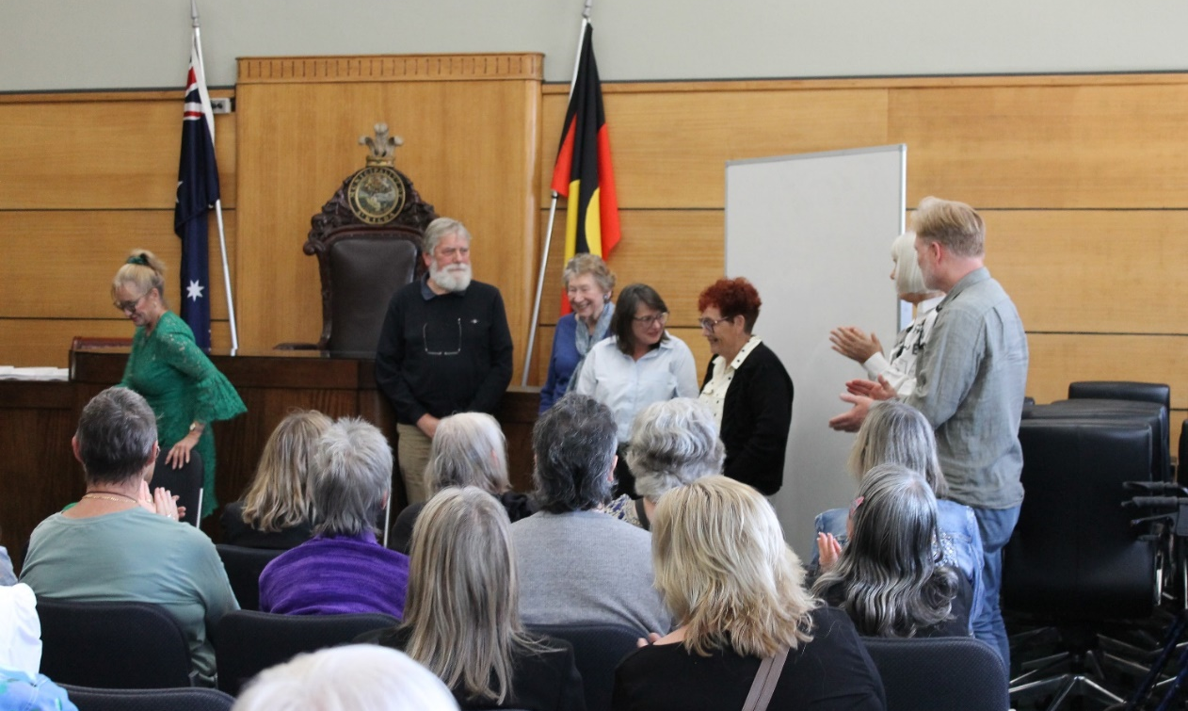
Image – Port Phillip Writing Awards 2024 (the closing event of the festival)

The festival also included a series of public events and showcases presented by the Port Phillip Library Service and the University of the Third Age Port Phillip in partnership with the Seniors Festival Subcommittee using codesign principles for delivery.
The 2024 festival closed with the largest ever 20th Port Phillip Writes Seniors Festival Writing Awards also co-designed and delivered by community members with strong writing backgrounds.
This year’s festival was unaffected by the election period and could be delivered as it was considered essential to Council operations however there could be no Councillor’s addressing participants.
The full program and the 2024 edition of Port Phillip Writes are available to download from the Council website.

Acknowledgement

The OPAC would like to acknowledge the support throughout the year of the Councillor nominated by the Council to support the OPAC, Cr Peter Martin.

This report was prepared by Simone Jamieson Team Leader Community Building in consultation with the 2024 OPAC Chair and Committee. It was confirmed by the OPAC Committee at the 17 February 2025 OPAC meeting.

Wendy Priddle
OPAC Chair

