Public Art Developer Guidelines
2019
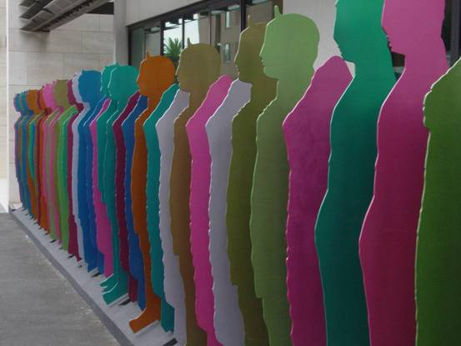

Contents

Visualising vibrant development 3
City of Port Phillip’s percent for art scheme and developer contribution 4
Principle 1: Responsive Design 4
Principle 2: Integrated Art 4
Approval process for developer contributions 5
Stage 1: Development application 5
Stage 2: Completion of artwork prior to occupancy 5
Assessment criteria 5
What is public art? 6
What is the difference between art and design? 6
Key differences 7
Key roles of artists 7
Art projects eligible for consideration include: 7
Art projects that are not eligible for consideration include: 7
Who is a professional artist? 8
Contact 9

Cover: Julia Gorman Over and Over 2009
Esplanade Apartments, St Kilda

Visualising vibrant development
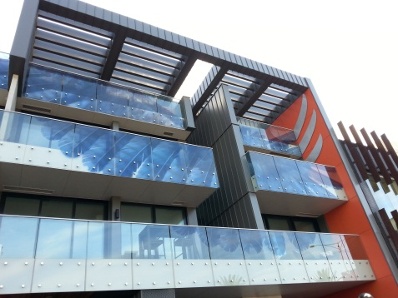
Vicki Couzens, Jeph Neale and Hilary Jackman 2013
40 Beach Street, Port Melbourne

The City of Port Phillip is a municipality with wide-ranging social, physical, historical, environmental and cultural qualities, and a reputation for innovation, creativity and inspired contemporary art that addresses local meaning and associations.
The City of Port Phillip considers public art as an integral part of any development and expects that it will be integrated into project proposals from inception.
Urban design responds to the identity of place and public art contributes to the way we visually perceive and physically inhabit public space. Public art can encourage sustainable cultural and economic activity and can be attractive to existing or potential residents, employers and investors.
Public art adds to the community’s sense of identity and local pride, engages audiences and provides ways of understanding the city’s history, future and places.
Private developers have an important role to play in improving and illuminating the intrinsic strengths and characteristics of the areas they develop. Artists can have a role in helping the design team identify and reflect local character and themes. Collaborations between developers and artists are critical to the success of public art projects.
Public art projects enhance the way people engage with a place and lend sophistication, beauty and interest to developments as well as providing a focal point for media and publicity.
These guidelines assist developers to incorporate public art in proposed developments as required in the Public Art Guidelines 2017.

City of Port Phillip’s percent for art scheme and developer contribution

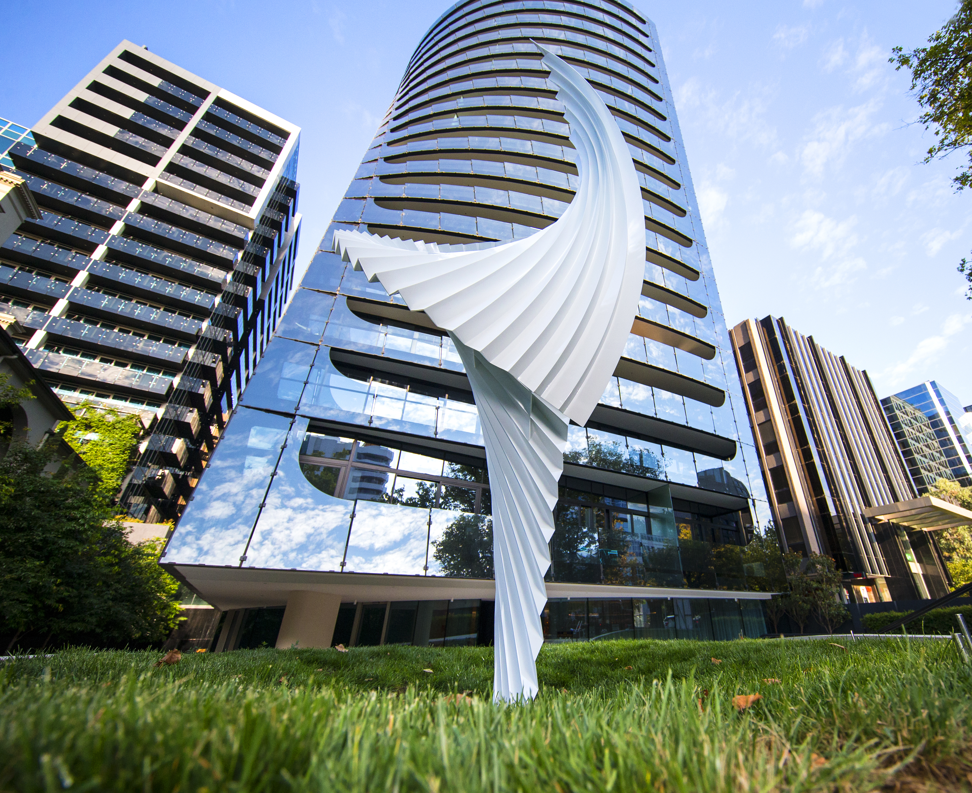
Matthew Harding Opera 2019
450 St Kilda Road, Melbourne. Photo courtesy ADA Consulting

The City of Port Phillip adopted a percent for art scheme in 2002 through its Urban Art Strategy. This scheme is maintained in our current Public Art Guidelines 2017 and is applicable to all the City’s residential and commercial developments.
Private developers are required to contribute to a public art outcome in accordance/proportion with the estimated construction cost.
The percent for art scheme requires all new developments, where the total project cost (as shown on the Planning Permit Application Form) exceeds two million dollars of the total build, to provide a 0.5 % public art contribution that addresses Principle 1 and 2 of the Urban Art Strategy 2002.
Developers are required to contact the Public Art Officer about the approval and clearance processes.

Principle 1: Responsive Design
The City of Port Phillip commits to a responsive design approach for the development of Public Art, which reflects the identity of place, community values and innovation and creativity.

Principle 2: Integrated Art
The City of Port Phillip commits to a relational art approach, which will ensure public art demonstrates appropriate aesthetic appeal, functionality and utility in design development. Within this approach, art emphasises integration (e.g. response, memory and facilitation for ‘place-making’), and/or promotes intervention (e.g. provocation, parody and challenge for ‘agenda-setting’).

Approval process for developer contributions
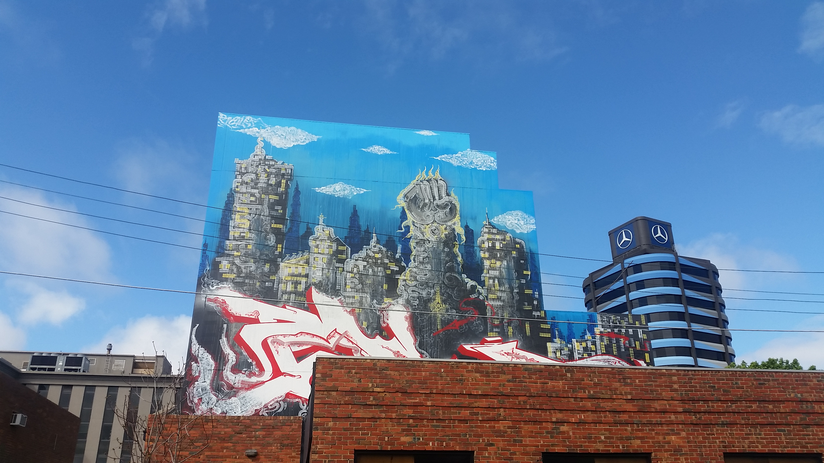
Bailer 2017
Coventry Street, South Melbourne
The City of Port Phillip oversees public art developer contributions through two stages that are aligned with the planning process.

Stage 1: Development application
Once the trigger opportunity for public art has been identified, the developer must submit an Application for public artwork design approval (Attachment 1) to the Public Art Officer. Developers are encouraged to discuss public art proposals with the Public Art Officer prior to submission.

Stage 2: Completion of artwork prior to occupancy
The public artwork must be completed prior to the first occupation of the new development and a Notification of artwork completion (Attachment 2) must be submitted to the Public Art Officer.

Assessment criteria
The public art contribution will be assessed in accordance with the City of Port Phillip’s Public Art Guidelines 2017.
- It is an original artwork/s designed and created by a professional artist/s.
- Artwork/s can be clearly seen from or is located in the public realm.
- The artwork/s contributes to an attractive, stimulating and functional environment, and does not detract from the amenity or safety of the public realm.
- The public artwork is durable.
- The artwork achieves standards of excellence and innovation.

What is public art?
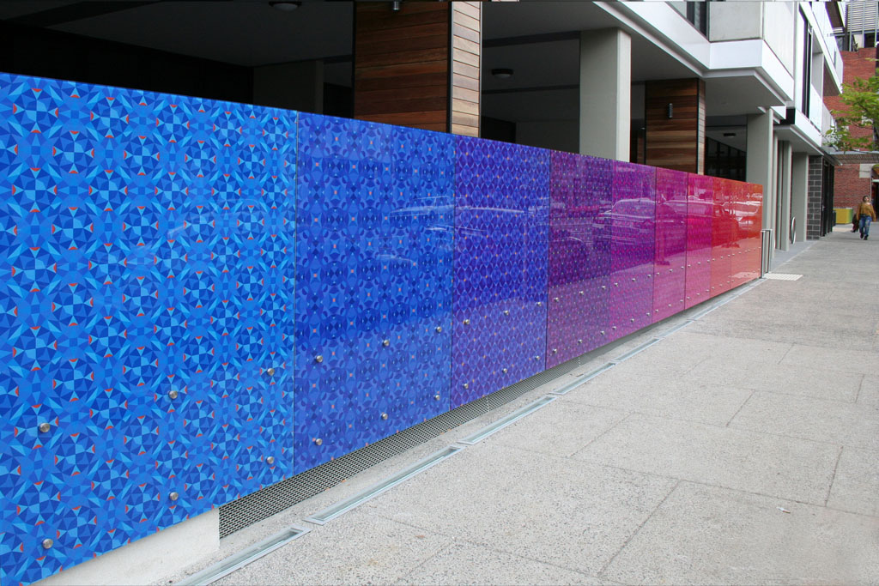
Elizabeth Gower Inkerman Oasis 2013
21 Inkerman Street, St Kilda

Public art can be defined as the process of producing artists’ creative ideas in the public realm. The definition captures a varied and flexible scope for public art projects and ensures that developers are not limited in their scope and thinking when considering the possibilities for working with artists.
Artists play a critical role in highlighting, monitoring, recording, expressing and responding to the world around us. The City of Port Phillip recognises the important role that artists can contribute towards the health and wellbeing of the city.

What is the difference between art and design?
The fundamental difference between art and design is their purpose.
The process of creating a work of art starts with nothing. A work of art stems from a view or opinion or feeling that the artist holds. Art is created to share that feeling with others, to allow the audience to relate to it, learn from it or be inspired by it.
When a designer sets out to create a new piece, they almost always have a fixed starting point, whether it’s a message, an image, an idea or an action. The purpose is to motivate the audience to do something: buy a product, use a service, visit a location or learn certain information.

Key differences
- Art asks questions – design solves problems.
- Design fills a need – art fills no need except to exist and engage the viewer.
- Design solves a problem using rules of design – art has no process that can be replicated across the board to achieve an optimal result.
- Good art is interpreted – good design is understood.

Key roles of artists
- Artists as members of design teams can work collaboratively and contribute to the use and form of urban planning and development through research, reflection and propositions.
- Artists work to creatively engage with communities in order to explore and articulate issues of significance.
- Artists work as commentators producing permanent, temporary or process based art.

Art projects eligible for consideration include:
- The work of an artist working individually, with the community or in collaboration.
- Art that encourages awareness or challenges ideas.
- Art that enhances a sense of play and celebration.
- Art that engages with aspects of contemporary art and design.
- Art that provides an artistic interpretation of historical research.
- Art that encourages interaction with a social space.

Art projects that are not eligible for consideration include:
- Commercial promotions in any form.
- Art projects that are mass produced, such as fountains or playground equipment.
- Most art reproductions.
- Landscaping or generic hard-scaping elements which would normally be associated with the project.
- Services or utilities necessary to operate or maintain artworks.

Who is a professional artist?

Geoffrey Bartlett Orion 2008
430 St Kilda Road, Melbourne

Professional artists will be eligible to carry out public art commissions.
A professional artist is a person who:
- Usually has experience or a university degree/ TAFE Diploma in visual arts.
- Who has specialist training and/or experience within their field and are involved in the creation of art as their profession.
- Has conceptualising and creative skills that result in the creation of artwork.
- Has demonstrated professional standing through exhibitions and commissions.

Selecting an artist
There are several ways a developer can access and select an appropriate artist for their project:
- General advice from the Public Art Officer
- Approaching and working with commercial and independent galleries. A list of galleries may be found through publications such as Art Almanac https://www.art-almanac.com.au
or Art Guide Australia https://artguide.com.au/
- Engage an art consultant
- Develop an Expression of Interest competitive model and advertise through relevant art networks

Contact
Public Art Officer
City of Port Phillip
Email: publicart@portphillip.vic.gov.au

Attachment 1

Application for artwork design approval
Address of development………………………………………………………………………………

Name of applicant……………………………………………………………………………………..
Applicant’s address……………………………………………………………………………………
Telephone………………………………………………………………………………………………
Email…………………………………………………………………………………………………….

Name of architect/designer…………………………………………………………………………
Architect/designer address……………………………………………………………………………
Telephone………………………………………………………………………………………………
Email…………………………………………………………………………………………………….

Name of Council Planner……………………………………………………………………………

Name of Artist…………………………………………………………………………………………
Artist’s address…………………………………………………………………………………………
Telephone………………………………………………………………………………………………
Email…………………………………………………………………………………………………….

Budget for total development $

Budget for Public Art (0.5% of budgets $2m or more) $

Anticipated artwork installation completion date……………………………………………..

Proposed artwork
- Description of proposed artwork
Please attach documentation which describes the proposed artwork including:
- Information about the artist (such as curriculum vitae)
- Artist/s concept
- Relationship to the building design and surrounding area, location, size, materials, life span and accessibility to the public
- Artwork documentation
Attach documentation which includes drawings of the proposed artwork that show colours, materials, dimensions, and an indication of maintenance required
- Location of proposed artwork
Attach plans that show the proposed artwork location in relation to the building and site
- Artwork budget
Attach a detailed artwork budget including artist’s fee

Artwork proposal assessment
City of Port Phillip officers assess applications based on the following criteria:
- That the public art contribution is provided in accordance with the City of Port Phillip’s Public Art Guidelines
- It is an original artwork/s designed and created by a professional artist/s
- Artworks can be clearly seen from, or are located, in the public realm
- The artwork/s contributes to an attractive, stimulating and functional environment, and does not detract from the amenity or safety of the public realm
- Durability and maintenance of materials and site
- Relevance of the work in context of the development and the site
- Standard of excellence and innovation

Please return the completed form to the Public Art Officer, City of Port Phillip either by email publicart@portphillip.vic.gov.au or by mail to PO Box 3 St Kilda, Victoria 3182

Attachment 2

Notification of artwork completion
I,………………………………………………..of……………………………………………………
Company name………………………………………………………………………………………
Address………………………………………………………………………………………………..
Contact email/phone…………………………………………………………………………………
Advise that the artwork has been installed and completed.

Accordingly, I hereby advise that the City of Port Phillip may inspect the site to ensure the artwork complies as approved.

Development address details………………………………………………………………………
Please attach photographic documentation of installation and in situ images of completed and installed artwork.
Complete this section if you wish to be present at the site inspection and a meeting will be arranged with the Public Art Officer
Name…………………………………………………………………………………………………
Email address……………………………………………………………………………………….
Contact phone………………………………………………………………………………………
Owner/applicant signature…………………………………………………………………………
Date of notification………………………………………………………………………………….

Please return the completed form to the Public Art Officer, City of Port Phillip at publicart@portphillip.vic.gov.au or by mail to PO Box 3 St Kilda, Victoria 3182.
The information you provide is protected by the City of Port Phillip Information Privacy Policy
The personal information requested on this form is being collected by the council for the assessment of art applications. The personal information will be used solely by the council for that primary purpose or directly related purposes. Council may disclose this information to Arts Culture and Strategic Planning. If this information is not collected the application can not be assessed and the project cannot be implemented. The applicant understands that the personal information provided is for the assessment of the application and that he or she may apply to the council for access to and/or amendment of the information.
Requests for access and or correction should be made to governance@portphillip.vic.gov.au or telephone 9209 6777.

