Community and Environmental Profile
Our Community and Context
Version 3.0, December 2024
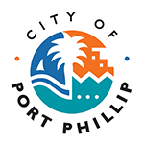

City of Port Phillip
99a Carlisle Street
St Kilda VIC 3182
Phone: ASSIST 03 9209 6777
Email: portphillip.vic.gov.au/contact-us
Website: portphillip.vic.gov.au

Divercity
Receive the latest news from your City and Council portphillip.vic.gov.au/divercity



National Relay Service
If you are deaf or have a hearing or speech impairment, you can phone us through the National Relay Service (NRS):
TTY users, dial 133677, ask for 03 9209 6777
Voice Relay users, phone 1300 555 727,
then ask for 03 9209 6777.
relayservice.gov.au


Contents
Executive Summary 4
Community Profile 6
Changes over time 7
Drivers of change 9
Social Trends 9
Community Providers 12
Our community provider network 12

Executive Summary
Local Government plays an important role in delivering directly to the community. Services, programs, initiatives and facilities are expected to be flexible, agile and responsive to changes in community needs while also being well considered and planned from a long term and financially responsible perspective. The environment in which Local Government operates in is constantly changing with pressures from the external environment as well as impacts from state and federal policy changes. These factors influence the demographic make up of our community and result in changing community needs and requirements.
This document outlines the context in which we are working to deliver for our community and their diverse needs. The content outlines the current profile of the community, their changing profile and the external environment impacting their needs and requirements. It also outlines the range of community service providers that support our community through infrastructure, programs and services. By understanding the community, the environment and our partner providers, we are better able to articulate Council’s role in meeting service gaps which meet the community’s evolving needs.

Our community
Our resident population has experienced a significant increase in the past two years placing pressure on housing, infrastructure and services. Population in CoPP now sits at 109,515, levels last seen in 2017, and it is anticipated growth will settle into the previous pattern seen of 1-2% per year with the most significant growth in Fishermans Bend.
The largest proportion of our residents are aged 25-44 (41%) with 41% of all residents residing alone and 33% being born overseas. A proportion of our residents are transient with 44% renting and 56% residing in high density housing. They also have above average levels of education (with a high proportion university educated), income (46% are in the highest income group) and employment (with 71% labour force participation rate compared to 64% in greater Melbourne). Despite this, a substantial proportion live with significant socio-economic disadvantage.
Over time, our community is aging with a slightly lower birthrate being off-set by a growing proportion of those aged 55 and over. They are increasingly living alone (with fewer group households) and becoming more culturally diverse (with a growing proportion speaking another language at home). Our community is also living with less space with a growing proportion residing in high density housing.
Despite the above average levels of education and income among our community base, complex social and economic circumstances have contributed to a growing number of those most vulnerable in our community. Additionally, these vulnerable cohorts are increasingly hard to reach and less often connected to Council. Other societal trends are driving social isolation and disconnect to Council which is demonstrated through declining civic participation and volunteerism and increase in hard to reach groups for community engagement.
While health data indicates our community is physically healthy on some health measures, they are faring worse than the broader Victorian Population in regards to their mental health and wellbeing and in social capital measures relating to affordability and food security. Furthermore, results show some signs of fractured social cohesion and inclusion.
Trends and external conditions will shape how our community changes and how they seek and use services. Conditions relating to our social, economic, political and legislative environment present multiple opportunities, risks and challenges for meeting the needs of our community.
As a whole the municipality is well serviced by community providers and by a wide range of service types. Services are predominantly clustered within or within close proximity to Activity Centres and well connected by public transport throughout the municipality which increases their visibility and accessibility. The challenge remains in being able to appropriately connect the community with community service providers and fill necessary gaps, within Council’s role, where our provider network is not able to address emerging community needs.

Community Profile
Census 2021 outlines what our population currently looks like and goes some way to help us understand what programs and services are relevant to our community. It also identifies changes to the make up of the demographics of our community over time and has some predictive ability to help us understand future trends.
Our current population of 109,515 residents has recommenced growth after a drop in 2020-21. 2023 saw a sharp uplift in population with a boost of international arrivals and the population is now back to levels seen in 2017. It is expected population growth will settle into the 1-2% growth per year pattern seen pre-2020 (with the most significant population growth occurring in Fishermans Bend).
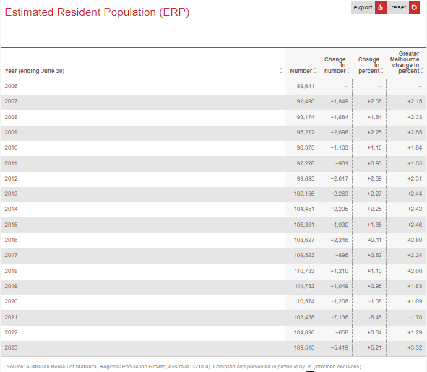

The largest proportion of our residents are aged 25-44 (41%) with 41% of all residents residing alone and 33% being born overseas. A proportion of our residents are transient with 44% renting and 56% reside in high density housing. On the most part, our residents have above average income (46% are in the highest income group), educated (with a high proportion university educated) and employed (with 71% labour force participation rate (64% in greater Melbourne). Despite this, a significant proportion live with significant socio-economic disadvantage.
Figure 1 outlines the snapshot profile of our community based on 2021 Census data. Further breakdowns of our population can be found here: Home | City of Port Phillip | Community profile (id.com.au)
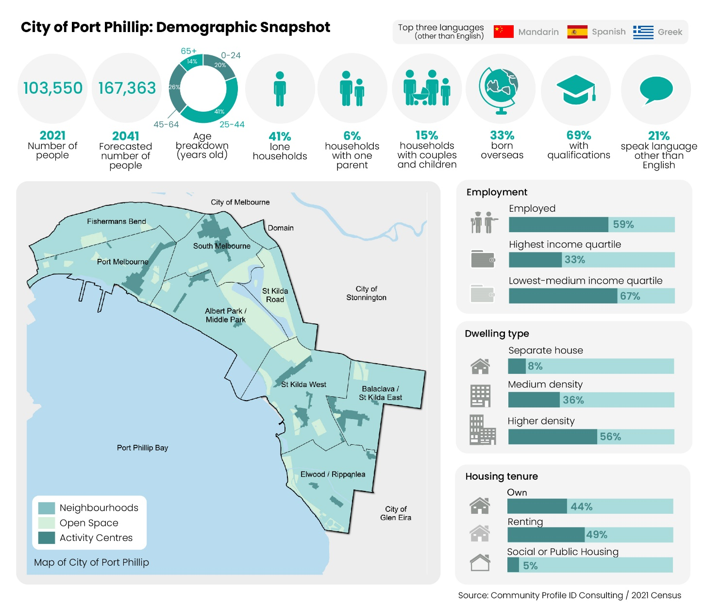
Figure 1: City of Port Phillip’s current community demographics

Changes over time
The recent Census reveals significant changes in our community’s demographic profile, highlighting both shifts and challenges. These changes will be reflected in the community’s changing needs and the way in which they seek services, programs and facilities.

One prominent trend is the ageing population. The proportion of residents classified as part of the 'young workforce'—those aged 25 to 34—has declined between 2016 and 2021 with a corresponding increase in the number of residents aged 50 and over. This ageing trend is accompanied by a rising need for assistance with daily activities, as the percentage of residents requiring support grew from 3.2% in 2016 to 3.7% in 2021.

Additionally, there has been a notable increase in the number of people living alone. In 2021, the community saw an increase of 3,538 lone households, while group households decreased by 828. This shift suggests a growing trend toward individual living arrangements, which brings both independence and a potential sense of isolation.

Culturally, our community is becoming increasingly diverse. More residents are speaking languages other than English at home, with Greek, Mandarin, and Spanish emerging as the most popular. Our area is attracting a significant number of English, Scottish, and Irish immigrants, alongside a rising presence of Colombian residents. This cultural diversification has enriched our community, leading to an increased demand for unique hobbies, interests, and services that cater to various backgrounds.

There has been a noticeable shift towards higher density housing with an increase proportion of residents residing in apartments. This shift will result in continued and increased demand on community facilities for recreation and social connection.
Context

Drivers of change
Our current context creates a number of opportunities and challenges.
The global and local issues and trends impact how our community interacts with our programs and services. Programs and services need to be flexible and adaptable to ensure they remain relevant.
Some global and local trends are outlined below.

Social Trends
As mentioned, our community is increasingly isolated. The increasing number of lone households highlights a need for more targeted engagement strategies, particularly as our community continues to diversify. Each year, the range of birthplaces among residents broadens, making it essential to adopt equitable approaches to programs, services and facilities planning and delivery.

Additionally, a noticeable decline in civic participation and community volunteerism has occurred since 2016. Service providers consistently report a pressing need for volunteers to support essential operations.

The transient nature of many residents further impacts community cohesion. Currently, 44% of residents live in rented accommodation, often feeling less connected to their neighbourhoods. The challenges of obtaining rental housing, combined with rising costs, have strained mental health and well-being. This housing crisis creates a divide between short-term and long-term residents, further complicating efforts to foster a strong, cohesive community. And global political instability has also strained social connections and community cohesion.

Current economic conditions have dampened consumer and business sentiment, with significant increases in the prices of food, fuel, utilities, insurance, mortgages, and rents. Food insecurity has emerged as a pressing concern, with food service providers reporting increased demand for food support. This demand is exacerbated by a decrease in donations and volunteers, putting additional strain on services that assist those in need.

Health and Wellbeing Trends
Overall, our community is generally happy and healthy, with nearly half rating their health as very good or excellent and many actively engage in physical activities. Social connections are also a positive aspect of community life, with a higher proportion of residents reporting strong ties to close friends and family. However, this sense of connection is compromised by the reality that many are living alone, and nearly one in four residents experience feelings of loneliness.

Despite these strengths, significant challenges persist. Mental health and well-being remain issues, as a comparable number of residents report high to very high levels of psychological distress. While more individuals are seeking professional help for mental health concerns, the need for support continues to grow.

Our community also faces the urgent impacts of climate change, with residents reporting the adverse effects of heat waves, storms, and droughts on their health. In addition, the issue of gambling remains concerning, with high player losses on gaming machines persisting. The rates of criminal incidents and family violence continue to be high, underscoring the need for effective interventions.

Certain cohorts within our community are particularly vulnerable. The rising costs of housing and rental affordability have led to the highest number of residents experiencing homelessness in the state, while the proportion of available social housing is declining. Food security is another critical concern; many residents report running out of money for food, and one in five express worries about affording meals at least occasionally.

Additionally, substance use poses a significant challenge. There is an increased risk of alcohol-related harm, evidenced by higher rates of ambulance attendance and hospitalizations. Drug use is also above average, and vaping is emerging as a new concern, with a growing number of residents vaping weekly or monthly.

In light of these challenges, community sentiment (as reported by those responding to Council community engagement survey regarding health priorities) indicates a strong desire for the Council to prioritise several key areas. Residents want a focus on promoting physical activity and social connections, as well as addressing housing and homelessness. They also seek targeted actions to improve food security and reduce the harms associated with smoking, vaping, alcohol, and drug use, alongside efforts to combat all forms of violence.

Strategic partnerships with external organisations, such as employment programs and registered training organizations (RTOs), as well as community agencies like Port Phillip Community Group, Launch Housing, Better Health Network, and Access Health, further enhance our capacity to address local needs. Our involvement in local government networks and special interest groups (SIGs) allows us to stay connected and share best practices with other councils.

We are committed to ongoing engagement with Victoria Police (VicPol) to improve safety and enhance the community's perceptions of safety. This partnership aims to create a more secure environment for residents and visitors alike.

Additionally, we recognize the importance of leveraging government funding opportunities for social and affordable housing projects. By accessing State and Federal capital funding, we can facilitate and broker the delivery of social and affordable housing in collaboration with the State, community housing organizations, and the private sector. This effort aligns with our broader goal of integrating affordable housing and homelessness policies, ensuring that all community members have access to safe and secure housing.

Economic trends
Our businesses are facing many economic challenges. Discretionary spending and local consumption rates have shrunk, with consumers pulling back on spending over the past two years. According to the Australian Bureau of Statistics, all Living Cost Indexes rose between 3.3% and 6.5% in the 12 months leading to the March 2024 quarter, while the Consumer Price Index saw an increase of 3.6% during the same period.

Governments at all levels are also facing increased financial demands such as cost-shifting from other levels of government and construction and service delivery costs that are running above projected inflation. This has resulted in growing pressure on non-rate revenue, complicating efforts to maintain services.

Tourism is another critical area impacted by these challenges. The number of international visitors to Australia remains 24% below pre-COVID levels (2019) and down 34% for Victoria as of December 2023. In response, the Victorian Government has launched "Experience Victoria 2033," a strategic plan aimed at revitalizing the visitor economy, which is projected to reach a total tourism spend of $58 billion by 2033. Similarly, the Australian Government's "THRIVE 2030" strategy aims to boost visitor spending to $230 billion by 2030.

The retail landscape is also evolving, with a renewed community focus on "buy local" initiatives. However, consumer spending is increasingly shifting to online shopping, prompting businesses to prioritize customer loyalty, innovation, and omnichannel commerce strategies.

Moreover, workforce shortages continue to impact our hospitality sector, alongside other hard-hit industries such as healthcare, community services, education, trades, and construction. Both the Australian and Victorian Governments are working to address skills shortages and workforce challenges.

The shift to remote working has transformed the local landscape, particularly in Port Phillip, which is the most densely populated municipality in Victoria. What began as a temporary measure during the pandemic has become a long-term trend, with many people now working part-time or full-time from home. This change will impact road networks, transportation options, and residential parking needs, with varying effects on local retail centers depending on their location.

Community Providers
Community providers provide critical support to our residents through the provision of social support, social inclusion, health and education and training services. They are an important network of services which improve the health and wellbeing outcomes for our residents. Understanding what is available to our residents helps Council identify gaps in the existing social infrastructure network which may benefit from Council initiatives in encouraging connection, improved visibility and accessibility to these services, backed by this baseline snapshot.

Our community provider network
The following data and spatial analysis provides an overview of the current social, recreational and support services provided within the municipality.
Services have been grouped under the following categories and include support services and recreational activities available to the community. These are recognised as gathering opportunities which contribute towards fostering social connection:
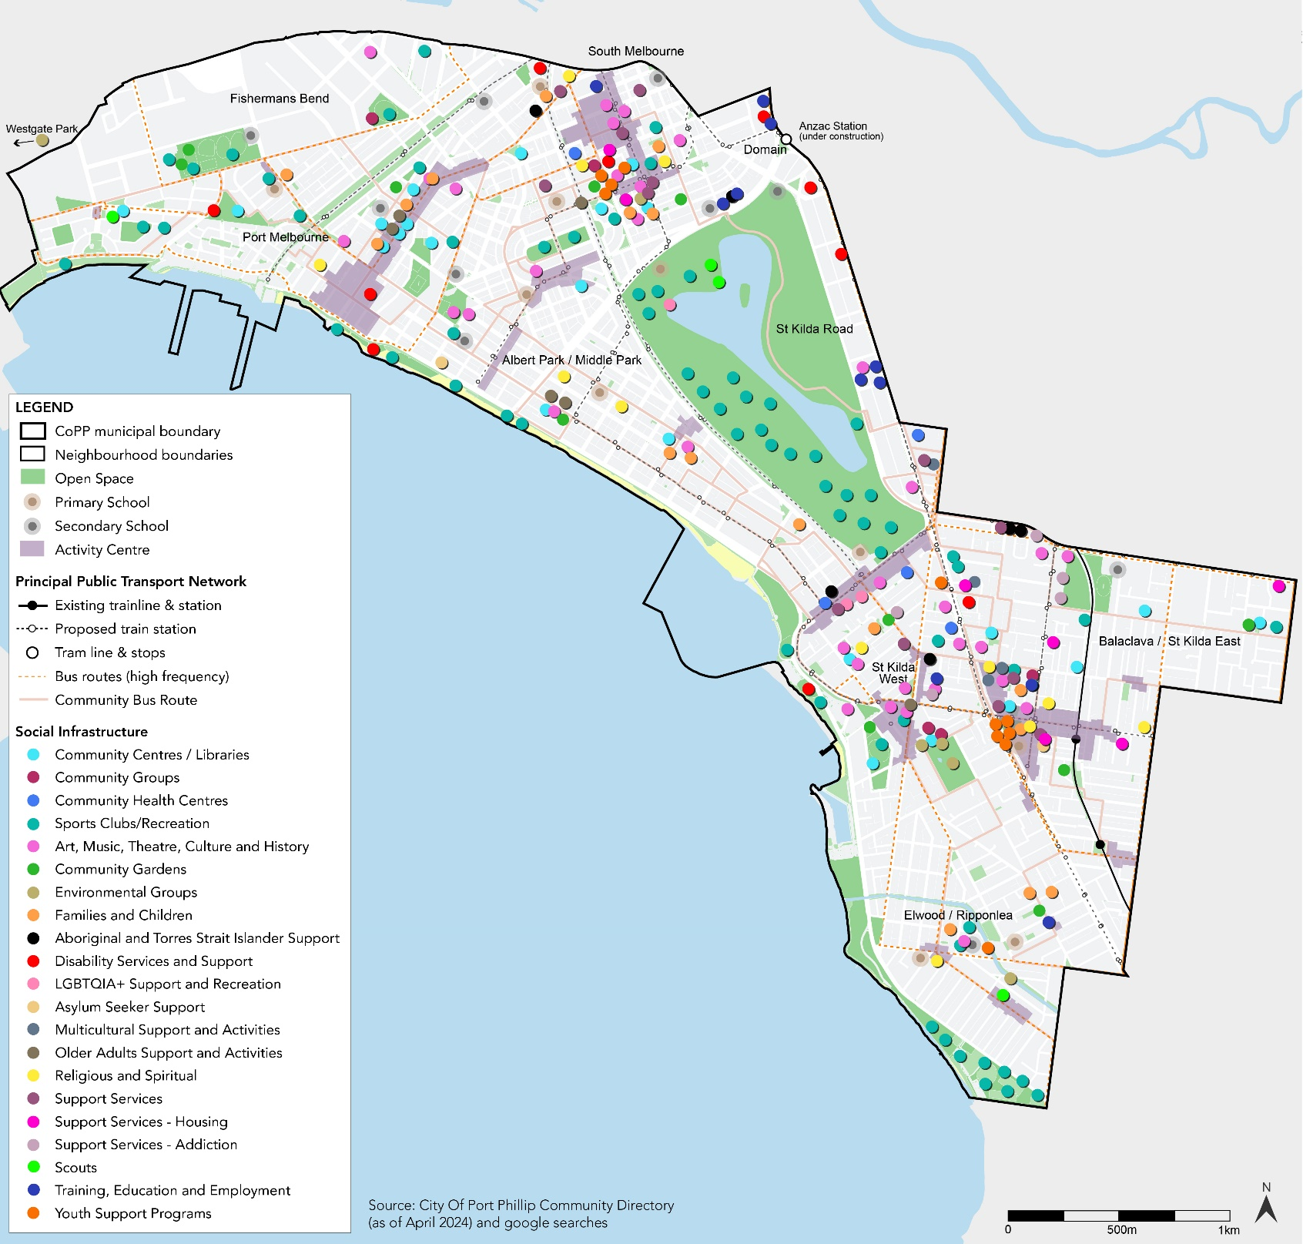
Community Centres/Libraries | Asylum Seeker Support
Community Groups | Multicultural Support and Activities
Community Health | Older Adults Support and Activities
Sports Clubs/Recreation | Religious and Spiritual
Art, Music, Theatre, Culture and History | Support Services – General
Community Gardens | Support Services – Housing
Environmental Groups | Support Services – Addiction
Families and Children, | Scouts
Aboriginal and Torres Strait Islander Support | Training, education and employment
Disability Services and Support | Youth Support Programs
LGBTQIA+ Support and Recreation
Mapping the distribution of these services, shown in Figure 1, indicates at a high level that the municipality as a whole is well serviced by community providers and by a wide range of service types. Services are predominantly clustered within or within close proximity to Activity Centres and well connected by public transport throughout the municipality which increases their visibility and accessibility.

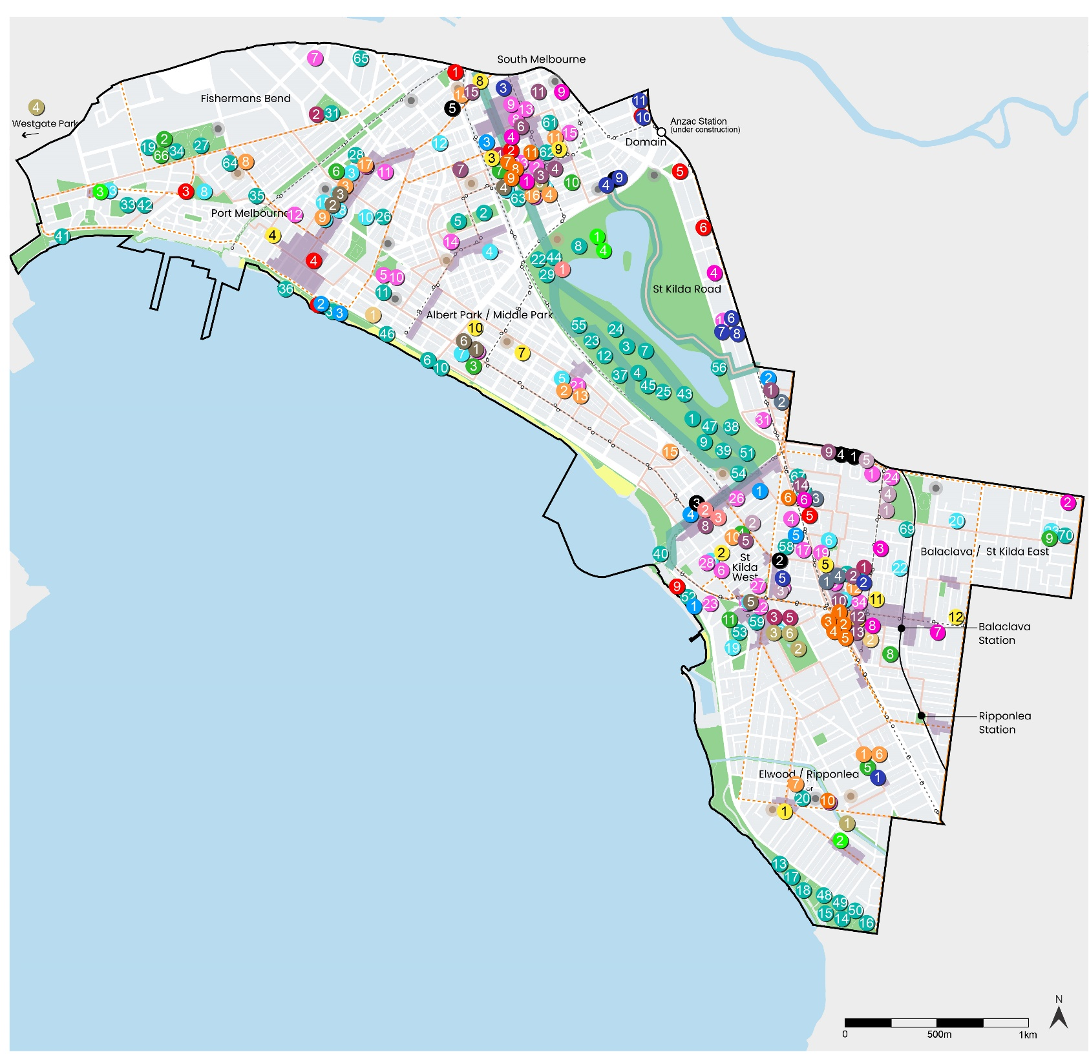
Figure 1: Detailed map of existing Community Social, Recreation and Support Services within the City of Port Phillip (as of May 2024).

The following pages list the services identified on the map above, including those which don’t have a specific fixed locations to map. This provides a snapshot ‘moment in time’ for what is currently happening in Port Phillip in terms of community support services and social infrastructure.

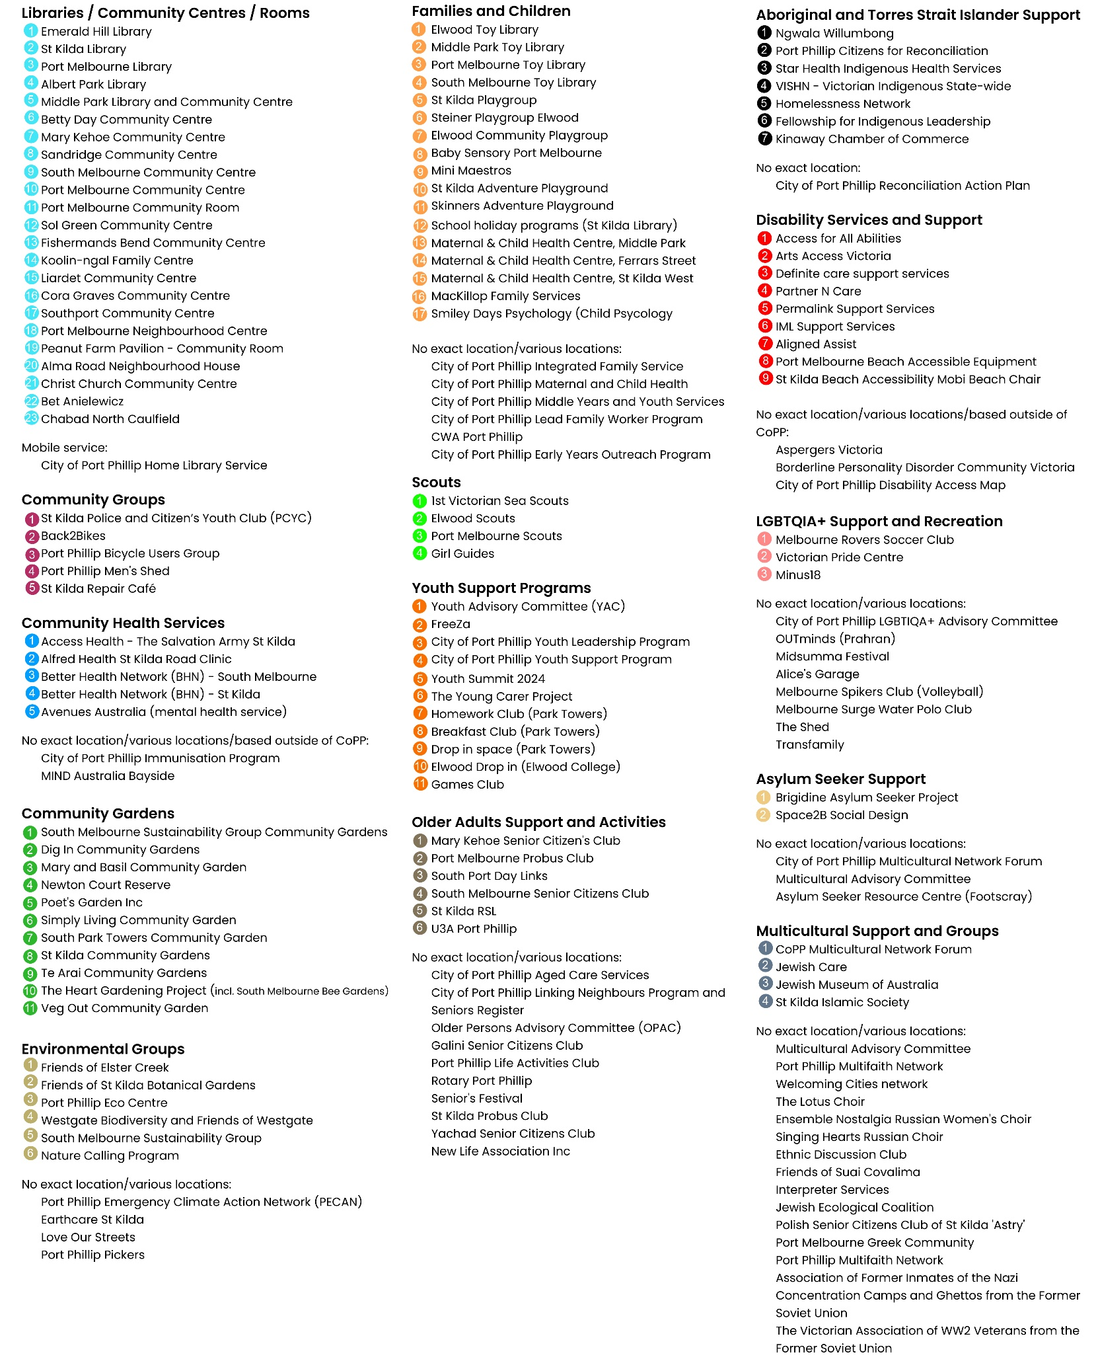

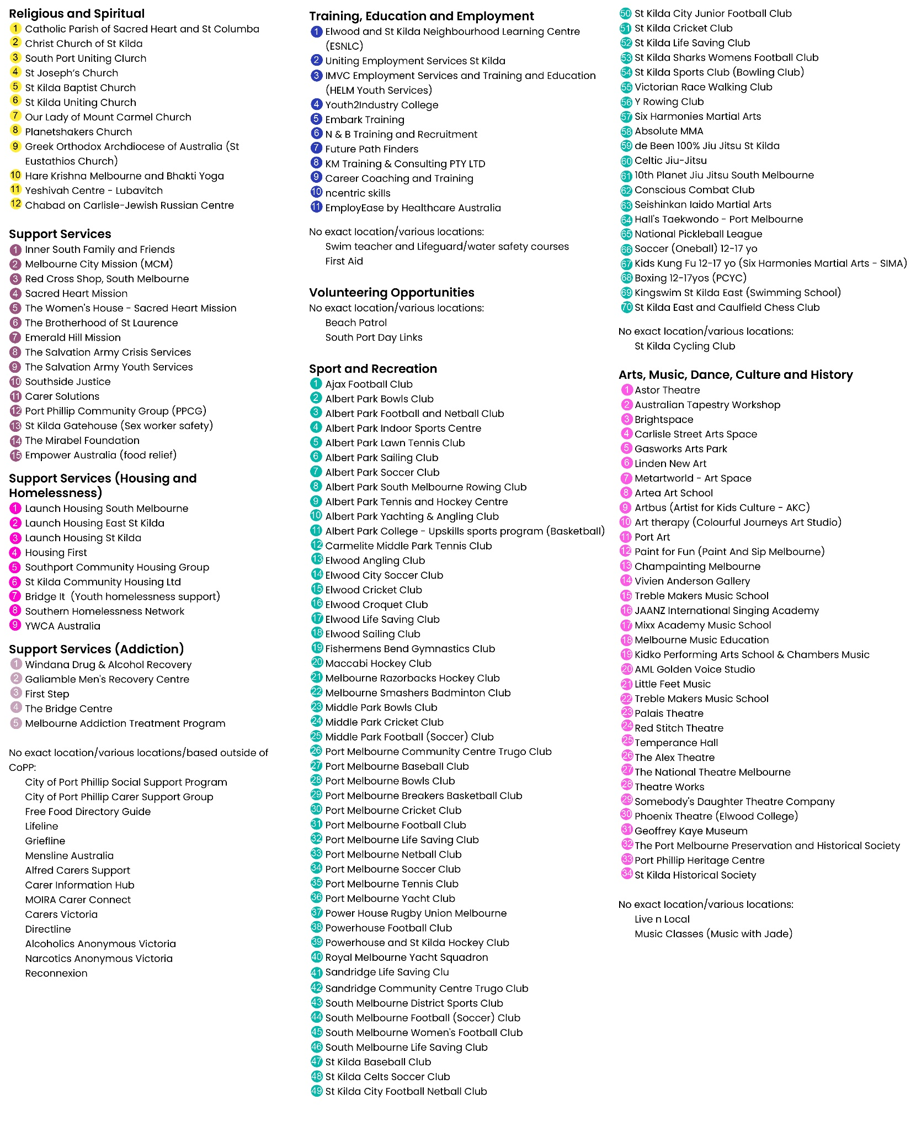

The Victorian Department of Health undertakes a survey of the population every three years: The Victorian Population Health Survey. This survey, capturing respondents in every LGA across Victoria, provides us with important health related information about our residents.

