How to order a Land Information Certificate online
We are aware that at this present time solicitors cannot put in their own reference number. We have flagged this as a priority upgrade with our technology team and this should be fixed shortly.

Initial set up
Solicitor’s must create an Online Services account.
Once an account is created you will not have to create it again. This is just for the initial set up on the new system. Save your log in details for next time you need to order a Land Information or Building Certificate and use the above link to log in again.
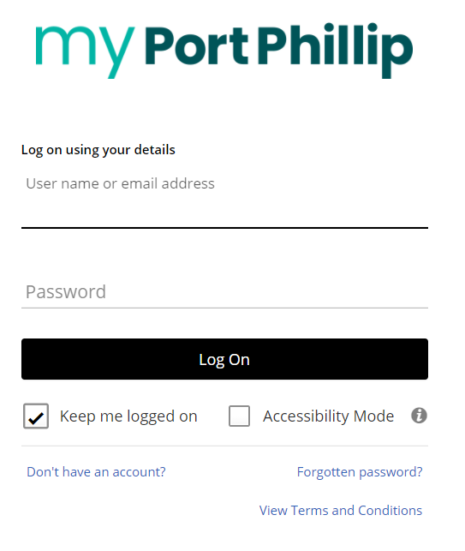

Selecting certificates
Once you have confirmed your log in with the new account, you are ready to order.
- Log in and in the next screen on the bottom right click on ‘apply for a permit of application’
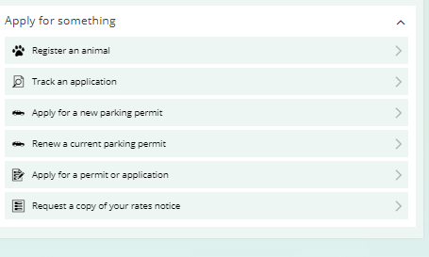
- Find Certificates. Select ‘Start’ and follow the steps to apply.
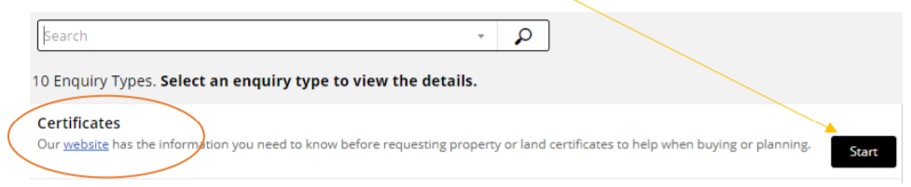

- Select which type of certificate you require. You can select multiple certificates by selecting ‘Add another’.
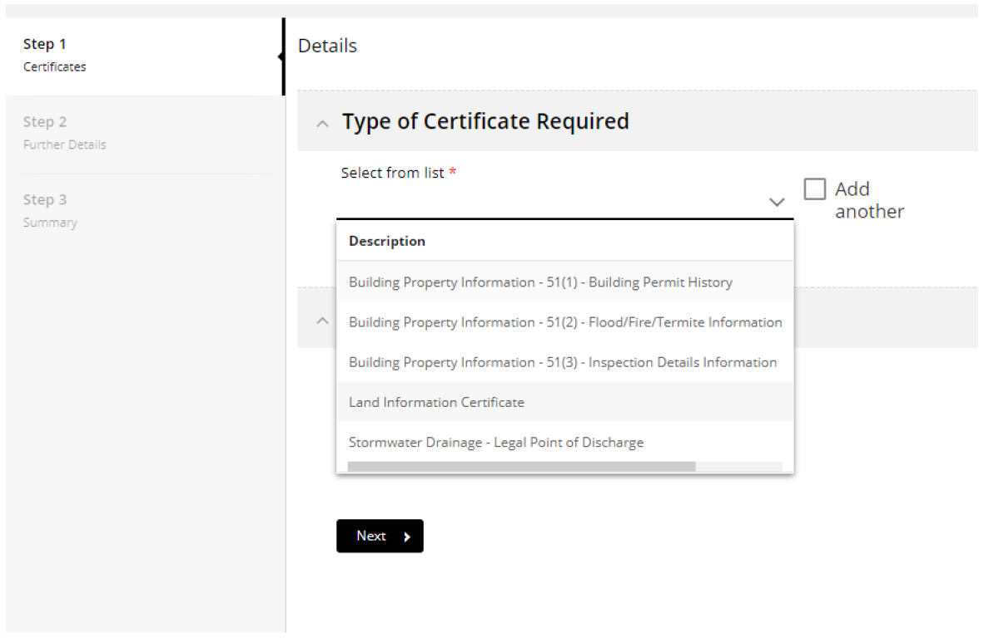
- Search the property address you require.
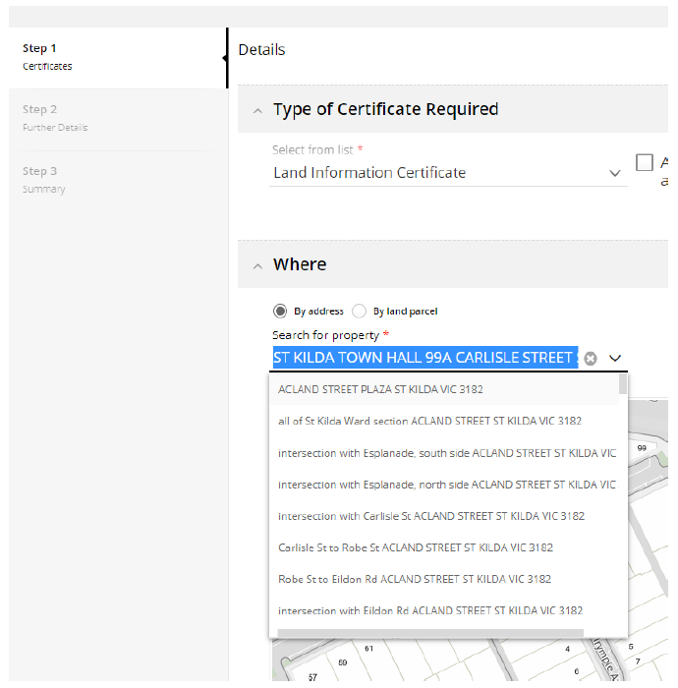
- Select ‘Next’ (top right corner).
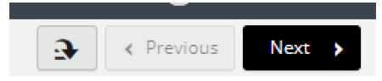
- Select ‘Land Information Certificate (5 days)’.
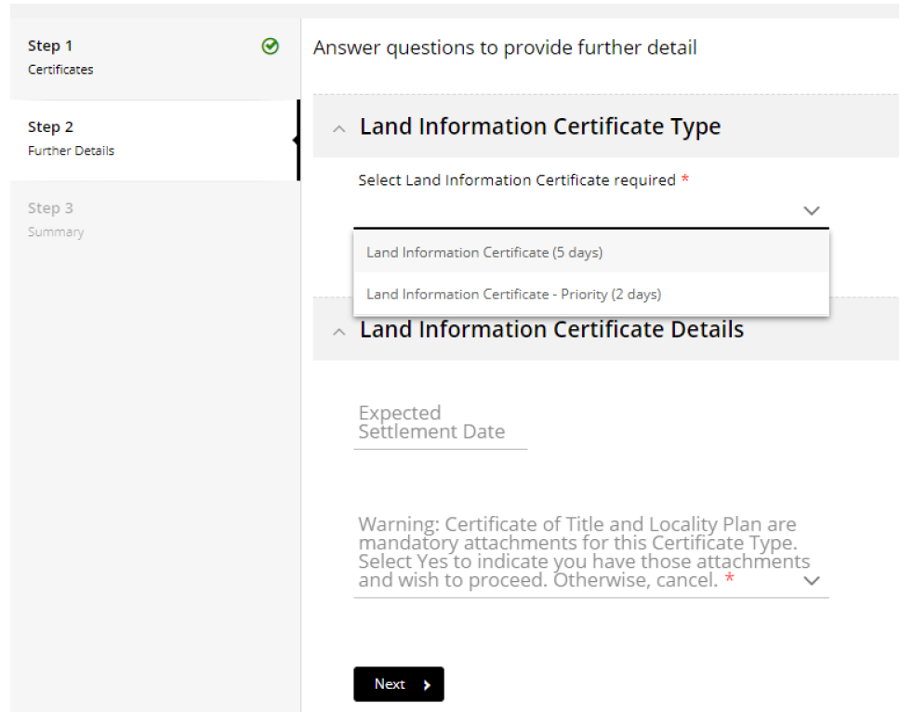
- Add in your settlement date, if there is one.
- In the drop down for Warning select ‘Yes’ - this is a prompt for titles and plans which will be required for every application in upcoming steps.
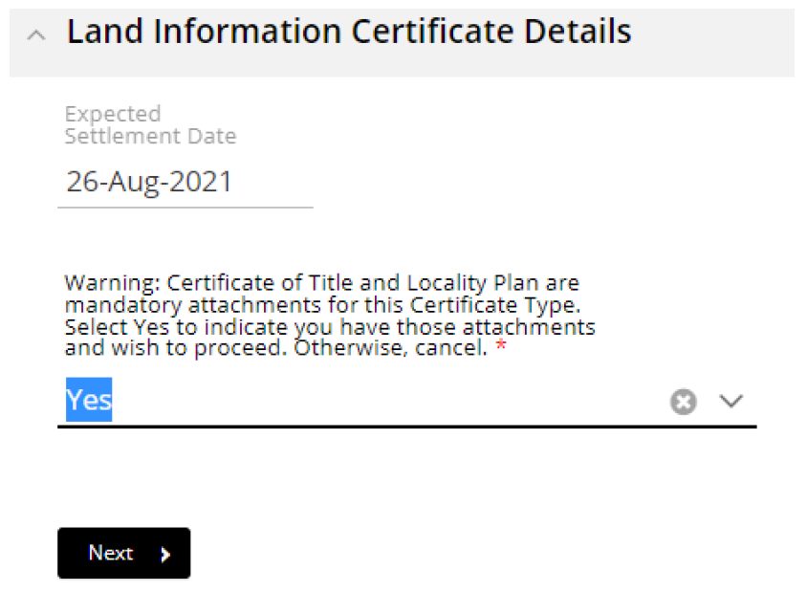
- Select ‘Next’.
- In the next screen you will find the summary for the order. Please check to make sure you’re ordering the correct certificate on the correct property.
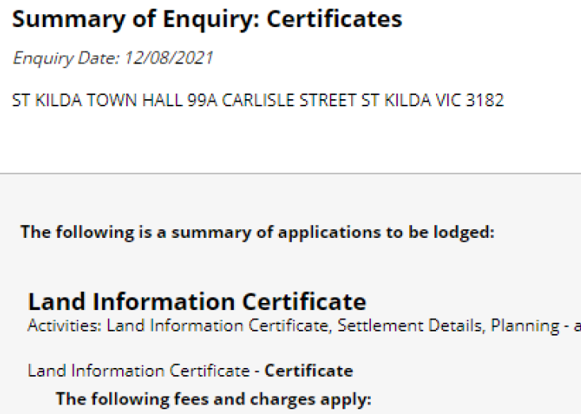
- Select ‘Lodge’ on the top right.

- Select ‘Accept’ or ‘Decline’ for the Terms and Conditions.
Note: you cannot order a certificate if you decline.
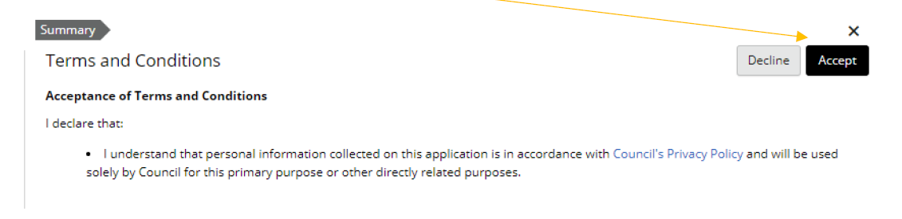

Application progress summary
You can keep track of where you are up to in the process by checking the summary below the list of steps in Online Services.
Any sections marked as ‘Required’ must be completed to finalise your order.
Any sections marked as ‘Actions required’ need to be checked by you.
Anything marked as ‘Actions completed’ indicate you have completed that section.
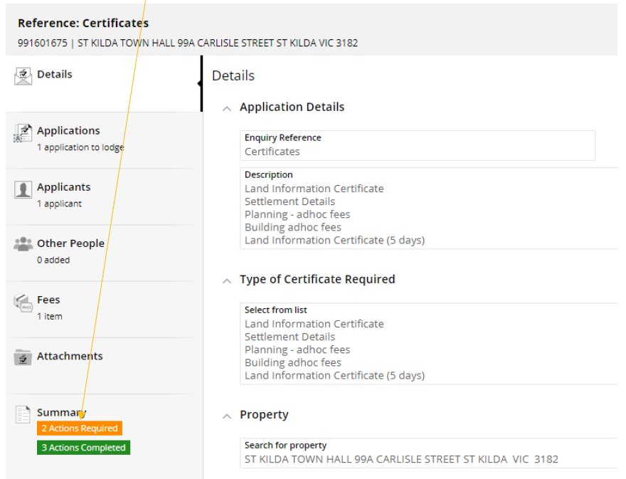
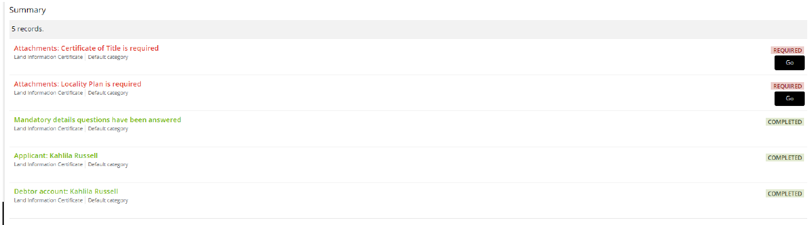

Attaching Plan and Title
In this section you will be attaching Copy of Plan and Copy of Title. You will need to attach a Copy of Title and Copy of Plan separately.
To attach your files:
- Locate ‘Certificate for Title’ under ‘Attachments’.
- Select ‘+ Add’ then ‘Add form local drive’.
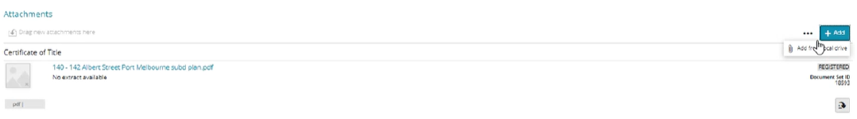
- Add your file then select ‘OK’
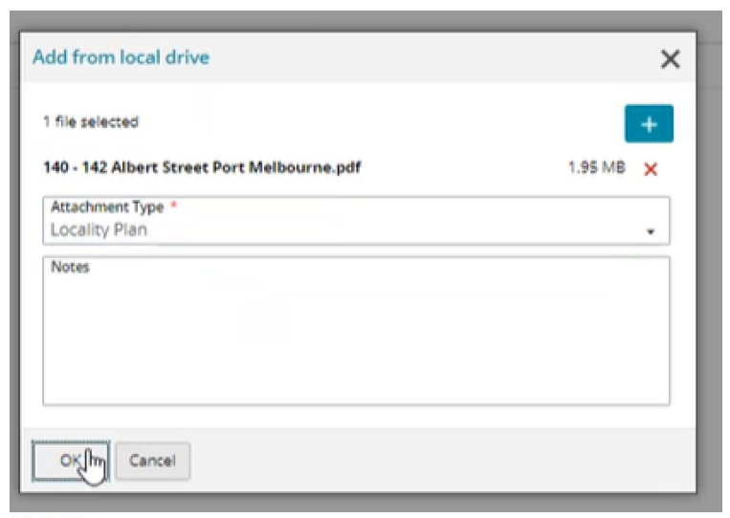
- Repeat the first three steps for your Copy of Title.

Adding contact details
Contact details are required so that Council can issue the certificates to you. You will only need to add your contact details once as Online Services will automatically save your details and reuse them in future applications.
- Navigate to the ‘Applicants’ step’.
- Complete the form with your contact details including:
  - email address
  - business address
  - phone number.
- Once all required fields have been filled in, select ‘Finalise and lodge’ to progress to the payment section.
Note: online payments are made by credit card.